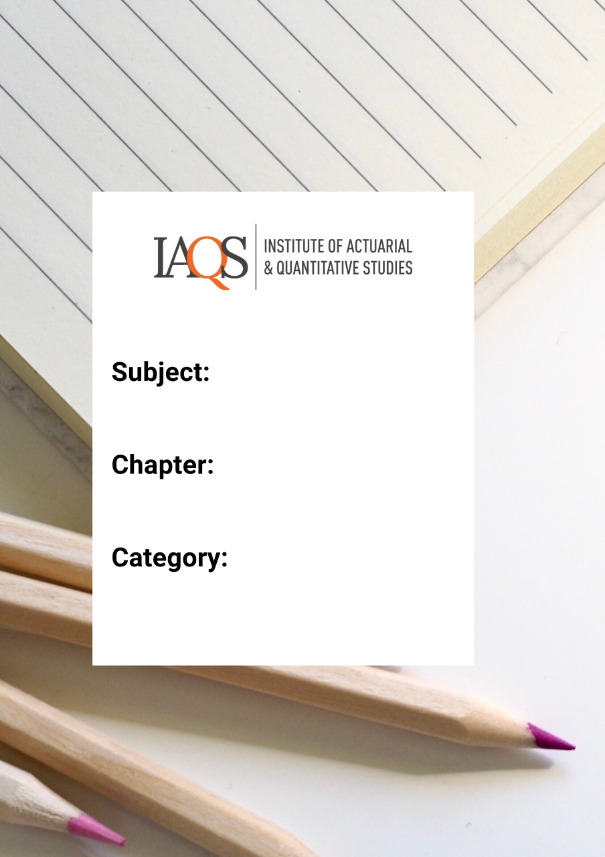
Advanced Excel – Quiz 1

Topics: Macros, Object Model

- A workbook with macros should be saved in which of the following formats?
  - .xlsx
  - .xlsm
  - .xls
  - .vba

- Which of the following best describes what a macro does?
  - It is a recording function
  - It is a set of instructions to automate tasks
  - It is an accessibility feature of excel
  - It is a type of worksheet format to save VBA files

- While recording a macro if you make a mistake, what is the best way to correct it?
  - Stop recording and re-record the macro
  - Hit Ctrl+z and continue recording
  - Keep recording and later edit the VBA file
  - Any of the above

- Which of the following macro names is not permitted:
  - $toINR
  - Dollar to INR
  - Rupee2$
  - _dollar_Rupee

- Which of the following is not correct about macros:
  - Macros may contain malicious code which can destroy your computer
  - Macros are used to automate routine tasks
  - Macros can only be created by recording them
  - If you save an excel workbook with macros as .xlsx format, all macros are deleted

- Which of the following is not an object in VBA
  - Application
  - Workbook
  - Sub
  - Worksheet

- Objects of the same type constitute a
  - Procedure
  - Dim
  - Collection
  - Workbook

- Which of the following syntax is incorrect
  - Excel.Workbooks(“Book1.xlsx”).Worksheet"s(“Sheet1”). Range(“A1”)
  - Application.Workbooks(“Book1.xlsx”).Range(“A1”)
  - Range(“A1)
  - Range(“A1”).Worksheets(“Sheet1”).Workbooks(“Book1.xlsx”)

- The shortcut for opening the Visual basic editor with 1 key stroke is
  - F11
  - Alt + F11
  - Alt + 0
  - Alt + Windows

- Which of the following is a property of a Range Object
  - Value
  - Type
  - HasTitle
  - Macro

- With respect to an Object, what is a Method
  - The algorithm followed by the macro that is using the object
  - An action that Excel performs on the object
  - The process of declaring the object
  - A property that describes what an object can store

- Which of the following are features of VBA?
  - Loops
  - Variables
  - Arrays
  - None of the above

- The first key in a macro shortcut is
  - Shift
  - Alt
  - Ctrl
  - Enter

- In VBA, the cell that was last selected is known as
  - Selected Cell
  - Highlighted Cell
  - Active Cell
  - Open Cell

- If you choose “Disable All Macros with notification”, and then try to open a workbook with macros, Excel will
  - Not open the workbook
  - Crash and show the blue screen of death
  - Display a warning
  - Delete the macros in the workbook

- Which of the following is true
  - All macros saved in any workbook can be run at any time if Excel is open
  - All macros saved in Personal Macro Workbook can be run when Excel is open
  - All macros can be run if any MS Office application is open
  - Macros can be run as stand-alone applications on any OS

- Which of the following is not true about a method?
  - A method can not change an object’s properties
  - A method can read an object’s properties
  - A method may take arguments
  - A method may not take arguments

- Which of the following is false
  - The object browser contains the list of all objects in Excel
  - If you type an object name, excel automatically provides a list of its methods and properties
  - The code generated by the Excel macro recorder is the most efficient code with no superfluous content
  - The VBA help system (F1) only works with a functional internet connection

- Which of the following is true?
  - All objects are collections
  - All collections are objects
  - Some collections are objects
  - No collections are objects

- What does the following sub do?
Sub AddAWorkbook()
Workbooks.Add
End Sub

- Add a new worksheet to the workbook
- Add a new workbook
- Nothing. It is superfluous
- Nothing. The code is erroneous.

