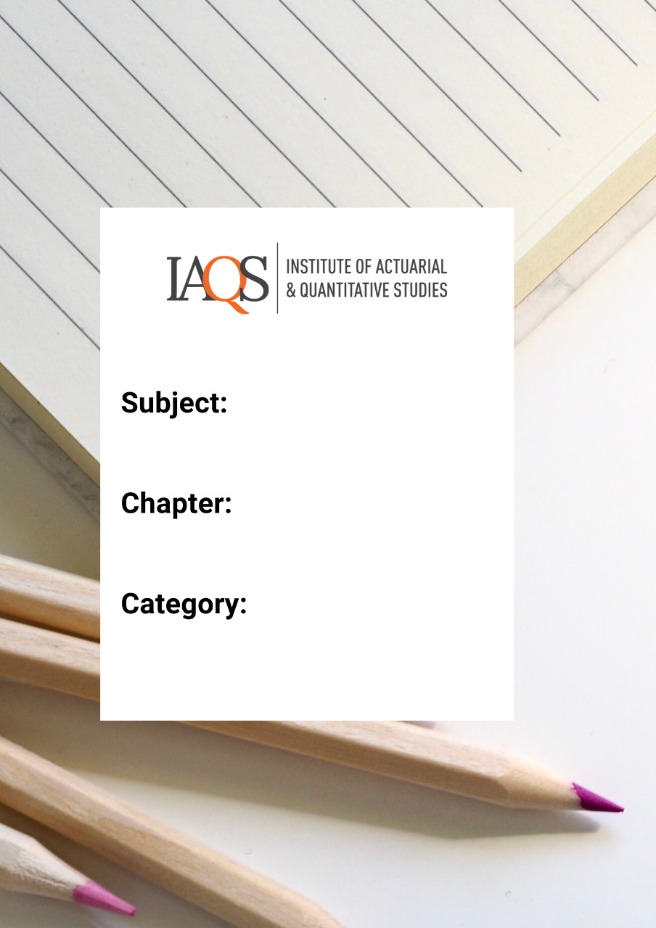
Advanced Excel – Quiz 1

Topics: Macros, Object Model

- A workbook with macros should be saved in which of the following formats?
  - .xlsx
  - .xlsm
  - .xls
  - .vba

- Which of the following best describes what a macro does?
  - It is a recording function
  - It is a set of instructions to automate tasks
  - It is an accessibility feature of excel
  - It is a type of worksheet format to save VBA files

- While recording a macro if you make a mistake, what is the best way to correct it?
  - Stop recording and re-record the macro
  - Hit Ctrl+z and continue recording
  - Keep recording and later edit the VBA file
  - Any of the above

- Which of the following macro names is not permitted:
  - $toINR
  - Dollar to INR
  - Rupee2$
  - dollar_Rupee

- What is the maximum length for a procedure name?
  - 32
  - 255
  - 64
  - 128

- A sub procedure can be run by (choose all that apply)
  - A customized button on the worksheet
  - Automatically on opening the workbook
  - From keyboard shortcut
  - All of the above

- The first character in a comment statement is
  - “
  - #
  - ‘
  - $

- In which of the following situations must you add a comment
  - To explain a workaround
  - To explain what a variable does
  - To indicate a change in code
  - All of the above

- The shortcut for opening the Visual basic editor with 1 key stroke is
  - F11
  - Alt + F11
  - Alt + 0
  - Alt + Windows

- A named data storage location in the memory of the computer that is used to store a value is called
  - Bit
  - Byte
  - Variable
  - Dim

- Which of the following can be used as a variable name in VBA
  - Plus
  - Sub
  - Dim
  - End

- VBA programmers may not explicitly define the data type for every variable used, because VBA is not
  - Object Oriented
  - Strictly Typed
  - Case sensitive
  - Option Explicit

- Which of the following data type is the smallest by the amount of memory it occupies
  - Long
  - Date
  - Currency
  - Boolean

- In order to create a variable that indicates whether a person is a millionaire or not, the most efficient data type is
  - Currency
  - Long
  - Boolean
  - Double

- The data type that can change with respect to the kind of data (string, numeric …) that is stored in it is called
  - Variable
  - Versatile
  - Variant
  - String

- Which of these is not a VBA data type
  - Currency
  - Float
  - Long
  - Date

- The command that does not permit any variable without a defined sata type is
  - Option Expression
  - Option Explicit
  - Option Implicit
  - Option Call

- Which of the following is false
  - The object browser contains the list of all objects in Excel
  - If you type an object name, excel automatically provides a list of its methods and properties
  - The code generated by the Excel macro recorder is the most efficient code with no superfluous content
  - The VBA help system (F1) only works with a functional internet connection

- A variable that is defined in the first line of a module preceded by the word public will be accessible by
  - None of the procedures in the module
  - All of the procedures in the module
  - All of the procedures in all the modules
  - First procedure in the module

- The lowets level of scope of a variable is
  - Procedure level
  - Module level
  - Public
  - Private

- What will happen if the following code is run (assume there is no Option Explicit command in the module)
  - Sub Addition()
Dim Variable as Integer
Varieble=Variable+1
End Sub

- Error, because Addition is a reserved keyword
- Error, because the word Varieble is misspelt
- No Error
- Error, because there is no output

- A variable whose value is not reset at the end of the procedure in which it is contained is called
  - Public
  - Static
  - Variant
  - Constant

- Which of the following is a valid VBA assignment
  - x=x+1
  - x==y
  - x->y
  - x is y

- The Mod operator in VBA stands for
  - Absolute value
  - Modulo Arithmetic
  - Modifier
  - Mode

- Which of the following array declaration is correct?
  - Dim Array1 (1 To 100)
  - Dim Array1 (1 to 100, 1To 10, 1 to 1)
  - Dim Array1 (3,4)
  - All of the above

