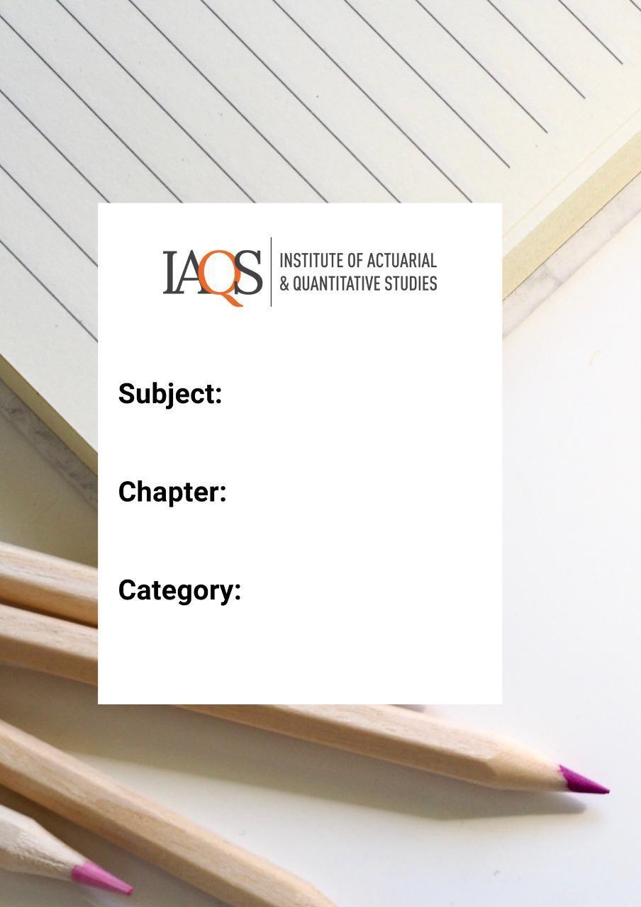
Subject CT4 September 2010 Q9
Notes
IKS – Vedic Maths
Unit 1
TOPIC NAME: MULTIPLY 2 DIGIT NUMBER BY 1 DIGIT NUMBER
EXPLANATION:

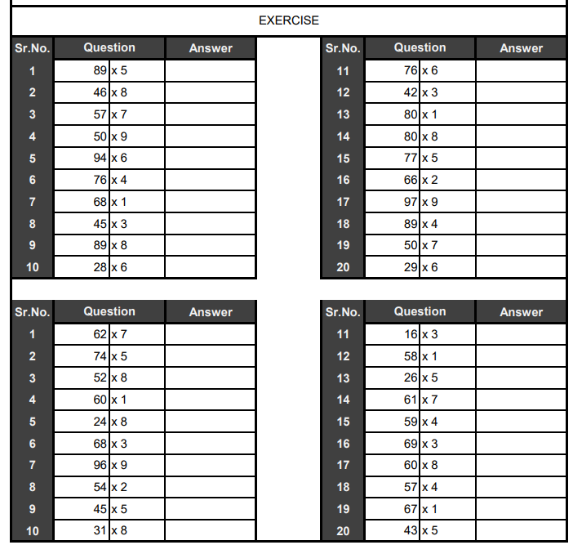

TOPIC NAME: MULTIPLY 2 DIGIT NUMBER BY 2 DIGIT NUMBER
EXPLANATION:

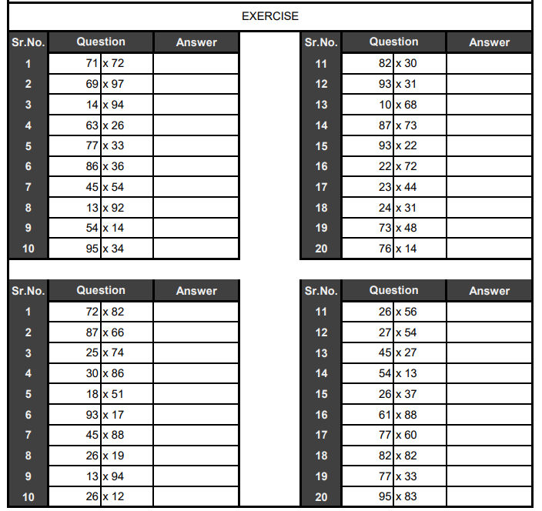

TOPIC NAME: NIKHILAM METHOD (POSITIVE DEVIATION)
EXPLANATION:

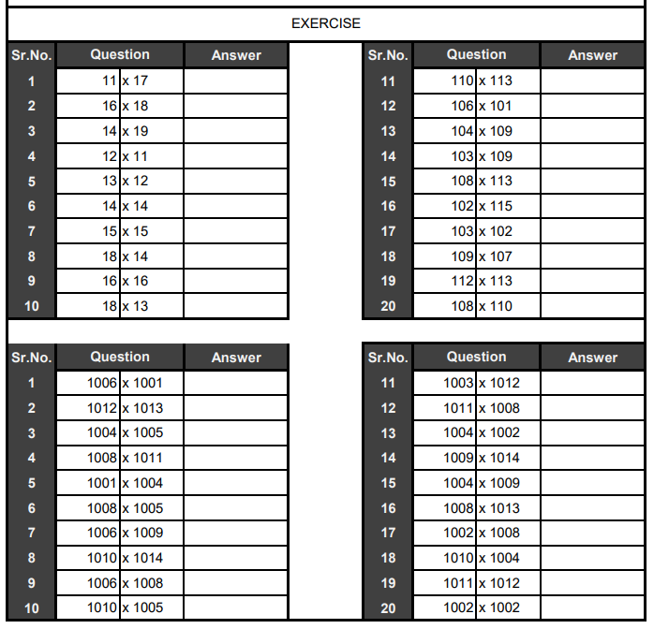
TOPIC NAME: ALL FROM 9 LAST FROM 10
EXPLANATION:

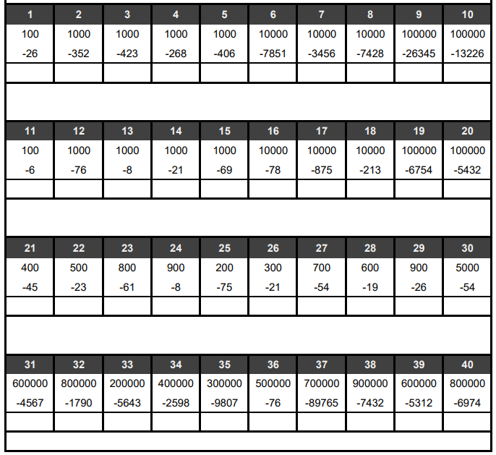
TOPIC NAME: DIVISON BY 5, 25 & 50
EXPLANATION:

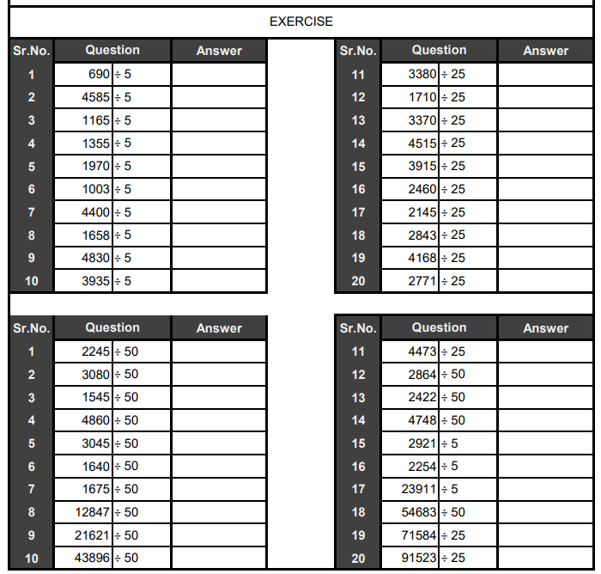
TOPIC NAME: MULTIPLY ANY NUMBER BY EQUAL DIGITS OF 9
EXPLANATION:

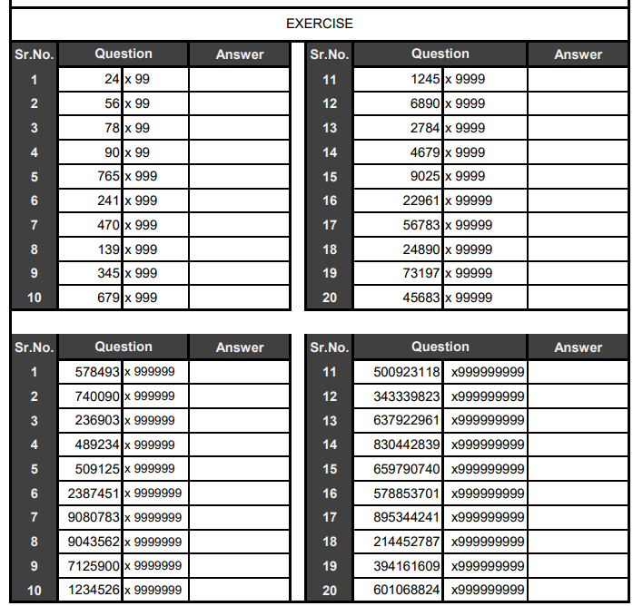

TOPIC NAME: MULTIPLY ANY NUMBER BY MORE DIGITS OF 9
EXPLANATION:

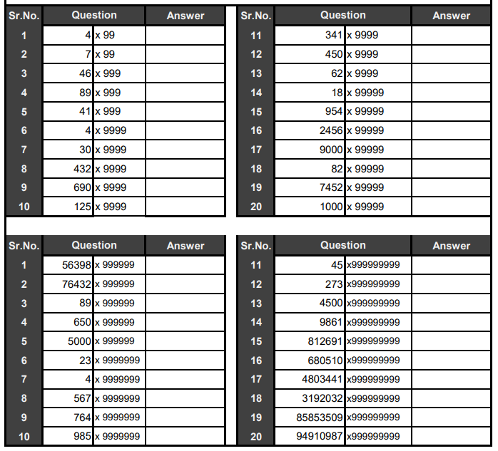
TOPIC NAME: LCM
EXPLANATION:

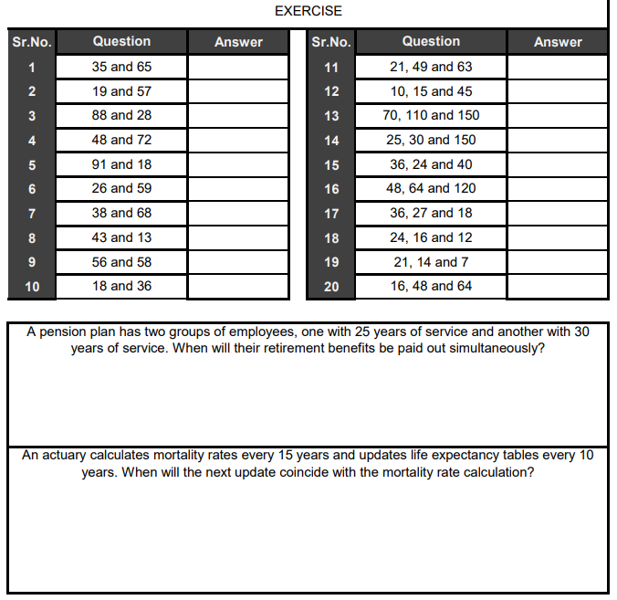
TOPIC NAME: MULTIPLY ANY NUMBER BY 11, 111 & 1111
EXPLANATION:

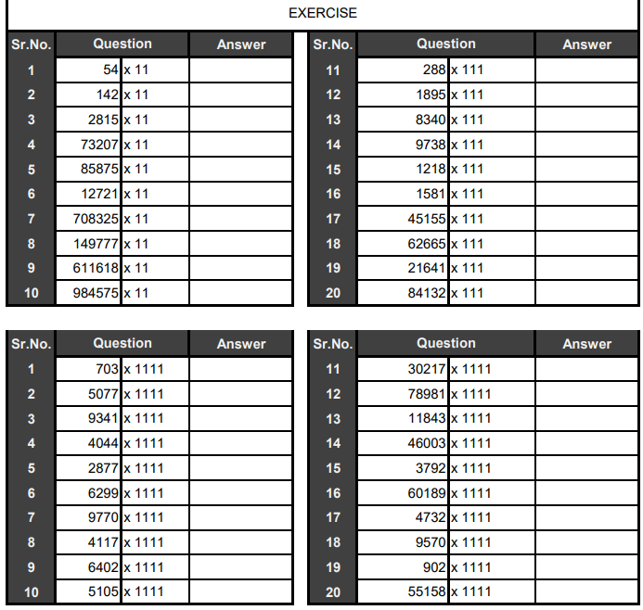
TOPIC NAME: ANTYAYORDASHKEPI METHOD
EXPLANATION:

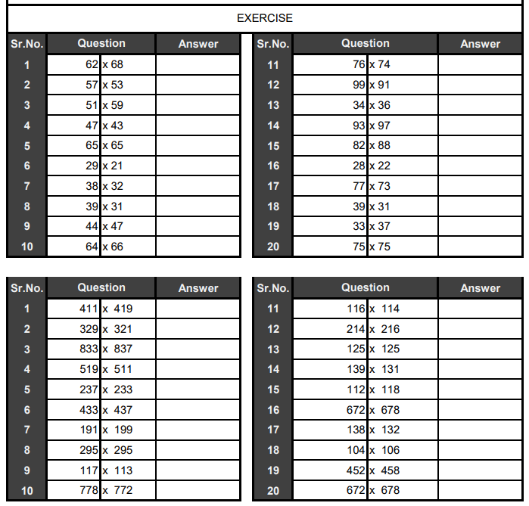
TOPIC NAME: OPPOSITE ANTYAYORDASHKEPI METHOD
EXPLANATION:

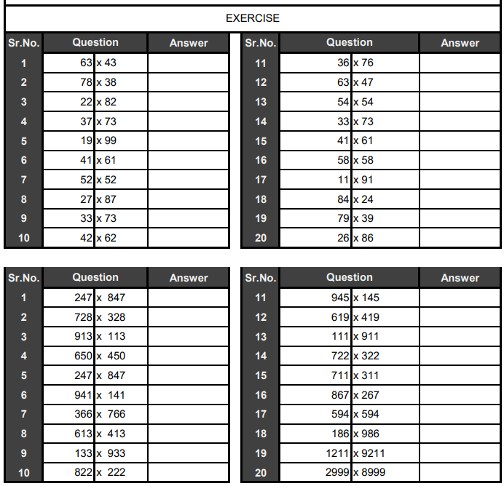
TOPIC NAME: NIKHILAM METHOD (NEGATIVE DEVIATION)
EXPLANATION:

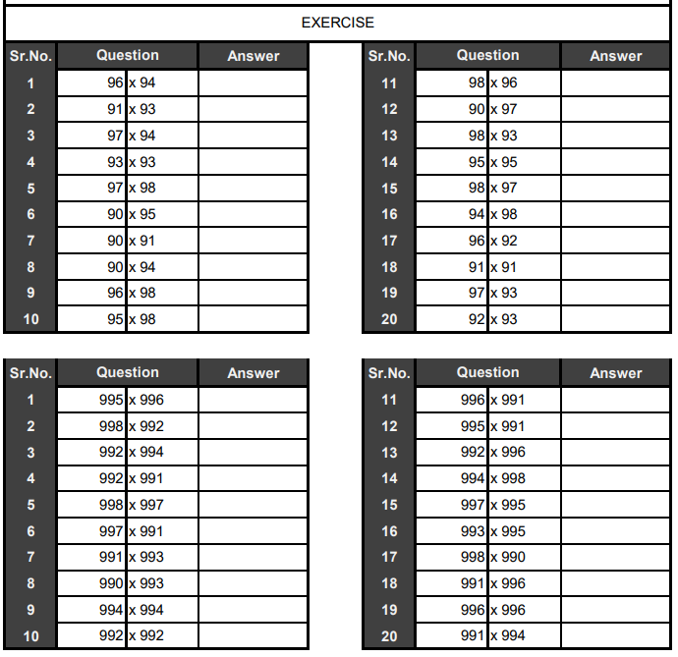
TOPIC NAME: DIVISION BY 9, 99 and 999
EXPLANATION:

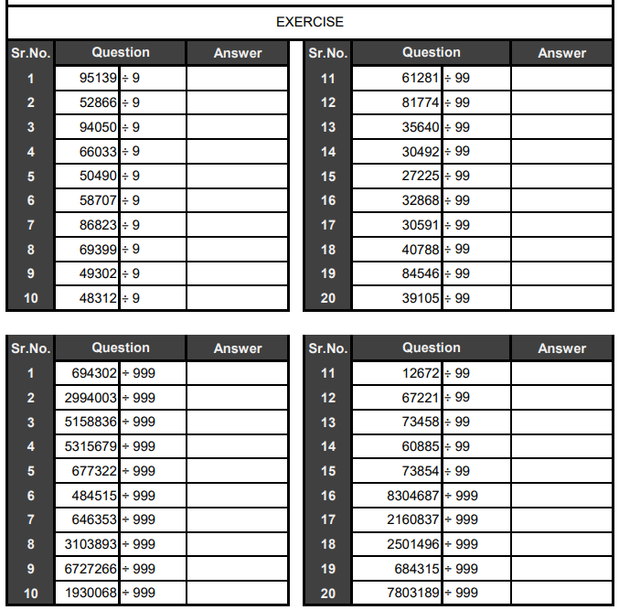
TOPIC NAME: MULTIPLY 3 DIGIT BY 3 DIGIT NUMBER
EXPLANATION:

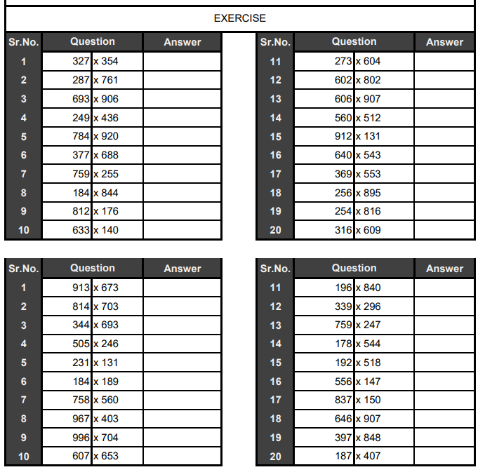
UNIQUE LEARNING

UNIQUE LEARNING

UNIQUE LEARNING

UNIQUE LEARNING

UNIQUE LEARNING

UNIQUE LEARNING

