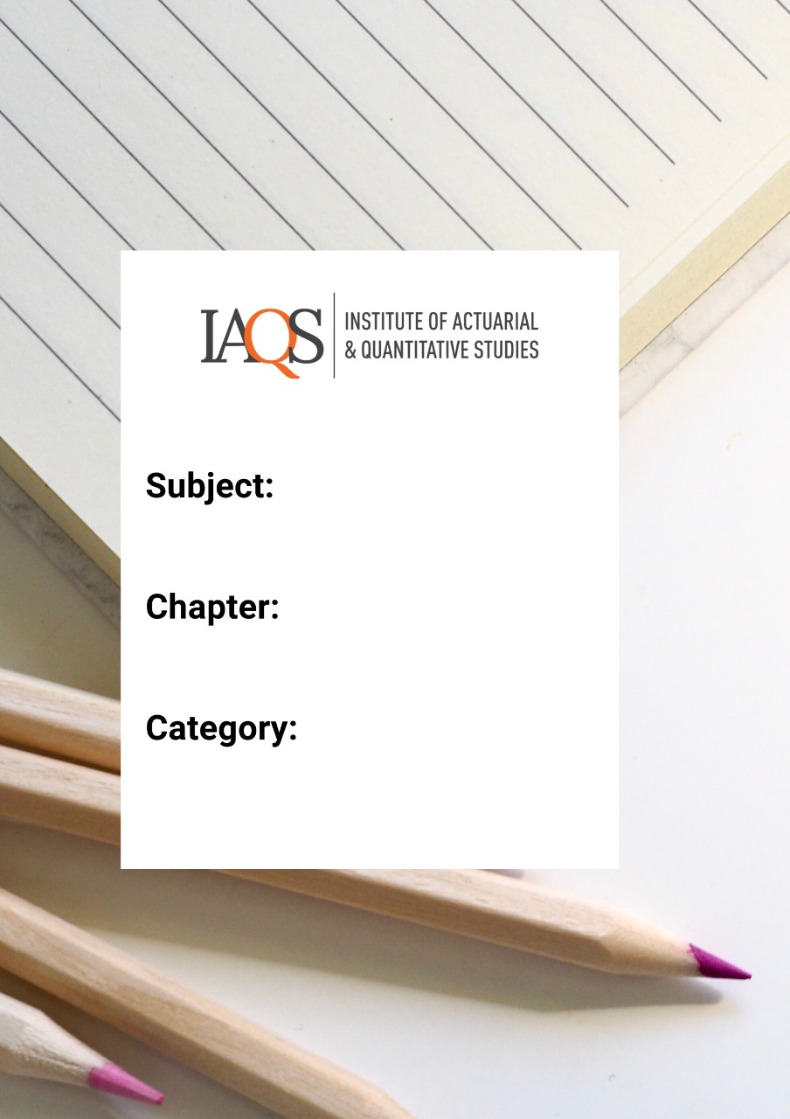
Ji
FM
Annuities

1. An annuity certain with payments of £150 at the end of each quarter is to be replaced by an annuity with the same term and present value, but with payments at the beginning of each month instead.
Calculate the revised payments, assuming an annual force of interest of 10%.
Solutions: 49.1724

2. A company has borrowed £500,000 from a bank. The loan is to be repaid by level instalments, payable annually in arrear for ten years from the date the loan is made. The annual instalments are calculated at an effective rate of interest of 9% per annum.
Calculate the amount of the level annual instalments.
Solutions: 77910.04

3. A loan is to be repaid by an increasing annuity. The first repayment will be £200 and the repayments will increase by £100 per annum. Repayments will be made annually in arrear for ten years. The repayments are calculated using a rate of interest of 6% per annum effective.
Calculate the amount of the loan.
Solutions: 4432.25

4. A loan is repayable by annual instalments in arrear for 20 years. The initial instalment is £5,000, with each subsequent instalment decreasing by £200. The effective rate of interest over the period of the loan is 4% per annum. Calculate the amount of the original loan.
Solutions: 45638.56

5. A bank makes a loan to be repaid by instalments paid annually in arrear. The first instalment is £400, the second is £380 with the payments reducing by £20 per annum until the end of the 15th year, after which there are no further repayments. The rate of interest charged is 4% per annum effective.
Calculate the amount of the loan.
Solutions: 3052.65

6. A loan of £20,000 is repayable by an annuity payable annually in arrear for 25 years. The annual repayment is calculated at an effective interest rate of 8% per annum and increases by £50 each year.
Calculate the amount of the first payment.
Solutions: 1462.31

7. Calculate, at a rate of interest of 5% per annum effective:
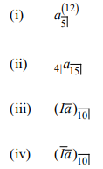
(v) the present value of an annuity that is paid annually in advance for 10 years with a payment of 12 in the first year, 11 in the second year and thereafter reducing by 1 each year.
Solutions:
(i) 4.4278, (ii) 8.5394, (iii) 40.3501, (iv) 36.3613, (v) 64.0592

8. A loan is to be repaid by a series of instalments payable annually in arrear for 15 years. The first instalment is £1,200 and payments increase thereafter by £250 per annum.
Repayments are calculated using a rate of interest of 6% per annum effective. Determine the amount of the loan.
Solutions: 26043.29

9. Show that:
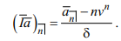

10. The nominal rate of interest per annum convertible quarterly is 2%. Calculate the present value of a payment stream paid at a rate of €100 per annum, monthly in advance for 12 years.
Solutions: 1068.05

11. A bank offers two repayment alternatives for a loan that is to be repaid over sixteen years:
Option 1: the borrower pays £7,800 per annum quarterly in arrear.
Option 2: the borrower makes payments at an annual rate of £8,200 every second year in arrear.
Determine which option would provide the better deal for the borrower at a rate of interest of 5% per annum effective.
Solution: 1st option

12. An individual aged exactly 65 intends to retire in five years’ time and receive an annuity-certain. The annuity will be payable monthly in advance and will cease after 20 years. The annuity will increase at each anniversary of the commencement of payment at the rate of 3% per annum.
The individual would like the initial level of annuity to be £20,000 per annum. The price of the annuity will be the present value of the payments on the date it commences using an interest rate of 7% per annum effective.
Calculate the price of the annuity
Solution: 276645

13. A loan is to be repaid by an increasing annuity. The first payment will be £100 and the payments will increase by £50 per annum. Payments will be made annually in arrear for ten years. The repayments are calculated using a rate of interest of 5% per annum effective.
Calculate the amount of the loan.
Solutions: 2354.78

14. An n-year decreasing annuity is payable annually in arrear where the payment at the end of the first year is n, the payment at the end of the second year is (n – 1), and so on until the final payment at the end of year n is 1.
(i) Show that the present value of this annuity is:
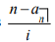

A loan is to be repaid over 25 years by means of annual instalments payable in arrear. The amount of the first instalment is £8,000 and each subsequent instalment reduces by £200. The effective rate of interest charged by the lender is 5.5% per annum.
(ii) Calculate the initial amount of the loan
Solution: 82372.95

15. A bank has just granted a loan of $10,000 to a business to be repaid in ten equal instalments, annually in arrears. The rate of interest is 4% per annum effective.
Calculate the amount of the annual repayment.
Solution: 1232.91

16. A loan of £80,000 was taken out on 1 January 2016. The loan was to be repaid over 10 years in level instalments payable monthly in arrears.
Calculate the level monthly instalment using an effective rate of interest of 8% per annum
Solution: 958.86

17. A loan is to be repaid by a series of instalments made annually in arrears. The first instalment is $200 per annum and thereafter instalments increase by $15 each year. The instalments are paid for 16 years and are calculated using an effective rate of interest of 5% per annum.
Calculate the amount of the loan.
Solutions: 3219.96

18.
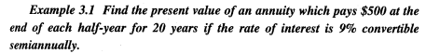
Solution: 9200.79

19.
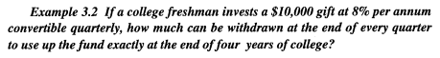
Solution: 736.50

20.
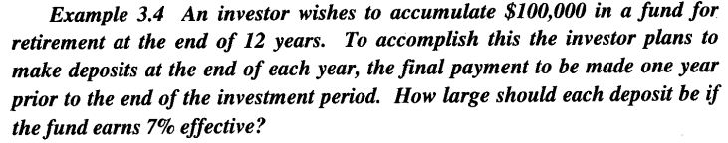
Solution: 5921.21

21.
Solution: 0.08905

22.
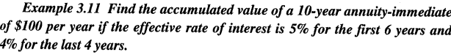
Solution: 1220.38

23.
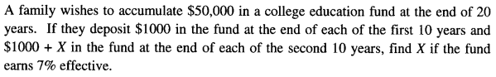
Solution: 651.72

24.
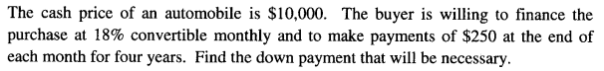
Solution: 1489.36

25.
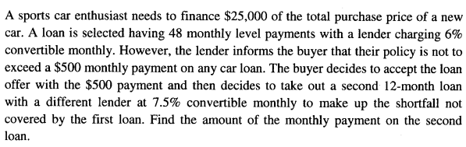
Solution: 321.86

26.
Solution:
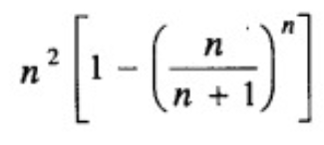

27.
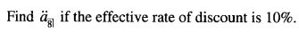
Solution: 5.695

28.
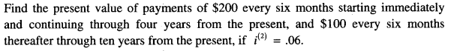
Solution: 2389.72

29.
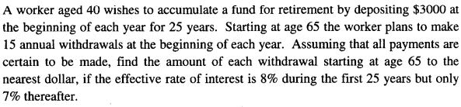
Solution: 24305

30.
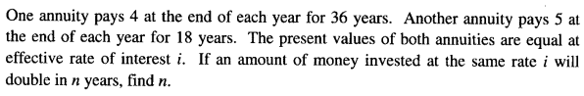
Solution: 9

31.
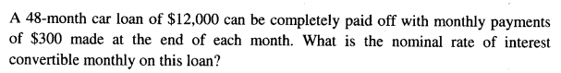
Solution: 9.24%

32.
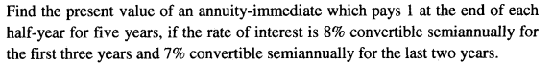
Solution: 8. 145

33.
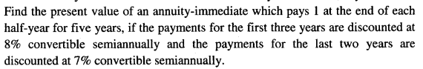
Solution: 8.230

34.
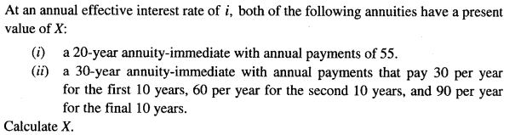
Solution: 574.60

35.
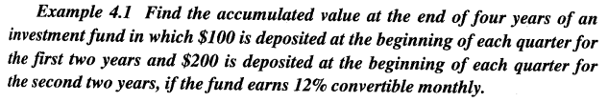
Solution: 2998.86

36.
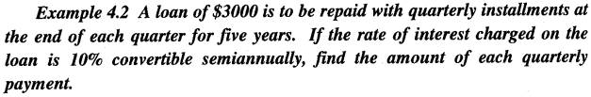
Solution: 191.89

37.
Solution: 9.46%

38.
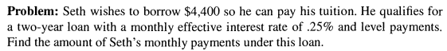
Solution: 189.05

39. At six-month interval, A deposited ₹2000 in a saving account which credit interest at 10% p.a. compounded semi-annually. The first deposit was made when A’ s son was six-month-old and the last deposit was made when his son was 8 years old. The money remained in the account and was presented to the son on his 10th birthday. How much did he receive?
Solution: 57511.68

40. An annuity of ₹500 p.a. is flowing continuously for 10 years. Find its future value if the rate of interest is 10% compounded continuously
Solution: 8591.5

41. Calculate the present value of an annuity-immediate of amount $100 paid annually for 5 years at the rate of interest of 9% per annum.
Solution: 388.97

42. Calculate the present value of an annuity-immediate of amount $100 payable quarterly for 10 years at the annual rate of interest of 8% convertible quarterly. Also calculate its future value at the end of 10 years.
Solution: 6040.20

43. A man borrows a loan of $20,000 to purchase a car at annual rate of interest of 6%. He will pay back the loan through monthly installments over 5 years, with the first installment to be made one month after the release of the loan. What is the monthly installment he needs to pay?
Solution: 386.66

44. A company wants to provide a retirement plan for an employee who is aged 55 now. The plan will provide her with an annuity-immediate of $7,000 every year for 15 years upon her retirement at the age of 65. The company is funding this plan with an annuity-due of 10 years. If the rate of interest is 5%, what is the amount of installment the company should pay?
Solution: 5501.53

45. Find the present value of an annuity-due of $200 per quarter for 2 years, if interest is compounded monthly at the nominal rate of 8%.
Solution: 1493.90

46. Al Bundy says he paid $25,000 down on a new house and will pay $525 per month for 30 years. If interest is 7.8% compounded monthly, what was the selling price of the house?
Solution: 97929.78

47. An perpetuity–immediate provides annual payments. The first payment of 13000 is one year from now. Each subsequent payment is 3.5% more than the one preceding it. The annual effective rate of interest is i = 6%. Find the present value of this perpetuity
Solution: 520000

48. Find the present value of a 15–year decreasing annuity–immediate paying 150000 the first year and decreasing by 10000 each year thereafter. The effective annual interest rate of 4.5%.
Solution: 946767.616.

49. Two twins Lauren & Mallory both will save $2000 at 12% compounded annually. Mallory begins at age 20 and deposits $2000 a year till age 29, for a total of 10 deposits, then does nothing till retirement at age 65 (36 years). How much will Mallory have at age 65? Lauren begins at age 29 depositing $2000 a year until retirement at age 65 (37 deposits). How much will Lauren have at retirement?
Solution: (i) 2075509.03, (ii) 1087197.38

50. Find the present value at time 0 of an annuity such that the payments start at 1, each payment thereafter increases by 1 until reaching 10, and they remain at that level until 25 payments in total are made. The effective annual rate of interest is 4%.
Solution: 117.1040897

51. An perpetuity provides annual payments. The first payment of 13000 is one year from now. Each subsequent payment is 3.5% more than the one preceding it. The annual effective rate of interest is i = 6%. Find the present value of this perpetuity.
Ans – 520000

52. A 15 year annuity pays 1000 at the end of year 1 and increases by 1000 each year until the payment is 8000 at the end of year 8. Payments then decrease by 1000 each year until a payment of 1000 is paid at the end of year 15. The annual effective interest rate of 6.5%. Compute the present value of this annuity.
Ans - 39482.626.

53. Chris makes annual deposits into a bank account at the beginning of each year for 10 years. Chris initial deposit is equal to 100, with each subsequent deposit k% greater than the previous year deposit. The bank credits interest at an annual effective rate of 4.5%. At the end of 10 years, the accumulated amount in Chris account is equal to 1657.22. Calculate k
Ans – 6%

54. An annuity provides for 20 annuals payments, the first payment a year hence being $4500. The payments increase in such a way that each payment is 4.5% greater than the previous one. The annual effective rate of interest is 4.5%. Find the present value of this annuity.
Ans – 86124.40191

55. An annuity provides for 10 annuals payments, the first payment a year hence being $2600. The payments increase in such a way that each payment is 3% greater than the previous one. The annual effective rate of interest is 4%. Find the present value of this annuity.
Ans - 23945.54454.

56. An annuity arrears consists of a first payment of $100, with subsequent payments increased by 10% over the previous one until the 10th payment, after which subsequent payments decreases by 5% over the previous one. If the effective rate of interest is 10% per payment period, what is the present value of this annuity with 20 payments?
Solution: 1351.94

57 A perpetuity-due pays $1000 for the first year and payments increase by 3% for each subsequent year until the 20th payment. After that the payments are the same as the 20th. Find the present value if the effective annual interest rate is 5%.
Ans - $30,641.46

58. Suppose a deposit of $1000 is made on the first of the months of January, February and March, $1,200 at the beginning of each month in the second quarter, $1,400 at the beginning of each month in the third quarter and $1,600 each month in the fourth quarter. If the account has a nominal 8% rate of interest compounded quarterly, what is the balance at the end of the year?
Ans - $16,226.10

59.
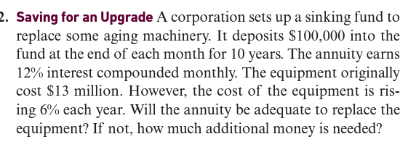
Solution:
AV of deposits = 23003868.9
AV of machine costs = 23281020.1

Extra amount required = 277151

60. An investor receives payments half-yearly in arrears for 20 years. The first payment is £250, and each payment is 2% higher than the previous one. The interest rate is 6% pa effective for the first 10 years and 4% pa effective for the final 10 years. Calculate, showing all workings, the present value of the payments. [6]
Solution: 8526.46

61 . You have successfully started and operated a company for the past 10 years. You have decided that it is time to sell your company and spend time on the beaches in Hawaii. A potential buyer is interested in your company, but he does not have the necessary capital to pay you a lump sum. Instead, he has offered $500,000 today and annuity payments for the balance. The first payment will be for $150,000 in three months. The payments will increase at 2% per quarter and a total of 25 quarterly payments will be made. If you require an EAR of 11%, how much are you being offered for your company?
Solution: Value of offer = $3,891,407.12

