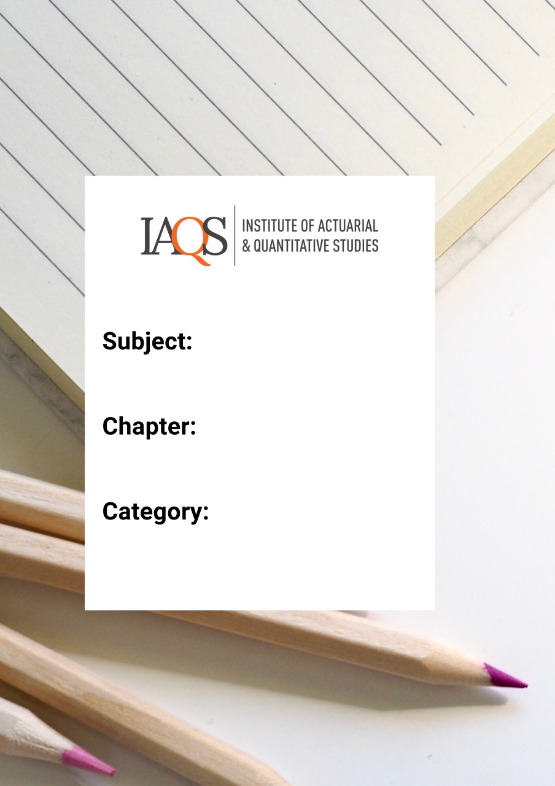
Ji
Financial mathematics
Annuity

1. An annuity certain with payments of £150 at the end of each quarter is to be replaced by an annuity with the same term and present value, but with payments at the beginning of each month instead.
Calculate the revised payments, assuming an annual force of interest of 10%. [3]
Solutions: 49.1724

2. An actuarial student has created an interest rate model under which the annual effective rate of interest is assumed to be fixed over the whole of the next ten years. The annual effective rate is assumed to be 2%, 4% and 7% with probabilities 0.25, 0.55 and 0.2 respectively.
(a) Calculate the expected accumulated value of an annuity of £800 per annum payable annually in advance over the next ten years.
(b) Calculate the probability that the accumulated value will be greater than £10,000
Solutions: (a) 10093.13 , (b) 0.2

3. An insurance company offers a customer two payment options in respect of an invoice for £456. The first option involves 24 payments of £20 paid at the beginning of each month starting immediately. The second option involves 24 payments of £20.50 paid at the end of each month starting immediately. The customer is willing to accept a monthly payment schedule if the annual effective interest rate per annum he pays is less than 5%.
Determine which, if any, of the payment options the customer will accept.
Solution:
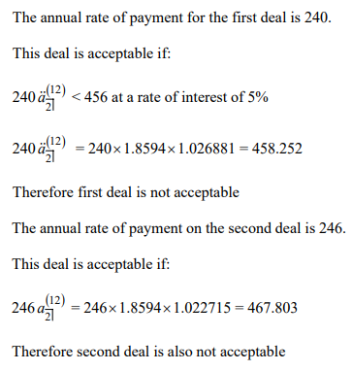

4. A mortgage company offers the following two deals to customers for twenty-five year mortgages.
Product A
A mortgage of £100,000 is offered with level repayments of £7,095.25 made annually in arrear. There are no arrangement or exit fees.
Product B
A mortgage of £100,000 is offered whereby a monthly payment in advance is calculated such that the customer pays an effective rate of return of 4% per annum ignoring arrangement and exit fees. In addition the customer also has to pay an arrangement fee of £6,000 at the beginning of the mortgage and an exit fee of £5,000 at the end of the twenty-five year term of the mortgage.
Compare the annual effective rates of return paid by customers on the two products.
Solution: Product B charges a lower effective annual return than Product A

5. An individual wishes to receive an annuity which is payable monthly in arrears for 15 years. The annuity is to commence in exactly 10 years at an initial rate of £12,000 per annum. The payments increase at each anniversary by 3% per annum. The individual would like to buy the annuity with a single premium 10 years from now.
Calculate the single premium required in 10 years’ time to purchase the annuity assuming an interest rate of 6% per annum effective.
Solution: 143774.45

6. A member of a pensions savings scheme invests £1,200 per annum in monthly instalments, in advance, for 20 years from his 25th birthday. From the age of 45, the member increases his investment to £2,400 per annum. At each birthday thereafter the annual rate of investment is further increased by £100 per annum. The investments continue to be made monthly in advance for 20 years until the individual’s 65th birthday.
(i) Calculate the accumulation of the investment at the age of 65 using a rate of interest of 6% per annum effective.
At the age of 65, the scheme member uses his accumulated investment to purchase an annuity with a term of 20 years to be paid half-yearly in arrear. At this time the interest rate is 5% per annum convertible half-yearly.
(ii) Calculate the annual rate of payment of the annuity.
(iii) Calculate the discounted mean term of the annuity, in years, at the time of purchase.
Solution: (i) 266138, (ii) 21203.88, (iii) 8.63 years

7. An individual intends to retire on his 65th birthday in exactly four years’ time. The government will pay a pension to the individual from age 68 of £5,000 per annum monthly in advance. The individual would like to purchase an annuity certain so that his income, including the government pension, is £8,000 per annum paid monthly in advance from age 65 until his 78th birthday. He is to purchase the annuity by a series of payments made over four years quarterly in advance starting immediately.
Calculate the quarterly payments the individual has to make if the present value of these payments is equal to the present value of the annuity he wishes to purchase at a rate of interest of 5% per annum effective. Mortality should be ignored.
Solution: 2414.45

8. Mrs Jones invests a sum of money for her retirement which is expected to be in 20 years’ time. The money is invested in a zero coupon bond which provides a return of 5% per annum effective. At retirement, the individual requires sufficient money to purchase an annuity certain of £10,000 per annum for 25 years. The annuity will be paid monthly in arrear and the purchase price will be calculated at a rate of interest of 4% per annum convertible half-yearly.
Calculate the sum of money the individual needs to invest at the beginning of the 20-year period.
Solutions: 158422

9. An investor pays £120 per annum into a savings account for 12 years. In the first four years, the payments are made annually in advance. In the second four years, the payments are made quarterly in advance. In the final four years, the payments are made monthly in advance. The investor achieves a yield of 6% per annum convertible half-yearly on the investment.
Calculate the accumulated amount in the savings account at the end of 12 years.
Solutions: 2128.75

10. On 1 January 2016, a student plans to take out a five-year bank loan for £30,000 that will be repayable by instalments at the end of each month. Under this repayment schedule, the instalment at the end of January 2016 will be X, the instalment at the end of February 2016 will be 2X and so on, until the final instalment at the end of December 2020 will be 60X. The bank charges a rate of interest of 15% per annum convertible monthly.
(i) Prove that
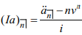
(ii) Show that X = £26.62.

11. An investor has a choice of two 15-year savings plans, A and B, issued by a company. In both plans, the investor pays contributions of $100 at the start of each month and the contributions accumulate at an effective rate of interest of 4% per annum before any allowance is made for expenses.
In plan A, the company charges for expenses by deducting 1% from the annual effective rate of return.
In plan B, the company charges for expenses by deducting $15 from each of the first year’s monthly contributions before they are invested. In addition it deducts 0.3% from the annual effective rate of return.
Calculate the percentage by which the accumulated amount in Plan B is greater than the accumulated amount in Plan A, at the end of the 15 years.
Solution: 4.33%

12. A university offers its students three financing options for a degree course that lasts exactly three years.
Option A
Fees are paid during the term of the course monthly in advance. The fees are £10,000 per annum in the first year and rise by 5% on the first and second anniversaries of the start of the course.

Option B
The university makes a loan to the students which is repaid in instalments after the end of the course. The instalments are determined as follows:
• No payments are made until three years after the end of the course.
• Over the following 15 years, students pay the university £1,300 per year, quarterly in advance.
• After 15 years of payments, the quarterly instalments are increased to £1,500 per year, quarterly in advance.
• After a further 15 years of payments, the quarterly instalments are increased to £1,800 per year, quarterly in advance, for a further 15-year period after which there are no more payments.

Option C
• Students pay to the university 3% of all their future earnings from work, with the payments made annually in arrear.
A particular student wishes to attend the university. He expects to leave university at the end of the three-year course and immediately obtain employment. The student expects that his earnings will rise by 3% per annum compound at the end of each year for 10 years and then he will take a five-year career break.
After the career break, he expects to restart work on the salary he was earning when the career break started. He then expects to receive salary increases of 1% per annum compound at the end of each year until retiring 45 years after graduating.
The student wishes to take the financing option with the lowest net present value at a rate of interest of 3% per annum effective.

(i) Calculate the present value of the payments due under option A.
(ii) Calculate the present value of the payments due under option B.
(iii) Calculate the initial level of salary that will lead the payments under option C to have the lowest present value of the three options.
Solution: (i) 30176, (ii) 30598, (iii) 38047

13. An investor pays £80 at the start of each month into a 25-year savings plan. The contributions accumulate at an effective rate of interest of 3% per half-year for the first 10 years, and at a force of interest of 6% per annum for the final 15 years.
Calculate the accumulated amount in the savings plan at the end of 25 years.
Solution: 55688.16

14. A company invests $50,000 now and receives the following income over the next 12 years:
During the first 4-year period: $4,000 per annum paid quarterly in arrears.
During the second 4-year period: $X per annum paid half-yearly in arrears.
During the final 4-year period: $12,000 per annum paid continuously.
There are no other payments under the investment.
Calculate X assuming the company achieves a nominal rate of return of 9% per annum convertible monthly.
Solution: 7412.46

15. On 1 January 2022, a student plans to take out a 10-year bank loan for $15,000. Under the repayment schedule, instalments will be paid monthly in arrears until the end of the term. The first instalment, at the end of January 2022, will be X, and the second instalment, at the end of February 2022, will be 2X, and so on, until the instalment at the end of December 2026, which will be 60X. The remaining instalments from the end of January 2027 will also be 60X. The bank charges a rate of interest of 12% p.a. effective.
(i) Write down an equation of value to calculate X.
(ii) Calculate the value of X using the equation of value in part (i).

Solution: 5.33

16. The Green Investment Company has the opportunity to purchase a factory for $400,000. The factory is to be leased and two different companies, A. The proposal made by the company is as follows:
Company A
The Green Investment Company will need to spend another $50,000 refurbishing the factory for Company A.
Company A will pay rent annually in advance for 20 years starting immediately. The rent will increase by 3% p.a. compound each year. At the end of 20 years, Company A will purchase the factory from the Green Investment Company for $450,000.
Calculate the initial annual rent payable by Company A, to give the Green Investment Company an internal rate of return of 9% p.a. effective on the proposal.

Solution: 30027.70

17.
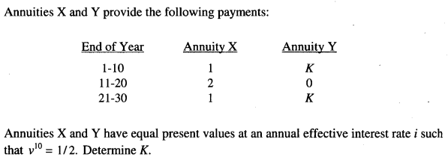
Solution: 1.8

18. Frasier is 33 years old and just received an inheritance from his parents’ estate. He wants to invest an amount of money today such that he can receive $5,000 at the end of every month for 15 years when he retires at age 65. If he can earn 9% compounded annually until age 65 and then 5% compounded annually when the fund is paying out, how much money must he invest today?

