Q1
1. The force of interest $δ(t)=0.04$ for $0<t≤8$
$=0.005t$ for $8<t≤20$
$=0.003t+0.0002t^{2}$ for $20<t$
i) Calculate the accumulated value of $₹1000$ at $t=22$, invested at $t=2$ (5m)
Solution 1
$$i. 1,000 A(2,22)=1,000\left[e^{\int_{2}^{8}{} 0.04 dt}Xe^{\int_{8}^{20}{} (0.005t)dt}×e^{\int_{20}^{22}{} \left(0.003t+0.0002t^{2}\right)dt}\right] e^{\int_{2}^{8}{} 0.04dt}=1.27125 e^{\int_{3}^{20}{} 0.005tdt}=2.316 e^{\int_{20}^{22}{} \left(0.003t+0.0002t^{2}\right)dt}=\left[\frac{0.003t^{2}}{2}+\frac{0.0002t^{3}}{3}\right]22 =(0.726+0.7098)-(0.6+0.5333) =1.3532$$
Accumulated value $=₹1,000$ X 1.27125 X 2.316X1.3532=₹3,984.11
2. Sanjay has choice to receive one of the following three payments:-
a) Rs. X at time 12
b) Rs. 1250 at time n, Rs.2500 at time 2n, Rs. 3750 at time 3n
c) Rs. 6500 at time 10
The present value of all the three payment streams are equal at interest rate of i p.a. effective.
Given that v^n = 0.517541, Calculate i and X.
Solution 2:
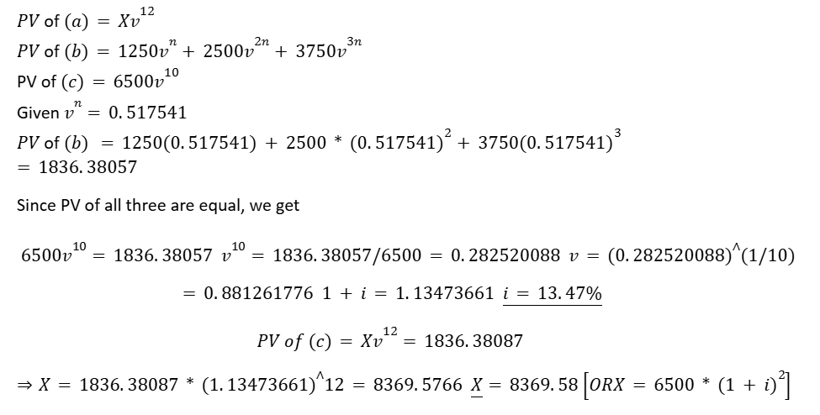

3. For each of the following calculate the equivalent effective annual rate of interest:
i) An effective rate of interest of $12\%$ paid every 2 years
ii) An effective rate of discount of $6\%$ per annum
iii) A force of interest $1\%$ per month
iv) A nominal rate of discount of $8\%$ per annum convertible quarterly
v) A nominal rate of interest of $12\%$ per annum convertible every 2 years
Solution 3
i. $i={1.12}^{\frac{1}{2}}-1=5.83\%$ [1]
ii. $i=\frac{d}{1-d}=6.38\%$ [1]
iii. $i=e^{12×0.01}-1=12.75\%$ [1]
iv. $i={\left(1-\frac{d^{(4)}}{4}\right)}^{-4}-1=8.416\%$ [1]
v. $1+i={\left(1+\frac{i^{(p)}}{p}\right)}^{p}={\left(1+\frac{0.12}{\frac{1}{2}}\right)}^{0.5}=11.35\%$ [1]
[5 Marks]

Q2
A. The $ABC$ trust runs the investment fund which had following fund value at the various dates:
- Date | Fund Value (in Rs crores)
$1^{st }$ January, 2011 | 30.50
${30}^{th }$ September, 2011 | 33.00
${31}^{st }$ December, 2011 | 38.50
$1^{st }$ July, 2012 | 41.05
${31}^{st }$ December, 2012 | 45.00
${30}^{th }$ June, 2013 | 45.60
${31}^{st }$ December, 2013 | 47.00

Over the three years period the investment fund has the following inflows and outflows:
Date | In-flows (in Rs crores) | Out-flows (in Rs crores)
$1^{st }$ October, 2011 | 6.00 | -
${30}^{th }$ June, 2012 | 4.50 | -
$1^{st }$ July, 2013 | - | 2.50

i) Calculate the annual effective TWRR & MWRR earned in the fund from 1/1/2011 - 31/12/2013
ii) Why TWRR is better measure of investment performance than MWRR
Solution 1
i) TWRR
$$(1+i)^{3} = 33/30.50*(41.05-4.5)/(33+6)*45.6/41.05*47/(45.6-2.50) (1+i)^{3} = 1.081967*0.937179*1.11084*1.090487 (1+i)^{3} = 1.228313 (1+i) = 1.070951 TWRR =7.0951\%$$
MWRR
$${30.5}^{*}(1+i)^{3}+6^{*}(1+i)^{2.25}+{4.5}^{*}(1+i)^{1.5}-{2.5}^{*}(1+i)^{0.5}=47$$
At $i=7\%$, LHS $=46.74$
At $i=7.5\%$, LHS $=47.37$
By interpolation,
$$MWRR =7.206\%$$
ii) TWRR eliminates the effect of the cashflow amount and timing, and therefore gives a fairer basis for assessing the investment performance for the fund. MWRR is sensitive to the amount and timing of the net cashflows.

2. A businessman has decided to purchase a leasehold property for INR 800,000 with a further payment of INR 50,000 for repairs in one year's time. The income associated with letting the property will be INR 100,000 per annum payable continuously for 20 years commencing in two years' time.
i) Explain what is a discounted payback period (DPP) for a project
ii) a) Given that the venture will be financed by bank loans on the basis of an effective annual rate of $7\%$ and that the loans may be repaid continuously, find the discounted payback period (DPP) for the project.
b) After the loan has been repaid the businessman will deposit all the available income in an account which will earn interest of $6\%$ p.a. Find the accumulated amount in the account in 22 years' time.

Solution 2
i) The discounted payback period of an investment project is the first time when the net presen Value of the cash flows from the project is positive
ii) a) Let us work in units of 1000 , to find the DPP
$$-800(1+i)^{t}-50(1+i)^{t-1}+100\underline{s_{t-2}} at 7\%=0$$
At $t=17$ the net present value is -75
At $t=18$ the net present value 22.85
Hence By interpolation $t=17.767$
b) The accumulated profit after 22 years is found by accumulating the income after DPP has elapsed at $6\%$ p.a.
$$100{S‾}_{4.233} at 6\%=480$$
The accumulated amount is INR. 480,000

3. Ravi wishes to receive an annuity which is payable monthly in arrears for 15 years. The annuity is to commence in exactly 10 years at an initial rate of INR 12,000 per annum. The payments increase at each anniversary by 3% per annum. Ravi would like to buy the annuity with a single premium 10 years from now. i) Calculate the single premium required in 10 years’ time to purchase the annuity assuming an interest rate of 6% per annum effective. (5)

Solution 3
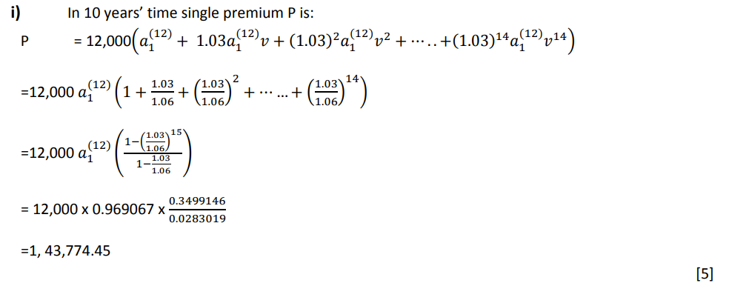

Q3
1. Simran is in the process of strategizing the establishment of a boarding facility near Andheri to address the increasing demand from college students in the area. To kickstart this venture, she foresees an initial expenditure of INR 20 Crores for the acquisition of a suitable building. Her plan is to commence the project on July 1, 2024. Subsequently, on January 1, 2025, there will be an additional investment of INR 2 Crores allocated for redevelopment and operational enhancements.
Equipped with a total of 50 beds, Simran anticipates a monthly rental income of INR 360,000 per bed for the next ten years. Following this decade, she envisions selling the property for INR 40 Crores. Determine Internal Rate of Return (IRR) for this project.

Solution 1
PV of inflow = PV of outflow
$$20+2v^{\frac{1}{2}}=1.8a_{\underline{10}|}+40v^{10.5}$$
$$f\left(x\right)=1.8a_{\underline{10}|}+40v^{10.5}-20-2v^{\frac{1}{2}}$$
Using table function and interpolation
i = 11.93%

2.Suresh is embarking on a venture to establish a lucrative paying guest business and has sought assistance from a friend who works in banking to secure the necessary financing. Her financial requirement consists of a loan amounting to INR 22 Crores, which will be disbursed in two parts. Initially, she intends to receive INR 20 Crores on July 1, 2024, followed by an additional INR 2 Crores six months later. She has devised a plan to repay this loan through monthly advance installments spanning a 15-year period. These installments are set to commence half a year after the second loan disbursement. Your task is to calculate the exact installment amount, as well as the total capital repaid within the first 10 years of instalment payments. Consider i = 8%.

Solution 2
$$20+2v^{0.5}=X.{\ddot{a}}_{\underline{15|}}^{\left(12\right)} @8\%$$
$$X=0.22cr$$
Loan o/s at the end of the 10 year
$$L_{120}=12X.{\ddot{a}}_{\underline{5|}}^{\left(12\right)}$$
$$=0.22 ×12× {\ddot{a}}_{\underline{5|}}^{\left(12\right)}$$
$$=11.045$$
$$L_{0}=12X.{\ddot{a}}_{\underline{15|}}^{\left(12\right)}$$
$$0.22 ×12× {\ddot{a}}_{\underline{5|}}^{\left(12\right)}$$
$$=23.6784$$
Capital repaid = L₀ -L₁₂₀
=12.63346

3. Mr. Elon Tusk a billionaire investor is looking for your advice to invest his wealth. He is really confused a new scheme launched by MP Jorgan Chase Bank. The bank offers different rates on investment and interest earned. The rate of interest provided on the principal invested is 7% pa effective and on interest it is 6% pa effective. Mr Tusk wants to invest 1 million USD pa for 10 years in advance into this account. He wants you to calculate the maturity value at the end of years

Solution 3
Since interest on principal and interest is difference both have to accumulated separately (1 Mark)
AV (at 10) = Interest cashflows accumulate at 6% + principal cashflows (1 Mark)
$= {0.07 \left(Ia\right)}_{10}*{\left(1+i\right)}^{10}+1*10$ (2 Mark)
$=$17.52 +10
$=27.52 million$ (1 Mark)

Q4 Part A
Akash wants to take a loan of Rs 10 Lacs from ABC bank for his higher education. The bank charges an interest of $7.5\%$ per annum convertible quarterly on the loan. The bank offers the following two options for the loan repayment:
Option (i) - No repayment will be required for next 2 years. After two years, the accumulated loan amount will need to be repaid over 20 equal half-yearly installments payable in advance.
Option (ii) -Only interest will need to be paid over next 2 years annually in arrears. The loan outstanding will need to be paid over 10 increasing annual installments, increasing at the rate of Rs $10,000/$ - per annum payable in advance.
a) Calculate the first installment amount to be paid after first two years of the loan for each of the above options.
b) Calculate the total amount Akash needs to pay in the case of option (ii).
c) Calculate the amount of capital repaid in the 9th installment, in the case of option (ii).

Solution Part A
a)
Interest rate charged by the bank, $i^{(4)}=7.5\%$ per annum
Hence effective rate of interest per annum,
$$i={\left(1+i^{(4)}/4\right)}^{4}-1=7.7136\%$$
Calculation for Option (i)
Loan amount after 2 years i.e. at the time of first installment payment
The first installment amount $X$ is given by the equation
$$2X{a¨}_{10}^{(2)}=L_{2} { d}^{(2)}=2\left(1-{\left(1-\frac{i}{1+i}\right)}^{(1/2)}\right)=7.2942\% a¨\frac{(2)}{10}=\frac{\left(1-(1+i)^{-10}\right)}{d^{(2)}}=7.1885 X=\frac{L_{2}}{2*{a¨}_{10}^{(2)}}=11.6022 Lacs /(2*7.188)=0.807 Lacs =₹80,700/-$$
Calculation for Option (ii)
Loan amount after $2$ years i.e. at the time of first installment payment
$L_{2}=L_{0}=10$ Lacs, as the interest on loan amount have been paid over the 2 years
The first installment amount $X$ is given by the equation
$$(X-10,000){a¨}_{\underline{10}∣}+10,000I{a¨}_{무 }=L_{2} {a¨}_{可 }=(1+i)\frac{\left(1-(1+i)^{-10}\right)}{i}=7.322$$
b)
$$I{a¨}_{무 }=(1+i)\frac{{a¨}_{\underline{10}}-10(1+i)^{-10}}{i}=35.8239$$
$$X=\frac{L_{2}-10,000I{a¨}_{\underline{10}}+10,000{a¨}_{\underline{10}}}{{a¨}_{10}}=0.97648 Lacs =₹97,648/-$$
In case of Option (ii) Akash need to pay
$$2*i*L_{2}+10*X+10,000*(1+2+3+….+9)=2iL_{2}+10X+10,000*(0.5*9*(9+1))$$
c)
$$=2*7.7136\%*10 Lacs +10*0.97648 Lacs +10,000*9*(10/2) =15.80752 Lacs =₹15,80,752/-$$
In case of Option (ii)
Amount payable at $9^{th }$ installment $=0.97648$ Lacs $+8*10,000=1.77648$ Lacs
Amount payable at ${10}^{th }$ installment $=0.97648$ Lacs $+9*10,000=1.87648$ Lacs
Hence,
Loan capital outstanding just after payment of $8^{th }$ installment
$$=\left(1.87648Lacs⁡/(1+7.7136\%)^{2}\right)+(1.77648Lacs⁡/(1+7.7136\%))=3.26661 Lacs$$
Interest element of $9^{th }$ installment payment
$$=3.26661 Lacs * 7.7136\%=0.25198 Lacs$$
Hence capital element of $9^{th }$ installment payment
$$=1.77648 Lacs -0.25198 Lacs =1.5245 Lacs =₹1,52,450/-$$

Part B
An investment project gives rise to the following cash flows. At the beginning of each of the first three years ' 180,000 will be invested in the project. From the beginning of the first year until the end of the twenty-fifth year, net revenue will be received continuously. The initial rate of payment of net revenue will begin at ' 25,000 per annum. The rate of payment is assumed to grow continuously at a rate of $6\%$ per annum effective.
i) In respect of an investment project, define:
a) the discounted payback period
b) the payback period
ii) Discuss why both the discounted payback period and the payback period are inferior measures compared to the net present value for determining whether to proceed with an investment project or not.
iii) Calculate the net present value of the project at an effective rate of interest of $7\%$ per annum.
iv) Calculate the discounted payback period of the project at an effective rate of interest of $7\%$ per annum

Solution Part Be
(i) (a) The discounted payback period for an investment project is the earliest time after the start of the project when the accumulated value (or Present Value) of the past cashflows (positive and negative), calculated using the borrowing rate, becomes greater or equal to zero. i.e., Acc. profit at discounted payback period $≥0$ (@ borrowing rate)
(b) The payback period is the earliest point of time since start of the project at which total cash inflow is greater than total cash outflow.
(ii)
- Discounted payback period or payback period is an inappropriate decision criterion because it does not tell us anything about the overall profitability of the project.
- Discounted payback period or payback period does not take account either of interest on borrowings or on cash flows received after the payback period.
- The discounted payback period simply shows when a project became profitable in present value terms, not how profitable it is. However, this information can be useful in the decision making process.
- The payback period ignores interest altogether and is therefore clearly an inferior criterion. It is also possible for the discounted payback period and the payback period to be before the end of the project but the NPV can be negative.
- There may not be one unique time when the balance in the investor's account changes from negative to positive. However, the NPV can always be calculated. The PP can give misleading results, as it does not take into account the time value of money.
(iii)
$$PV of outflow =180,000{a¨}_{\underline{3}∣}@7_{7\%} {a¨}_{\underline{3}∣}=\frac{1-v^{3}}{d}=\frac{1-{0.9346}^{3}}{0.06452}$$
$$PV of outflow = 180,000×2.80802 = 505,443.2701$$
$$PV of inflow =25,000*\int_{0}^{25}{} (1.06)^{t}*(1.07)^{-t}dt$$
This is equivalent to present value of annuity with $v^{t}=(1.06/1.07)^{t}$
$$= {0.990654}^{t} i.e., i=0.943396\% = 25,000{a‾}_{25/}@i=0.943396\% = 25,000*\left(1-{0.990654}^{25}\right)/δ = 25,000*22.28244 = 557,061.06$$
$$NPV =PV of inflow -PV of outflow =557,061.0636-505,443.2701 =₹51617.79$$
(iv)
Need to find $t$ such that
$$505,443.2701=25,000*\left(1-{0.990654}^{t}\right)/0.00938974 0.189839=1-{0.990654}^{t} Ln⁡(0.189839-1)=t^{*}ln⁡(-99.0654) t=22.42 years$$
[15 Marks]

