- Read the background document, which describes the scenarios that need to be modelled and documented for this project.
- Construct a spreadsheet model that produces the following calculations and charts. You should ensure that your spreadsheet contains appropriate self-checks and that you have performed robust reasonableness checks at each stage of your calculations.
    - Build a model that uses the data provided to project the numbers of future sales of each of the four classes up to and including the year 2032, using each of the three suggested approaches. [You have been provided with a spreadsheet which contains the data exactly as shown in this booklet.]
    - Illustrate these projections using three suitable charts, one for each of the suggested approaches.
    - Demonstrate that your results support the decision to use projection method Approach 3, other than for physical dozen where Approach 1 has been chosen.
    - Project the expected annual sales revenue under these chosen approaches (i.e. Approach 1 for physical dozens and Approach 3 for the other data classes)
    - Determine the year in which annual revenue from digital sales is first expected to exceed that from physical sales for each scenario.
    - Illustrate the following sales revenue projections using two suitable charts:
- Projected total physical and total digital annual sales revenue in each year to 2032
- Projected total overall annual sales revenue in each year to 2032
Marks available for spreadsheet model and checks:
Accurate completion of above modelling steps [25]
Demonstration of good modelling technique and practice [5]
Other self and reasonableness checks [5]
[Sub-total 35]

- Produce an audit trail for your spreadsheet model which includes the following:
  - purpose of the model
  - data and assumptions used
  - methodology, i.e., description of how each calculation stage in the model has been produced
  - explanation of any checks performed

Both senior actuaries and your colleagues should be able to peer review your work in your absence or independently.

Marks available for audit trail:
Audit approach
Fellow student can review and check methods used in the model [10]
Senior actuary can scrutinise and understand what has been done [10]
Written in clear English [5]
Written in a logical order [5]

Audit content
All steps clearly explained [8]
Clear signposting included throughout [7]
Statement of assumptions made [5]
All model steps accurately covered [15]

[Sub-total 65]

Background
In the country of Quantaria, students are stressed out. Fidget spinners have become the ideal stress busters especially the ones sold by MyyFidgets. These are available via two different mediums – Online or at physical stores either as singles or in dozens (one dozen is 12 single pieces).
You are an actuarial student working for a consultancy in Quantaria. MyyFidgets has approached your boss, a qualified actuary, and asked whether it is possible to construct a model which projects numbers of sales and sales revenue for the different formats for each year up to and including 2032. In particular it is interested in understanding when revenue from the online sales might overtake that from physical sales.
In order to perform these projections and analysis, MyyFidgets has provided you with its data on the numbers of dozen and singles sold in each of the two formats (physical and digital) in the calendar years 2018 to 2023 inclusive.
Numbers of sales
Your boss has suggested three possible approaches by which the numbers of sales could be projected. He has asked you to construct a model projecting future model sales and revenue. For each of the four classes of data (physical singles, physical dozen, digital single, digital dozen), you first need to calculate the % change (year on year) of sales numbers for each of the past years for which this is possible. This % year on year change is defined as the additional increase (or decrease) rather than as the ratio of values. So for example, the % change from 100 to 105 should be expressed as 5% rather than 105%.
Each class should then be projected forward assuming that:
Approach 1: the future year on year % change is constant, and at the same level as it was from 2018 to 2019.
Approach 2: the future year on year % change is constant, and at the same level as the arithmetic mean of the year on year % changes over the 2018–2023 data period.
Approach 3: the future year on year % change varies, in line with patterns in the historic % changes. More specifically, if {xi} represents the set of historic % changes from year i − 1 to year i (for i = 2019 to 2023), then your colleague first needed to calculate the second order % changes in the form of ratios xi / xi−1. The Actuary suggested that you then take the arithmetic mean of these ratios and assume that the second order % changes stay at this level in future. This enables you to produce the first order % changes (i.e. the xi for i > 2023) and hence to project the future sales numbers.
Your boss has asked you to produce projections of the numbers of sales for each of the four data classes using each of these three approaches in turn.
Although he feels that it is useful to present the client with the projections from each of the three approaches, having performed some high-level preliminary analysis she has decided that the most appropriate method is Approach 3 for all classes other than physical dozens, for which Approach 1 appears to be preferable. He would like you to use your projections to demonstrate that this decision is appropriate, and then to use these specified approaches for the rest of your analysis.
Sales revenue
MyyFidgets has also provided the following data on the prices of dozens and singles in each format (figures in INR):
- Single Fidgets sold at physical stores cost an average of INR 30 each in 2018, but had fallen to INR 25 in 2023.
- Dozen Fidgets sold at physical stores cost an average of INR 200 each in 2018, but had fallen to INR 160 in 2023.
- Single Fidgets sold on digital stores cost an average of INR 20 each in 2018, but had fallen to INR 16 in 2023.
- Dozen Fidgets sold on digital stores cost an average of INR 200 each in 2018, but had fallen to INR 150 in 2023.
You have been told by MyyFidgets that inflation over the period was close to zero.
Your boss has asked you to use your projections of sales numbers and the above price information to estimate future annual sales revenues to 2032 for each of the four classes. He wishes you to assume that the reduction in prices continues at the same annual rate throughout the projection period.
He then wishes you to use these revenue projections to determine the year in which annual revenue from digital sales is first expected to exceed that from physical sales.
Unfortunately, your boss is in a bad mood and from past experience you are 100% certain, you shouldn’t approach him until the calculation are complete in the allocated time post which he is expected to cool down.

Data
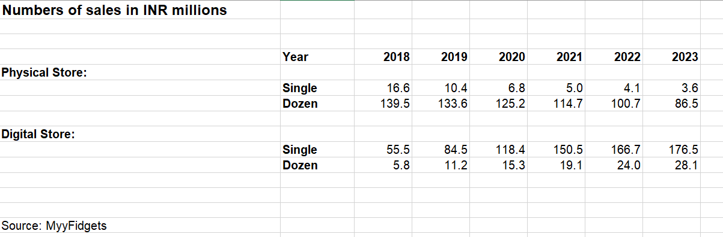

Additional Guidance

Data projection under Approach 3

For each of the four data classes in turn:
- Let ni represent the number of sales in year i (for i = 2018 to 2023) as per the data provided.
Start from the first order % change ratios xi (for i = 2019 to 2023) used for Approaches 1 and 2. These should be calculated as xi = ni / ni−1 – 1.
- Calculate the second order % change ratios yi (for relevant i), where yi = xi / xi−1.
- Calculate the constant Y, the arithmetic mean of these {yi}.
- The required % change (xi) in year i > 2018 can be projected as:
x₂₀₁₈ multiplied by Y^{N} where N = i – 2018.
- These xi can then be applied to the numbers of sales to obtain the projected future sales as required, i.e. for i > 2018:
n_{i} = n_{i−1} × [ 1 + x_{i} ].
Marks will be awarded for any other valid approach. The above approach is just suggestive.
END OF PAPER

