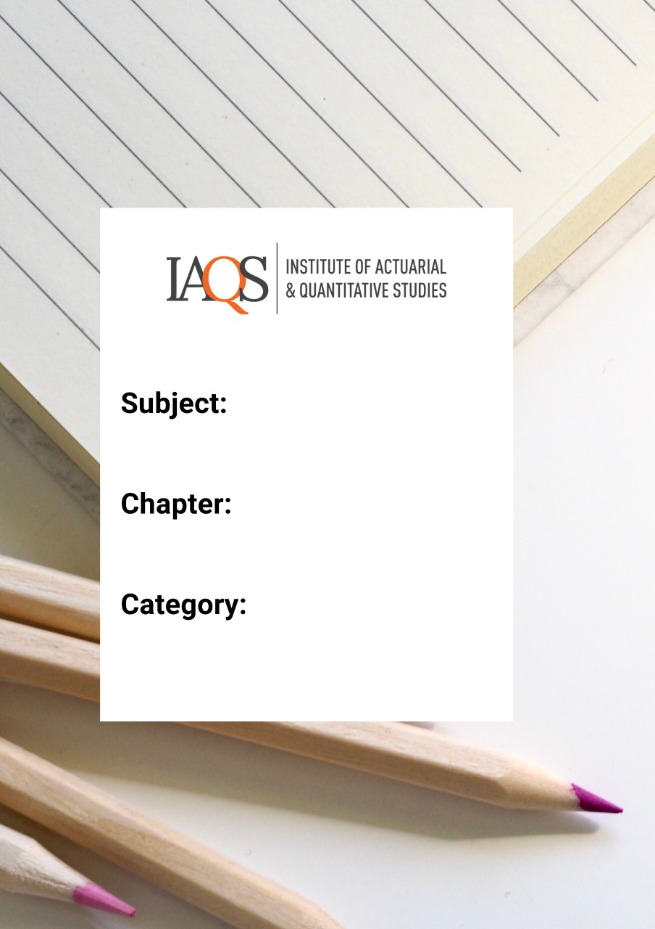
Numerical Methods and Algebra – Practice Questions 2

Topics: Inequalities, Modulus function, Quadratic

- Solve for x:
$$4x+15<23$$
  - $x<2$
  - $x>2$
  - $x<8$
  - $x>8$

- Solve for all positive value of x:
$$x^{2}-3>25$$
  - $\left[0,5\right)$
  - $\left(\sqrt{28}, ∞\right)$
  - $\left[\sqrt{28},∞\right)$
  - $(0,5)$

- If $-7≤x<6$and $-5≤y≤8,$what are the maximum and minimum possible values of xy
  - Maximum: 48 Minimum: 35 recording and re-record the macro
  - Maximum: 56, Minimum: -30
  - Maximum: 48, Minimum: -56
  - Maximum: -30 Minimum: -56

- Solve for y
$$5y+3≥-7y+13$$
  - $y≤10/12$
  - $y≥10/12$
  - $y≥12/10$
  - y<=12/10

- If r is a real number such that | r | < 1 and if a = 5 (1 – r), then
  - $-5<a<5$
  - $0<a<5$
  - $0<a<10$
  - $0≤a<10$

- The roots of $x^{2}-6x+12$ are
  - Real and distinct
  - Real and coinciding
  - Complex
  - Cannot be determined

- The roots of $5x^{2}-10x+20=0$are
  - Real and distinct
  - Real and coincident
  - Complex
  - Cannot be determined

- Which of the following is a quadratic equation?
  - $x^{2}-4x+5=x^{2}+8x-3$
  - $x^{2}+x^{3}+7=0$
  - $x^{2}+\sqrt{x}-3=0$
  - $x^{2}-4=0$

- The polynomial equation $\left(x-1\right)\left(x-2\right)=x\left(x+1\right)=8$ is a
  - Quadratic equation
  - Linear equation
  - Cubic equation
  - None of the above

- The quadratic equation whose roots are 1 and -3 is
  - $x^{2}-2x-3=0$
  - $x^{2}+2x+3=0$
  - $x^{2}-2x+3=0$
  - $x^{2}+2x-3=0$

- Solve the inequality $\left|2x-5\right|>|x+1|$

- Plot the modulus function $f\left(x\right)=2|3x+7|$ in the interval x belongs to [-4,4]

- Solve the quadratic equation $4x^{2}-4x-3=0$ by factorization, formula and by completion of squares method.

- The product of two number is 91 while the difference between them is 5. Find the two numbers.

- Solve the quadratic inequality $x^{2}-6x-16≤0$

- Solve for all real values of x, $x^{4}+2x^{2}-3=0$

- Solve
  - $\frac{1}{x^{2}+2x-8}>0$
  - $-x^{2}-8x-12≤0$
  - $x^{2}+6x-7≥0$

