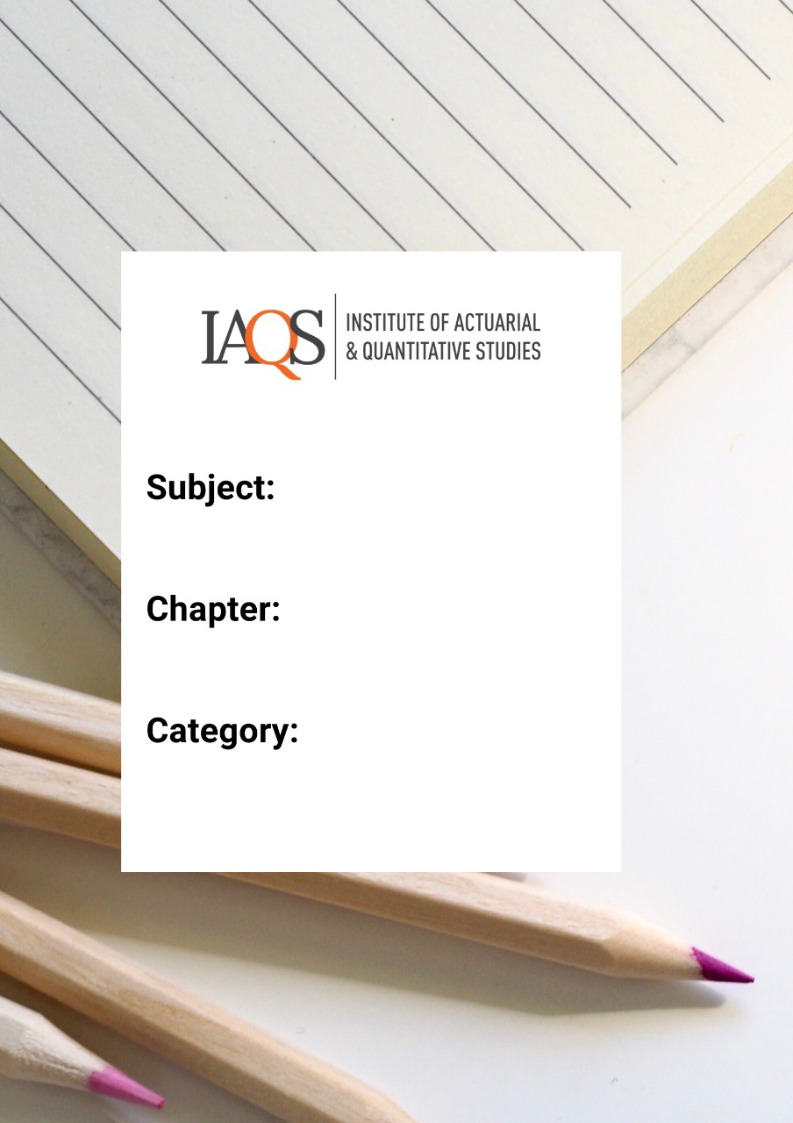
Numerical Methods and Algebra – Practice Questions 4

Topics: Sequences and Series, Significant Figures, Max/Min Function

- Find the 18th, 23rd and nth term of the arithmetic progression
$$-11, -9,-7, -5….$$
Solution
We can see the first term of the AP is -11 and the common difference is 2
The nth term of the AP is
$$a+\left(n-1\right)d=-11+2\left(n-1\right)$$
The 18th term=$-11+2×17=23$
The 23rd term = $-11+2×22=33$

- Which term of the AP 3,15, 27, 39 …will be 132 more than its 54th term?

Solution
Let the term be the nth term
We have a=3 and common difference = 12
From the given condition
$$a+\left(n-1\right)d=a+\left(53\right)d+132$$
$$d\left(n-54\right)=132$$
Since d=12
$$n-54=11$$
$$n=65$$

- Find $k$ so that $\frac{2}{3}-k, k,\frac{5}{8}-k$are three consecutive terms of an AP.

Solution
To be in AP, the difference between the terms should be constant
$$k-\left(\frac{2}{3}-k\right)=\frac{5}{8}-k-\left(k\right)$$
$$4k=\frac{5}{8}+\frac{2}{3}$$
$$4k=\frac{31}{24}$$
$$k=\frac{31}{96}$$

- How many terms of the A.P. 1,4,7,…….. must be taken so that the sum may be 715?

Solution
We can see that $a=1, d=3$
Sum to n terms = $\frac{n}{2}\left(2a+\left(n-1\right)d\right)$
$$715=\frac{n}{2}\left(2+3\left(n-1\right)\right)$$
$$1430=n\left(3n-1\right)$$
$$1430=3n^{2}-n$$
$$3n^{2}-n-1430=0$$
$$3n^{2}-66n+65n-1430=0$$
$$3n\left(n-22\right)+65\left(n-22\right)=0$$
$$\left(3n+65\right)\left(n-22\right)=0$$
Rejecting the negative value, we take n=22.

- If in an A.P. $a = 2$ and the sum of first five terms is one–fourth of the sum of the next five terms, show that $a_{20} = – 112$.

Solution
Since $S_{5}=\frac{1}{4}(a_{6}+a_{7}+a_{8}+a_{9}+a_{10})$
$$4S_{5}=a_{6}+a_{7}+a_{8}+a_{9}+a_{10}$$
$$5S_{5}={S_{5}+a}_{6}+a_{7}+a_{8}+a_{9}+a_{10}$$
$$5S_{5}=S_{10}$$
$$5×\frac{5}{2}\left(2×2+4d\right)=\frac{10}{2}\left(2×2+9d\right)$$
$$\frac{5}{2}\left(4+4d\right)=\left(4+9d\right)$$
Solving we get d=-6
$$a_{20}=a+19d=2+19\left(-6\right)=-112$$

- Find the sum of all integers between 100 and 1000 which are divisible by 9.
Solution
The lowest between 100 and 1000 which is divisible by 9 is 108=$9×12$
The highest between 100 and 1000 which is divisible by 9 is 999=$9×111$
We have an AP with d=9, first term = 108 and last term = 999
Number of terms =111-12+1=100
Sum = $\frac{100}{2}\left(108+999\right)=55350$

- A man accepts a position with an initial salary of Rs 52000 per month. It is understood that he will receive an automatic increase of Rs 3200 in the very next month and each month thereafter.
  - Find his salary for the tenth month
  - What is his total earnings during the first year?

Solution
- The salary for each month is increased by a constant amount so it forms an AP with a =52000 and d=3200
Salary for 10th month will be the 10th term of the AP = $a+\left(n-1\right)d=52000+9×3200=Rs 80800$

- The total earnings in the first year will be the sum to 12 terms of the AP
Sum = $\frac{12}{2}\left(2×52000+11×3200\right)=Rs 835200$

- The 5th, 8th and 11th terms of a GP are a,b, c respectively. Show that a, b, c are in GP.
Solution
Let the first term of the GP be u and the common ratio be r
We have
$$a=ur^{4}$$
$$b=ur^{7}$$
$$C=ur^{10}$$
Now
$$\frac{b}{a}=\frac{ur^{7}}{ur^{4}}=r^{3}$$
$$\frac{c}{a}=\frac{ur^{10}}{ur^{7}}=r^{3}$$
Since the ratio between a, b and c is constant, they are in GP

- Find the sum to n terms of the series 9 + 99 + 999 + …………..

Solution
$$S=9+99+999+…n terms$$
$$S=\left(10-1\right)+\left(100-1\right)+\left(1000-1\right)+…n terms$$
$$S=\left(10+100+1000+…n terms\right)-\left(1+1+1…n terms\right)$$
The first term is a GP with a = 10 and r=10 and the second is an AP with a=1 and d=0
$$S=\frac{10\left({10}^{n}-1\right)}{9}-n$$

- If sum of three numbers in GP is 38 and their product is 1728, find the numbers.

Solution
Let the numbers in GP be $\frac{t}{r}, t and tr$
Their product = $\left(\frac{t}{r}\right)\left(t\right)\left(tr\right)=1728$
$$t^{3}=1728$$
$$t=12$$
We have
$$\frac{t}{r}+t+tr=38$$
$$\left(1+r+\frac{1}{r}\right)=\frac{38}{12}$$
$$r+r^{2}+1=\frac{38}{12}$$
$$12r^{2}+12r+12=38r$$
$$12r^{2}-26r+12=0$$
$$6r^{2}-13r+6=0$$
$$6r^{2}-4r-9r+6=0$$
$$2r\left(3r-2\right)-3\left(2r-6\right)=0$$
$$r=\frac{2}{3},\frac{3}{2}$$
The numbers are 18,12,8

- The common ratio of a GP is –4/5 and the sum to infinity is 80/9. Find the first term of the GP.

Solution
$$S_{∞}=\frac{a}{1-r}$$
$$\frac{80}{9}=\frac{a}{1-\left(-\frac{4}{5}\right)}=\frac{a}{\frac{9}{5}}$$
$$a=\frac{80}{9}×\frac{9}{5}=16$$

- Find the sum to n terms of the series 0.6 + 0.66 + 0.666 + …………………..

Solution

$$S_{n}=0.6+0.66+0.666+…n terms$$
$$=6\left(0.1+0.11+0.111….n terms\right)$$
$$=\frac{6}{9}\left(0.9+0.99+0.999+…n terms\right)$$
$$=\frac{6}{9}\left[ \left(1-0.1\right)+\left(1-0.01\right)+\left(1-0.001\right)+…n terms\right]$$
$$\frac{6}{9}\left[\left(1+1+1…n terms\right)-\left(0.1+0.01+0.001…n terms\right)\right]$$
The first is an AP with a=1, d=0 and the second is a GP with a =0.1 and r=0.1
$$S_{n}=\frac{6}{9}\left(n-\frac{0.1\left(1-{0.1}^{n}\right)}{1-0.1}\right)$$
$$=\frac{6}{9}\left(n-\frac{(1-{0.1}^{n})}{9}\right)$$

- The sum to infinity of a GP is twice the sum of the first two terms. Find possible values of the common ratio.
Solution
$$\frac{a}{1-r}=2\left(a+ar\right)$$
$$\frac{1}{1-r}=2\left(1+r\right)$$
$$1=2\left(1-r^{2}\right)$$
$$2r^{2}=1$$
$$r=\frac{±1}{\sqrt{2}}$$

- Find the sum of the series (33 – 23 ) + (53 – 43 ) + (73 – 63) + ... to
  - n terms
  - 10 terms

Solution
- The kth term of the series is ${\left(2k+1\right)}^{3}-{\left(2k\right)}^{3}=1^{3}+3\left(2k+1\right)\left(2k\right)=12k^{2}+12k+1$
$$\sum_{k=1}^{n}{(12k^{2}}+12k+1)=\frac{12\left(n\left(n+1\right)\left(2n+1\right)\right)}{12}+\frac{12\left(n\left(n+1\right)\right)}{2}+n$$
$$=n\left(n+1\right)\left(2n+1\right)+6n\left(n+1\right)+n$$
$$=n\left(n+1\right)\left(2n+1\right)+n(6n+7)$$
- Sum to 10 terms = $10.11.21+10.67=2980$

- Find the sum to 10 terms of the series
  - 6.8.10+8.10.12+10.12.14+12.14.16+……..
  - 92+102+112+………

Solution
a. The kth term is $\left[2\left(k+2\right)\right].\left[2\left(k+3\right)\right].\left[2.\left(k+4\right)\right]=8\left(k+2\right)\left(k+3\right)\left(k+4\right)=8\left(k^{3}+9k^{2}+26k+24\right)$
$$S=\sum_{k=1}^{n}{8\left(k^{3}+9k^{2}+26k+24\right)=8\sum_{k=1}^{n}{k^{3}+72}\sum_{k=1}^{n}{k^{2}+208}\sum_{k=1}^{n}{k+192\sum_{k=1}^{n}{1}}}$$
$$=8{\left[\frac{n\left(n+1\right)}{2}\right]}^{2}+\frac{72\left(n\right)\left(n+1\right)\left(2n+1\right)}{12}+\frac{208\left(n\right)\left(n+1\right)}{2}+192n$$
Replace n by 10 to find the answer

b. The kth term is ${\left(k+8\right)}^{2}$
$$S=\sum_{k=1}^{n}{{\left(k+8\right)}^{2}=\sum_{k=1}^{n}{k^{2}+16k+64=\frac{n\left(n+1\right)\left(2n+1\right)}{6}+\frac{16\left(n\right)\left(n+1\right)}{2}+64n}}$$

Replace n with 10 to find the solution

- Find the lowest value of n such that
  - The sum of first n natural numbers is less than half of the sum of squares of the first n natural numbers
  - The sum of square of first n natural numbers is less than half of the sum of cubes of the first n natural numbers

Solution
- Sum of first n natural numbers =$\frac{n\left(n+1\right)}{2}$
Sum of squares of first n natural numbers = $\frac{n\left(n+1\right)\left(2n+1\right)}{6}$
We have
$$\frac{n\left(n+1\right)}{2}<\frac{1}{2}.\frac{n\left(n+1\right)\left(2n+1\right)}{6}$$
Simplifying we get
$$2n+1>6$$
$$n>\frac{5}{2}$$
The lowest value of n=3

Sum of squares of first n natural numbers = $\frac{n\left(n+1\right)\left(2n+1\right)}{6}$
Sum of cube of first n natural numbers = ${\left[\frac{\left(n\right)\left(n+1\right)}{2}\right]}^{2}$
We have
$$\frac{\left(n\right)\left(n+1\right)\left(2n+1\right)}{6}<\frac{1}{2}. {\left[\frac{\left(n\right)\left(n+1\right)}{2}\right]}^{2}$$
$$\frac{2n+1}{3}<\frac{\left(n\right)\left(n+1\right)}{4}$$
$$3n^{2}-5n-4>0$$
On solving, and ignoring the negative root (since n is a natural number), we get
$$n>\frac{5+\sqrt{73}}{6}=13.54/6$$
The lowest value of n=3

- Carry out the following arithmetic operations using the correct number of significant figures.
  - (0.085)(2.79)
  - 4.5 + 8.59
  - (1.10 )(103)*(665)
  - 1.058
The Rules of Significant figures are:
- All non-zero numbers ARE significant.
- Zeros between two non-zero digits ARE significant.
- Leading zeros are NOT significant.
- Trailing zeros to the right of the decimal ARE significant.
- Trailing zeros in a whole number with the decimal shown ARE significant.
- Trailing zeros in a whole number with no decimal shown are NOT significant.
- Exact numbers have an INFINITE number of significant figures. This rule applies to numbers that are definitions.
- For a number in scientific notation

Solution
- $\left(0.085\right)\left(2.79\right)=0.23715$
The first no has 2 significant figures. The second one has 3. Therefore the answer must not have more than 2 significant figures. Therefore the answer will be rounded to 0.24
- 4.5+8.59=13.09
The first no has 2 significant figures. The second one has 3. Therefore the answer must not have more than 2 significant figures. Therefore the answer will be rounded to 13.

- $\left(1.10 \right)\left({10}^{3}\right)*\left(665\right)=731.5×{10}^{3}$
By the 8th rule, the number ${10}^{3}$ is in scientific notation and has 1 significant figure. Therefore the answer must have only 1 significant figure
The answer is rounded to $7×{10}^{3}$

- ${\left(1.05\right)}^{8}$
$$={{{(\left(1.05\right)}^{2})}^{2})}^{2}$$
1.05 has 3 significant figures, therefore the result of each calculation can be rounded to 3 significant figures
$${{{(\left(1.05\right)}^{2})}^{2})}^{2}={{((1.10)}^{2})}^{2}={1.21}^{2}=1.46$$

- Evaluate the following function
  - maxx2-10,xfor all real x
  - min4x2-10, 100 for all real x
  - maxx2-x, 25for all x
  - minx3-2x2-x, 4xfor all x

Solution
- $x^{2}-10-x>0$
$$x^{2}-x-10>0$$
Solving we get $x=\frac{1±\sqrt{41}}{2}$
$$x> \frac{1+\sqrt{41}}{2} or x<\frac{1-\sqrt{41}}{2}$$

maxx2-10,x=x2-10 for x> 1+412 or x<1-412x for 1+412 ≤ x≤1-412

