UNIT 1
Q1. There is a new virus called DaroNa-virus that is affecting humans around the world that has a current prevalence of 1% in Actuaria. A blood test has been devised to diagnose suspects with the infection of this virus. This test has a 99% accuracy among both virus-patients as well as non-patients (i.e. probability that the test result is positive for a virus-patient is 99%, and probability that the test result is negative for a non-patient is also 99%). Your Actuarian friend, Poisson and Bernoulli, have been tested. Poisson has tested positive, while Bernoulli has tested negative. What is the probability that Poisson has the virus? What is the same probability for Bernoulli?
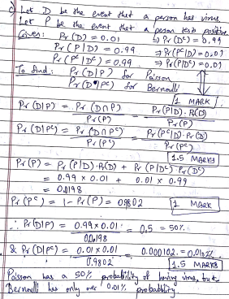

UNIT 2
1. The probability that a person can achieve a target is 3/4. The count of tries is 5. What is the probability that he will attain the target at least thrice?
Ans
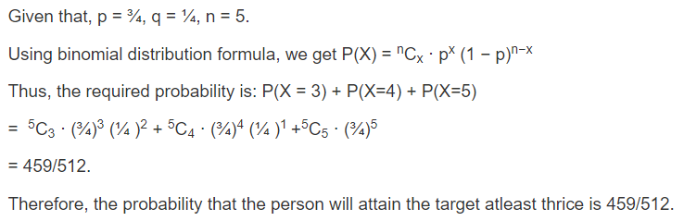

2.
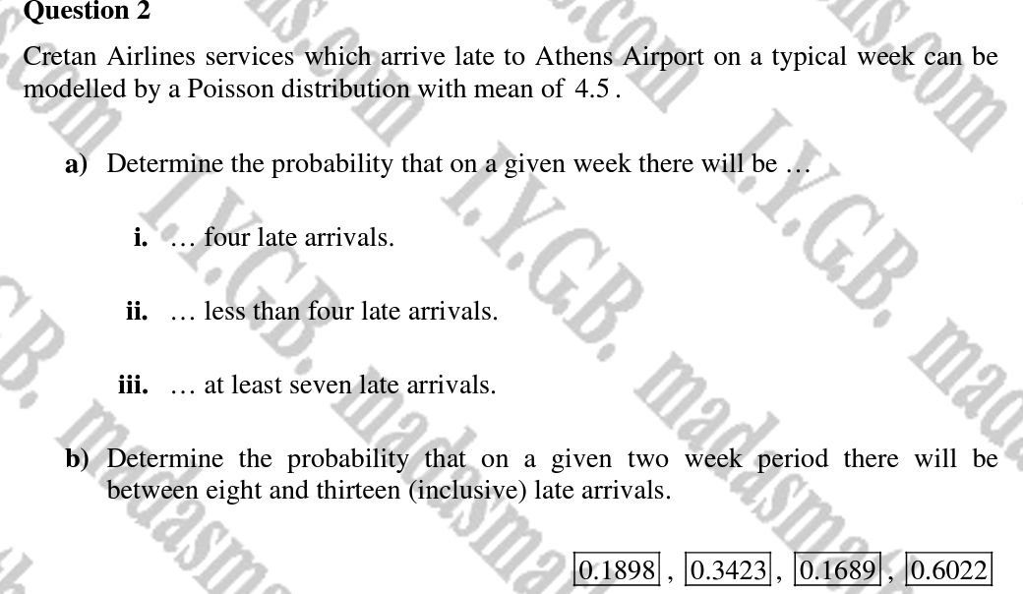
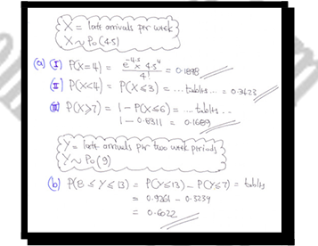

3, On the average, a certain computer part lasts ten years. The length of time the computer part lasts is exponentially distributed.
- What is the probability that a computer part lasts more than 7 years?
- On the average, how long would five computer parts last if they are used one after another?
- What is the probability that a computer part lasts between nine and 11 years?

Ans
a. 0.4966.
b. On the average, one computer part lasts ten years. Therefore, five computer parts, if they are used one right after the other would last, on the average , (5)(10) = 50 years.
c. The probability that a computer part lasts between nine and 11 years is 0.0737.

4. Claim sizes on a fixed benefit health insurance policy are normally distributed about a mean of INR 900 and with a standard deviation of INR 100. Claim sizes on a indemnity based health insurance policy are normally distributed about a mean INR 1,400 and with a standard deviation of INR 300. All claim sizes are assumed to be independent and in units of INR 100.
To date, there have already been fixed benefit health insurance claims amounting to INR 900 and no indemnity based health insurance claims. Assuming that there will be further 4 fixed benefit health insurance claims and 3 indemnity based health insurance claims in next year, calculate the probability that the total claim amount under the indemnity based health insurance claims exceeds the total claim amount under fixed benefit health insurance claims.

Ans -
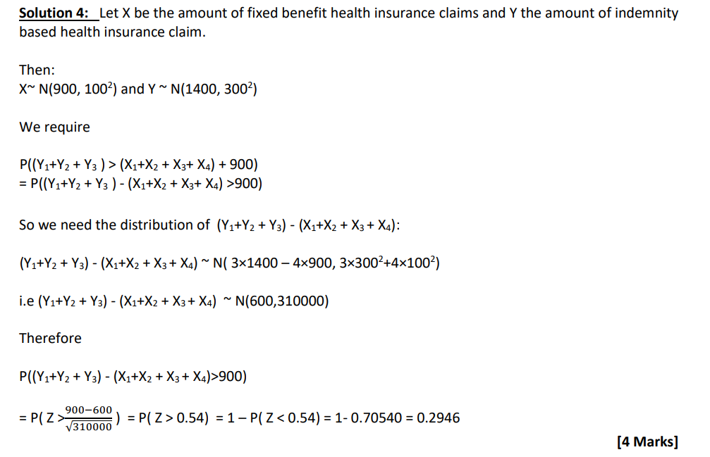

5. The number of hospitalizations due to COVID19 have varied experience over months and data corresponding to a group illustrates that one should expect: Two hospitalisations in October Three hospitalisations in November One hospitalisation in December Determine the probability that there will be less than five hospitalisations in the period October to December given the hospitalisation in each month are independent and are assumed to follow Poisson distribution

Ans -
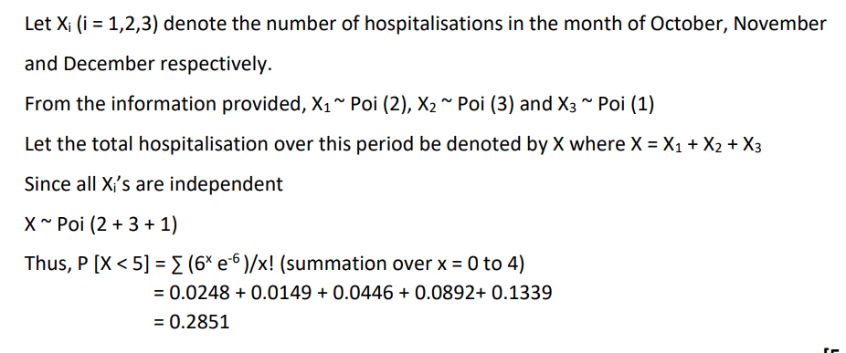

6. Claim sizes in a certain insurance portfolio are modelled by a normal distribution with mean μ = 30000 and standard deviation σ = 4000. A claim amount exceeding 35000 is defined as a large claim.
(a) Calculate the probability That the amount of a large claim exceeds 36000. (3)
(b) Calculate the probability that a random sample of 5 claims includes 2 which exceed 35000 and 3 which would be less than 35000. (2)

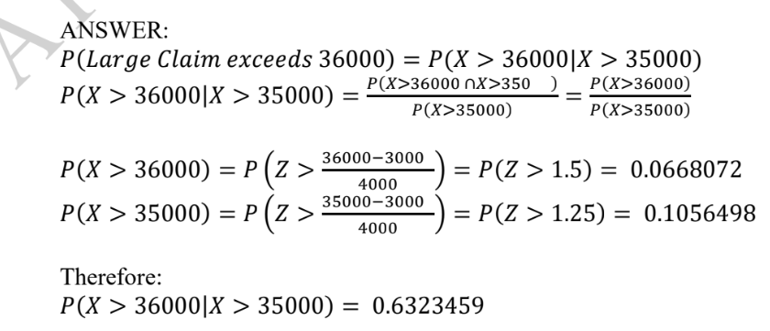

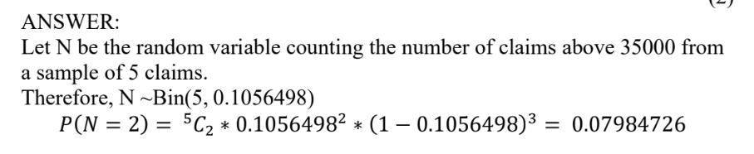

7.
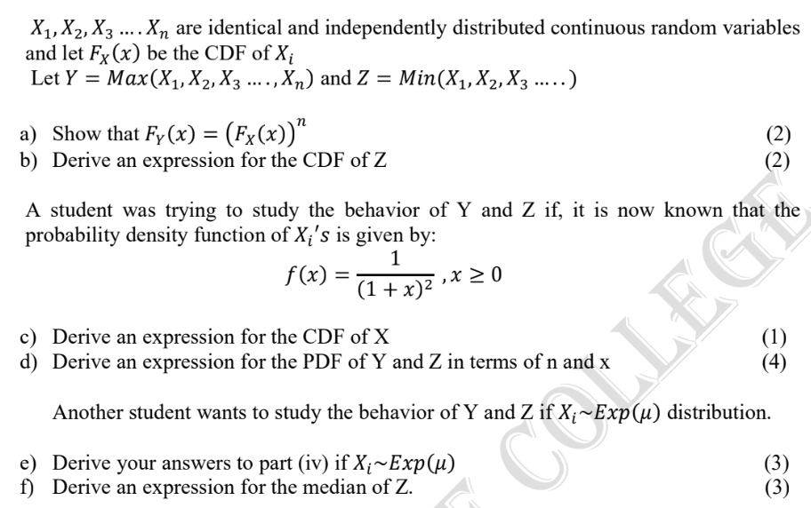

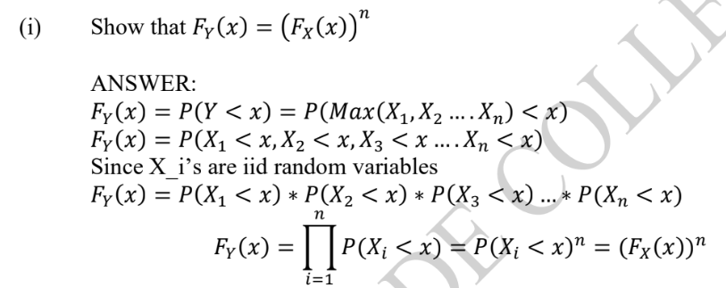

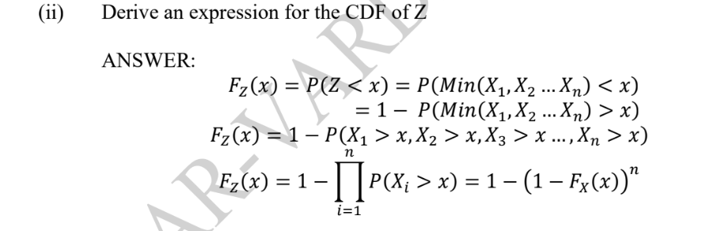
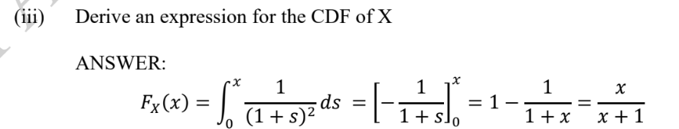

iv)
