
Name: Darshan Lodha
Roll No.: 433
Subject: Statistical and Risk Modelling 1
Topic: Graduation Tests

Question 1)
Read in the data as a data table
In order to load the data file in R, the working directory has been set to the folder “Statistical and Risk Modelling 1” using the setwd function.
The data file “Graduation.csv” was loaded into R using read.table function.
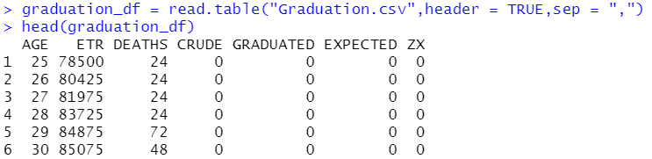
Filling the entries for the CRUDE column
The crude mortality rate for age ‘x’ last birthday has been calculated using the formula:
$$Crude mortality rate for age x last birthday= \frac{Number of deaths recorded at age x last birthday }{Central exposed to risk for age x last birthday}$$
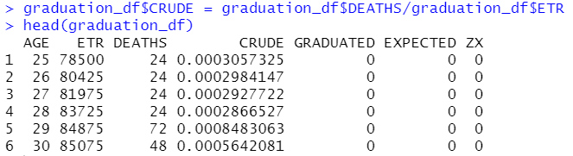

Question 2)
Using Gompertz law to fill the entries in the GRADUATED column
Gompertz law of mortality is
$$μ_{x}=Bc^{x}$$
Taking log on both the sides,
$$\ln\left(μ_{x}\right)=\ln\left(B\right)+xln\left(c\right) ---(I)$$
This is of the form: $y= α+ βx$
Equation I show that $ln⁡(μ_{x})$ and x has a linear relationship. Thus, using the lm function in R to fit a linear model such that $ln⁡(μ_{x})$ is the response variable and x is the explanatory variable.
The coefficient of age (x) derived form this linear model would be $ln⁡(c)$ and the intercept is $\ln\left(B\right).$
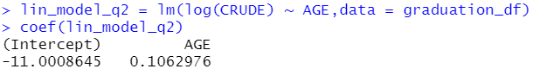
Therefore, $\ln\left(B\right)= -11.0008645 and\ln\left(c\right)=0.1062976$
In order to get the estimated values of B and c, exponential is used to take into consideration the log of B and c.
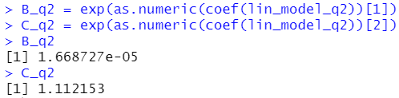
Filling the entries in the GRADUATED columns using Gompertz law: $μ_{x}=Bc^{x}$ where, the parameters B and c are estimated using linear model approach.
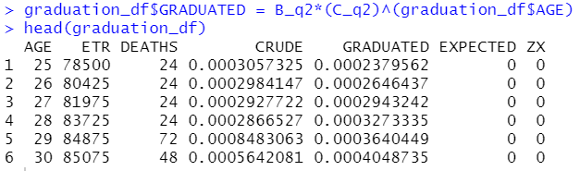
Question 3)
Checking for smoothness by applying the third differences to the crude and graduated rates.
For calculating the third differences to the mortality rates, a function ‘one_diff’ was defined in R which could be used to calculated the first difference to the rates. The third differences were calculated by using the function ‘one_diff’ three times to the rates.

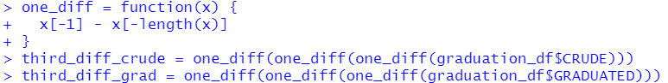
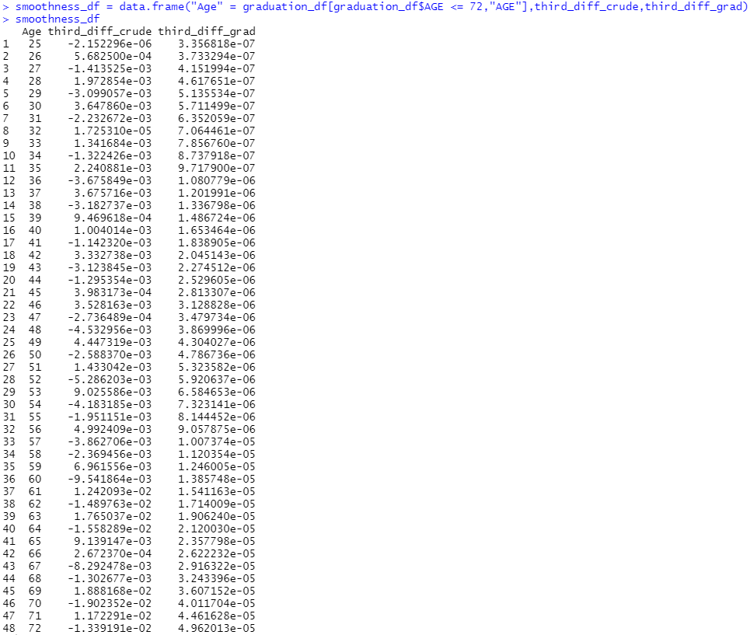
The columns of AGE, third differences to the crude and graduated rates were combined into a data frame in order to check for smoothness. Since, while calculating the third differences to the mortality rates, the last three entries do not result into the final output, age of only up to 72 was combined with these columns.

Comment
The third differences measure the change in curvature. The criterion of smoothness usually used is that the third differences should be small in magnitude and progress regularly. We can observe in the above data frame that the third differences of the crude rates are much larger in magnitude and progress erratically. However, the magnitude of the third differences of the graduated rates is very small and progress regularly. Thus, the graduated rates which were computed by fitting Gompertz law are smooth which is what was desirable.
Question 4)
Filling the entries in the column of EXPECTED
The expected number of deaths at age ‘x’ last birthday has been calculated using the formula:
$$Expected number of deaths at age x last birthday= Central exposed to risk ffor age x last birthday*Graduated mortality rate for age x last birthday$$
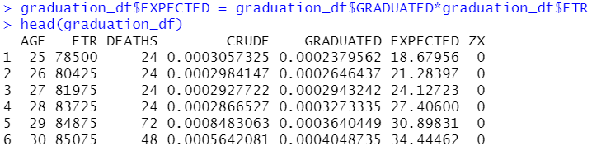
Calculating the values in ZX
Individual standardized deviations “$z_{x}$” are calculated using the formula:
$$z_{x}= \frac{d_{x}- E_{x}^{c}u_{x}(circle)}{\sqrt{E_{x}^{c}u_{x}(circle)}}$$
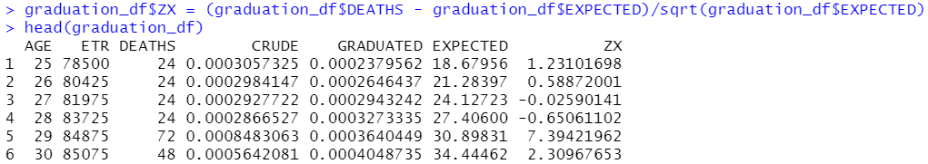
Chi-squared test to check the goodness of fit between DEATHS and EXPECTED
H0: The graduated rates are consistent with the true underlying mortality rates i.e., there are no significant differences between the two set of rates.
Vs
H1: The graduated rates are not consistent with the true underlying mortality rates.
The test statistic for chi-squared test is : $\sum_{all ages x}{z_{x}^{2}}$
Calculating the test statistic in R
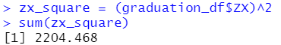
Degrees of freedom: there are 51 ages. We have not constrained the totals. The graduated rates have been calculated by estimating 2 parameters B and c. So, the number of degrees of freedom is 51 – 2 = 49.
From the Actuarial Tables, the upper 5% point for $X_{40}^{2}$ and $X_{50}^{2}$ distributions are 55.76 and 67.50 respectively. Thus, $X_{49}^{2}$ will not exceed 67.50. But since, 2204.468 is much higher than 67.50, we have sufficiently strong evidence to reject the null hypothesis at 5% level of significance and even at 1% level of significance.
So, we conclude that the mortality experience does not confirm to the Gompertz formula assumed in the graduation.
Question 5) (a)
Performing the standardized deviations test
H0: The standardized deviations confirm to a standard normal distribution i.e., there is no under/over graduation.
Vs
H1: the standardized deviations do not confirm to a standard normal distribution i.e., there might be under/over graduation.
The table of interval , expected and observed standardized deviations was constructed in R.
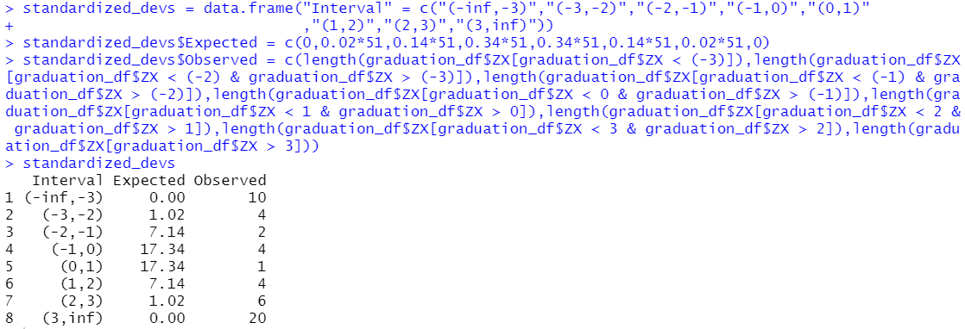
The standardized deviations test is used to look for the first defect of the chi-squared test i.e., the failure to detect a number of excessively large deviations. Under the null hypothesis, the ISDs are sampled from the N(0,1) distribution.
By the test of eye,
- Overall shape
For the $z_{x}$ to be normally distributed, the number of values in each of the ranges should confirm broadly with the percentages for the normal distribution.
This is not the case here since, most of the observed $z_{x}$ lie in the tails of the distribution. Ideally there should have been around 34 values in the range (-1,1) but actually only 5 values were observed in this range.
Thus, the curve would be flatter at peak relative to the standard normal distribution with thick tails
- Absolute deviations
There are only 5 values approximately in the range (-2/3,2/3). So, there appear to be too few values in the centre of the distribution and too many in the tails. This might indicate over graduation.
- Outliers
There are approximately 30 values with absolute value greater than 2.57. This strongly indicates the presence of outliers.
- Symmetry
There are 20 negative and 31 positive standardized deviations. Thus, the ISDs cannot be considered to be fairly symmetric as there should have been around 25 negative or positive standardized deviations.
- Conclusion about null hypothesis
We have sufficient evidence to reject our null hypothesis and conclude that the standardized deviations do not confirm to a standard normal distribution.
Question 5) (b)
Performing the signs test
H0: There is no overall bias in the graduated rates
Vs
H1: Overall bias is present in the graduated rates
The signs test is a simple test for overall bias. It is designed to overcome the second limitation of chi-squared test i.e., the failure to detect where there is an imbalance between positive and negative deviations.
The number of negative ISDs is 20 and that of positive ISDs is 31.
Let P be a random variable denoting the number of positive ISDs.
Under the null hypothesis, P ~ Binomial (51,0.5)
Since, n is too large, using the normal approximation to binomial distribution.
Therefore, P ~ N(25.5,12.75)
We have more positive deviations than expected. So, the p-value is
2P(P ≥ 31) = 2P(P > 30.5) …(Using continuity correction; This is a two-sided test)
The p-value was calculated in R using pnorm function
Since, the p-value is greater than 5%, there is insufficient evidence to reject the null hypothesis at 5% level of significance. So, we conclude that the rates are not biased.
Question 5) (c)
Performing the cumulative deviations test for the entire age range
H0: There is no overall bias in the graduated rates
Vs
H1: There is overall bias in the graduated rates
The test statistic for cumulative deviations test is:
$$\frac{\sum{d_{x}- \sum{E_{x}^{c}μ_{x}(circle)}}}{\sqrt{\sum{E_{x}^{c}μ_{x}(circle)}}}\sim N(0,1)$$

This is a two-tailed test. Since, 18.83024 > 1.96, we have sufficient evidence to reject the null hypothesis at 5% level of significance.
Thus, we conclude that the graduated rates are biased as per the cumulative deviations test.
Question 5) (d)
Performing the serial correlations test
H0: There is no clumping of deviations of the same sign
Vs
H1: There is clumping of deviations of the same sign
Under null hypothesis: $r_{j}\sqrt{m} \sim N(0,1)$
$r_{j}$ is calculated using cor (correlation) function in R. The correlation was calculated between the one lagged deviation.
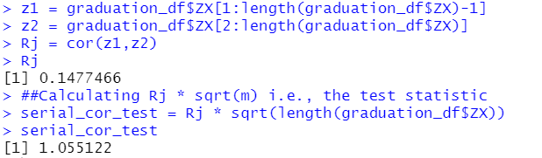
Since, this is less than 1.6449, the upper 5% point of the standard normal distribution, we do not have sufficient evidence to reject H0. Hence, we conclude that there is no grouping of deviations of the same sign.
___________________________________ END ___________________________________

