#assignamnet 1
mark_data =read.csv(file.choose())

#explorartory data analyisss
head(mark_data)
dim(mark_data)
str(mark_data)

##checking for any missing value

sum(is.na(mark_data))
# their is no such missing value
outliers = sapply(mark_data[,c(-6,-7)],function(x)(length(boxplot(x)$out)))
outliers
output :-
outliers
Exam1. Exam2. Exam3. Exam4. Final_score.
0 0 15 0 0
# replacing outliears
boxplot(mark_data$Exam3.)$out
mark_data$Exam3.[(mark_data$Exam3.%in%(boxplot(mark_data$Exam3.)$out))]=mean(mark_data$Exam3.,na.rm = TRUE)
boxplot(mark_data$Exam3.)
sapply(mark_data[,c(-6,-7)],function(x)(length(boxplot(x)$out)))
Exam1. Exam2. Exam3. Exam4. Final_score.
0 0 0 0 0

Output :-
explorartory data analyisss
> head(mark_data)
Exam1. Exam2. Exam3. Exam4. Final_score. Grade. Pass.fail
1 60 10 16 7.0 40.79 C P
2 90 0 0 0.0 69.23 B P
3 130 20 24 1.0 76.75 B P
4 130 10 24 8.5 75.66 B P
5 90 5 22 9.5 55.48 C P
6 100 30 20 3.0 67.11 B P
> dim(mark_data)
[1] 108 7
> str(mark_data)
'data.frame': 108 obs. of 7 variables:
$ Exam1. : num 60 90 130 130 90 100 105 120 120 130 ...
$ Exam2. : num 10 0 20 10 5 30 20 40 20 45 ...
$ Exam3. : num 16 0 24 24 22 20 22 18 30 22 ...
$ Exam4. : num 7 0 1 8.5 9.5 3 8 16 18 10.5 ...
$ Final_score.: num 40.8 69.2 76.8 75.7 55.5 ...
$ Grade. : chr "C " "B " "B " "B " ...
$ Pass.fail : chr "P" "P" "P" "P" ...
sum(is.na(mark_data))
[1] 0
> # their is no such missing value

Input :-
##performing thetrain-test splitting

s=sample(nrow(mark_data),.8*nrow(mark_data))
s_train =mark_data[s,]
s_test =mark_data[-s,]

nrow(s_train)
nrow(s_test)
dim(mark_data)

# for the prediction of the final score
colnames(mark_data)
#a ) linear regression
model1=lm(Final_score.~.,data = s_train)
summary(model1)

output :-
Call:
lm(formula = Final_score. ~ ., data = s_train)

Residuals:
Min 1Q Median 3Q Max
-9.5245 -4.1653 -0.4518 3.8474 17.2765

Coefficients: (1 not defined because of singularities)
Estimate Std. Error t value Pr(>|t|)
(Intercept) 65.82295 3.54930 18.545 < 2e-16 ***
Exam1. 0.08334 0.02208 3.775 0.00032 ***
Exam2. 0.09725 0.06639 1.465 0.14722
Exam3. 0.29972 0.10602 2.827 0.00604 **
Exam4. 0.19423 0.16844 1.153 0.25257
Grade.A -0.56680 3.85040 -0.147 0.88337
Grade.B -12.89749 3.06334 -4.210 7.09e-05 ***
Grade.B -13.24115 2.50078 -5.295 1.18e-06 ***
Grade.C -28.00677 3.19555 -8.764 4.64e-13 ***
Grade.C -28.71726 3.15182 -9.111 1.03e-13 ***
Grade.D -45.67833 4.15838 -10.985 < 2e-16 ***
Grade.D -50.93610 3.49572 -14.571 < 2e-16 ***
Pass.failP NA NA NA NA
---
Signif. codes: 0 ‘***’ 0.001 ‘**’ 0.01 ‘*’ 0.05 ‘.’ 0.1 ‘ ’ 1

Residual standard error: 6.456 on 74 degrees of freedom
Multiple R-squared: 0.9311, Adjusted R-squared: 0.9209
F-statistic: 90.98 on 11 and 74 DF, p-value: < 2.2e-16
Input :-
## as in thie data set , ogically grade does not depende on the final score
# so we will only use exam 1,2,3,4

model2=lm(Final_score.~Exam1.+Exam2.+Exam3.+Exam4.,data = s_train)
summary(model2)

##r square has decresed from 91 to 69.5 % , but the p value of data varible is lesss than 0.05
##which make thme significnat parameter

AIC(model2)
AIC(model1)

## where as aic has also decresed but choosing this varble make sense.
Output :-
model2=lm(Final_score.~Exam1.+Exam2.+Exam3.+Exam4.,data = s_train)
> summary(model2)

Call:
lm(formula = Final_score. ~ Exam1. + Exam2. + Exam3. + Exam4.,
data = s_train)

Residuals:
Min 1Q Median 3Q Max
-25.622 -9.810 -0.487 4.863 57.062

Coefficients:
Estimate Std. Error t value Pr(>|t|)
(Intercept) 22.30119 3.33645 6.684 2.73e-09 ***
Exam1. 0.22563 0.03831 5.890 8.43e-08 ***
Exam2. 0.38480 0.12605 3.053 0.00307 **
Exam3. 0.58605 0.20495 2.859 0.00539 **
Exam4. 0.43527 0.31959 1.362 0.17698
---
Signif. codes: 0 ‘***’ 0.001 ‘**’ 0.01 ‘*’ 0.05 ‘.’ 0.1 ‘ ’ 1

Residual standard error: 12.99 on 81 degrees of freedom
Multiple R-squared: 0.695, Adjusted R-squared: 0.6799
F-statistic: 46.15 on 4 and 81 DF, p-value: < 2.2e-16
##r square has decresed from 91 to 64.3% % , but the p value of data varible is lesss than 0.05
##which make thme significnat parameter,but exam 4 p value is almost close to 0.05 so we will remove tahat varible

model2=lm(Final_score.~Exam1.+Exam2.+Exam3.,data = s_train)
summary(model2)
#removal of the exam 4 varible is ot affecting r square

Output :-
Call:
lm(formula = Final_score. ~ Exam1. + Exam2. + Exam3., data = s_train)

Residuals:
Min 1Q Median 3Q Max
-25.206 -4.697 -0.316 4.733 50.674

Coefficients:
Estimate Std. Error t value Pr(>|t|)
(Intercept) 15.51328 6.16006 2.518 0.013734 *
Exam1. 0.19302 0.03488 5.533 3.67e-07 ***
Exam2. 0.44692 0.11950 3.740 0.000340 ***
Exam3. 1.07797 0.31395 3.434 0.000936 ***
---
Signif. codes: 0 ‘***’ 0.001 ‘**’ 0.01 ‘*’ 0.05 ‘.’ 0.1 ‘ ’ 1

Residual standard error: 12.68 on 82 degrees of freedom
Multiple R-squared: 0.6405, Adjusted R-squared: 0.6274
F-statistic: 48.71 on 3 and 82 DF, p-value: < 2.2e-16

>

##checking some assumption of the linearity that does this varible follow them ore not
#multicollinerity
library(car)
vif(model2)
output :-
vif(model2)
Exam1. Exam2. Exam3.
1.572052 1.367778 1.248582
## as all values are lesss than 5 means they are not multicollinear .
#linear data
plot(mark_data)
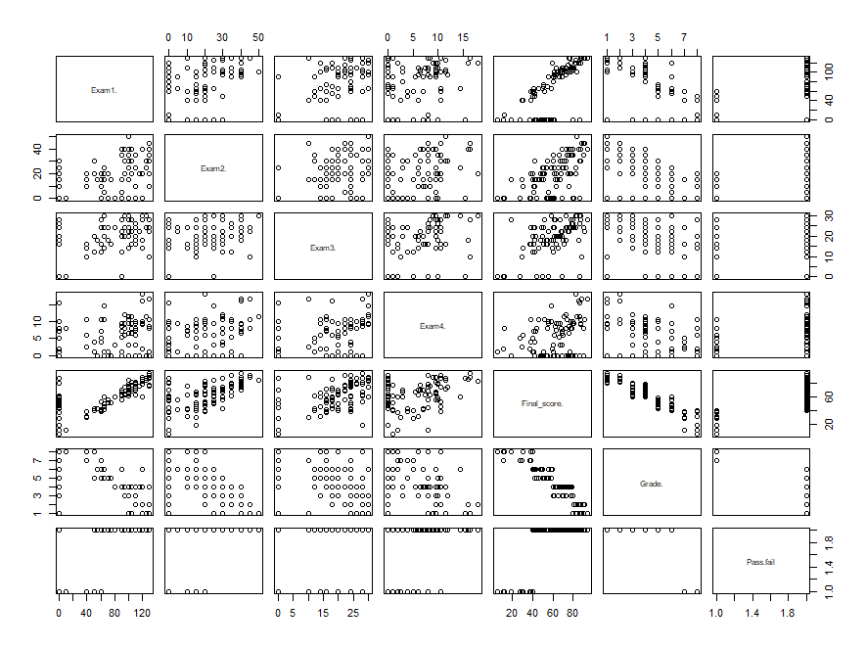
## multivariate assumpation
library(stats)
shapiro.test(model2$residuals)
output:-
Shapiro-Wilk normality test

data: model2$residuals
W = 0.88547, p-value = 1.527e-06
#as p value is 1.527e-06, whic is less tha 0.05 , so conclude that residuals does not follow the
# normal distribution
plot(density(model2$residuals))
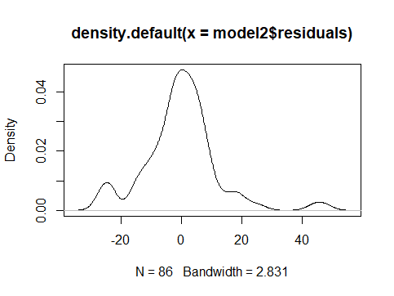
##its something about skewed distribution

##its something about skewed distribution
## assumption of homoskedasticty
library(lmtest)
bptest(model2)

## p value is 1.149e-05 we reject H0 , and conclude that residuals pr error do not possed the # homoscedasticity
Outpu:-
studentized Breusch-Pagan test

data: model2
BP = 20.681, df = 4, p-value = 0.0003663

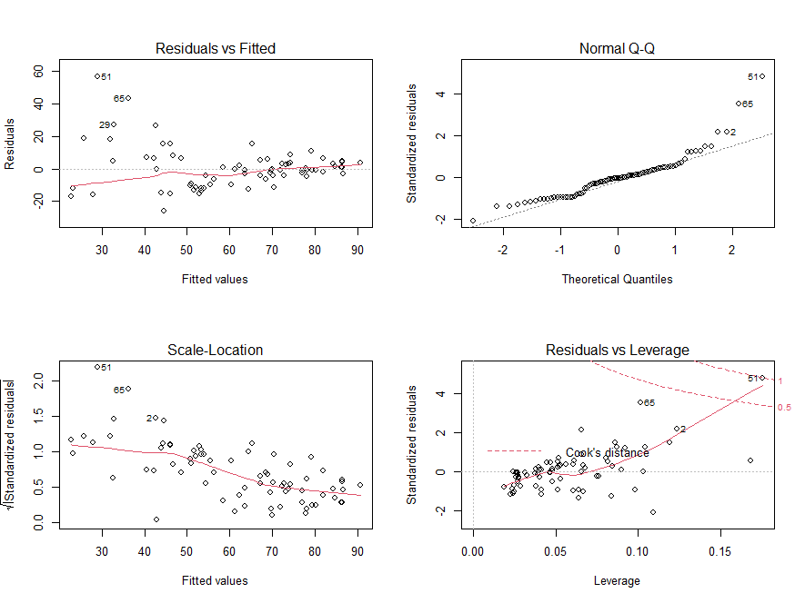

##residual vs fitted value slightly showig the u shaped , hence residual follow normal distribution
# normal Q-Q plot follows the straight line but deviated in upper side at the end which shows
# that residulas follow normal distribution

#scale location plot has equal data points either side of the red line , it mean it does not
#possed the homoskedasticty

## perfroming the prediction based on model2 and testing data
p=predict(model2,s_test)
p

r_2=(cor(p,s_test$Final_score.))**2
r_2

## aaccuracy is 52% which is very low , as linear regression is giving low accuracy
# now perfoming regression tree for some better prediction
library(rpart)
library(rattle)
colnames(mark_data)
dtree = rpart(Final_score.~Exam1.+Exam2.+Exam3.+Exam4.,data = s_train)
fancyRpartPlot(dtree)

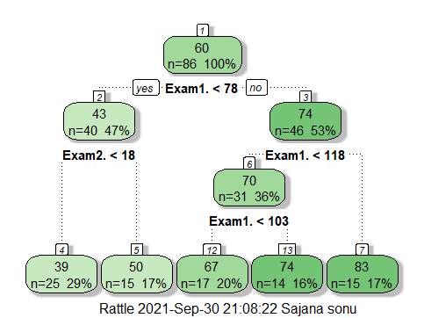

predictive model base on dtree
p1=predict(dtree,s_test)
p1

# now checkig the r squred for accuracy
r_2_1 = cor(s_test$Final_score.,p1)**2
r_2_1

# regression tree giving the accuray 64% which is higher than the linear regression .
#accuracy of this prediction(min_max_accuracy)
mm= mean(apply(predicted_value,1,min)/apply(predicted_value,1,max))
mm
# accuracy is coming around 78.5 %
##2)prediction for grades of the student .
##creating decision classifctaion tree for prediction
colnames(mark_data)
dtree_1=rpart(Grade.~.,data = s_train,method = "class")
fancyRpartPlot(dtree_1)
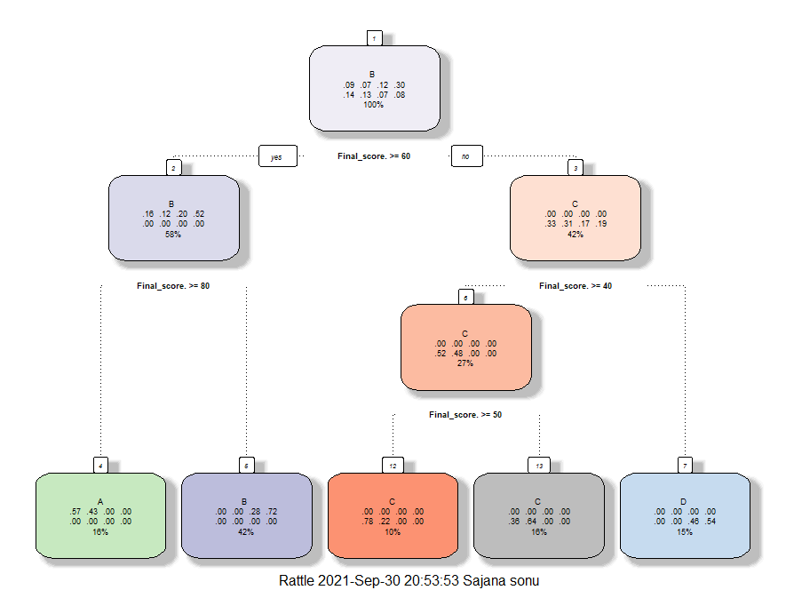

#decision classified based on the final score withut any removal of the varible
##complexity paarmter

printcp(dtree_1)
plotcp(dtree_1)
Classification tree:
rpart(formula = Grade. ~ ., data = s_train, method = "class")

Variables actually used in tree construction:
[1] Final_score.

Root node error: 60/86 = 0.69767

n= 86

CP nsplit rel error xerror xstd
1 0.200000 0 1.00000 1.00000 0.070984
2 0.133333 1 0.80000 0.83333 0.076249
3 0.116667 2 0.66667 0.70000 0.077259
4 0.066667 3 0.55000 0.66667 0.077092
5 0.010000 4 0.48333 0.55000 0.075161
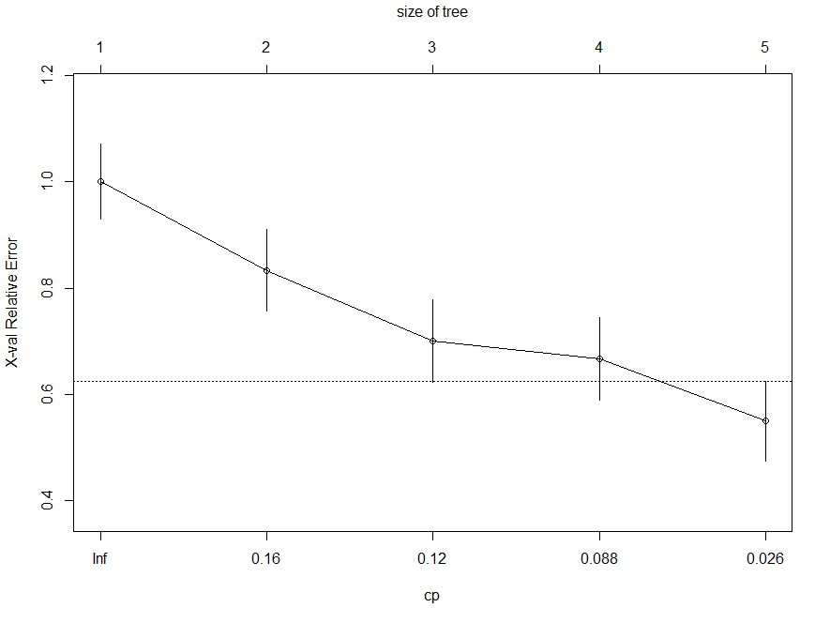
creting predictive model for grades
p_1 =predict(dtree_1,s_test,type = "class")
p_1
5 6 11 17 20 24 26 35 36 37 42 47 50 56 65 75 78 85 86 92 98 103
C B B B C C A A C B C B A C A D B D B C D D
Levels: A A B B C C D D
##2)prediction for grades of the student .
##creating decision classifctaion tree for prediction
colnames(mark_data)
dtree_1=rpart(Grade.~.,data = s_train,method = "class")
fancyRpartPlot(dtree_1)

#decision classified based on the final score withut any removal of the varible
##complexity paarmter

printcp(dtree_1)
plotcp(dtree_1)

#creting predictive model for grades
o =predict(dtree_1,s_test,type = "class")
o

#confusionmatrix

t=table(s_test$Grade.,o)
t

accuracy=sum(diag(t))/sum(t)
accuracy

##accuracy is 27 % which is not so good.
>

