SRM PROJECT
ROLL NO:408
PRANAVI SHAH

- I imported the data in r and then filled in the crude mortality column.
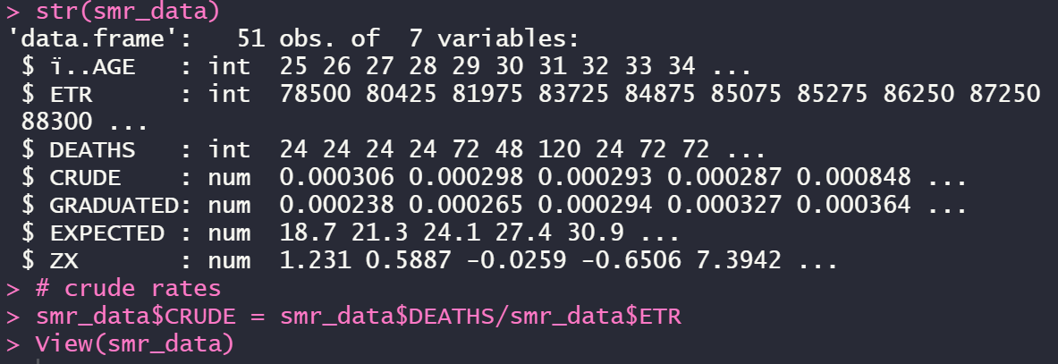

- Using Gompetz law
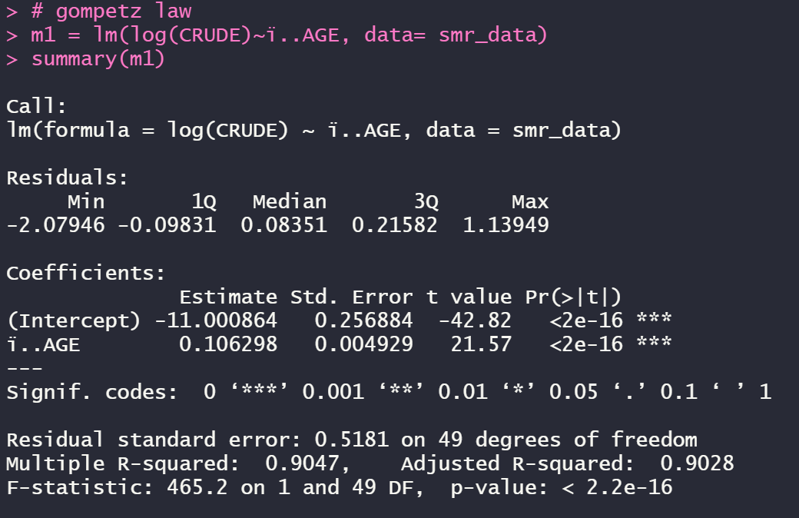

- Checking smoothness by applying third differences to the crude and graduated rates. The values are very low compared to the original values and they progress regularly , the data is smooth.
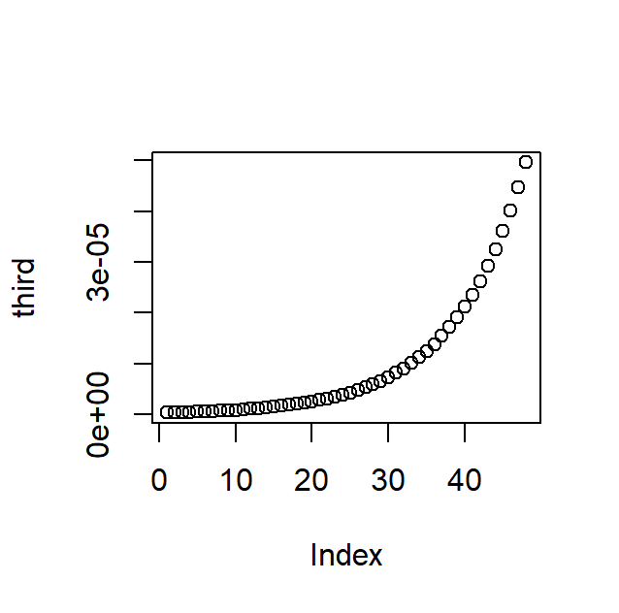

- Chi-squared test to check goodness of fit between DEATHS and EXPECTED.
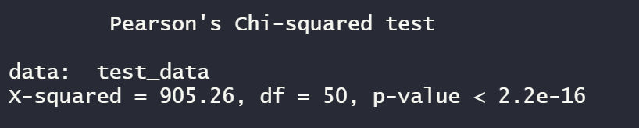

- A) standard deviation test
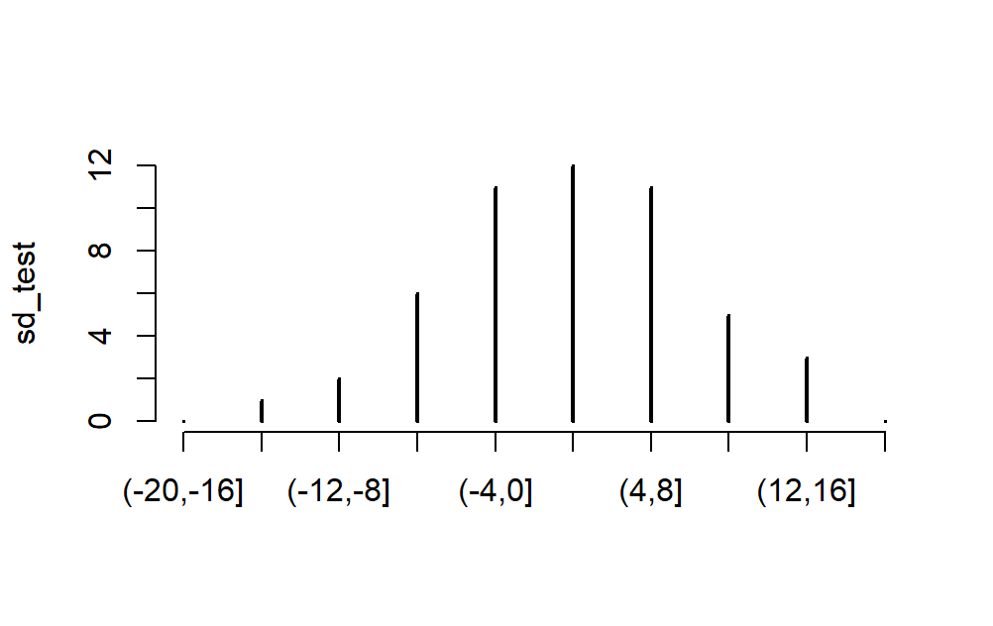
i. The graph is very wide compared to a standard normal graph, with several values higher than abs(10)
ii. the Values of the absolute deviations are very high relative to the expected value
iii. The lower bound is approx. -2 and the upper bound is approx. 6. IQR is 8. There are some outliers on the lower side but none on the upper side
iv. The Graph is positively skewed. It looks like it is centered about 2
v. The graduated rates do not represent the underlying mortality rates with accuracy.

b) sign test
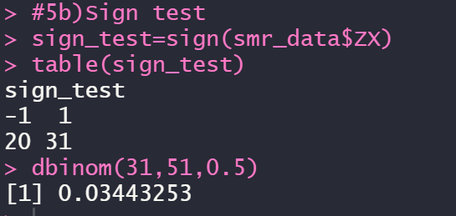
since it's a two tailed test, at 5% significance level, we accept the NULL hypothesis that the data is a true representation of the underlying mortality rates.

c) cumulative deviation test
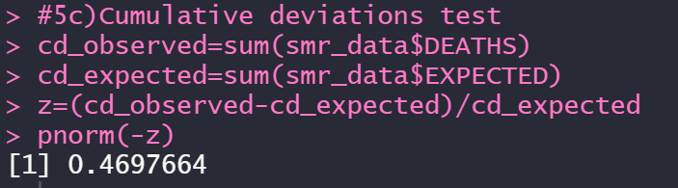

at 5% significance level, we accept the NULL hypothesis that the data is a true representation of the underlying mortality rates.

