Name: Darshan Lodha
Roll No.: 18
Note: This word document consists of R code along with the outputs from R. It also consists of just the R code at the end of the document.

##______________ Statistical Modelling in R Assignment _________________##
##______________ Classification and Regression Trees ____________________##

##____Name: Darshan Lodha___##

##Converting the given data into csv file using notepad
##Loading the dataset in R
df_msc_stud = read.csv("D:/Darshan/Darshan Docs/Semester 3/Statistical Modelling in R/CSV Files/M.Sc. Students Dataset.csv")
##Performing EDA
##1]Viewing the dataset
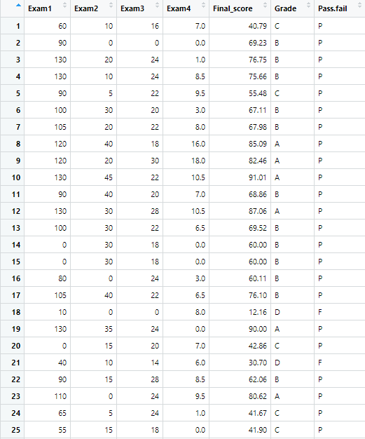
View(df_msc_stud)

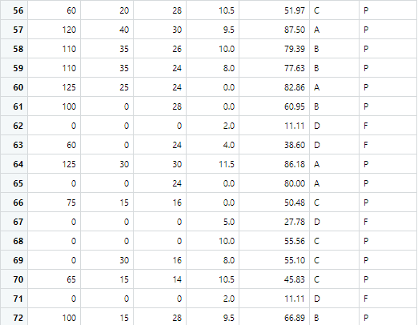
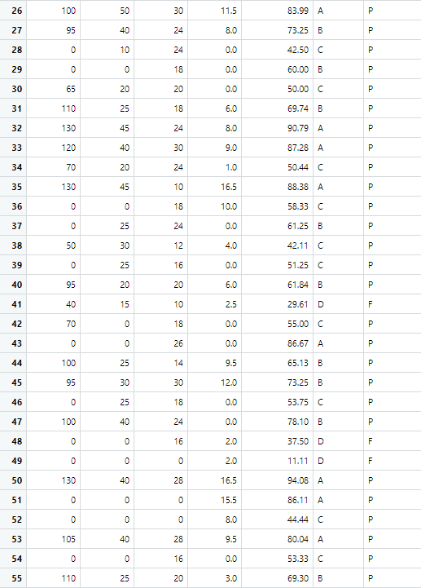

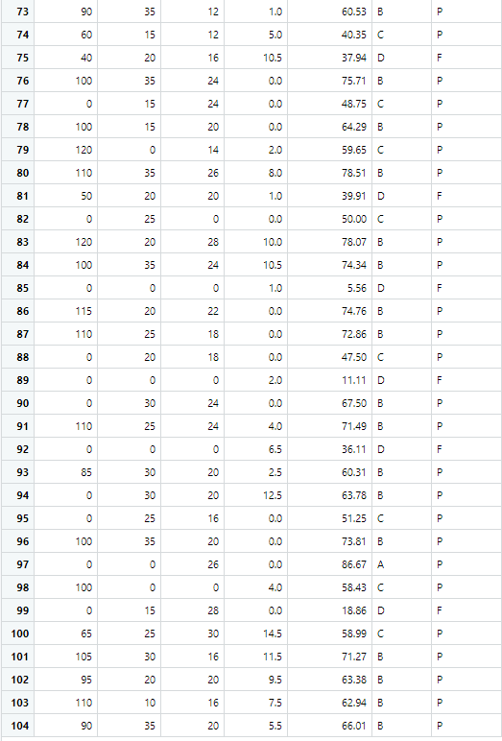

##2]Head and tail of the dataset
head(df_msc_stud)
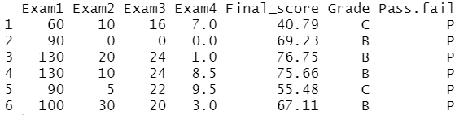
Output:

tail(df_msc_stud)
Output:
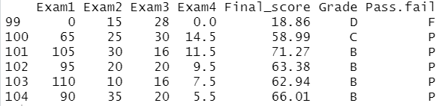

##3]Dimensions of the dataset
dim(df_msc_stud)
Output:
[1] 104 7
##4]Structure of the dataset (using glimpse())
library(tidyverse)
Output:
-- Attaching packages ---------------------------------------------------------- tidyverse 1.3.1 --
v ggplot2 3.3.3 v purrr 0.3.4
v tibble 3.1.1 v dplyr 1.0.5
v tidyr 1.1.3 v stringr 1.4.0
v readr 1.4.0 v forcats 0.5.1
-- Conflicts ------------------------------------------------------------- tidyverse_conflicts() --
x dplyr::filter() masks stats::filter()
x dplyr::lag() masks stats::lag()

glimpse(df_msc_stud)
Output:
Rows: 104
Columns: 7
$ Exam1 <int 60, 90, 130, 130, 90, 100, 105, 120, 120, 130, 90, 130, 100, 0, 0, 80, 105, 1~
$ Exam2 <int 10, 0, 20, 10, 5, 30, 20, 40, 20, 45, 40, 30, 30, 30, 30, 0, 40, 0, 35, 15, 1~
$ Exam3 <int 16, 0, 24, 24, 22, 20, 22, 18, 30, 22, 20, 28, 22, 18, 18, 24, 22, 0, 24, 20,~
$ Exam4 <dbl 7.0, 0.0, 1.0, 8.5, 9.5, 3.0, 8.0, 16.0, 18.0, 10.5, 7.0, 10.5, 6.5, 0.0, 0.0~
$ Final_score <dbl 40.79, 69.23, 76.75, 75.66, 55.48, 67.11, 67.98, 85.09, 82.46, 91.01, 68.86, ~
$ Grade <chr "C", "B", "B", "B", "C", "B", "B", "A", "A", "A", "B", "A", "B", "B", "B", "B~
$ Pass.fail <chr "P", "P", "P", "P", "P", "P", "P", "P", "P", "P", "P", "P", "P", "P", "P", "P~
##5]Column names
col_names_mscdata = colnames(df_msc_stud)
col_names_mscdata
Output:
[1] "Exam1" "Exam2" "Exam3" "Exam4" "Final_score" "Grade"
[7] "Pass.fail"
##6]Missing values
sapply(df_msc_stud,function(z) sum(is.na(z)))
Output:
Exam1 Exam2 Exam3 Exam4 Final_score Grade Pass.fail
0 0 0 0 0 0 0
##There are no missing values in the dataset
##7]Outliers
boxplot(df_msc_stud[,1:5],main = "Boxplot of M.Sc. Students dataset",col = "light green")
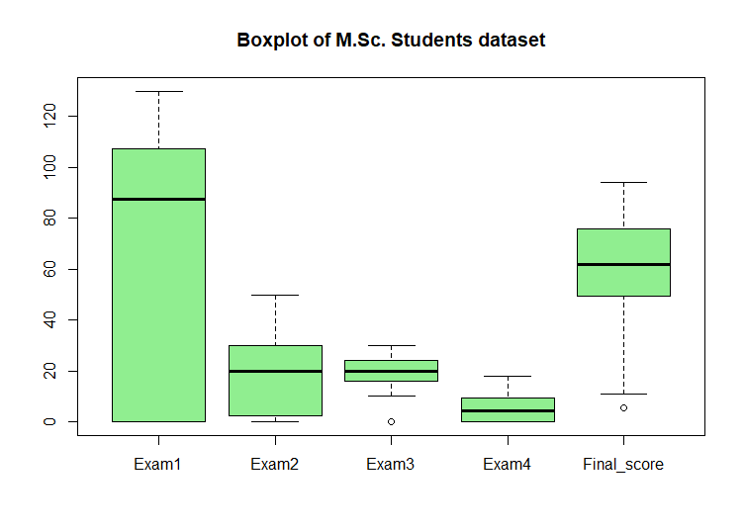
##Interpretation: There are no major significant outliers. Thus, no need to perform outlier
##handling process.
##8]Five number summary
summary(df_msc_stud)
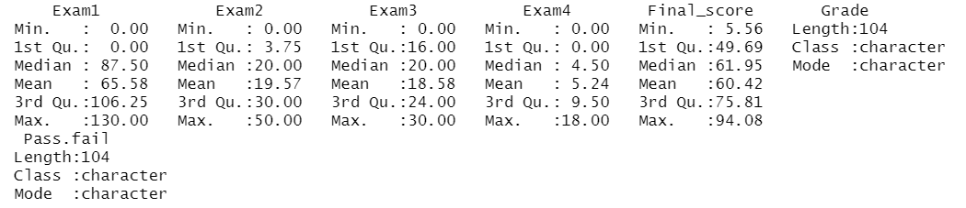
Output:

##_______________________________________________________________________##

##___Question 1] Creating predictive model to determine the grade of the students

##The grade of the students can be determined using a decision tree.
##Since it's not a continuous variable, linear regression is not appropriate and
##the grades not being a binary data type, they cannot be predicted using logistic
##regression.
##Thus, decision trees are most appropriate

##Copying into another dataset
df_msc_grade = df_msc_stud
glimpse(df_msc_grade)
Output:
Rows: 104
Columns: 7
$ Exam1 <int 60, 90, 130, 130, 90, 100, 105, 120, 120, 130, 90, 130, 100, 0, 0, 80, 105, 1~
$ Exam2 <int 10, 0, 20, 10, 5, 30, 20, 40, 20, 45, 40, 30, 30, 30, 30, 0, 40, 0, 35, 15, 1~
$ Exam3 <int 16, 0, 24, 24, 22, 20, 22, 18, 30, 22, 20, 28, 22, 18, 18, 24, 22, 0, 24, 20,~
$ Exam4 <dbl 7.0, 0.0, 1.0, 8.5, 9.5, 3.0, 8.0, 16.0, 18.0, 10.5, 7.0, 10.5, 6.5, 0.0, 0.0~
$ Final_score <dbl 40.79, 69.23, 76.75, 75.66, 55.48, 67.11, 67.98, 85.09, 82.46, 91.01, 68.86, ~
$ Grade <chr "C", "B", "B", "B", "C", "B", "B", "A", "A", "A", "B", "A", "B", "B", "B", "B~
$ Pass.fail <chr "P", "P", "P", "P", "P", "P", "P", "P", "P", "P", "P", "P", "P", "P", "P", "P~

##Converting Grade and Pass.fail to factor
df_msc_grade$Grade = as.factor(df_msc_grade$Grade)
df_msc_grade$Pass.fail = as.factor(df_msc_grade$Pass.fail)
glimpse(df_msc_grade)
Output:
Rows: 104
Columns: 7
$ Exam1 <int 60, 90, 130, 130, 90, 100, 105, 120, 120, 130, 90, 130, 100, 0, 0, 80, 105, 1~
$ Exam2 <int 10, 0, 20, 10, 5, 30, 20, 40, 20, 45, 40, 30, 30, 30, 30, 0, 40, 0, 35, 15, 1~
$ Exam3 <int 16, 0, 24, 24, 22, 20, 22, 18, 30, 22, 20, 28, 22, 18, 18, 24, 22, 0, 24, 20,~
$ Exam4 <dbl 7.0, 0.0, 1.0, 8.5, 9.5, 3.0, 8.0, 16.0, 18.0, 10.5, 7.0, 10.5, 6.5, 0.0, 0.0~
$ Final_score <dbl 40.79, 69.23, 76.75, 75.66, 55.48, 67.11, 67.98, 85.09, 82.46, 91.01, 68.86, ~
$ Grade <fct C, B, B, B, C, B, B, A, A, A, B, A, B, B, B, B, B, D, A, C, D, B, A, C, C, A,~
$ Pass.fail <fct P, P, P, P, P, P, P, P, P, P, P, P, P, P, P, P, P, F, P, P, F, P, P, P, P, P,~

##Printing the statistical values
library(psych)
Output:
Attaching package: ‘psych’
The following objects are masked from ‘package:ggplot2’:
%+%, alpha
describe(df_msc_grade)
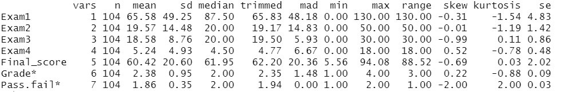
Output:

##Interpretation: All the numeric variables have skewness between -1 to +1

##Splitting the dataset into training and testing dataset
set.seed(101)
s = sample(nrow(df_msc_grade),0.75*nrow(df_msc_grade))
df_msc_grade_tr = df_msc_grade[s,]
df_msc_grade_test = df_msc_grade[-s,]
nrow(df_msc_grade_tr)
Output:
[1] 78
nrow(df_msc_grade_test)
Output:
[1] 26
head(df_msc_grade_tr)
Output:
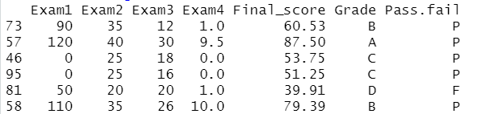

head(df_msc_grade_test)
Output:
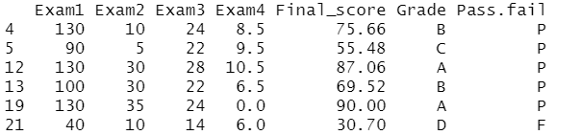

##Creating a decision tree
library(rpart)
library(rattle)
Output:
Loading required package: bitops
Rattle: A free graphical interface for data science with R.
Version 5.4.0 Copyright (c) 2006-2020 Togaware Pty Ltd.
Type 'rattle()' to shake, rattle, and roll your data.

##Full model
dec_tree1 = rpart(Grade~.,data = df_msc_grade_tr,method = "class")
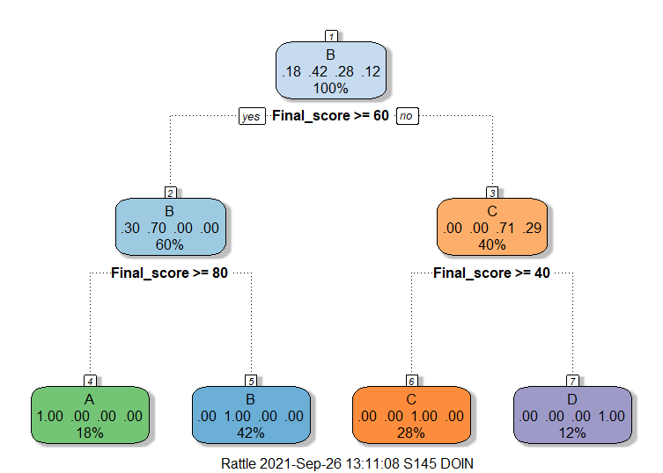
fancyRpartPlot(dec_tree1)

##Predicting using full model
p = predict(dec_tree1,df_msc_grade_test[,-6],type = "class")
p
Output:

##Printing the confusion matrix
##Using library caret
library(caret)
Output:
Loading required package: lattice
Attaching package: ‘caret’
The following object is masked from ‘package:purrr’:
lift
confusionMatrix(df_msc_grade_test$Grade,p)
Output:
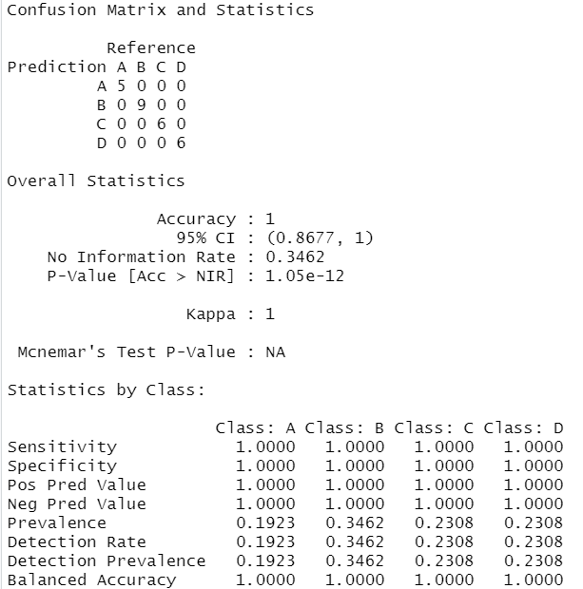

##Using table
t = table(df_msc_grade_test$Grade,p)
t
Output:
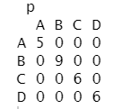
accuracy1 = sum(diag(t))/sum(t)
accuracy1
Output:
[1] 1

##Results:
##This full model gives 100% accuracy

##Complexity parameter
printcp(dec_tree1)
Output:
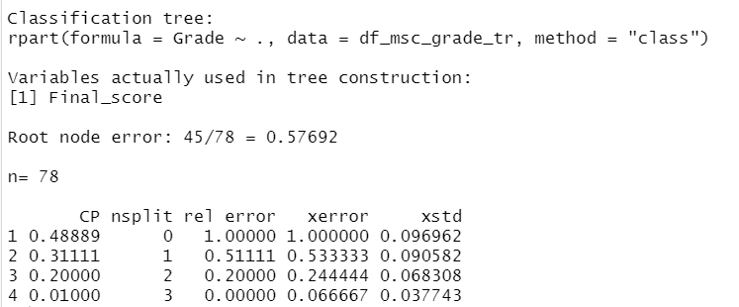

plotcp(dec_tree1)
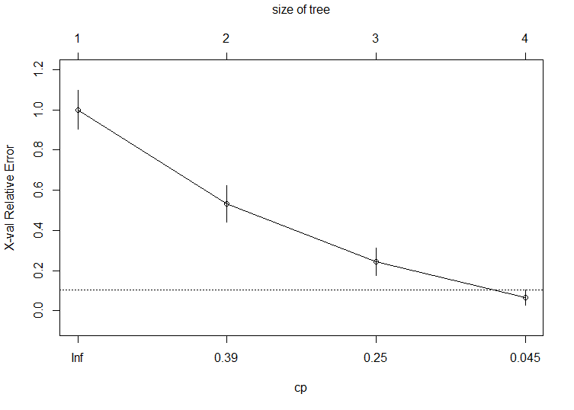
Output:

##Pruning can’t be performed further for this decision tree

##Results:
##This full model gives 100% accuracy

##_______________________________________________________________________##

##___Question 2] Creating predictive model to determine the percentage of marks obtained
##i.e., the Final_score

##The final score is a numeric i.e., continuous variable. Thus, we can use regression
##method to create a predictive model to predict final score.
##The regression method can be linear regression or a regression tree.
##If linear regression does not yield good accuracy then a regression tree can be
##constructed.

##___________First trying to construct a linear regression model_____________##

##Transferring to a new dataset
df_msc_finscore = df_msc_stud
##Examining the structure of the dataset
glimpse(df_msc_finscore)
Output:
Rows: 104
Columns: 7
$ Exam1 <int 60, 90, 130, 130, 90, 100, 105, 120, 120, 130, 90, 130, 100, 0, 0, 80, 105, 1~
$ Exam2 <int 10, 0, 20, 10, 5, 30, 20, 40, 20, 45, 40, 30, 30, 30, 30, 0, 40, 0, 35, 15, 1~
$ Exam3 <int 16, 0, 24, 24, 22, 20, 22, 18, 30, 22, 20, 28, 22, 18, 18, 24, 22, 0, 24, 20,~
$ Exam4 <dbl 7.0, 0.0, 1.0, 8.5, 9.5, 3.0, 8.0, 16.0, 18.0, 10.5, 7.0, 10.5, 6.5, 0.0, 0.0~
$ Final_score <dbl 40.79, 69.23, 76.75, 75.66, 55.48, 67.11, 67.98, 85.09, 82.46, 91.01, 68.86, ~
$ Grade <chr "C", "B", "B", "B", "C", "B", "B", "A", "A", "A", "B", "A", "B", "B", "B", "B~
$ Pass.fail <chr "P", "P", "P", "P", "P", "P", "P", "P", "P", "P", "P", "P", "P", "P", "P", "P~

##Converting grade and pass.fail to factor
df_msc_finscore$Grade = as.factor(df_msc_finscore$Grade)
df_msc_finscore$Pass.fail = as.factor(df_msc_finscore$Pass.fail)
str(df_msc_finscore)
Output:
'data.frame': 104 obs. of 7 variables:
$ Exam1 : int 60 90 130 130 90 100 105 120 120 130 ...
$ Exam2 : int 10 0 20 10 5 30 20 40 20 45 ...
$ Exam3 : int 16 0 24 24 22 20 22 18 30 22 ...
$ Exam4 : num 7 0 1 8.5 9.5 3 8 16 18 10.5 ...
$ Final_score: num 40.8 69.2 76.8 75.7 55.5 ...
$ Grade : Factor w/ 4 levels "A","B","C","D": 3 2 2 2 3 2 2 1 1 1 ...
$ Pass.fail : Factor w/ 2 levels "F","P": 2 2 2 2 2 2 2 2 2 2 ...

##We have already tested for missing value and outliers previously

##Converting grade and pass.fail to numbers
library(plyr)
Output:
-------------------------------------------------------------------------------------------------
You have loaded plyr after dplyr - this is likely to cause problems.
If you need functions from both plyr and dplyr, please load plyr first, then dplyr:
library(plyr); library(dplyr)
-------------------------------------------------------------------------------------------------
Attaching package: ‘plyr’
The following objects are masked from ‘package:dplyr’:
arrange, count, desc, failwith, id, mutate, rename, summarise, summarize
The following object is masked from ‘package:purrr’:
compact

df_msc_finscore$Grade = revalue(df_msc_finscore$Grade,c("A" = 1,"B" = 2,"C" = 3,"D" = 4))
df_msc_finscore$Pass.fail = revalue(df_msc_finscore$Pass.fail,c("P" = 1,"F" = 0))
str(df_msc_finscore)
Output:
'data.frame': 104 obs. of 7 variables:
$ Exam1 : int 60 90 130 130 90 100 105 120 120 130 ...
$ Exam2 : int 10 0 20 10 5 30 20 40 20 45 ...
$ Exam3 : int 16 0 24 24 22 20 22 18 30 22 ...
$ Exam4 : num 7 0 1 8.5 9.5 3 8 16 18 10.5 ...
$ Final_score: num 40.8 69.2 76.8 75.7 55.5 ...
$ Grade : Factor w/ 4 levels "1","2","3","4": 3 2 2 2 3 2 2 1 1 1 ...
$ Pass.fail : Factor w/ 2 levels "0","1": 2 2 2 2 2 2 2 2 2 2 ...

##Splitting the dataset into a training and test dataset
set.seed(101)
s_linreg = sample(nrow(df_msc_finscore),0.75*nrow(df_msc_finscore))
df_msc_finscore_tr = df_msc_finscore[s_linreg,]
df_msc_finscore_test = df_msc_finscore[-s_linreg,]
nrow(df_msc_finscore_tr)
Output:
[1] 78
nrow(df_msc_finscore_test)
Output:
[1] 26

##Independent variable selection
##Constructing a scatter plot
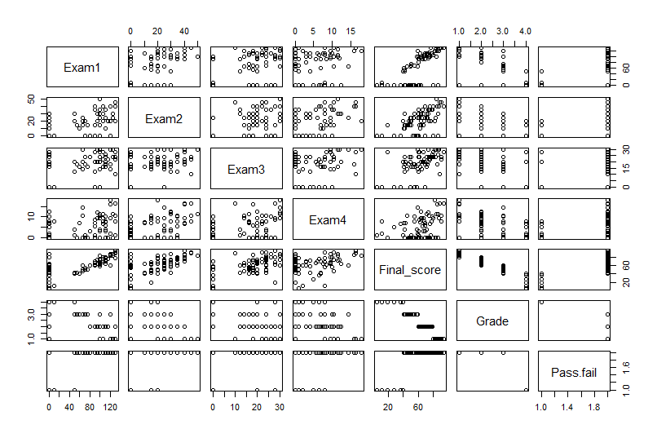
pairs(df_msc_finscore_tr)
##It can be seen that the final score has fairly linear relationship with
##Exam1,Exam2,Exam3,Exam4

##Constructing a correlation plot
library(corrplot)
Output:
corrplot 0.90 loaded
cor_mat_linreg = cor(df_msc_finscore_tr[,1:5])
cor_mat_linreg
Output:
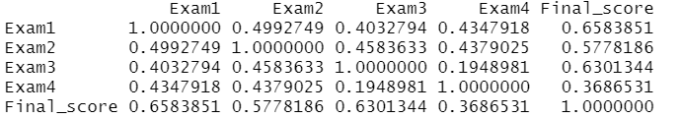

corrplot(cor_mat_linreg,method = "number")
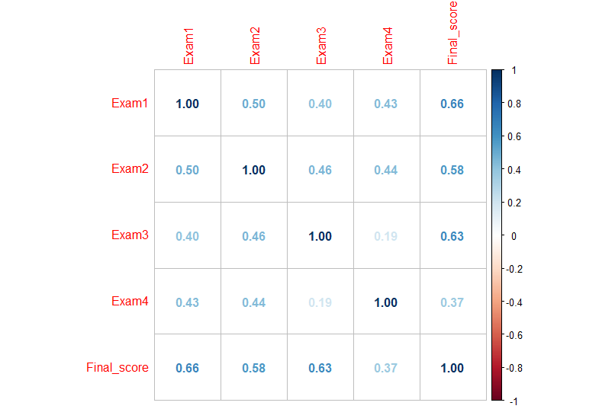

##Constructing a linear model
##1] Full model
finscore_linmod1 = lm(Final_score~.,data=df_msc_finscore_tr)
summary(finscore_linmod1)
Output:
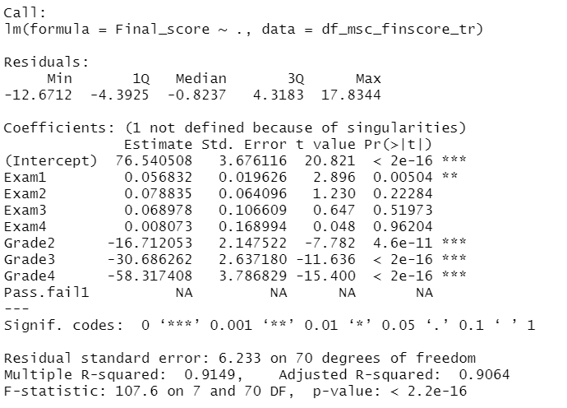
##Adjusted R-squared = 90.64%

##2]Removing Pass.fail
finscore_linmod2 = lm(Final_score~.-Pass.fail,data = df_msc_finscore_tr)
summary(finscore_linmod2)
Output:
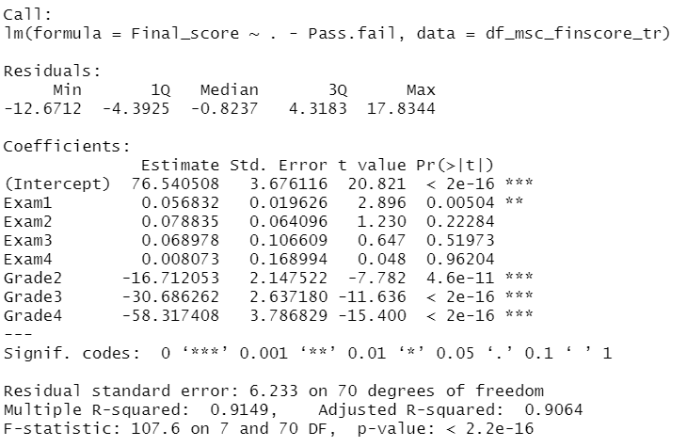
##Adjusted R-squared = 90.64%

##3] Considering Exam1, Exam2, Exam3 and Exam4
finscore_linmod3 = lm(Final_score~.-Pass.fail-Grade,data = df_msc_finscore_tr)
summary(finscore_linmod3)
Output:
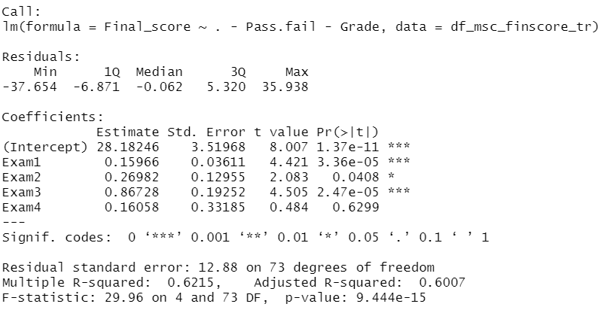

##Adjusted R-squared reduces drastically to 60.07%

##Prediction
p_linreg = predict(finscore_linmod2,df_msc_finscore_test[,-5])
p_linreg
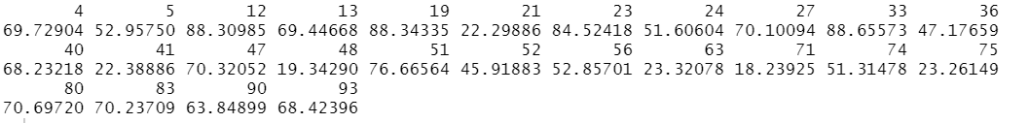
Output:
##Manually checking the accuracy
(cor(df_msc_finscore_test$Final_score,p_linreg))^2
Output:
[1] 0.8833972
##R-squared turns out to be 88.33972%

##Thus, the 2nd model is the best linear regression model

##Checking the assumptions of linear regression

##1]Linear relationship
##From the scatter plots, it can be interpreted that there is a fairly linear
##relationship between the variables except for Final score and grade.
##And grade is an important independent variable since, if removed the R squared
##reduces drastically

##2]Multivariate normality
library(psych)
describe(df_msc_finscore_tr)
Output:
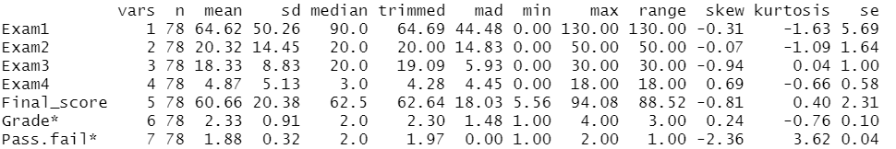
##The skewness of the variables considered are between -1 and +1

##3]Residuals are normally distributed
##Shapiro Wilk Test

##H0:Residuals follow normal distribution
##H1:Residuals do not follow normal distribution
shapiro.test(finscore_linmod2$residuals)
Output:
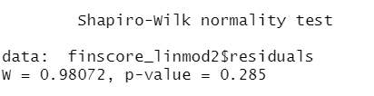

##Since, p-value is greater than 0.05, i.e., 0.285, we don not have sufficient
##evidences to reject our null hypothesis.
##Thus, we fail to reject that the residuals follow normal distribution

##4]No multicollinearity
##VIF
library(car)
Output:
Loading required package: carData
Attaching package: ‘car’
The following object is masked from ‘package:psych’:
logit
The following object is masked from ‘package:dplyr’:
recode
The following object is masked from ‘package:purrr’:
some

vif(finscore_linmod2)
Output:
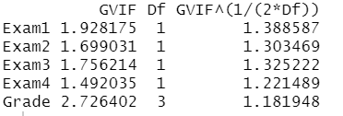
##The vif does not exced 5 and hence there is no strong multicollinearity.

##5]No autocorrelation
##Durbin Watson test
##A value between 1.5 < d < 2.5, it shows that there is no auto correlation

##H0: No first order auto-correlation
##H1: First order auto-correlation exists
durbinWatsonTest(finscore_linmod2)
Output:
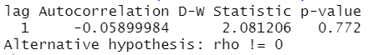
##Since, the p-value is 0.772 which is more than 0.05, we don not have sufficient
##evidence to reject our null hypothesis at 5% level of significance.
##Hence, we conclude that there is no autocorrelation
##Also, the D-W statistic is 2.081206 which lies between the range 1.5 and 2.5, which
##indicates no autocorrelation

##6]Homoscedasticity
##Breusch Pagan test
library(lmtest)
Output:
Loading required package: zoo
Attaching package: ‘zoo’
The following objects are masked from ‘package:base’:
as.Date, as.Date.numeric
##H0: Data is homoscedastic
##H1: Data is heteroscedastic
bptest(finscore_linmod2)
Output:
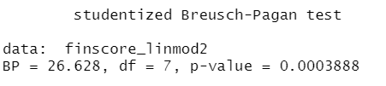
##Since, p-value is 0.0003888 which is less than 0.05, hence we have sufficient
##evidence to reject our null hypothesis at the 5% level of significance.
##Hence, we conclude that residuals are heteroscedastic in nature
par(mfrow = c(2,2))
plot(finscore_linmod2)
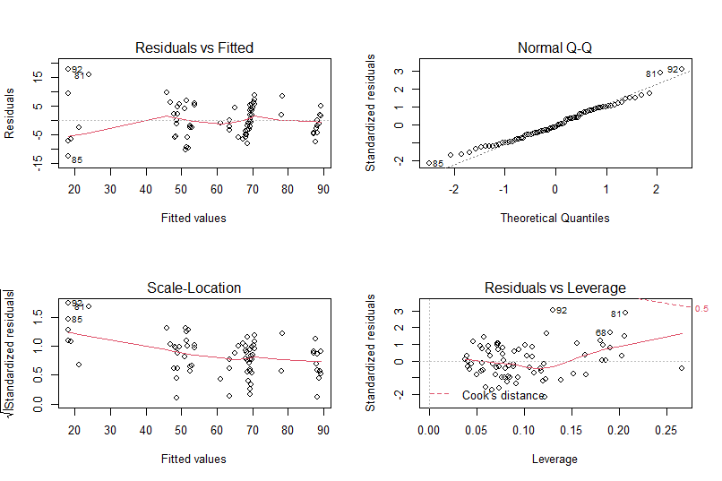

par(mfrow = c(1,1))

##_________Now trying linear regression tree for a better accuracy___________##

##Transferring the dataset
df_msc_finscore_regtr = df_msc_stud

##Splitting into a training and testing dataset
s_regtr = sample(nrow(df_msc_finscore_regtr),0.75*nrow(df_msc_finscore_regtr))
df_msc_finscore_regtr_train = df_msc_finscore_regtr[s_regtr,]
df_msc_finscore_regtr_test = df_msc_finscore_regtr[-s_regtr,]

##Examining the structure of the dataset
glimpse(df_msc_finscore_regtr)
Output:
Rows: 104
Columns: 7
$ Exam1 <int 60, 90, 130, 130, 90, 100, 105, 120, 120, 130, 90, 130, 100, 0, 0, 80, 105, 1~
$ Exam2 <int 10, 0, 20, 10, 5, 30, 20, 40, 20, 45, 40, 30, 30, 30, 30, 0, 40, 0, 35, 15, 1~
$ Exam3 <int 16, 0, 24, 24, 22, 20, 22, 18, 30, 22, 20, 28, 22, 18, 18, 24, 22, 0, 24, 20,~
$ Exam4 <dbl 7.0, 0.0, 1.0, 8.5, 9.5, 3.0, 8.0, 16.0, 18.0, 10.5, 7.0, 10.5, 6.5, 0.0, 0.0~
$ Final_score <dbl 40.79, 69.23, 76.75, 75.66, 55.48, 67.11, 67.98, 85.09, 82.46, 91.01, 68.86, ~
$ Grade <chr "C", "B", "B", "B", "C", "B", "B", "A", "A", "A", "B", "A", "B", "B", "B", "B~
$ Pass.fail <chr "P", "P", "P", "P", "P", "P", "P", "P", "P", "P", "P", "P", "P", "P", "P", "P~

##Constructing the regression tree
finscore_regtr1 = rpart(Final_score~.,data = df_msc_finscore_regtr_train,method = "anova")
fancyRpartPlot(finscore_regtr1)
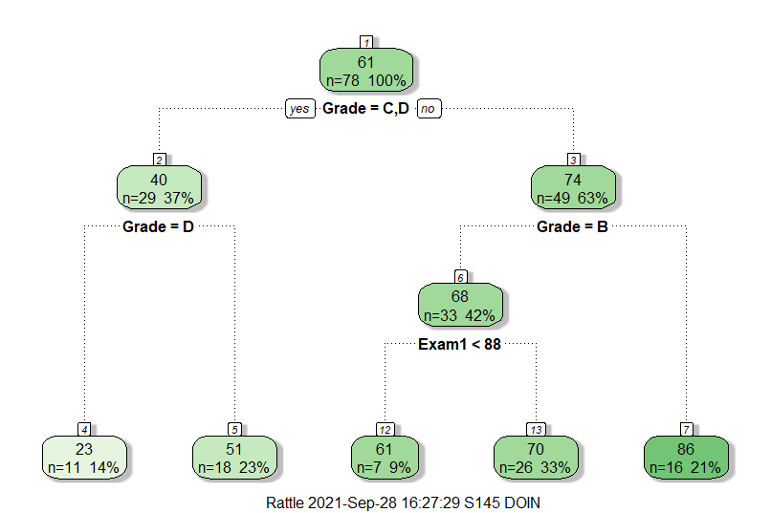
##Prediction
p_regtr = predict(finscore_regtr1,df_msc_finscore_regtr_test[,-5])
p_regtr
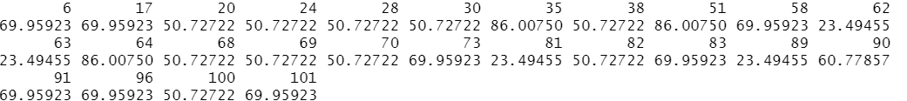
Output:

##R-square calculation
(cor(df_msc_finscore_regtr_test$Final_score,p_regtr))^2
Output:
[1] 0.8550858

##Dataframe
df_pred_finscore = data.frame("Actual" = df_msc_finscore_regtr_test$Final_score,"Predicted" = p_regtr)
##Min max accuracy for Regression Tree
minmax_acc = mean((apply(df_pred_finscore,1,min))/(apply(df_pred_finscore,1,max)))
minmax_acc
Output:
[1] 0.8594351
##Accuracy = 85.94351%

##In testing dataset while predicting
##The second linear regression model that was constructed had a R-squared value
##of 88.33972% whereas this regression tree has a R-squared value of 85.50858%

The same R Code as the rest of the document just for reference (Without Output)
##______________Statistical Modelling In R Assignment ________________________##
##______________ Classification and Regression Trees ________________________##

##____Name: Darshan Lodha___##

##Converting the given data into csv file using notepad
##Loading the dataset in R
df_msc_stud = read.csv("D:/Darshan/Darshan Docs/Semester 3/Statistical Modelling in R/CSV Files/M.Sc. Students Dataset.csv")

##Performing EDA

##1]Viewing the dataset
View(df_msc_stud)
##2]Head and tail of the dataset
head(df_msc_stud)
tail(df_msc_stud)
##3]Dimensions of the dataset
dim(df_msc_stud)
##4]Structure of the dataset (using glimpse())
library(tidyverse)
glimpse(df_msc_stud)
##5]Column names
col_names_mscdata = colnames(df_msc_stud)
col_names_mscdata
##6]Missing values
sapply(df_msc_stud,function(z) sum(is.na(z)))
##There are no missing values in the dataset
##7]Outliers
boxplot(df_msc_stud[,1:5],main = "Boxplot of M.Sc. Students dataset",col = "light green")
##Interpretation: There are no major significant outliers. Thus, no need to perform outlier
##handling process.
##8]Five number summary
summary(df_msc_stud)

##____________________________________________________________________________##

##___Question 1] Creating predictive model to determine the grade of the students

##The grade of the students can be determined using a decision tree.
##Since it's not a continuous variable, linear regression is not appropriate and
##the grades not being a binary data type, they cannot be predicted using logistic
##regression.
##Thus, decision trees are most appropriate

##Copying into another dataset
df_msc_grade = df_msc_stud
glimpse(df_msc_grade)

##Converting Grade and Pass.fail to factor
df_msc_grade$Grade = as.factor(df_msc_grade$Grade)
df_msc_grade$Pass.fail = as.factor(df_msc_grade$Pass.fail)
glimpse(df_msc_grade)

##Printing the statistical values
library(psych)
describe(df_msc_grade)
##Interpretation: All the numeric variables have skewness between -1 to +1

##Splitting the dataset into training and testing dataset
set.seed(101)
s = sample(nrow(df_msc_grade),0.75*nrow(df_msc_grade))
df_msc_grade_tr = df_msc_grade[s,]
df_msc_grade_test = df_msc_grade[-s,]
nrow(df_msc_grade_tr)
nrow(df_msc_grade_test)
head(df_msc_grade_tr)
head(df_msc_grade_test)

##Creating a decision tree
library(rpart)
library(rattle)

##Full model
dec_tree1 = rpart(Grade~.,data = df_msc_grade_tr,method = "class")
fancyRpartPlot(dec_tree1)

##Predicting using full model
p = predict(dec_tree1,df_msc_grade_test[,-6],type = "class")
p

##Printing the confusion matrix
##Using library caret
library(caret)
confusionMatrix(df_msc_grade_test$Grade,p)
##Using table
t = table(df_msc_grade_test$Grade,p)
t
accuracy1 = sum(diag(t))/sum(t)
accuracy1

##Results:
##This full model gives 100% accuracy

##Complexity parameter
printcp(dec_tree1)
plotcp(dec_tree1)
##Pruning cant be performed further for this decision tree

##Results:
##This full model gives 100% accuracy

##___________________________________________________________________________##

##___Question 2] Creating predictive model to determine the percentage of marks obtained
##i.e., the Final_score

##The final score is a numeric i.e., continuous variable. Thus, we can use regression
##method to create a predictive model to predict final score.
##The regression method can be linear regression or a regression tree.
##If linear regression does not yield good accuracy then a regression tree can be
##constructed.

##___________First trying to construct a linear regression model_____________##

##Transferring to a new dataset
df_msc_finscore = df_msc_stud
##Examining the structure of the dataset
glimpse(df_msc_finscore)

##Converting grade and pass.fail to factor
df_msc_finscore$Grade = as.factor(df_msc_finscore$Grade)
df_msc_finscore$Pass.fail = as.factor(df_msc_finscore$Pass.fail)
str(df_msc_finscore)

##We have already tested for missing value and outliers previously

##Converting grade and pass.fail to numbers
library(plyr)
df_msc_finscore$Grade = revalue(df_msc_finscore$Grade,c("A" = 1,"B" = 2,"C" = 3,"D" = 4))
df_msc_finscore$Pass.fail = revalue(df_msc_finscore$Pass.fail,c("P" = 1,"F" = 0))
str(df_msc_finscore)

##Splitting the dataset into a training and test dataset
set.seed(101)
s_linreg = sample(nrow(df_msc_finscore),0.75*nrow(df_msc_finscore))
df_msc_finscore_tr = df_msc_finscore[s_linreg,]
df_msc_finscore_test = df_msc_finscore[-s_linreg,]
nrow(df_msc_finscore_tr)
nrow(df_msc_finscore_test)

##Independent variable selection
##Constructing a scatter plot
pairs(df_msc_finscore_tr)
##It can be seen that the final score has fairly linear relationship with
##Exam1,Exam2,Exam3,Exam4

##Constructing a correlation plot
library(corrplot)
cor_mat_linreg = cor(df_msc_finscore_tr[,1:5])
cor_mat_linreg
corrplot(cor_mat_linreg,method = "number")

##Constructing a linear model
##1] Full model
finscore_linmod1 = lm(Final_score~.,data=df_msc_finscore_tr)
summary(finscore_linmod1)
##Adjusted R-squared = 90.64%

##2]Removing Pass.fail
finscore_linmod2 = lm(Final_score~.-Pass.fail,data = df_msc_finscore_tr)
summary(finscore_linmod2)
##Adjusted R-squared = 90.64%

##3] Considering Exam1, Exam2, Exam3 and Exam4
finscore_linmod3 = lm(Final_score~.-Pass.fail-Grade,data = df_msc_finscore_tr)
summary(finscore_linmod3)
##Adjusted R-squared reduces drastically to 60.07%

##Prediction
p_linreg = predict(finscore_linmod2,df_msc_finscore_test[,-5])
p_linreg

##Manually checking the accuracy
(cor(df_msc_finscore_test$Final_score,p_linreg))^2
##R-squared turns out to be 88.33972%

##Thus, the 2nd model is the best linear regression model

##Checking the assumptions of linear regression

##1]Linear relationship
##From the scatter plots, it can be interpreted that there is a fairly linear
##relationship between the variables except for Final score and grade.
##And grade is an important independent variable since, if removed the R squared
##reduces drastically

##2]Multivariate normality
library(psych)
describe(df_msc_finscore_tr)
##The skewness of the variables considered are between -1 and +1

##3]Residuals are normally distributed
##Shapiro Wilk Test

##H0:Residuals follow normal distribution
##H1:Residuals do not follow normal distribution
shapiro.test(finscore_linmod2$residuals)
##Since, p-value is greater than 0.05, i.e., 0.285, we don not have sufficient
##evidences to reject our null hypothesis.
##Thus, we fail to reject that the residuals follow normal distribution

##4]No multicollinearity
##VIF
library(car)
vif(finscore_linmod2)
##The vif does not exced 5 and hence there is no strong multicollinearity.

##5]No autocorrelation
##Durbin Watson test
##A value between 1.5 < d < 2.5, it shows that there is no auto correlation

##H0: No first order auto-correlation
##H1: First order auto-correlation exists
durbinWatsonTest(finscore_linmod2)
##Since, the p-value is 0.772 which is more than 0.05, we don not have sufficient
##evidence to reject our null hypothesis at 5% level of significance.
##Hence, we conclude that there is no autocorrelation
##Also, the D-W statistic is 2.081206 which lies between the range 1.5 and 2.5, which
##indicates no autocorrelation

##6]Homoscedasticity
##Breusch Pagan test

library(lmtest)

##H0: Data is homoscedastic
##H1: Data is heteroscedastic
bptest(finscore_linmod2)
##Since, p-value is 0.0003888 which is less than 0.05, hence we have sufficient
##evidence to reject our null hypothesis at the 5% level of significance.
##Hence, we conclude that residuals are heteroscedastic in nature

par(mfrow = c(2,2))
plot(finscore_linmod2)
par(mfrow = c(1,1))

##_________Now trying linear regression tree for a better accuracy___________##

##Transferring the dataset
df_msc_finscore_regtr = df_msc_stud

##Splitting into a training and testing dataset
s_regtr = sample(nrow(df_msc_finscore_regtr),0.75*nrow(df_msc_finscore_regtr))
df_msc_finscore_regtr_train = df_msc_finscore_regtr[s_regtr,]
df_msc_finscore_regtr_test = df_msc_finscore_regtr[-s_regtr,]

##Examining the structure of the dataset
glimpse(df_msc_finscore_regtr)

##Constructing the regression tree
finscore_regtr1 = rpart(Final_score~.,data = df_msc_finscore_regtr_train,method = "anova")
fancyRpartPlot(finscore_regtr1)

##Prediction
p_regtr = predict(finscore_regtr1,df_msc_finscore_regtr_test[,-5])
p_regtr

##R-square calculation
(cor(df_msc_finscore_regtr_test$Final_score,p_regtr))^2

##Dataframe
df_pred_finscore = data.frame("Actual" = df_msc_finscore_regtr_test$Final_score,"Predicted" = p_regtr)
##Min max accuracy for Regression Tree
minmax_acc = mean((apply(df_pred_finscore,1,min))/(apply(df_pred_finscore,1,max)))
minmax_acc
##Accuracy = 85.94351%

##In testing dataset while predicting
##The second linear regression model that was constructed had a R-squared value
##of 88.33972% whereas this regression tree has a R-squared value of 85.50858%

