NON-LIFE INSURANCE
(ASSIGNMENT-1)
- The premium collected by an insurance company for a portion of the policy that has expired is called earned premium (c)
- Surplus reinsurance is similar to quota share insurance as the reinsurer and reinsured’s share of the claim is proportionate. (a)
- It is true that an individual loss on an insured risk triggers the reinsurance coverage if it’s exceeds the deductible, is described as an excess of loss per risk treaty. (a)
- It is true that a non-proportional reinsurance is usually expressed as percentage of the risk a reinsurer is taking from the primary insurer. (a)
- It is true that a reinsurance contract is a contract of indemnity. (a)

- Reinsurance is a process whereby one entity (the reinsurer) takes on all or part of the risk covered under a policy issued by an insurance company in consideration of a premium payment. In other words, it is a form of an insurance cover for insurance companies.
- It can be divided into two basic categories: treaty and facultative.
- Treaties are agreements that cover broad groups of policies such as all of a primary insurer’s auto business. Facultative covers specific individual, generally high-value or hazardous risks, such as a hospital, that would not be accepted under a treaty.
- The difference between stop loss insurance and excess loss of insurance is that in excess of loss reinsurance, the reinsurer indemnifies the ceding company for losses that exceed a certain limit where as in stop loss reinsurance an agreement is made whereby a reinsurer assumes on a per loss basis all loss amounts of the reinsured, subject to the policy limit, in excess of the stated amount.
- The various ratios used in profit analysis of reinsurance are as follows:
RATIO | FORMULA | SIGNIFICANCE IN ANALYSIS
Premium Growth | GPWT – GPWT-1 * 100 /GPWT-1 GPW:  Gross Premium Written T: Current year  T-1: Previous year | Indicates growth in business undertaken by the insurance entity.
Risk Retention | Net Premium Written/Gross Premium Written | Indicates the level of risks retained by the insurer vis-à-vis that ceded to reinsurers. Reinsurance plays an essential role in the risk spreading process.
Loss Ratio | Net Claims Incurred * 100 /Net Premium Earned | The ratio measures the company’s loss experience as a proportion of premium income earned during the year. The loss ratio is a reflection on the nature of risk underwritten and the adequacy or inadequacy of pricing of risks.
Expense Ratio | Management Expense +/(-) Net Commission Paid/(Earned) * 100/ Net Premium Earned | Expense ratio reflects the efficiency of insurance operations. Expense ratio for an insurer is analyzed by class of business, along with the trend of the same.
Combined Ratio | Loss Ratio + Expense Ratio | Combined ratio is a measure of underwriting profitability of an insurance company after factoring claims expenses and operating expenses of the insurer.
Investment Yield | Total Investment Income/ Average Total Investments | This ratio measures the average return on the company’s invested assets before and after capital gains and losses. While calculating the investment yield including capital gains, both realized as well as unrealized capital gains are considered.
Net Earnings Ratio | Profit After Tax/ Net Premium Written | This ratio measures the overall profitability of an insurer after factoring underwriting result, operating expenses as well as investment income and tax.
Return on Net worth | Profit After Tax/Average Net worth | This ratio reflects the post-tax return generated on net worth of an insurer. It’s a measure of overall return on the equity deployed in the business.

- The history of general insurance in India:
- In India the first insurance policy was issued in the year 1870 by 'The European & The Albert'. It was during this same year that the first Insurance company 'Bombay Mutual Assurance Society Ltd.' was formed.
- The history of General Insurance can be dated back to the 17th Century; during the Industrial Revolution. General Insurance in India came as a British Occupation. So, Triton Insurance Company Ltd., in the year 1850 in Calcutta came to the introduced by the British. In the year 1907, Indian Mercantile Insurance Ltd, was the first company to manage all classes of general insurance business.
- Since, 1907, there has been no stopping for emergence of general insurance companies. So today, may it be securing home, car, two wheeler, travel, health and more a company like ICICI Lombard General Insurance Company Ltd. is a single platform that can fulfill right from basic to other insurance needs of every individual.

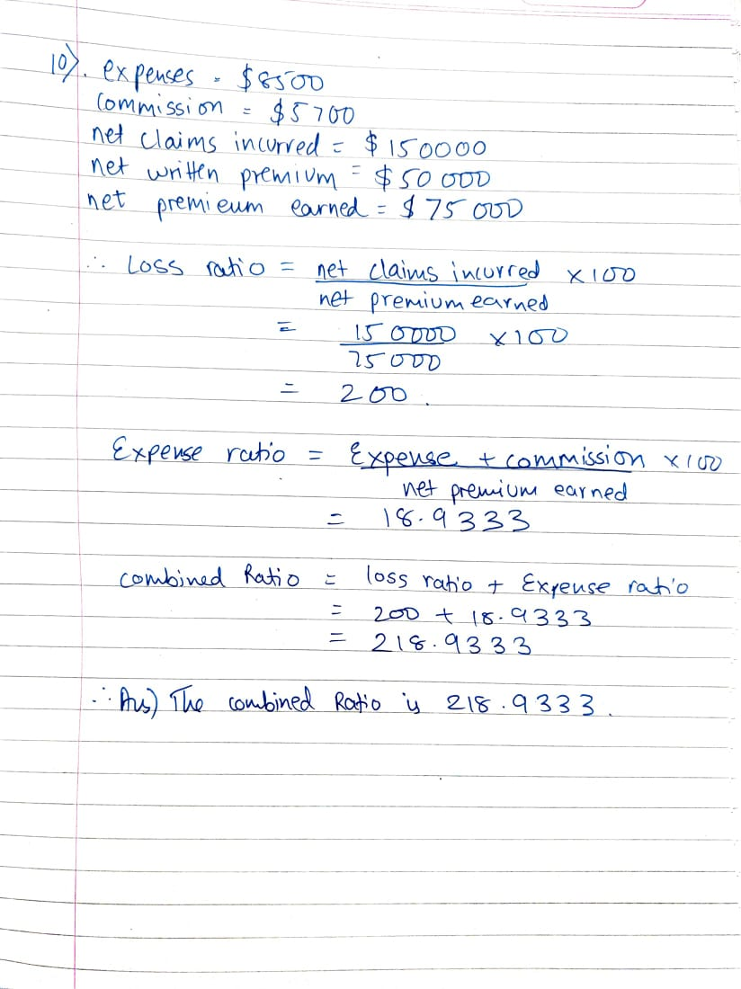
The combined ratio is 218.9333

