Screener
Market Cap- 1.50B to 15.25T
52 Week high = -20.00 to 0
Stocks:
- Siemens ltd : it is going up but there are major lows in them
- Titan : yes
- SBI life: not sure
- Bajaj finance: yes
- Bharti airtel: low to up but there are lots of highs and
- Adani Enterprises: yes
- Larsen & Toubro: yes
- Maruti Suzuki: no
- ITC: no

52 week low = 0 to 20
Stocks:
- HeidelbergCement India: starts low but ends lower
- Hero Motocorp : yes
- Shree Cements: no
- Mahindra & Mahindra: no
- Britannia Industries: not sure
- Godrej Consumer: no
- Bharat Petroleum: yes
- Eicher Motors : no
- Biocon: yes

For 29-03-2022
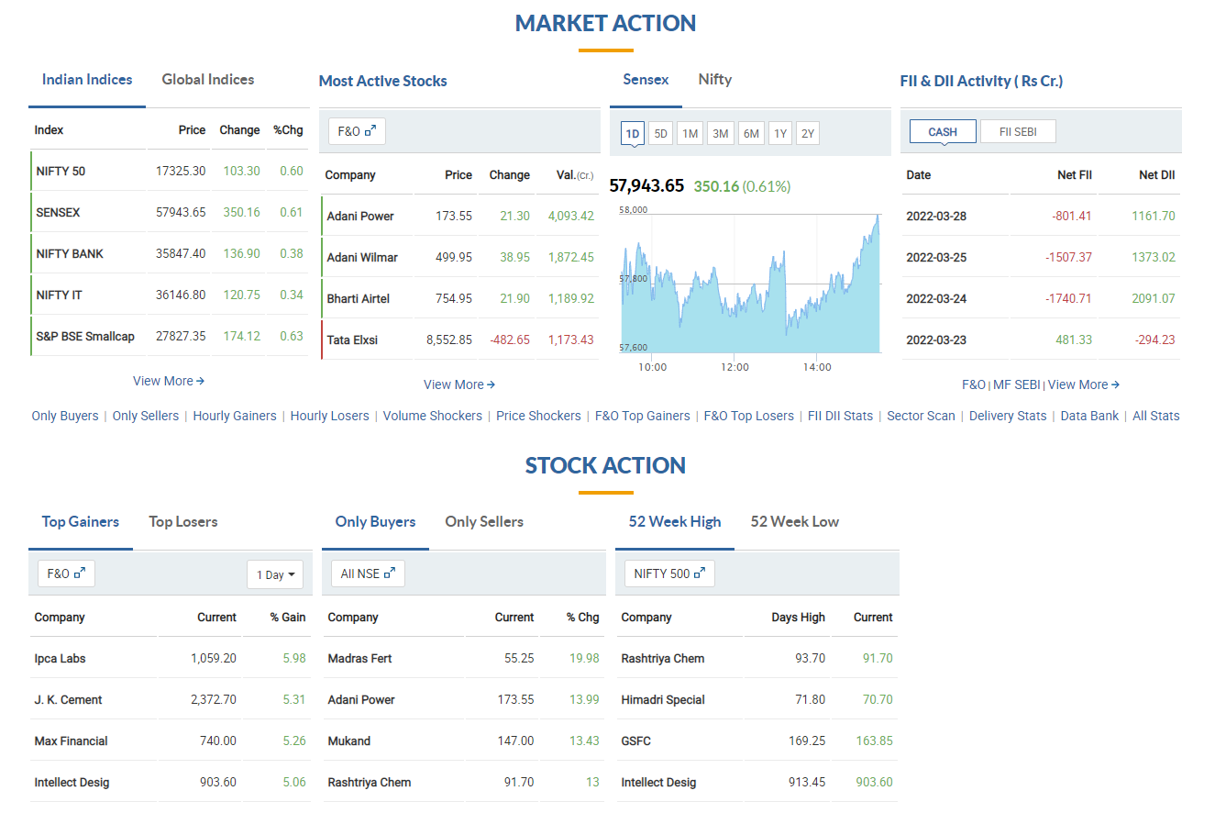

Indian Market rose by 0.60%
In spite of net selling combined of FII and DII. Mostly led by smaller institutions and retailers

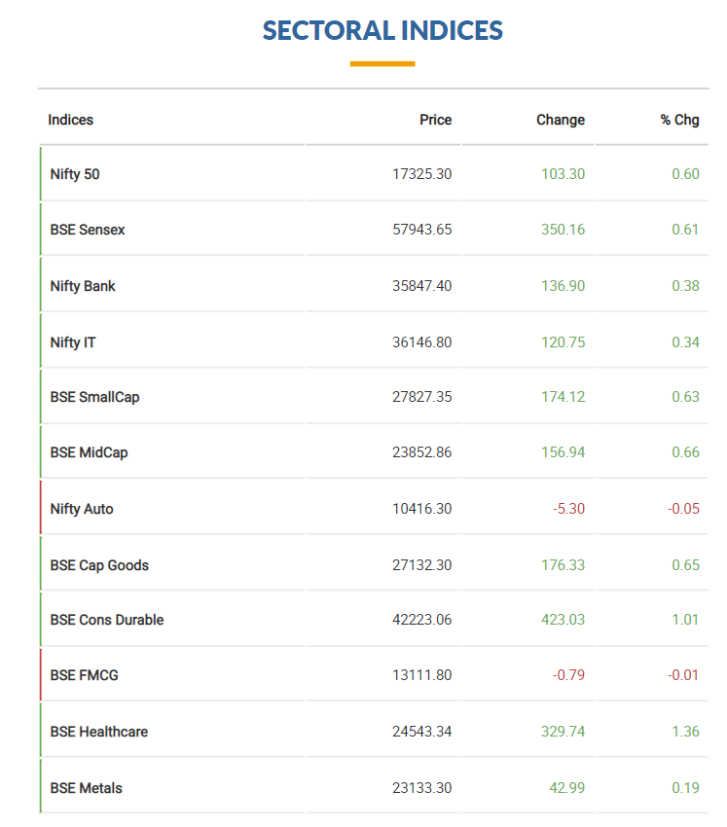
In rally
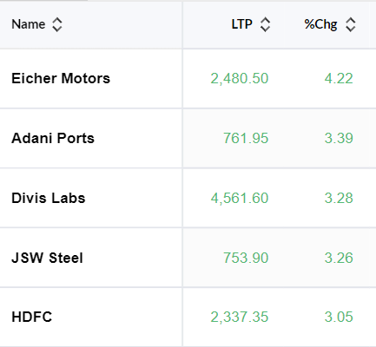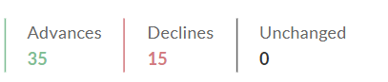
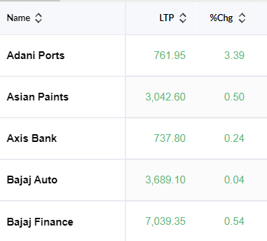
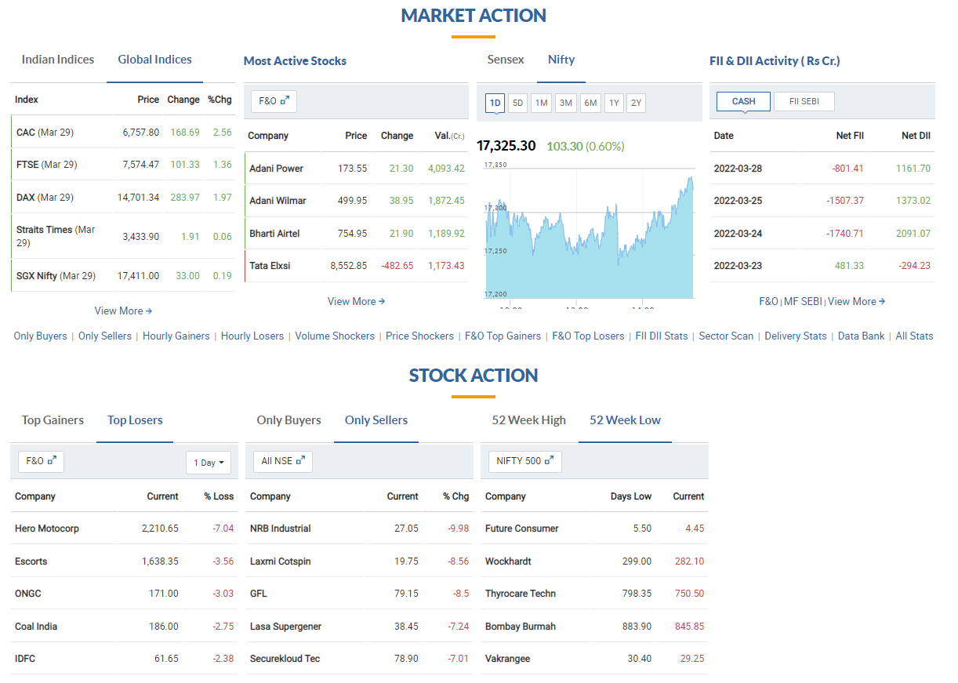

DOW THEORY for BATA

High candle date | Buy Price | Sell Price | Low Candle Date | PNL Point
04-01-99 | 90 | 69.30 | 18-10-99 | (20.7)
08-05-06 | 164.25 | 452.45 | 08-02-16 | 288.2
18-02-19 | 1320.00 |  | Trade open

