BEM Assignment

- C
- B
- C
- D
- D
- C
- C
- B
- C
- B
- D
- A
- B
- C
- C
- B
- A
- B
- B
- C
- D
- A
- C
- C
- C
- B
- D
- C
- A

- Use of Plastic
- The major impact of plastic bags on the environment is that it takes many years to for them to decompose. In addition, toxic substances are released into the soil when plastic bags perish under sunlight and, if plastic bags are burned, they release a toxic substance into the air causing ambient air pollution.
- The major impact of plastic bags on the environment is that it takes many years to for them to decompose. In addition, toxic substances are released into the soil when plastic bags perish under sunlight and, if plastic bags are burned, they release a toxic substance into the air causing ambient air pollution.
- Plastics contain and leach hazardous chemicals, including endocrine-disrupting chemicals (EDCs) that threaten human health. The report describes a wealth of evidence supporting direct cause-and-effect links between the toxic chemical additives in plastics and specific health impacts to the endocrine system
- Hence, Plastic will result in dead weight welfare loss to society.

- the short-run aggregate supply curve
- In economics, aggregate supply is the total supply of goods and services that firms in a national economy plan to sell during a specific time period. It is the total amount of goods and services that the firms are willing to sell at a given price level in the economy. Aggregate supply is the relationship between the price level and the production of the economy.
- In the short-run, the aggregate supply is graphed as an upward sloping curve. The equation used to determine the short-run aggregate supply is: Y = Y* + α(P-P_{e}). In the equation, Y is the production of the economy, Y* is the natural level of production of the economy, the coefficient α is always greater than 0, P is the price level, and P_{e} is the expected price level from consumers.
- The short-run aggregate supply curve is upward sloping because the quantity supplied increases when the price rises. In the short-run, firms have one fixed factor of production (usually capital ). When the curve shifts outward the output and real GDP increase at a given price. As a result, there is a positive correlation between the price level and output, which is shown on the short-run aggregate supply curve.

- Negative Externality
- Negative externalities exist when individuals bear a portion of the cost associated with a good’s production without having any influence over the related production decisions. For example, parents may have to pay higher health-care costs related to pollution-induced asthma among their children because of increased.

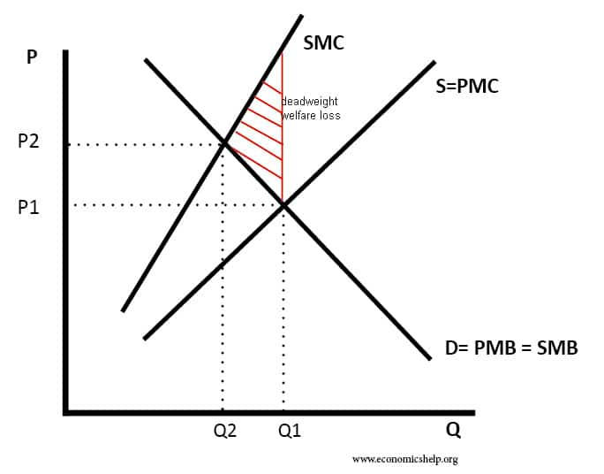

- Actual Vs Potential growth
- Actual economic growth is measured by the annual percentage change in a country's real national output (GDP).
- Potential economic growth is also known as trend growth and is measured by the estimated annual change in a country's potential level of national output.
- Potential growth is driven by improvements in long run aggregate supply (LRAS).
- Potential GDP is an estimate that is often reset each quarter by real GDP, while real GDP describes the actual financial status of a country or region.
- It is based on a constant inflation rate, so potential GDP cannot rise any higher, but real GDP can go up.

- Three methods of measuring national income are:
The three different ways to measure GDP are - Product Method, Income Method, and Expenditure Method.
i) Product Method
In this method, all goods and services produced during the year in various industries are added up. This is also known as value-added to GDP or GDP at the sector of origin's cost factor. India includes the following items: agriculture and allied services; mining; development, construction, the supply of electricity, gas, and water, transport, communication, and trade; banking and insurance; real estate and property ownership of residential and commercial services and public administration and defence and other services (or government services). It is, in other words, the amount of the added gross value.
ii) The Income Method:
In a nation that produces GDP during a year, people earn income from their jobs. Thus the sum of all factor incomes is GDP by revenue method: wages and salaries (employee compensation) + rent + interest + benefit.
iii) Expenditure Method:
This approach focuses on products and services generated during one year within the region.
GDP is subtracted from the portion of consumption, investment, and government spending expended on imports. Likewise, all manufactured components, such as raw materials used in the manufacture of products for sale, are also exempt.
Thus GDP by expenditure method at market prices is net export, which can be positive or negative.

