Project Report on Cigarettes
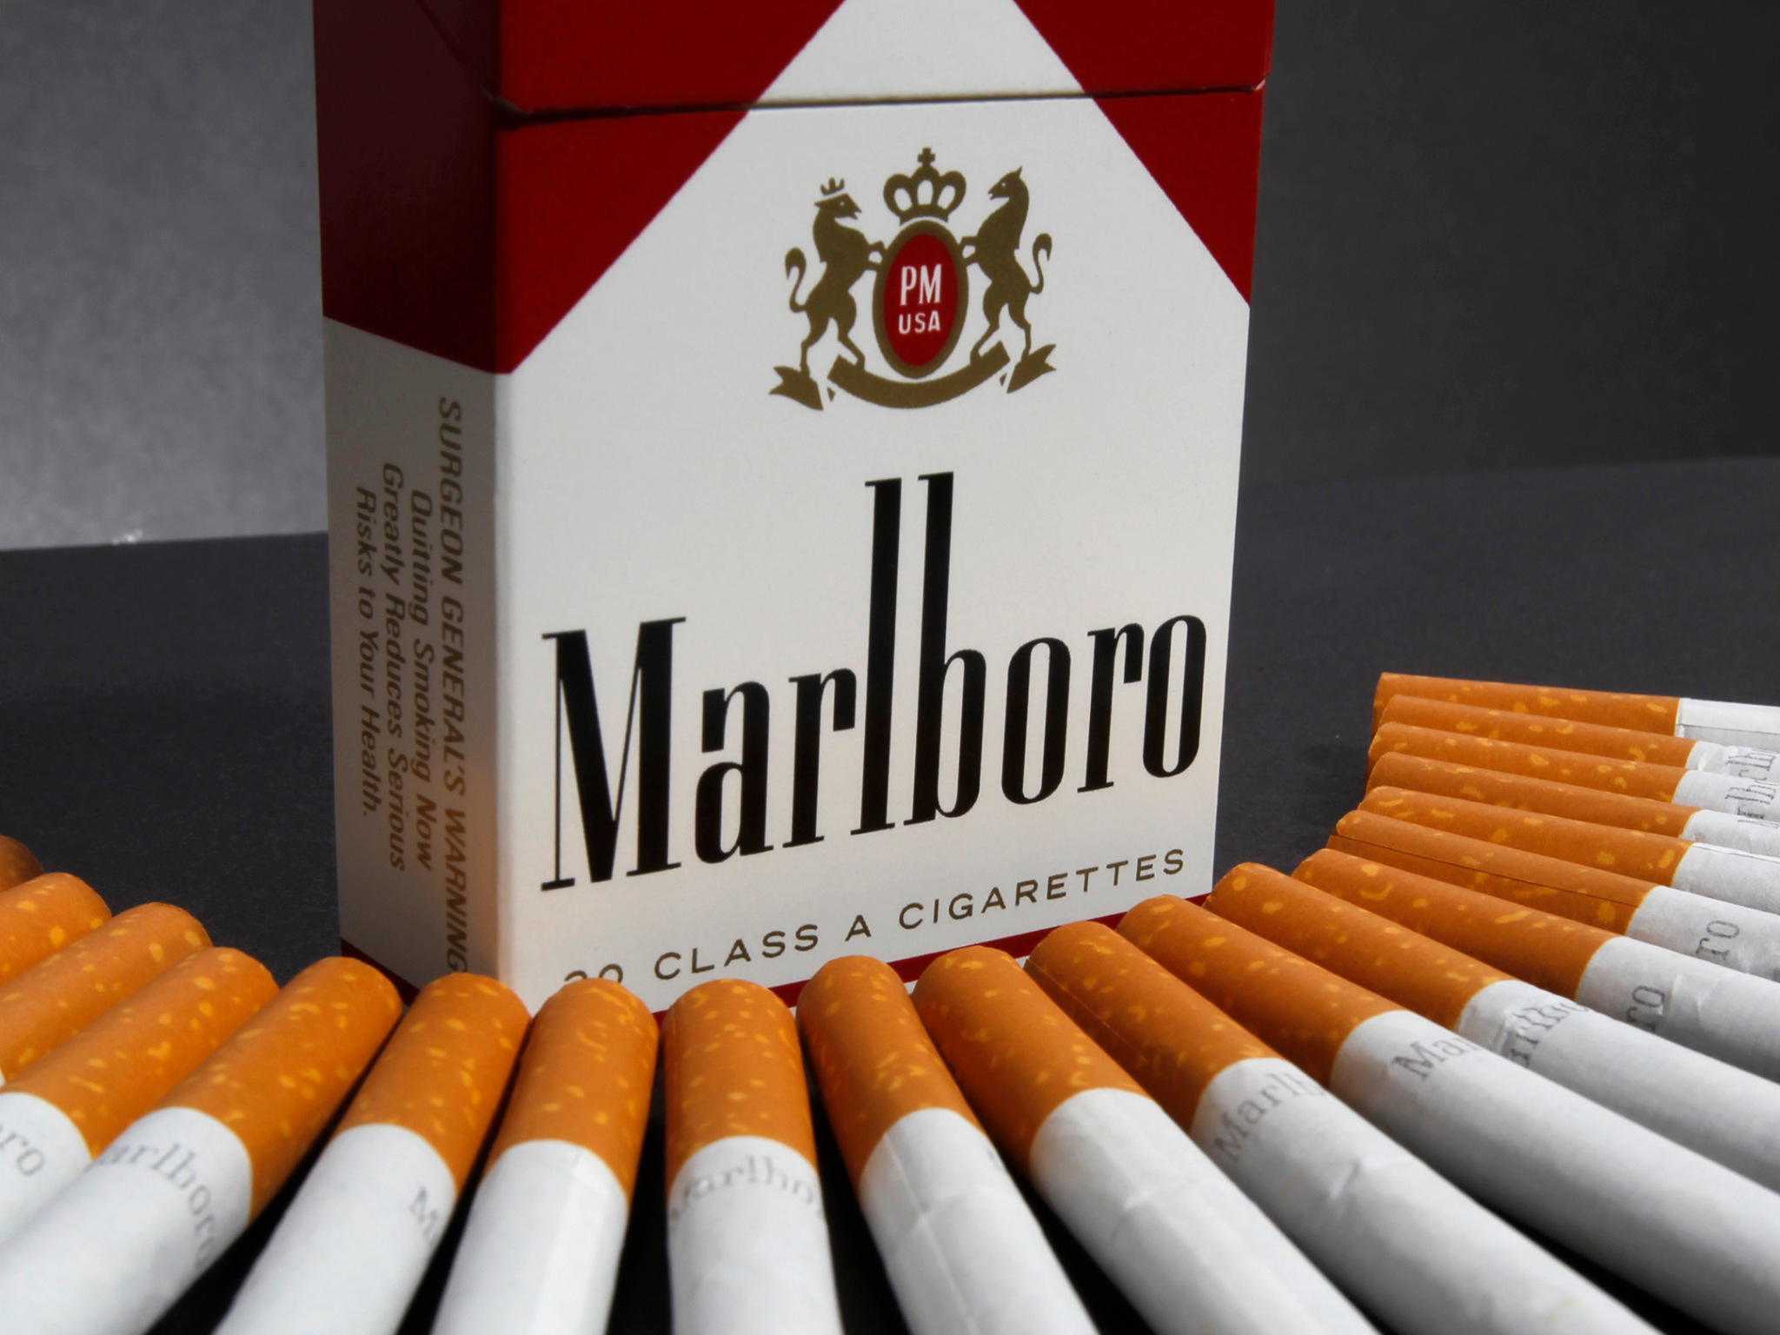
- PRESENTED BY AJAY DHANDHA
- ROLL NUMBER iD- 309

Introduction
Smoking, the act of inhaling and exhaling the fumes of burning plant material. A variety of plant materials are smoked, including marijuana and hashish, but the act is most commonly associated with tobacco as smoked in a cigarette, cigar, or pipe. Tobacco contains nicotine, an alkaloid that is addictive and can have both stimulating and tranquilizing psychoactive effects. Smoking soon spread to other areas and today is widely practiced around the world despite medical, social, and religious arguments against it. The most common tobacco products were cigars, pipe tobacco, and chewing tobacco. The mass production of cigarettes was in its infancy, although cigarette smoking was beginning to increase dramatically.Tobacco had become recognized as being highly addictive and one of the world’s most-devastating causes of death and disease.
Tobacco products are manufactured with various additives to preserve the tobacco’s shelf life, alter its burning characteristics, control its moisture content, inhibit the hatching of insect eggs that may be present in the plant material, mask the irritative effects of nicotine, and provide any of a wide array of flavours and aromas. The smoke produced when tobacco and these additives are burned consists of more than 4,000 chemical compounds. Many of these compounds are highly toxic, and they have diverse effects on health.

Body
PRODUCT ANALYSIS
Cigarettes are inferior goods. Typical cigarette design components and parameters are tobacco filler-related (eg, tobacco blend, type and amounts of additives used, tobacco weight) and non-tobacco cigarette features (eg, cigarette paper, filter type, filter ventilation, and cigarette rod dimensions (circumference, length). Novel design features include innovative filter elements such as flavor-delivering capsules and selective filtration.
Minimum price laws contain formulas that specify wholesale and retail markups in calculation of the minimum price of cigarettes. Typically, the wholesaler’s price is calculated as the manufacturer’s list price plus the state excise tax plus the wholesaler’s cost of doing business (usually between 2–6%.) Then, the retailer’s price is calculated as the wholesaler’s price minus trade discounts plus the retailer’s cost of doing business (usually between 5–10%, except for Massachusetts where it is 25%).
A success rate of 53% over the counter and 79% from vending machines are achieved. The results show that minors can purchase cigarettes in all types of businesses, even those characterized as “adult” locations. Boys in this study had more difficulty than girls in purchasing cigarettes over the counter, and younger individuals had more difficulty than 15-year-olds. However, these differences were not found in vending machine sales.

SWOT ANALYSIS :

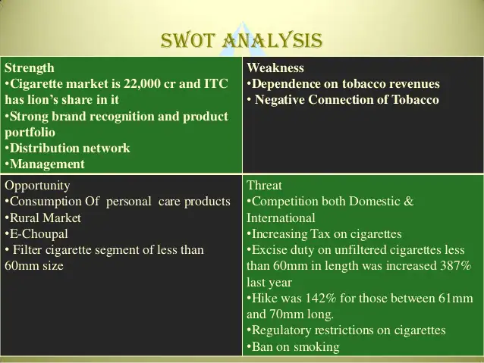

DEMAND OF CIGARETTES
It was observed that out of 12 people from the survey, 4 people smoke cigarettes and demand one cigarette per day.
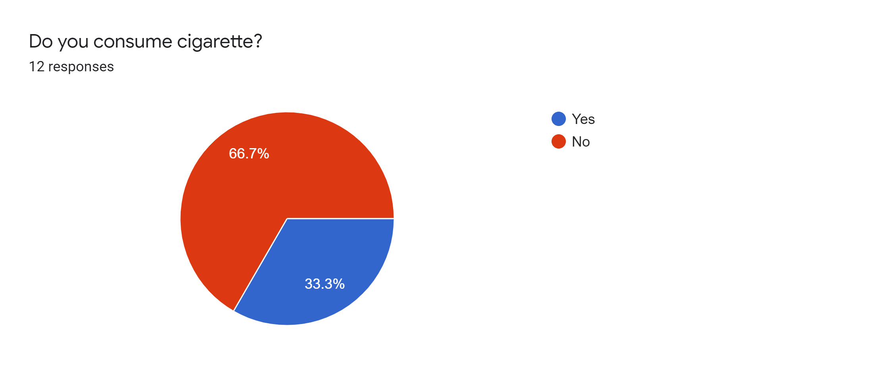
- Cigarette advertising and promotional expenses totaled about $7.62 billion in 2019—a decrease from 2018. However, even though cigarette companies spent less overall on advertising and promotion in 2019 than in 2018, they spent a larger percentage (74.7%, or about $5.7 billion) of their 2019 advertising and promotion dollars on price discounts paid to cigarette retailers than they did the year before.
- Manufacturers spent a total of $576.1 million on smokeless tobacco advertising and promotion during 2019—a decrease from 2018.2 Smokeless tobacco products include dry snuff, moist snuff, plug/twist, loose-leaf chewing tobacco, snus, and dissolvable products.
- A number of electronic products, such as electronic cigarettes (e-cigarettes), electronic cigars (e-cigars), and electronic pipes (e-pipes), are on the market. However, current information on spending for marketing and promotion of these products is currently not available.
- From 2014 through 2020, e-cigarette sales generally increased as product prices decreased. Total e-cigarette sales increased by 122.2% during this timeframe (i.e., from 7.7 million to 17.1 million units per 4-week interval).
- Despite overall sales growth, e-cigarettes sales fluctuated across time by product type. Specifically, during 2014-2019, sales of rechargeables, prefilled cartridges, and e-liquids grew relatively steadily over time. However, sales for disposables increased sharply from 10.3% of total sales in August 2019 to 19.8% in May 2020.

GOVERNMENT POLICIES :
The Government enacted the Cigarettes and Other Tobacco Products (Prohibition of Advertisement and Regulation of Trade and Commerce, Production, Supply and Distribution) Act (COTPA), in 2003. The provisions under the act included prohibition of smoking in public places, prohibition of advertisements of tobacco products, prohibition on sale of tobacco products to and by minors (persons below 18 years), ban on sale of tobacco products within 100 yards of all educational institutions and mandatory display of pictorial health warnings on tobacco products packages. The law also mandates testing all tobacco products for their tar and nicotine content.

TAX AND SUBSIDIES ON CIGARETTES :
The Indian Government is clamping down on tobacco consumption by imposing higher taxes on cigarettes, chewing tobacco products, and unmanufactured tobacco. The increase in excise duty in the range of 11–72% for different types of cigarettes is the steepest in a decade. With this move, government taxes are projected to account for around 70% of the retail price of some cigarette types.
Nearly 1 million deaths in India each year are attributable to tobacco-related diseases. The death toll is set to rise as the absolute number of male smokers is rising—from 83 million in 1998 to 105 million in 2010, according to data published by the Centre for Global Health Research in 2013. Young men aged between 15–24 years accounted for the largest proportion of the increase in male smokers during this period.

As per the survey report, it was observed that 33.33% of people would start consuming cigarettes if the government reduces tax on it.
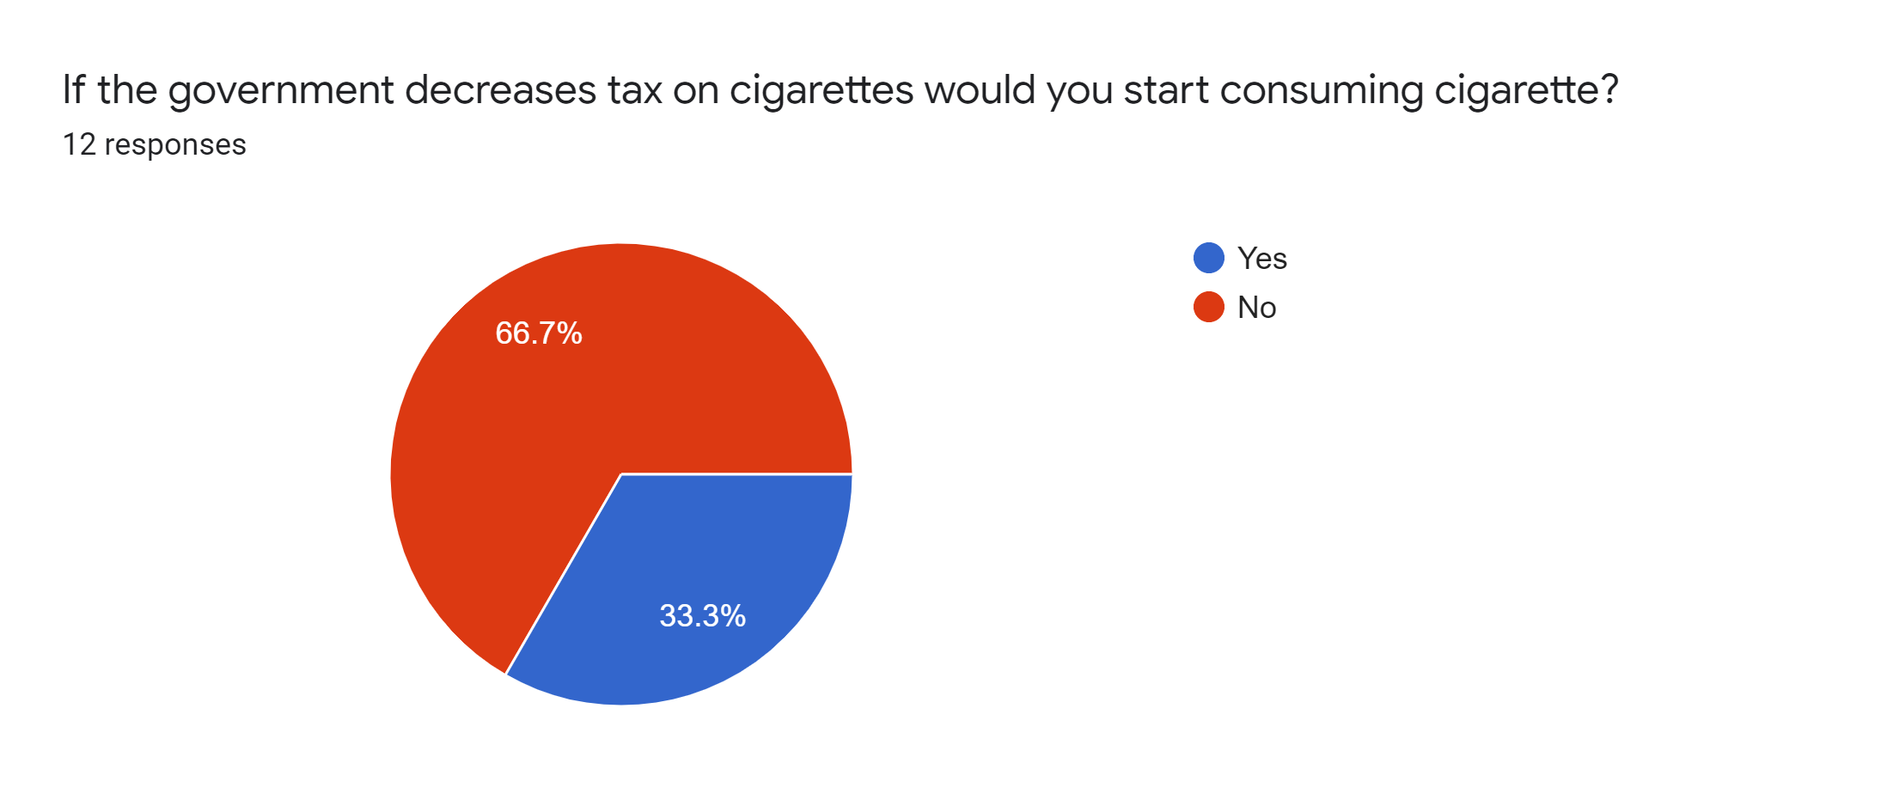

SUPPLY OF CIGARETTES :
Around 6.5 trillion cigarettes are sold around the world each year, which translates to roughly 18 billion cigarettes per day.

AVAILABLE SUBSTITUTE OF CIGARETTES :

1. Nicotine Patches
One can find nicotine patches at local drugstores. These products, like Nicoderm CQ, work by delivering small doses of nicotine through your skin, so as to reduce your cravings. You progress through a series of increasingly lower dose patches, until you’re essentially weaned off of nicotine. The Mayo Clinic says the process usually takes between eight and 12 weeks.

2. Nicotine Gum
The oral habit of smoking can sometimes be as difficult to break as the nicotine addiction itself. Over-the-counter nicotine gums deliver nicotine to help reduce your cravings. Like the patch, smokers begin with a higher dose or frequency, reducing it over time to wean themselves off of nicotine. Unlike the patch, gums like Nicorette also give quitting smokers something to do with their mouth.

3. Lozenges
Nicotine lozenges, like those made by GoodSense, are another nicotine replacement product sold without a prescription. They are short-acting, according to the Mayo Clinic, and you can take around 20 lozenges each day to control cravings.
PRICE ELASTICITY :
The effectiveness of tax increases on cigarette consumption is mainly determined by cigarette price elasticity. Although numerous studies have demonstrated that cigarette price elasticities of low- and middle-income countries are higher than in high-income countries, price elasticity in several developing countries were similar to those of developed countries. Differences in cigarette price elasticities may have been caused by applying different demand functions, information patterns, and estimation methods. Therefore, employing the same demand function, information pattern, and estimation method can facilitate a standardized comparison of the price elasticity of demand for cigarettes among different countries.

Price elasticity of demand refers to the extent to which use of a product falls or rises after increases or decreases in its price. If price elasticity of demand for a product were very low–that is, if it were inelastic–then demand would fall or rise only slightly in response to price changes. For instance, if price elasticity for a particular good were about –0.1, then demand for that good would fall by only 0.1% for every 1% increase in price. Demand would fall by 1% for a 10% increase in price, by 2% for a 20% price increase and so on. Demand for a good with high price elasticity would fall much more sharply in response to price increases. If price elasticity of demand for a good were about –1.0, then demand for that good would fall by 1% for every 1% increase in price. Demand would fall by 10% for a 10% price increase, 20% for a 20% price increase, 100% for a 100% price increase, and so on.

The demand for tobacco products is not as elastic as demand for many other consumer products. Research has consistently demonstrated that increases in the price of tobacco products are followed by moderate falls in both the percentage of people smoking and the amount or number of tobacco products that remaining smokers consume.
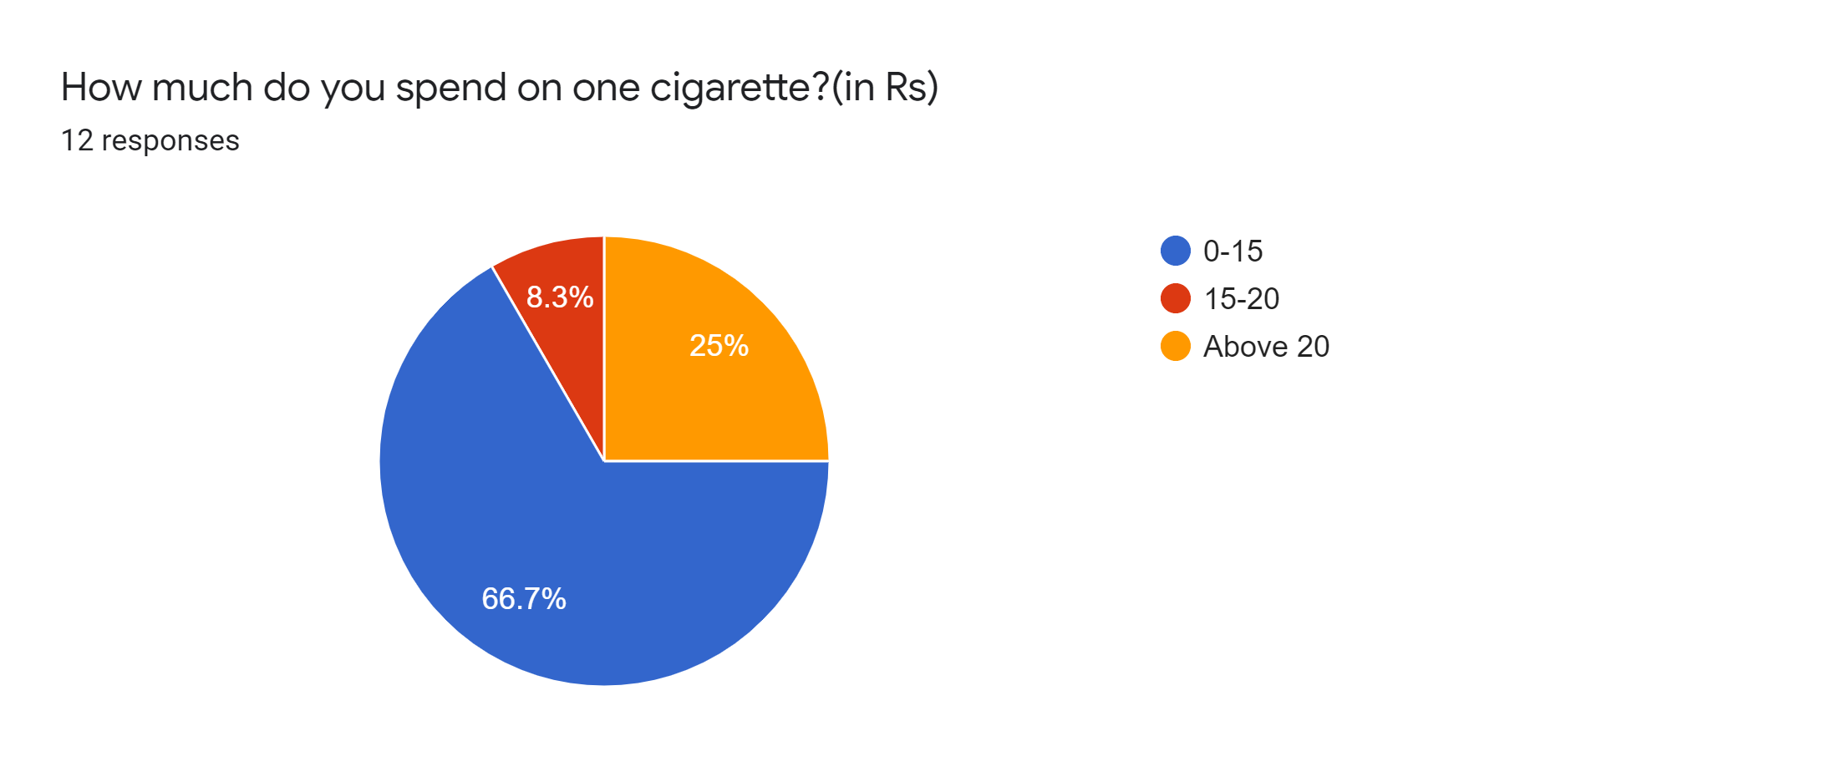

Conclusion
The study says that the number of smokers is less than the number of non-smokers. People are well aware about the disadvantages of cigarettes. And also are health conscious. But also there are some people who smoke cigarettes as there are outliers in every study. Smokers are ready to buy cigarettes at any price, at any government tax. Government has raised taxes on cigarettes.

LIMITATIONS OF CIGARETTES
Smoking causes around 7 out of every 10 cases of lung cancer.
It also causes cancer in many other parts of body, including the:
- Mouth
- Throat
- Voice box (larynx)
- Oesophagus ( the tube between mouth and stomach)
- Bladder
- Bowel
- Cervix
- Kidney
- Liver
- Stomach
- Pancreas
Smoking damages heart and blood circulation, increasing risk of developing conditions such as:
- Coronary heart diseases
- Heart attack
- Stroke
- Peripheral vascular diseases (damaged blood vessels)
- Cerebrovascular disease (damaged arteries that supply blood to brain)

Smoking also damages lungs, leading to conditions such as:
- Chronic obstructive pulmonary disease (COPD) which incorporates bronchitis and emphysema
- Pneumonia
Smoking can also worsen or prolong the symptoms of respiratory conditions such as asthma or respiratory tract infections such as the common cold.

In men, smoking causes impotence because it limits blood supply to penis. It can also reduce fertility of both men and women.

SCOPE :
Approximately one fourth of the population uses tobacco products, and 19.4 percent smoke cigarettes. According to the 2016 National Survey on Drug Use and Health (NSDUH), an estimated 63.4 million people aged 12 or older used a tobacco product, including 51.3 million cigarette smokers. Smoking rates continue to go down year to year; the percentage of people over age 18 who smoke cigarettes declined from 20.9 percent in 2005 to 15.8 percent in 2016, according to the 2017 National Health Interview Survey.
Smoking rates are substantially higher among some of the most vulnerable people in our society. The 25 percent with mental disorders, including addiction, account for 40 percent of the cigarettes smoked. More than 40 percent of people with a General Education Development certificate (GED) smoke—which is the highest prevalence of any socioeconomic group. Also, people who live in rural areas, use all forms of tobacco at higher rates than people who live in urban areas. These differences cannot be fully explained by different levels of poverty or affluence.

References

- https://bmcpublichealth.biomedcentral.com/articles/10.1186/s12889-017-4685-x

- https://www.tobaccoinaustralia.org.au/chapter-13-taxation/13-1-price-elasticity-of-demand-for-tobacco-produc
- https://www.drugabuse.gov/publications/research-reports/tobacco-nicotine-e-cigarettes/what-scope-tobacco-use-its-cost-to-society
- www.wikipidea.com

