LIFE INSURANCE PROJECT

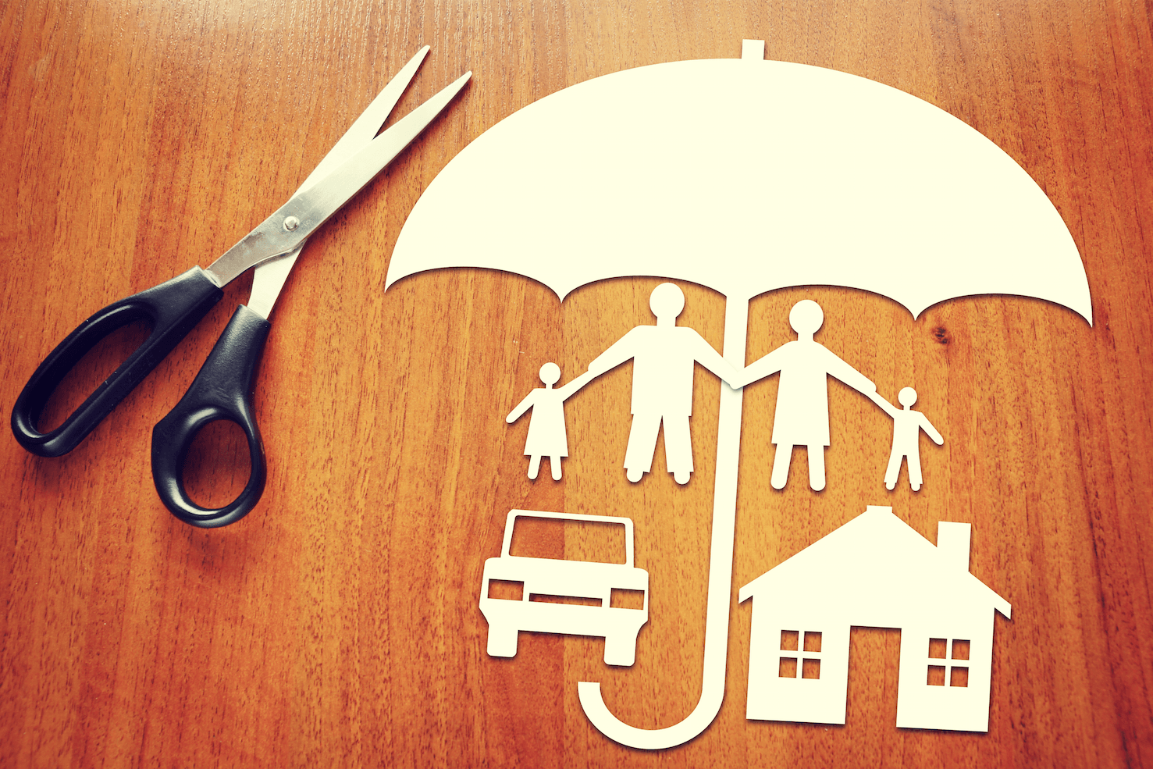

TASK 1 - PRODUCT DESIGN- EXPENSIVE BOOK INSURANCE

TASK 2 - A CASE STUDY ABOUT JAMIE

BY- SAKSHI TRIPATHI

TASK 1

PRODUCT DESIGN
- BOOK INSURANCE-
Book Insurance is the insurance coverage of particularly ‘Costly Books' that covers a Book up to an amount of 500000 and a minimum amount of a book ranging from 15000-20000. It can be claimed against any damages or loss resulting from termites, theft, Poor quality pages, Printing errors etc.

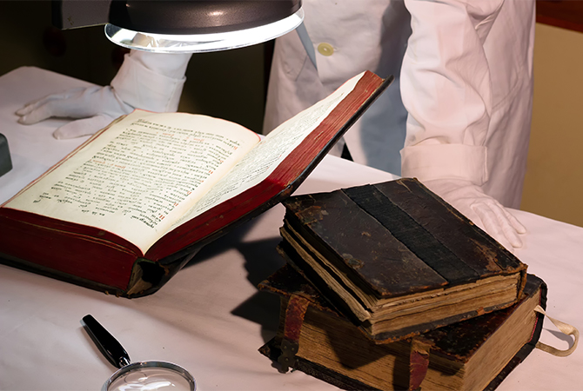

- KEY FEATURES-
- Cashless repairs like fixing the pages it getting the pages replaced.
- Book Insurance Premium- Starting @ 2050/- year
- Pay as you use Insurance – Pay as you use Book Insurance can be considered as book-based insurance usage. It allows a policyholder to pay the premium if the Insurance is according to the number of years the person has used the book from the day of purchase.

- HOW TO CALCULATE INSURANCE PREMIUM?

Book Insurance price can be decided on several factors: -
- It is also easy to find out the premium from the cost of the book, the costlier book insurance will be fixed based on the market price and the rate at which the buyer purchased the product.

- However, the insurance provider takes into consideration the following parameters before fixing the Book Insurance Price-
- Period and the frequency of usage of the product by the customer
- Market Price of the product when purchased – Discount received (if any) – Depreciation Value in the current period
- The area and the store from where the customer purchased the product.

- Here are some of the Reasons to buy a new book insurance policy in India:-
- It pays for the book damage as a result of termites, Loss by fire at home having a bookshelf
- Students pursuing Medicine, Lawyers, Engineers, and other higher studies have to spend an expensive amount for the study material and especially for the lower-middle-class family, it’s like an investment to them. The books they once purchased is most likely to be used in the future as well and for the maintenance of all the costly textbooks, it’s difficult to maintain them for the long term and that’s the reason book insurance can be a great option f, for them. After a point of time, it'll become important to have insurance of the book of a minimum amount of 15,000-20,000.
- It reduces the parents' financial stress that apart from their children health, their education books are also under coverage.

- What’s COVERED in the BOOK INSURANCE?

- Loss or damage to the Insured book
- Loss or damage to your book caused by theft, fire explosion, termites, poor quality of cover page/poor binding of the book/ missing of a lot of pages caused by the store or the manufacturer for a repetitive time.
- Damage caused due to water or rains if the student is travelling although all the measures should be taken to protect the books from getting damaged and this is a responsibility of the insurer.

- What’s NOT covered in the Book Policy?

- The insurance of the book will be valid if the bill of the purchased book is available and within one month the insurer gets the book insured with all the required documents related to the book. If the insurer gets the book post one month of purchase, it will not be considered and they won’t be eligible for the insurance.
- Loss or damage if a policy is not in force
- Gradual wear and tear of the book do not come under the insurance company's responsibility, not the store, which means any forceful activity performed by the insurer is nullified.
- Loss or damage to the book used by a person without a shopkeeper bill with a GST no. And a reason for the purchase and the reason for getting it insured of the same will be considered. Eg- Costly book, educational purpose, habituated reader.
- Any activity deliberately performed by the Insurer to damage the product cannot be claimed, they should be aware that if they get it insured it’s their moral responsibility to take all the actions to protect their books and not just think that they have insurance so they will be claimed. This attitude shouldn’t be entertained.

CONCLUSION
These books are scarce, desirable and hold a lot of value, thus they are expensive and not very easy to preserve and maintain, according to my perspective this would save the insured from a lot of damage and also serve his emotional attachment with the books and help them exercise this hobby with a backup, maintaining a collection of such books also would help us preserve historical data and such interest should be supported due to its educative and informative nature.

TASK 2

month | Which insurance would cover this | Did Jamie have coverage | How much will Jamie have to pay? (If she has insurance, what is her copay or deductible?)
January | Medical | Yes | Rs. 30 copay for doctor visit; Rs. 10 copay for prescription
March | Medical | Yes | Rs. 50 copay for emergency room visit
July | Renter’s | No | Rs. 2,500 (She replaced the damaged items.)
September | Auto | Yes | Rs. 300 deductible
October | Vision | Yes | Rs. 30 co-pay for doctor visit; Rs. 10 co-pay for prescription

1. SUMMARISING THE COST (Including deductibles, co-pays, and premiums) :

Jamie has paid a total of Rs. 2,930 for the incidents that year. Without any insurance, she would have paid $6,620. After subtracting Jamie’s total premiums of Rs. 2,149 for the year, her insurance choices saved her Rs. 1,541 (that is, Rs. 6,620 [costs without insurance] – Rs. 2,930 [costs paid that year] – Rs. 2,149 [total premiums for the year] = Rs. 1,541).

2. CONSIDER INSURANCE IN YOUR LIFE:

Buying insurance is important as it ensures that you are financially secure to face any type of problem in life, and this is why insurance is a very important part of financial planning.
The world we live in is full of uncertainties and risks. Individuals, families, businesses, properties and assets are exposed to different types and levels of risks. These include the risk of losses of life, health, assets, property, etc. While it is not always possible to prevent unwanted events from occurring, the financial world has developed products that protect individuals and businesses against such losses by compensating them with financial resources. Insurance is a financial product that reduces or eliminates the cost of loss or effect of loss caused by different types of risks.

According to my personal experience over the last year,
I believe, health insurance, automobile insurance, property insurance and life insurance are some of the most important and reliable insurance products in today’s uncertain world.
As covid 19 has reshaped our economy and increased our day to day exposure to risks
We all have understood the value of Life and how uncertain and surprising it is,
Life insurance can be an important part of your financial strategy. That's because a life insurance policy can help you ensure that your loved ones have a secure financial future after you pass away.
Not only can life insurance help cover your final expenses — it can also provide your family with a financial safety net by helping to replace your income or serving as an inheritance for a loved one.

3. Jamie’s advice

Insurance is a way to manage and share the risk of unexpected events. I’d say insurance is definitely worth the cost. It is a way to get secured and have some extent of financial protection. When I got sick and had to visit a doctor, luckily my health insurance covered some expenses and it was not a dent in my pocket.

Same way when a deer accidentally hit my car and it got damaged, my auto insurance helped me cover those damage expenses too. I was at least at peace that I wouldn’t have to pay full expenses. If I had no insurance, all costs would be my responsibility. It definitely helps to reduce the financial burden. Just think about which insurance suits you the most like health insurance, auto insurance, life insurance etc. and do proper research and homework about the services provided and if it suits your pocket. Adhering to your day-to-day life, decide upon what risks u come across most often it is a smart financial strategy to be prepared for your future mishaps, as we say precautions is better than cure, it would be a great way to support your family and take care of your loved ones by understanding the importance of insurance and implementing it in your life.
I hope this has helped you get a clearer vision of what insurance is and how it could help you.

