Business Finance
Project
By Priyansh Gupta
Section: A
Roll No. 23

NCC Limited
NCC Ltd was founded in 1978 as a partnership firm by Padma Sri Awardee Dr. AVS Raju (Founder and Chairman Emeritus). NCC became a limited company in 1990, and was listed on National Stock Exchange in 1992. NCC has progressed consistently over past three decades. It is among the top three construction companies in India in terms of revenue.
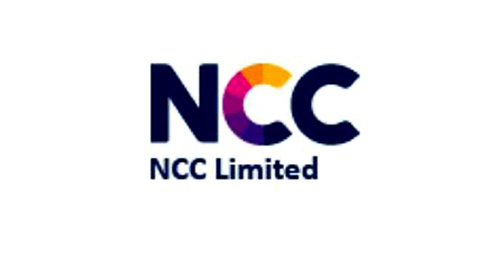
NCC undertakes civil construction in segments such as buildings, water, roads, irrigation, power, electrical, railways, metals, mining and has also a presence in the Middle East where it currently undertakes works in roads, buildings, and water segments.
NCC was born from a vision to provide world class construction solutions with focus on quality, timely completion, customer satisfaction, continuous learning and enhancement of stakeholder’s value.
- Dividend Yield
The dividend yield, expressed as a percentage, is a financial ratio (dividend/price) that shows how much a company pays out in dividends each year relative to its stock price. It's important for investors to keep in mind that higher dividend yields do not always indicate attractive investment opportunities because the dividend yield of a stock may be elevated as the result of a declining stock price.
Ex-Dividend  Date | Dividend Per Share  (DPS) | Share Price | Dividend Yield  = (DPS/Share Price)*100
13th September, 2012 | Rs. 0.30 | Rs. 19.98 | 1.50%
12th September, 2013 | Rs. 0.30 | Rs. 12.46 | 2.40%
8th July, 2014 | Rs. 0.20 | Rs. 46.85 | 0.43%
10th August, 2015 | Rs. 0.40 | Rs. 81.05 | 0.49%
8th August, 2016 | Rs. 0.60 | Rs. 78.80 | 0.76%
7th August, 2017 | Rs. 0.40 | Rs. 87.40 | 0.46%
30th July, 2018 | Rs. 0.40 | Rs. 93.50 | 0.43%
8th August, 2019 | Rs. 1.50 | Rs. 72.80 | 2.06%
7th September, 2020 | Rs. 0.20 | Rs. 34.20 | 0.59%
5th August, 2021 | Rs. 0.80 | Rs. 86.90 | 0.92%

- Dividend Pay-out
The dividend pay-out ratio is the ratio of the total amount of dividends paid out to shareholders relative to the net income of the company. It is the percentage of earnings paid to shareholders via dividends.

Financial Year | Dividend per share  (DPS) | Earnings per share  (EPS) | Dividend pay-out  =(DPS/EPS)*100
2011-12 | Rs.0.30 | Rs. 1.40 | 21.43%
2012-13 | Rs. 0.30 | Rs. 2.44 | 12.30%
2013-14 | Rs. 0.20 | Rs. 1.58 | 12.66%
2014-15 | Rs. 0.40 | Rs. 2.56 | 15.63%
2015-16 | Rs. 0.60 | Rs. 4.32 | 13.89%
2016-17 | Rs. 0.40 | Rs. 4.06 | 9.85%
2017-18 | Rs. 0.40 | Rs. 5.09 | 7.86%
2018-19 | Rs. 1.50 | Rs. 9.39 | 15.97%
2019-20 | Rs. 0.20 | Rs. 6.34 | 3.15%
2020-21 | Rs. 0.80 | Rs. 4.28 | 18.69%

- Sales Growth Rate
The Sales Growth Rate of a business is the rate at which it is growing its sales year over year. Sales growth shows the increase in sales over a specific period of time. This is important because, as an investor, you want to know whether the demand for a company's products or services will be increasing in the future.
Financial Year | Current Sales  (In Rs. Crores) | Initial Sales  (In Cr.) | Sales Growth Rate  = (Current-initial/Current)*100
2011-12 | 6,518 | 6,105 | 6.76%
2012-13 | 6,968 | 6,518 | 6.90%
2013-14 | 7,272 | 6,968 | 4.36%
2014-15 | 9,513 | 7,272 | 30.82%
2015-16 | 9,527 | 9,513 | 0.15%
2016-17 | 9,001 | 9,527 | -5.53%
2017-18 | 8,931 | 9,001 | -6.78%
2018-19 | 12,896 | 8,931 | 53.69%
2019-20 | 8,901 | 12,896 | -30.98%
2020-21 | 7,949 | 8,901 | -10.69%

- Buyback Amount Spent
A share repurchase is a transaction whereby a company buys back its own shares from the marketplace. A company might buy back its shares because management considers them undervalued. It represents an alternate and more flexible way of returning money to shareholders. The share repurchase reduces the number of existing shares, making each worth a greater percentage of the corporation.
NCC Ltd. has not indulged in any share buyback in the last 10 years.

- Free Cash Flow to Equity
Free cash flow to equity is a measure of how much cash is available to the equity shareholders of a company after all expenses, reinvestment, and debt are paid. FCFE is a measure of equity capital usage. The FCFE metric is often used by analysts in an attempt to determine the value of a company. Free cash flow to equity is composed of net income, capital expenditures, working capital, and debt.

Financial Year | Cash from Operating Activities  (Rs. in crore) | Capital Expenditure  (Rs. in crore) | Net Debt Issued (Repaid)  (Rs. in crore) | FCFE  =  Cash from Operating Activities – Capital Expenditures + Net Debt Issued  (Rs. in crore)
2011-12 | 976.35 | 147.48 | -35.67 | 793.2
2012-13 | 372.23 | 127.03 | -55.27 | 190.05
2013-14 | 369.89 | 76.17 | -18.81 | 274.91
2014-15 | 513.93 | 70.24 | 230.55 | 674.24
2015-16 | 488.63 | 106.66 | -115.14 | 266.83
2016-17 | 396.78 | 134.96 | -118.49 | 144.33
2017-18 | 446.9 | 315.65 | 206.55 | 337.8
2018-19 | 345.33 | 527.37 | 322.02 | 139.98
2019-20 | 636.43 | 144.06 | -144.73 | 347.64
2020-21 | 689.34 | 191.53 | -71.23 | 426.58

Summary
- Dividend Yield

- Dividend Pay-out

- Sales Growth Rate

- Free Cash Flow to Equity

