Machine Learning Assignment
Name: Kareena Tated
Roll no.: 709
Topic: Machine Leaning

What is Machine Learning?
Machine learning is a method of data analysis that automates analytical model building. It is a branch of artificial intelligence based on the idea that systems can learn from data, identify patterns and make decisions with minimal human intervention.
In other words, Machine learning describes a set of methods by which computer algorithms are developed and applied to data to generate information. This information can consist simply of hidden patterns in the data, but often the information is applied to solve a specific problem. Machine learning methods have become popular in recent years with the advent of increasing quantities of data and the concomitant rapid increase in computing power

Where is it used?
There are limitless applications of machine learning and there are a lot of machine learning algorithms are available to learn. They are available in every form, from simple to highly complex.
In order for machine learning to be useful in tackling a problem we need the following to apply:
- A pattern should exist. If there is no pattern, there is no information to be had, and
- machine learning will not help (indeed, it might be counterproductive by ‘discovering’ patterns that do not exist).
- The pattern cannot be practically pinned down mathematically by classical methods.
- If it could be pinned down, we could proceed to describe it mathematically.
- We have data relevant to the pattern.
Examples of problems which are commonly solved in this way include:
- Targeting of advertising at consumers using web sites
- location of stock within supermarkets to maximise turnover
- forecasting of election results
- prediction of which borrowers are most likely to default on a loan.
In context of the Actuarial/ Finance domain, ML can be applied to solve the following problems:
- Classifying the risk for motor insurance policyholders using in-car monitoring devices
- Identifying marker genes that are associated with particular medical conditions
- Identifying insurance claims that might be fraudulent
- Identifying fraudulent benefit claims.
- Using health-monitoring devices such as wearables to track real team data of customers willing to purchase health insurance products.
- Identifying fraudulent tax declarations.

Advantages and disadvantages
The advantages of Machine Learning are vast. It helps us to create ways of modernizing technology. The disadvantages of Machine Learning tell us its limits and side effects. This would help us to find potential ways to reduce these problems.
Advantages:
- Automation of Everything
- Wide Range of Applications
- Scope of Improvement
- Efficient Handling of Data

Disadvantages:
- Possibility of High Error
- Algorithm Selection
- Data Acquisition
- Time consuming and Expensive

Supervised vs Unsupervised learning?
Machine learning techniques can be divided into several branches, which we can refer to as supervised learning, unsupervised learning, semi-supervised learning and reinforcement learning. The difference between these lies not (as one might think) in the level of involvement of the human researcher in the development of the algorithm, or in the supervision of the machine. Instead, it lies in the extent to which the machine is given an instruction as to the end-point (or target) of the analysis.
Here we are going to understand the difference between Supervised and Unsupervised Learning Algorithm.
Supervised Learning is the machine learning approach defined by its use of labelled datasets to train algorithms to classify data and predict outcomes. The labelled dataset has output tagged corresponding to input data for the machine to understand what to search for in the unseen data.
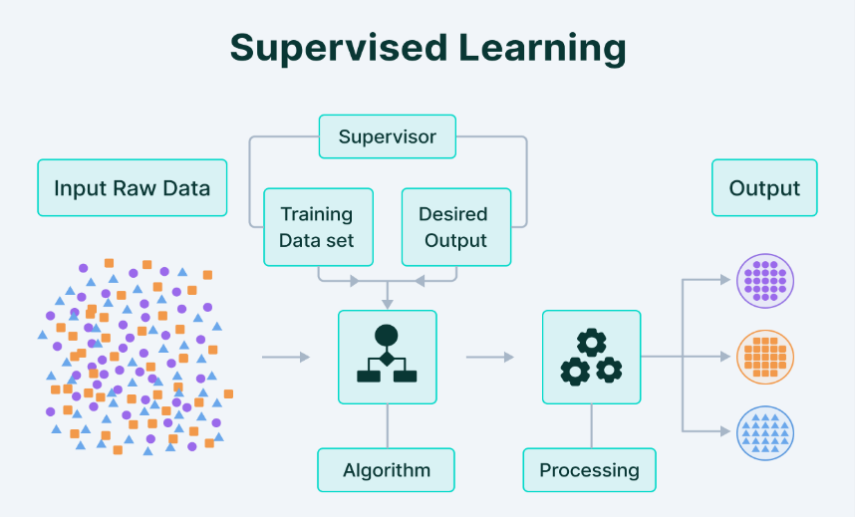

Figure 1. Supervised Learning
Unsupervised Learning is a type of machine learning in which the algorithms are provided with data that does not contain any labels or explicit instructions on what to do with it. The goal is for the learning algorithm to find structure in the input data on its own.
To put it simply—Unsupervised Learning is a kind of self-learning where the algorithm can find previously hidden patterns in the unlabelled datasets and give the required output without any interference.
Unsupervised Learning
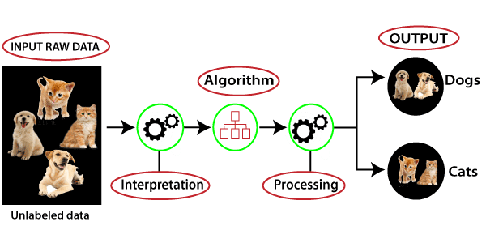

Figure 2. Unsupervised Learning

Deep diving into Supervised learning: Multiple Linear Regression
In order to gain a deeper insight into the working of a Supervised Learning Algorithm, let’s consider the example of Multiple Linear Regression
Multiple Linear Regression refers to a statistical technique that is used to predict the outcome of a variable based on the value of two or more variables. It is sometimes known simply as multiple regression, and it is an extension of linear regression. The variable that we want to predict is known as the dependent variable, while the variables we use to predict the value of the dependent variable are known as independent or explanatory variables. MLR is used extensively in econometrics and financial inference.
What Multiple Linear Regression can tell you?
Simple linear regression is a function that allows an analyst or statistician to make predictions about one variable based on the information that is known about another variable. Linear regression can only be used when one has two continuous variables—an independent variable and a dependent variable. The independent variable is the parameter that is used to calculate the dependent variable or outcome. A multiple regression model extends to several explanatory variables.
The multiple regression model is based on the following assumptions:
- There is a linear relationship between the dependent variables and the independent variables
- The independent variables are not too highly correlated with each other
- yi observations are selected independently and randomly from the population
- Residuals should be normally distributed with a mean of 0 and variance σ

Math Behind the Algorithm
The dependent variable is related to the k independent variables using the following formula:
$$Y = β0 + β1x1 + β2x2 + · · · + βkxk + e$$
Where,
- β0 is the intercept
- β1, β2,……, βk are the slope coefficients for each explanatory variables
- x1,x2,……,xk are are explanatory variables
- Y is the dependent variable
- e is the error term
Fitted Values from the model are given by:
$yˆi = βˆ0 + βˆ 1xi1 + βˆ 2xi2 + · · · + βˆ kxik$,
for i = 1, . . . , n that should be close to the actual values yi .
The differences are the residuals:
$$ei = yi - yˆi .$$
Multiple Linear Regression
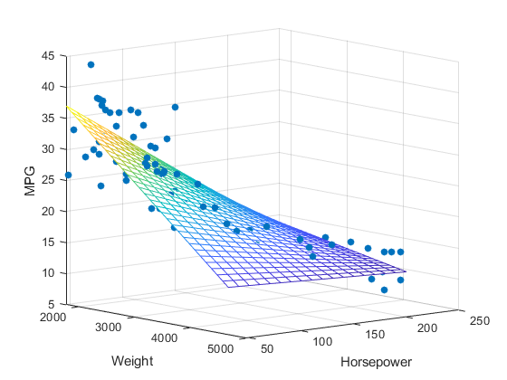

Model Performance
The coefficient of determination (R-squared) is a statistical metric that is used to measure how much of the variation in outcome can be explained by the variation in the independent variables. R2 always increases as more predictors are added to the MLR model, even though the predictors may not be related to the outcome variable.
R2 by itself can't thus be used to identify which predictors should be included in a model and which should be excluded.
R2 can only be between 0 and 1, where 0 indicates that the outcome cannot be predicted by any of the independent variables and 1 indicates that the outcome can be predicted without error from the independent variables.
When interpreting the results of multiple regression, beta coefficients are valid while holding all other variables constant ("all else equal"). The output from a multiple regression can be displayed horizontally as an equation, or vertically in table form.

Deep diving into Unsupervised learning: K-Nearest neighbours
- K-NN algorithm assumes the similarity between the new case/data and available cases and put the new case into the category that is most similar to the available categories.
- K-NN algorithm stores all the available data and classifies a new data point based on the similarity. This means when new data appears then it can be easily classified into a well suite category by using K- NN algorithm.
- K-NN algorithm can be used for Regression as well as for Classification but mostly it is used for the Classification problems.
- K-NN is a non-parametric algorithm, which means it does not make any assumption on underlying data.
- It is also called a lazy learner algorithm because it does not learn from the training set immediately instead it stores the dataset and at the time of classification, it performs an action on the dataset.
- KNN algorithm at the training phase just stores the dataset and when it gets new data, then it classifies that data into a category that is much similar to the new data.
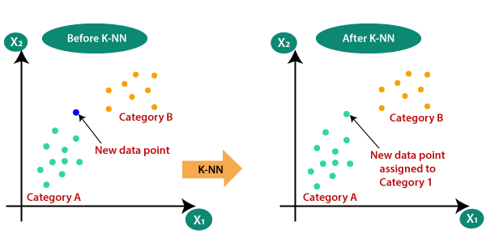

The K-NN working can be explained on the basis of the below algorithm:
Step-1: Select the number K of the neighbors
Step-2: Calculate the Euclidean distance of K number of neighbors
Step-3: Take the K nearest neighbors as per the calculated Euclidean distance.
Step-4: Among these k neighbors, count the number of the data points in each category.
Step-5: Assign the new data points to that category for which the number of the neighbor is maximum.
Step-6: Our model is ready.
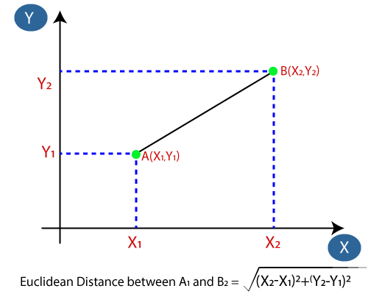
Note: The Euclidean Distance formula is used to find the nearest neighbors
Differences in the Application of supervised and unsupervised learning
The main distinction between the two approaches is the use of labelled datasets. To put it simply, supervised learning uses labelled input and output data, while an unsupervised learning algorithm does not. However, there is also a difference between the two, when it comes to purpose of model building and their applications
Goals: In supervised learning, the goal is to predict outcomes for new data. You know up front the type of results to expect. With an unsupervised learning algorithm, the goal is to get insights from large volumes of new data. The machine itself determines what is different or interesting from the dataset.
Applications: Supervised learning models are ideal for spam detection, sentiment analysis, weather forecasting and pricing predictions, among other things. In contrast, unsupervised learning is a great fit for anomaly detection, recommendation engines, customer personas and medical imaging.
Application of ML: Image Classification: Usage and Merits
What is Image Classification?
Classification between objects is a fairly easy task for us, but it has proved to be a complex one for machines and therefore image classification has been an important task within the field of computer vision. Image classification refers to the labelling of images into one of a number of predefined classes.
There are potentially n number of classes in which a given image can be classified. Manually checking and classifying images could be a tedious task especially when they are massive in number (say 10,000) and therefore it will be very useful if we could automate this entire process using computer vision.
Areas where Image classification is used:
Some examples of image classification include:
- Labelling an x-ray as cancer or not (binary classification).
- Classifying a handwritten digit (multiclass classification).
- Assigning a name to a photograph of a face (multiclass classification).
- The advancements in the field of autonomous driving also serve as a great example of the use of image classification in the real-world. For example, we can build an image classification model that recognizes various objects, such as other vehicles, pedestrians, traffic lights, and signposts on the road.
A key advantage of using image classification is that this can greatly reduce the labour requirement of a company and it can lead to cost savings. The task, when automated, reduces the need for human intervention.
Structure of an Image Classification Task
- Image Pre-processing - The aim of this process is to improve the image data(features) by suppressing unwanted distortions and enhancement of some important image features so that our Computer Vision models can benefit from this improved data to work on.
- Detection of an object - Detection refers to the localization of an object which means the segmentation of the image and identifying the position of the object of interest.
- Feature extraction and Training- This is a crucial step wherein statistical or deep learning methods are used to identify the most interesting patterns of the image, features that might be unique to a particular class and that will, later on, help the model to differentiate between different classes. This process where the model learns the features from the dataset is called model training.
- Classification of the object - This step categorizes detected objects into predefined classes by using a suitable classification technique that compares the image patterns with the target patterns.
Convolutional neural networks and image classification
Convolutional neural networks (CNN) are a special architecture of artificial neural networks, proposed by Yann LeCun in 1988. CNN uses some features of the visual cortex. One of the most popular uses of this architecture is image classification. For example, Facebook uses CNN for automatic tagging algorithms, Amazon — for generating product recommendations and Google — for search through among users’ photos.
Let us consider the use of CNN for image classification in more detail. The main task of image classification is acceptance of the input image and the following definition of its class. This is a skill that people learn from their birth and are able to easily determine that the image in the picture is an elephant. But the computer sees the pictures quite differently:
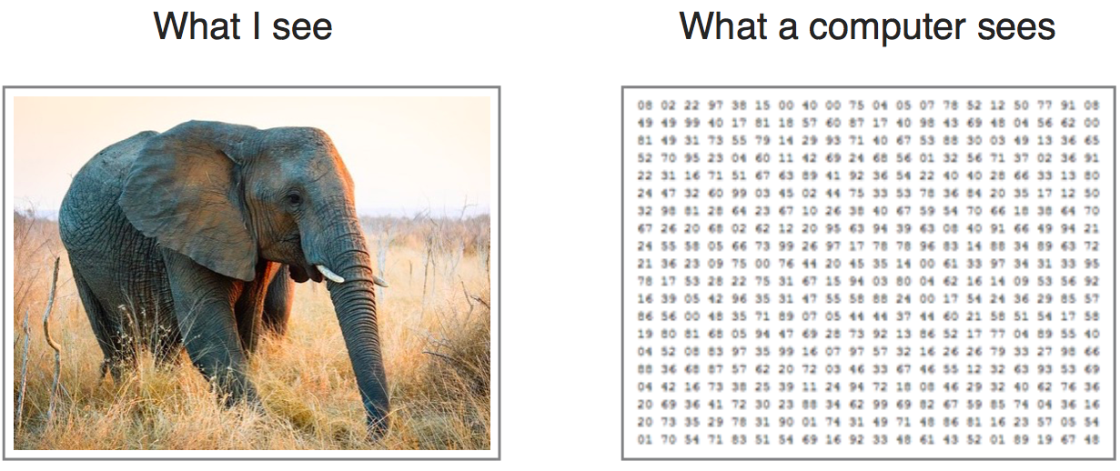
Instead of the image, the computer sees an array of pixels. For example, if image size is 300 x 300. In this case, the size of the array will be 300x300x3. Where 300 is width, next 300 is height and 3 is RGB channel values. The computer is assigned a value from 0 to 255 to each of these numbers. Тhis value describes the intensity of the pixel at each point.
To solve this problem the computer looks for the characteristics of the base level. In human understanding such characteristics are for example the trunk or large ears. For the computer, these characteristics are boundaries or curvatures. And then through the groups of convolutional layers the computer constructs more abstract concepts.
In more detail: the image is passed through a series of convolutional, nonlinear, pooling layers and fully connected layers, and then generates the output.
