PROJECT

REPORT
YES BANK SCAM
- A Financial Scam / Crisis / Fraud
Drishti Chulani  drishti.chulani@gmail.com | 



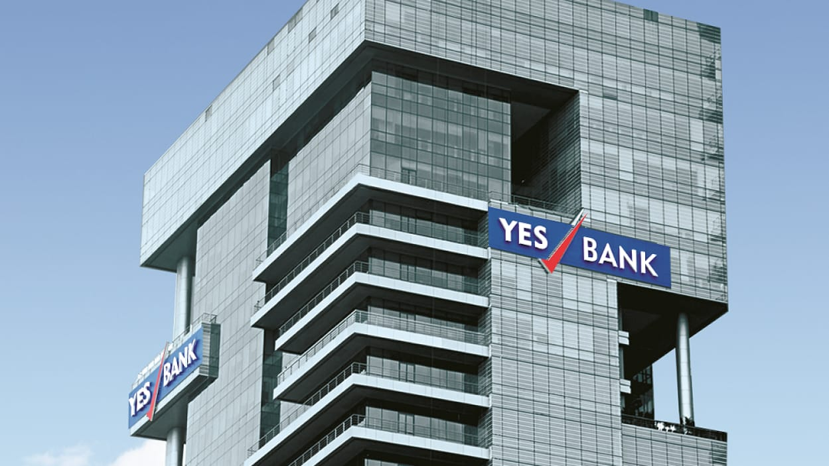

Table of Contents
Introduction 2
Facts of the case 3
Major Effects and Reforms 5
Analysis of the case 7
Conclusion and Recommendation 8
Sources 9

Introduction
Financial fraud happens when someone or a group of people like brokers, traders, insiders trick investors into buying the shares or commodities at an unreasonable price through misleading, deceptive, or other illegal practices.

Over many years, financial crimes and diverse crimes activities within the corporate sector have been witnessed, the very first being the Mundhra Scam, which was exposed in 1957 and is the first big financial scam of independent India to the present day YES Bank crisis and the further crises. With the increase in technology and the number of rules and rising demand for regulations, corporate crimes are increasing, and the scale doesn’t seem to be decreasing any time soon as there are loopholes in every system and law.



It is a difficult task for authorities to uncover the fraudulent activities that go behind in an organization as people are well connected and each scam/fraud/crisis has a set of people from different backgrounds to contribute to the scam. To catch them and let alone prosecute them as per due process of law is a slow moving and complicated process. These are the ethical issues that lay in the management. YES Bank was one such ethical failure. Ethics in management can be defined as a set of moral principles. Managerial ethics is what is communicated by top management that defines what is right & wrong in an organization. It is an ethical failure that the founder Mr. Rana Kapoor did money laundering using the Bank.
What was the Yes Bank Crisis?
The Yes Bank Scam started around 2015 wherein the private bank, Yes Bank, falsely gave out loans to borrowers. The scam lasted for months before it was found out and by then, many innocent people had lost their money.
After the bank’s financial health deteriorated on account of its inefficiency to raise capital to take over potential loan losses, on 5th March 2020, YES Bank was placed under a 30 day moratorium by RBI. Prashant Kumar, who was serving as chief financial officer and deputy managing director at State Bank of India (SBI) was appointed as an administrator. State Bank of India and some private-sector lenders prompted a ₹10,000 crore rescue for the Bank.

How was Yes Bank come into?
YES Bank Ltd runs three units that are- YES Asset Management Services, YES Capital and YES Bank. Once the country’s fifth-largest private lender by market capitalization, YES Bank had been founded by billionaires Rana Kapoor and Ashok Kapoor in 2004. YES Bank deals in financial services like banking and investment. In a short amount of time, it saw a great deal of success. It was one of the fastest growing banks in India and had experienced tremendous growth since its opening in 2004. YES bank was the sole banking partner for UPI transactions. The bank also took part in high-risk lending, providing loans to those who could not raise funds elsewhere.
The Bank’s progress became a attracting component in increasing their customer base uniformly with people depositing more and more going up to 2 lakh crores and the value of shares went as high as Rs 400/share and non-performing assets valued at a paltry 0.31%. In the period between December 2015-2016, YES Bank's stock prices rose 13%. In 2017, Rana Kapoor was noted to enter the Billionaire club.



Facts of the Case

YES Bank Downfall and its Crisis
Facts of the Case
YES Bank had taken partnered loans from eight large international entities including ADB, OPIC, European investment bank, banks in Taiwan and Japan for amounts ranging from US$30 million to US$410 million. It had also taken loans from the United States, government based OPIC and Wells Fargo.
Once the bank was at its top, it started lending in billions to companies which turned out to have red flags with their financial health. There was the chain reaction in India's shadow-banking space that started with the Infrastructure Leasing & Financial Services (IL&FS) and then went to Dewan Housing Finance Limited (DHFL). YES Bank’s total exposure to IL&FS and DHFL was 11.5% on September. In April 2019, the bank had put about Rs 10,000 crore of the total risks, about 4.1% of its total loans under potential non-performing loans (NPA) over the next 12 months.
YES Bank’s loss started to magnify in the gross Non-performing Assets which were estimated to be around Rs.40000 crore (Gross NPA). But they were under-reported, which were later found out by RBI. The bank’s loan book on March 31, 2014, was Rs 55,633 crore, and its deposits were Rs 74,192 crore. Since then, the loan book increased four times as much and the deposits failed to keep pace with loan growth. The loan book grew to ₹2,24,505 crore as of September 2019, while deposits were at only at ₹2,09,497 crore. Due to which, YES Bank was unable to raise capital to sustain its balance sheet.
YES Bank also faced several governance and regulatory issues/ practices that led to its decline as a result Rana Kapoor, who was the CEO of YES Bank, was asked to step down in January 2019.
YES Bank’s financial condition discouraged many depositors from keeping funds in the bank over a longer term. The bank was facing regular outflow of liquidity which means it was bleeding.
All the above factors led the RBI to conclude that there was no appropriate comeback plan from the end of YES bank and so in the interest of the bank’s depositors, the bank was placed under a moratorium.


Major Effects and Reforms
Collapse of YES Bank was highly undesirable, at a phase when the growth in the Indian economy has dropped to 5%.
After the scam was uncovered by the RBI that the bank had under-reported NPAs of Rs 3,277 crores, RBI placed the bank under moratorium and appointed R Gandhi, one of its former deputy governors, to the board of the bank. RBI took over from YES bank board for 30 days. The central bank had appointed deputy managing director and chief finance officer of State Bank of India, Prashant Kumar, as an administrator of the bank.
RBI announced a draft ‘Scheme of Reconstruction’ that entails SBI investing capital to acquire a 49% stake in the restructured private lender. The act proposed the details of the scheme for raising fresh capital for YES Bank
Moratorium is basically imposed due to the lender’s inability to raise adequate capital to make provisions for potential non-performing assets. This failing resulted in downgrades by credit rating agencies, which in turn made capital raising even more difficult. It is a temporary suspension of activities until all the issues have been resolved.
As per the government act, the authorized capital of the Reconstructed YES Bank will get modified to Rs. 6200 crores from the Rs.1100 crore earlier. The number of equity shares will get modified to 3000 crores. The capital of the reconstructed bank at Rs.2 face value per share would be Rs. 6000 crores.
SBI also cannot reduce its holding below 26% before the completion of three years from the date of infusion of the capital.
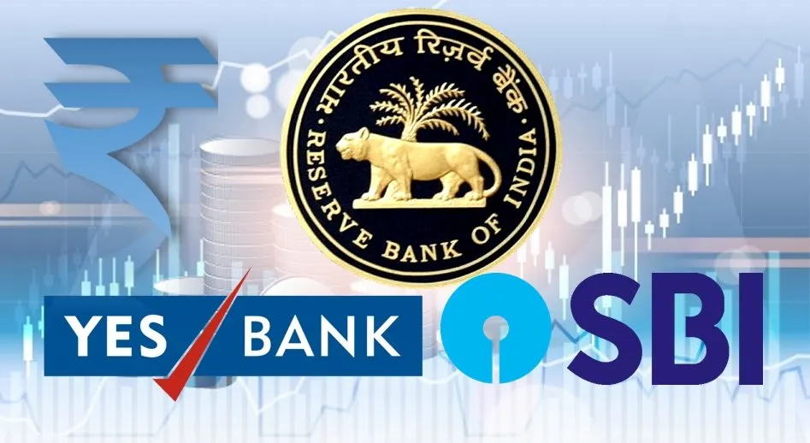
YES Bank would continue to function with the employees having the same service conditions, including remuneration, at least for one year. However, in the case of key managerial personnel, the new board would be empowered to take a call.

Major Effects and Reforms
Who is Rana Kapoor and What happened?
Rana Kapoor is a co-founder and former managing director & chief executive of YES Bank.
He is supposed to be the main frame of drafting and communicating all the ethical policies or any policy or rule that the management must follow. It’s somewhere an ethical failure that Mr. Kapoor is under arrest for Money Laundering. Shady data was provided, fake loans were given. The general public was shaken, they were not able to withdraw their own hard earned money.
Rana Kapoor had sold his entire stake in the bank in November 2019, after it turned out that Yes Bank had completely become bankrupt which was later taken over by RBI and SBI.
The Enforcement Directorate (“ED”) arrested Rana Kapoor on charges of money laundering and setting up shell companies for laundering money and creating tainted assets under the Prevention of Money Laundering Act, 2002.
Many other cases are against Rana Kapoor and several others in connection with alleged cheating, criminal conspiracy, fraud for taking huge amounts of kickbacks particularly the scam-hit, Dewan Housing Finance Corporation Limited (DHFL), a shadow-banking space.
It alleged that he was the controlling authority and decision maker during the material period when the fraud was perpetrated.
Aside from Rana Kapoor, the ED had named his wife Bindu, three daughters-- Rakhee, Roshini, and Radha--and three firms, Morgan Credits, RAB Enterprises (India), and Doit Urban Ventures, that were allegedly controlled by them and the CBI court sent them to the judiciary custody.


The only thing that was very clear was that thousands of crores owned by the depositors were embezzled by this bank. It may even be stated that, it is one of the biggest financial fraud which cannot be compared to another banking fraud in this world. It could be rightly said that it was a chain of banks, promoters, senior bank managements, auditors, borrowers, regulators from the RBI and the key government officials who all worked hand in hand and due to which the people that is mainly the retired people, honest tax payers, etc. are the one who have suffered loss.
Analysis of the Case

As we spoke about the major reasons for the collapse that is:
- Increase in the Loans ratio, that is the loans the bank is taking to the number of deposits the account holder is putting in the bank, and lapses in the management led to the increase of Non-Performing Assets
- While debtors failing to pay back was the central problem, what further increased YES Bank’s financial problems was the distrust of its depositors. As YES Bank faltered on NPAs, its share price went down and public confidence in it fell. YES Bank lost out on capital (money) from both depositors and debtors.
- The domino effect of the Non-Banking Financial Company crisis with the two main borrowers that are Infrastructure Leasing & Financial Services and Dewan Housing Finance Ltd.
- The bank under-reported the NPAs to the RBI causing more problems
- The financial crisis that plagued the bank discouraged most depositors to keep their money in the Bank and increased the withdrawals.
- Due to these, YES Bank could not even raise funds and the investors said no to help it. It was after RBI brought in SBI which made investors trust in the bank again.
YES Bank was placed under moratorium after its financial health deteriorated on account of its inability to raise capital to address potential loan losses. This prompted a ₹10,000 crore rescue, which saw State Bank of India and some private-sector lenders infuse capital. Since then, it has focused on limiting its corporate loan book and growing its retail and mid and small corporate segments.
Although the Yes Bank empire began with the right reasons and had all the ingredients of a sustainable success story, its skilled management team perhaps lived up to the name of the bank a bit too much and had to resort to uncomfortable measures to steer a sinking ship home.
Conclusion and
Recommendation
The whole situation had raised quite the unrest among the people and very rightfully so. The huge loss of the public fund led many to lose and question the deposited safety in the bank. The whole situation also rendered the bank with lesser deposits and to a point where it was unable to raise capital.
This financial failure is undoubtedly a big loss to our Financial System but if we see it other way round, it’s more of an ethical loss.
It is high time that the Government and RBI take steps that are fundamental in preventing such crisis with the help of policy reforms and change in the manner of governance especially with the increasing need to bail out private sector banks in case of a financial or banking crisis.
The decision of the Reserve Bank to bring in State Bank of India is highly commendable and seems to be sensible in light of the circumstances and it is truly a test of time to see whether both the banks come out as winners or not.

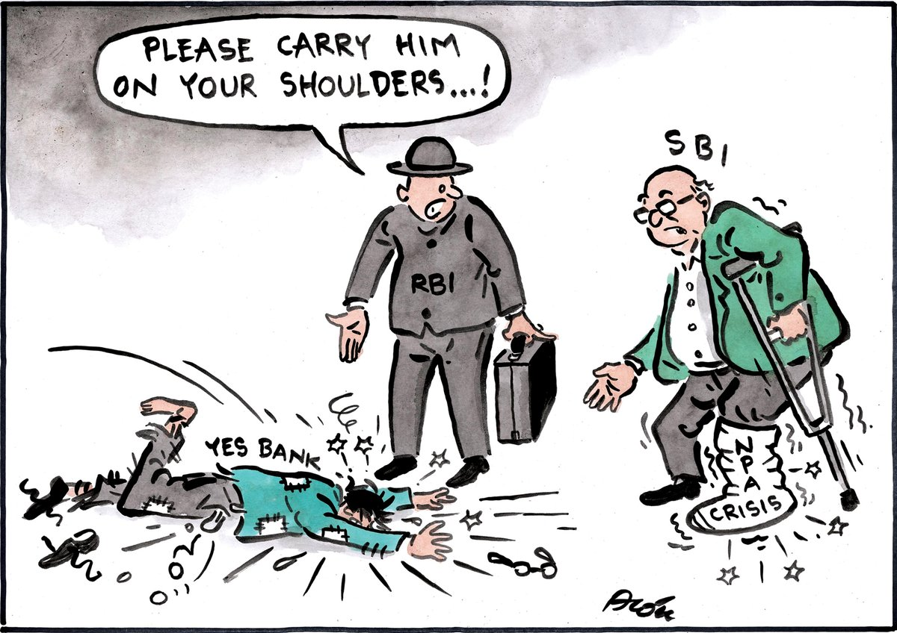

https://en.wikipedia.org/wiki/Yes_Bank
Sources
https://www.iralr.in/post/decoding-the-yes-bank-scam-and-its-legal-issues
https://www.business-standard.com/about/what-is-yes-bank-crisis
https://www.svpnpa.gov.in/images/npa/pdfs/CompletedResearchProject/25_analyticalstudybankfrauds.pdf
https://economictimes.indiatimes.com/industry/banking/finance/banking/yes-bank-scam-cbi-court-sends-rana-kapoors-wife-daughters-to-judicial-custody/articleshow/86323306.cms



