Mansi Mandaliya
Roll no. 412
Statistical risk modelling 1
Project-
Graduation tests

Documented:
-Summary
-Process
-Steps
-Interpretations

Summary:
This entire project has been carried out on R programming using various codes and outputs.
We have been provided with a data file Graduation.csv, which includes the following columns:
AGE- Age x
ETR- Central exposed to risk for age x last birthday
DEATHS- Number of deaths recorded at age x last birthday
CRUDE- Crude mortality rate for age x last birthday
GRADUATED- Graduated mortality rate for age x last birthday
EXPECTED- Expected number of deaths at age x last birthday based on the graduated rates Individual
ZX- standardised deviation for age x

Some columns are filled with the value 0 and hence have to be filled using different formulas and codes.
Various tests have been performed in order to check whether we had to accept or reject the individual deviations.

Process:
- Importing data.
- Filling in the entries for CRUDE column.
- Gompertz law to fill entries in GRADUATED column.
- Checking for smoothness.
- Filling values in EXPECTED AND ZX columns.
- Chi-square test.
- Signs test.
- Cumulative deviations test.
- Serial Correlation test.

Steps:

- The “graduation” csv file was imported in R programming. And it was saved in “grad”.
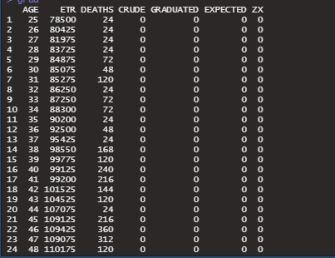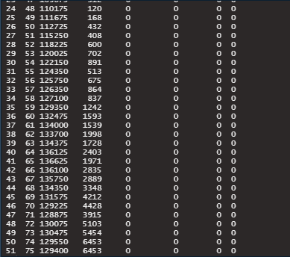

From the above output, we see that there are 7 columns namely AGE, ETR, DEATHS, CRUDE, GRADUATED, EXPECTED and ZX. AGE ranges from 25 years to 75 years.
And the columns CRUDE, GRADUATED, EXPECTED AND ZX are 0 and hence have to be filled in.
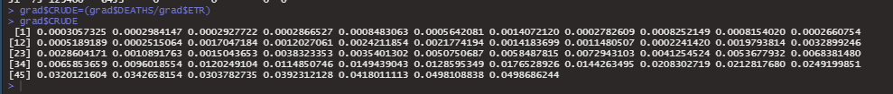
CRUDE column is filled by dividing DEATHS/ ETR.

2)
Gompertz law- The Gompertz law states that the human death rate is the sum of an age-dependent component, which increases exponentially with age and an age-independent component. It was named after Benjamin Gompertz.
For fitting the gompertz law, lm function is used to find the relationship between log of CRUDE and AGE.

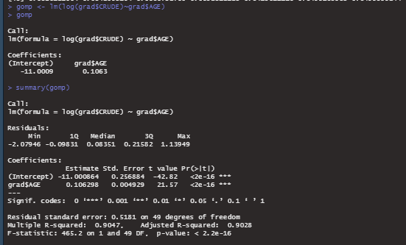
From this output, coefficients are extracted,
Formula for gompertz law is,
B*C^y variable.
Hence, we find the values for B and C which are the 2 coefficients of our output.
Taking our y variable as AGE, GRADUATED column is being filled with these values.

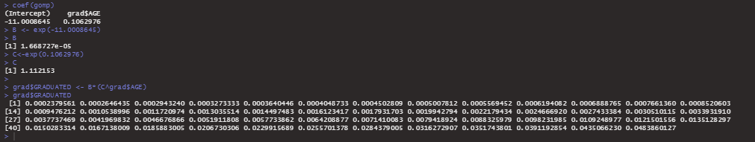

3)
Checking the smoothness:
Applying the third differences to the crude and graduated rates.
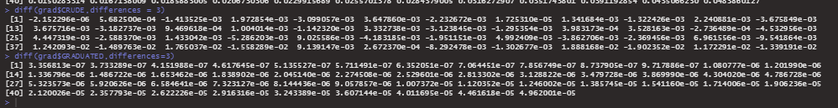

We see that there isn’t a steady increase or decrease in the differences.
It has both positive and negative values.

4)

EXPECTED and ZX columns have been filled.
EXPECTED = ETR*GRADUATED.
ZX = (DEATHS-EXPECTED)/sqrt(EXPECTED)

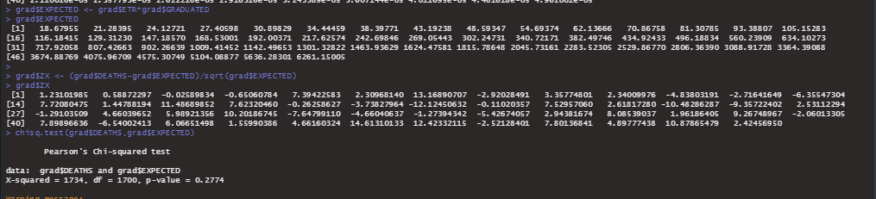

Chi square test- It tells you if your sample data represents the data you would expect to find in the actual population.
So a chi-square test has been carried out between DEATHS and EXPECTED.
Since the p value is greater than 0.05, we assume that the data is a good fit.

5) b)
m=51
The signs test is a simple test for overall bias. In other words, this test checks whether the graduated rates are too high or too low.
Define the test statistic: P = Number of x z that are positive
Under the hypothesis, P Binomial ~ (m ,½).

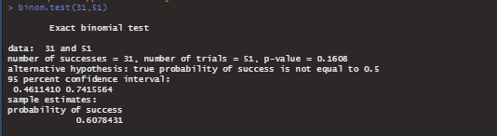

Carrying out a signs test,
Since p value is greater than 0.05, we do not reject the null hypothesis.

c) Cumulative deviations test
The cumulative deviations test detects overall bias or long runs of deviations of the same sign.

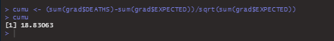

d) Serial correlation test
A final test, detecting grouping of signs of deviations, is the serial correlations test.
rj ~N(0,1/ m) , under the null hypothesis.
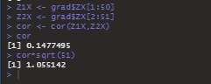

We do not reject the null hypothesis, since 1.055142 lies between -1 and 1.

THANKYOU.

