library(tidyverse, MASS, readxl)
data = read.csv(file.choose())

Code:

summary(data)

Output:

Inspection.ID DBA.Name AKA.Name License.. Facility.Type Risk
Min. : 44247 Length:196825 Length:196825 Min. : 0 Length:196825 Length:196825
1st Qu.:1150792 Class :character Class :character 1st Qu.:1225118 Class :character Class :character
Median :1493299 Mode :character Mode :character Median :1979973 Mode :character Mode :character
Mean :1449379 Mean :1601134
3rd Qu.:2009233 3rd Qu.:2240843
Max. :2352738 Max. :9999999
NA's :17
Address City State Zip Inspection.Date Inspection.Type
Length:196825 Length:196825 Length:196825 Min. :10014 Length:196825 Length:196825
Class :character Class :character Class :character 1st Qu.:60614 Class :character Class :character
Mode :character Mode :character Mode :character Median :60625 Mode :character Mode :character
Mean :60629
3rd Qu.:60643
Max. :60827
NA's :50
Results Violations Latitude Longitude Location Historical.Wards.2003.2015
Length:196825 Length:196825 Min. :41.64 Min. :-87.91 Length:196825 Mode:logical
Class :character Class :character 1st Qu.:41.83 1st Qu.:-87.71 Class :character NA's:196825
Mode :character Mode :character Median :41.89 Median :-87.67 Mode :character
Mean :41.88 Mean :-87.68
3rd Qu.:41.94 3rd Qu.:-87.64
Max. :42.02 Max. :-87.53
NA's :690 NA's :690
Zip.Codes Community.Areas Census.Tracts Wards
Mode:logical Mode:logical Mode:logical Mode:logical
NA's:196825 NA's:196825 NA's:196825 NA's:196825

Code:

View(head(data, 6))

Output:
Shows 1st 6 entries of dataframe

Code:

View(tail(data, 10))

Output:

Shows last 10 entries of dataframe.

Code:

dim(data)

Output:

196825 22

Code:

class(data)

Output:

"data.frame"

Code:

colnames(data)

Output:

[1] "Inspection.ID" "DBA.Name" "AKA.Name" "License.."
[5] "Facility.Type" "Risk" "Address" "City"
[9] "State" "Zip" "Inspection.Date" "Inspection.Type"
[13] "Results" "Violations" "Latitude" "Longitude"
[17] "Location" "Historical.Wards.2003.2015" "Zip.Codes" "Community.Areas"
[21] "Census.Tracts" "Wards"

Code:

numeric_data = data[unlist(lapply(data, FUN = is.numeric))]
for (col in colnames(numeric_data)) {
print(col)
print(fivenum(unlist(numeric_data[col])))
}

Output:

[1] "Inspection.ID"
Inspection.ID196811 Inspection.ID145757 Inspection.ID108177 Inspection.ID50095 Inspection.ID6
44247 1150792 1493299 2009233 2352738
[1] "License.."
License..820 License..173540 License..54181 License..44589 License..195886
0 1225115 1979973 2240843 9999999
[1] "Zip"
Zip6676 Zip49478 Zip164472 Zip107493 Zip196696
10014 60614 60625 60643 60827
[1] "Latitude"
Latitude17868 Latitude185616 Latitude46770 Latitude52279 Latitude190811
41.64467 41.83490 41.89198 41.93981 42.02106
[1] "Longitude"
Longitude2 Longitude47534 Longitude23559 Longitude9143 Longitude184393
-87.91443 -87.70774 -87.66681 -87.63496 -87.52509

Code:

data[3]

Output:

AKA.Name
1 CHIPOTLE MEXICAN GRILL
2 CHILI'S (T1-B14)
3 NICK'S FIRE GRILL STEAK & LEMONADE INC.
4
5 MOSAIC EARLY CHILDHOOD ACADEMY
6 AMARIT RESTAURANT
7 CHIPOTLE MEXICAN GRILL
8 NAIBOA LATIN STORE
9 JAMIESON PUBLIC SCHOOL
10 GATEWAY MONTESSORI
[ reached 'max' / getOption("max.print") -- omitted 196815 rows ]

Code:

data_lis = data[data$License..> 2000000 & data$License.. < 3000000,]

Output:

NA

Code:

blue_line = data[data$DBA.Name == "BLUE LINE", ]

Output:

NA

Code:

data[, c("Ã¯..Inspection.ID", "Facility.Type")]

Output:

Inspection.ID Facility.Type
1 2352683 Restaurant
2 2352734 Restaurant
3 2352713
4 2352701 Restaurant
5 2352727 Children's Services Facility
6 2352738 Restaurant
7 2352684 Restaurant
8 2352702 Grocery Store
9 2352718 School
10 2352696 Children's Services Facility

Code:

data[grep("High", data$Risk), "DBA.Name"]

Output:

[1] "CHIPOTLE MEXICAN GRILL" "CHILI'S T-I"
[3] "NICK'S FIRE GRILL STEAK & LEMONADE INC." "TAQUERIA BLUE LINE INC."
[5] "PORTAGE PARK DAY NURSERY" "AMARIT RESTAURANT"
[7] "CHIPOTLE MEXICAN GRILL" "JAMIESON"
[9] "GATEWAY MONTESSORI SCHOOL" "BLUE LINE"
[11] "SWEETGREEN" "SAME SAME"
[13] "CHIPOTLE MEXICAN GRILL" "HARRY CARAY'S SHORTSTOP"
[15] "THE GRAIL CAFE" "SUBWAY"
[17] "AMARIT RESTAURANT" "RPM SEAFOOD"
[19] "LITTLE FEET BIG STEPS CENTER" "KENTUCKY FRIED CHICKEN"

Code:

View(head(data[data$Results == "Fail",], 2))

Output:

Shows 2nd column where results are Fail.

Code:

nrow(data)

Output:

196825

Code:

which(unlist(lapply(data, is.na)))

Output:

Check for NA values

Code:

df = data %>% select_if(~ !all(is.na(.)))

Output:

Removes last 5 columns with null values.

Code:

ggplot(data, mapping = aes(x = Latitude)) +
geom_histogram(color = "red", fill = "black") +
ggtitle("Latitude Histogram") +
theme_minimal() +
theme(plot.title = element_text(hjust = 0.5))

ggplot(data, mapping = aes(x = Longitude)) +
geom_histogram(color = "red", fill = "black") +
ggtitle("Longitude Histogram") +
theme_minimal() +
theme(plot.title = element_text(hjust = 0.5))

Output:
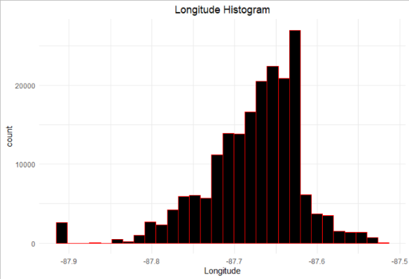
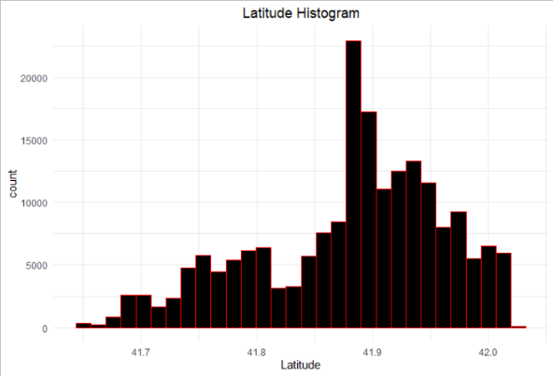

Code:

is.na(data$Latitude) = mean(data$Latitude)
is.na(data$Longitude) = mean(data$Longitude)

Output:

Replaces NA values with the mean.

Code:

which(unlist(lapply(data, duplicated)) == T)

Output:
Checks for duplicates.

Code:

data %>% count(Risk, Results) %>% filter(Results == "Pass")

Output:
Risk Results n
1 Pass 12
2 Risk 1 (High) Pass 78054
3 Risk 2 (Medium) Pass 20595
4 Risk 3 (Low) Pass 7405

Code:

data$Inspection.Date = as.Date(data$Inspection.Date, format = "%m/%d/%Y")
data["Year"] = format(data$Inspection.Date, "%Y")
data["Month"] = format(data$Inspection.Date, "%B")
data["Day"] = format(data$Inspection.Date, "%d")

Output:

Adding in the Year, Month and Day columns.

