> str(df.graduation)
'data.frame': 51 obs. of 7 variables:
$ AGE : int 25 26 27 28 29 30 31 32 33 34 ...
$ ETR : int 78500 80425 81975 83725 84875 85075 85275 86250 87250 88300 ...
$ DEATHS : int 24 24 24 24 72 48 120 24 72 72 ...
$ CRUDE : int 0 0 0 0 0 0 0 0 0 0 ...
$ GRADUATED: int 0 0 0 0 0 0 0 0 0 0 ...
$ EXPECTED : int 0 0 0 0 0 0 0 0 0 0 ...
$ ZX : int 0 0 0 0 0 0 0 0 0 0 ...
> dim(df.graduation)
[1] 51 7
> df.graduation$CRUDE = df.graduation$DEATHS/df.graduation$ETR
> df.graduation
AGE ETR DEATHS CRUDE GRADUATED EXPECTED ZX
1 25 78500 24 0.0003057325 0 0 0
2 26 80425 24 0.0002984147 0 0 0
3 27 81975 24 0.0002927722 0 0 0
4 28 83725 24 0.0002866527 0 0 0
5 29 84875 72 0.0008483063 0 0 0
6 30 85075 48 0.0005642081 0 0 0
7 31 85275 120 0.0014072120 0 0 0
8 32 86250 24 0.0002782609 0 0 0
9 33 87250 72 0.0008252149 0 0 0
10 34 88300 72 0.0008154020 0 0 0
11 35 90200 24 0.0002660754 0 0 0
12 36 92500 48 0.0005189189 0 0 0
13 37 95425 24 0.0002515064 0 0 0
14 38 98550 168 0.0017047184 0 0 0
15 39 99775 120 0.0012027061 0 0 0
16 40 99125 240 0.0024211854 0 0 0
17 41 99200 216 0.0021774194 0 0 0
18 42 101525 144 0.0014183699 0 0 0
19 43 104525 120 0.0011480507 0 0 0
20 44 107075 24 0.0002241420 0 0 0
21 45 109125 216 0.0019793814 0 0 0
22 46 109425 360 0.0032899246 0 0 0
23 47 109075 312 0.0028604171 0 0 0
24 48 110175 120 0.0010891763 0 0 0
25 49 111675 168 0.0015043653 0 0 0
26 50 112725 432 0.0038323353 0 0 0
27 51 115250 408 0.0035401302 0 0 0
28 52 118225 600 0.0050750687 0 0 0
29 53 120025 702 0.0058487815 0 0 0
30 54 122150 891 0.0072943103 0 0 0
31 55 124350 513 0.0041254524 0 0 0
32 56 125750 675 0.0053677932 0 0 0
33 57 126350 864 0.0068381480 0 0 0
34 58 127100 837 0.0065853659 0 0 0
35 59 129350 1242 0.0096018554 0 0 0
36 60 132475 1593 0.0120249104 0 0 0
37 61 134000 1539 0.0114850746 0 0 0
38 62 133700 1998 0.0149439043 0 0 0
39 63 134375 1728 0.0128595349 0 0 0
40 64 136125 2403 0.0176528926 0 0 0
41 65 136625 1971 0.0144263495 0 0 0
42 66 136100 2835 0.0208302719 0 0 0
43 67 135750 2889 0.0212817680 0 0 0
44 68 134350 3348 0.0249199851 0 0 0
45 69 131575 4212 0.0320121604 0 0 0
46 70 129225 4428 0.0342658154 0 0 0
47 71 128875 3915 0.0303782735 0 0 0
48 72 130075 5103 0.0392312128 0 0 0
49 73 130475 5454 0.0418011113 0 0 0
50 74 129550 6453 0.0498108838 0 0 0
51 75 129400 6453 0.0498686244 0 0 0
> graduated = lm(log(CRUDE)~AGE, df.graduation)
> summary(graduated)

Call:
lm(formula = log(CRUDE) ~ AGE, data = df.graduation)

Residuals:
Min 1Q Median 3Q Max
-2.07946 -0.09831 0.08351 0.21582 1.13949

Coefficients:
Estimate Std. Error t value Pr(>|t|)
(Intercept) -11.000864 0.256884 -42.82 <2e-16 ***
AGE 0.106298 0.004929 21.57 <2e-16 ***
---
Signif. codes: 0 ‘***’ 0.001 ‘**’ 0.01 ‘*’ 0.05 ‘.’ 0.1 ‘ ’ 1

Residual standard error: 0.5181 on 49 degrees of freedom
Multiple R-squared: 0.9047, Adjusted R-squared: 0.9028
F-statistic: 465.2 on 1 and 49 DF, p-value: < 2.2e-16

> B = exp(coef(gl))[1]
Error: object of type 'closure' is not subsettable
> c = exp(coef(graduated))[2]
> B = exp(coef(graduated))[1]
> B
(Intercept)
1.668727e-05
> c
AGE
1.112153
> df.graduation$GRADUATED = round(B*C^df.graduation$AGE, 6)
Error in C^df.graduation$AGE : non-numeric argument to binary operator
> df.graduation$GRADUATED = round(B*c^df.graduation$AGE, 6)
> df.graduation
AGE ETR DEATHS CRUDE GRADUATED EXPECTED ZX
1 25 78500 24 0.0003057325 0.000238 0 0
2 26 80425 24 0.0002984147 0.000265 0 0
3 27 81975 24 0.0002927722 0.000294 0 0
4 28 83725 24 0.0002866527 0.000327 0 0
5 29 84875 72 0.0008483063 0.000364 0 0
6 30 85075 48 0.0005642081 0.000405 0 0
7 31 85275 120 0.0014072120 0.000450 0 0
8 32 86250 24 0.0002782609 0.000501 0 0
9 33 87250 72 0.0008252149 0.000557 0 0
10 34 88300 72 0.0008154020 0.000619 0 0
11 35 90200 24 0.0002660754 0.000689 0 0
12 36 92500 48 0.0005189189 0.000766 0 0
13 37 95425 24 0.0002515064 0.000852 0 0
14 38 98550 168 0.0017047184 0.000948 0 0
15 39 99775 120 0.0012027061 0.001054 0 0
16 40 99125 240 0.0024211854 0.001172 0 0
17 41 99200 216 0.0021774194 0.001304 0 0
18 42 101525 144 0.0014183699 0.001450 0 0
19 43 104525 120 0.0011480507 0.001612 0 0
20 44 107075 24 0.0002241420 0.001793 0 0
21 45 109125 216 0.0019793814 0.001994 0 0
22 46 109425 360 0.0032899246 0.002218 0 0
23 47 109075 312 0.0028604171 0.002467 0 0
24 48 110175 120 0.0010891763 0.002743 0 0
25 49 111675 168 0.0015043653 0.003051 0 0
26 50 112725 432 0.0038323353 0.003393 0 0
27 51 115250 408 0.0035401302 0.003774 0 0
28 52 118225 600 0.0050750687 0.004197 0 0
29 53 120025 702 0.0058487815 0.004668 0 0
30 54 122150 891 0.0072943103 0.005191 0 0
31 55 124350 513 0.0041254524 0.005773 0 0
32 56 125750 675 0.0053677932 0.006421 0 0
33 57 126350 864 0.0068381480 0.007141 0 0
34 58 127100 837 0.0065853659 0.007942 0 0
35 59 129350 1242 0.0096018554 0.008833 0 0
36 60 132475 1593 0.0120249104 0.009823 0 0
37 61 134000 1539 0.0114850746 0.010925 0 0
38 62 133700 1998 0.0149439043 0.012150 0 0
39 63 134375 1728 0.0128595349 0.013513 0 0
40 64 136125 2403 0.0176528926 0.015028 0 0
41 65 136625 1971 0.0144263495 0.016714 0 0
42 66 136100 2835 0.0208302719 0.018588 0 0
43 67 135750 2889 0.0212817680 0.020673 0 0
44 68 134350 3348 0.0249199851 0.022992 0 0
45 69 131575 4212 0.0320121604 0.025570 0 0
46 70 129225 4428 0.0342658154 0.028438 0 0
47 71 128875 3915 0.0303782735 0.031627 0 0
48 72 130075 5103 0.0392312128 0.035174 0 0
49 73 130475 5454 0.0418011113 0.039119 0 0
50 74 129550 6453 0.0498108838 0.043507 0 0
51 75 129400 6453 0.0498686244 0.048386 0 0
> 1diff = function(x)x[-1]-x[-length(x)]
Error: unexpected symbol in "1diff"
> a_diff = function(x)x[-1]-x[-length(x)]
> a_diff
function(x)x[-1]-x[-length(x)]
> diff.crude = round(a_diff(a_diff(a_diff(df.graduation$CRUDE)))*10^6,0)
> diff.crude
[1] -2 568 -1414 1973 -3099 3648 -2233 17 1342 -1322 2241 -3676 3676 -3183 947 1004 -1142 3333
[19] -3124 -1295 398 3528 -274 -4533 4447 -2588 1433 -5286 9026 -4183 -1951 4992 -3863 -2369 6962 -9542
[37] 12421 -14898 17650 -15583 9139 267 -8292 -1303 18882 -19024 11723 -13392
> graduated.crude = round(a_diff(a_diff(a_diff(df.graduation$GRADUATED)))*10^6,0)
> graduated.crude
[1] 2 0 0 0 2 -1 1 2 -1 2 1 0 2 2 0 2 3 1 3 2 2 5 2 5 3 6 4 7 7 6 9 9 9 13 11 15 14 19 17 23 23 25
[43] 31 31 37 40 45 48
> third.difference = cbind(df.graduation$AGE[df.graduation$AGE<=72], diff.crude, graduated.crude)
> third.difference
diff.crude graduated.crude
[1,] 25 -2 2
[2,] 26 568 0
[3,] 27 -1414 0
[4,] 28 1973 0
[5,] 29 -3099 2
[6,] 30 3648 -1
[7,] 31 -2233 1
[8,] 32 17 2
[9,] 33 1342 -1
[10,] 34 -1322 2
[11,] 35 2241 1
[12,] 36 -3676 0
[13,] 37 3676 2
[14,] 38 -3183 2
[15,] 39 947 0
[16,] 40 1004 2
[17,] 41 -1142 3
[18,] 42 3333 1
[19,] 43 -3124 3
[20,] 44 -1295 2
[21,] 45 398 2
[22,] 46 3528 5
[23,] 47 -274 2
[24,] 48 -4533 5
[25,] 49 4447 3
[26,] 50 -2588 6
[27,] 51 1433 4
[28,] 52 -5286 7
[29,] 53 9026 7
[30,] 54 -4183 6
[31,] 55 -1951 9
[32,] 56 4992 9
[33,] 57 -3863 9
[34,] 58 -2369 13
[35,] 59 6962 11
[36,] 60 -9542 15
[37,] 61 12421 14
[38,] 62 -14898 19
[39,] 63 17650 17
[40,] 64 -15583 23
[41,] 65 9139 23
[42,] 66 267 25
[43,] 67 -8292 31
[44,] 68 -1303 31
[45,] 69 18882 37
[46,] 70 -19024 40
[47,] 71 11723 45
[48,] 72 -13392 48
> df.graduation$EXPECTED = round(df.graduation$ETR*df.graduation$GRADUATED,2)
> df.graduation$ZX = round((df.graduation$DEATHS-df.graduation$EXPECTED)/sqrt(df.graduation$EXPECTED),3)
> df.graduation
AGE ETR DEATHS CRUDE GRADUATED EXPECTED ZX
1 25 78500 24 0.0003057325 0.000238 18.68 1.231
2 26 80425 24 0.0002984147 0.000265 21.31 0.583
3 27 81975 24 0.0002927722 0.000294 24.10 -0.020
4 28 83725 24 0.0002866527 0.000327 27.38 -0.646
5 29 84875 72 0.0008483063 0.000364 30.89 7.397
6 30 85075 48 0.0005642081 0.000405 34.46 2.307
7 31 85275 120 0.0014072120 0.000450 38.37 13.178
8 32 86250 24 0.0002782609 0.000501 43.21 -2.922
9 33 87250 72 0.0008252149 0.000557 48.60 3.357
10 34 88300 72 0.0008154020 0.000619 54.66 2.345
11 35 90200 24 0.0002660754 0.000689 62.15 -4.839
12 36 92500 48 0.0005189189 0.000766 70.86 -2.716
13 37 95425 24 0.0002515064 0.000852 81.30 -6.355
14 38 98550 168 0.0017047184 0.000948 93.43 7.715
15 39 99775 120 0.0012027061 0.001054 105.16 1.447
16 40 99125 240 0.0024211854 0.001172 116.17 11.489
17 41 99200 216 0.0021774194 0.001304 129.36 7.618
18 42 101525 144 0.0014183699 0.001450 147.21 -0.265
19 43 104525 120 0.0011480507 0.001612 168.49 -3.736
20 44 107075 24 0.0002241420 0.001793 191.99 -12.124
21 45 109125 216 0.0019793814 0.001994 217.60 -0.108
22 46 109425 360 0.0032899246 0.002218 242.70 7.529
23 47 109075 312 0.0028604171 0.002467 269.09 2.616
24 48 110175 120 0.0010891763 0.002743 302.21 -10.481
25 49 111675 168 0.0015043653 0.003051 340.72 -9.357
26 50 112725 432 0.0038323353 0.003393 382.48 2.532
27 51 115250 408 0.0035401302 0.003774 434.95 -1.292
28 52 118225 600 0.0050750687 0.004197 496.19 4.660
29 53 120025 702 0.0058487815 0.004668 560.28 5.987
30 54 122150 891 0.0072943103 0.005191 634.08 10.203
31 55 124350 513 0.0041254524 0.005773 717.87 -7.646
32 56 125750 675 0.0053677932 0.006421 807.44 -4.661
33 57 126350 864 0.0068381480 0.007141 902.27 -1.274
34 58 127100 837 0.0065853659 0.007942 1009.43 -5.427
35 59 129350 1242 0.0096018554 0.008833 1142.55 2.942
36 60 132475 1593 0.0120249104 0.009823 1301.30 8.086
37 61 134000 1539 0.0114850746 0.010925 1463.95 1.961
38 62 133700 1998 0.0149439043 0.012150 1624.45 9.268
39 63 134375 1728 0.0128595349 0.013513 1815.81 -2.061
40 64 136125 2403 0.0176528926 0.015028 2045.69 7.900
41 65 136625 1971 0.0144263495 0.016714 2283.55 -6.541
42 66 136100 2835 0.0208302719 0.018588 2529.83 6.067
43 67 135750 2889 0.0212817680 0.020673 2806.36 1.560
44 68 134350 3348 0.0249199851 0.022992 3088.98 4.660
45 69 131575 4212 0.0320121604 0.025570 3364.37 14.614
46 70 129225 4428 0.0342658154 0.028438 3674.90 12.423
47 71 128875 3915 0.0303782735 0.031627 4075.93 -2.521
48 72 130075 5103 0.0392312128 0.035174 4575.26 7.802
49 73 130475 5454 0.0418011113 0.039119 5104.05 4.898
50 74 129550 6453 0.0498108838 0.043507 5636.33 10.878
51 75 129400 6453 0.0498686244 0.048386 6261.15 2.425
> chi_square = data.frame(df.graduation$DEATHS, df.graduation$EXPECTED)
> chi_square
df.graduation.DEATHS df.graduation.EXPECTED
1 24 18.68
2 24 21.31
3 24 24.10
4 24 27.38
5 72 30.89
6 48 34.46
7 120 38.37
8 24 43.21
9 72 48.60
10 72 54.66
11 24 62.15
12 48 70.86
13 24 81.30
14 168 93.43
15 120 105.16
16 240 116.17
17 216 129.36
18 144 147.21
19 120 168.49
20 24 191.99
21 216 217.60
22 360 242.70
23 312 269.09
24 120 302.21
25 168 340.72
26 432 382.48
27 408 434.95
28 600 496.19
29 702 560.28
30 891 634.08
31 513 717.87
32 675 807.44
33 864 902.27
34 837 1009.43
35 1242 1142.55
36 1593 1301.30
37 1539 1463.95
38 1998 1624.45
39 1728 1815.81
40 2403 2045.69
41 1971 2283.55
42 2835 2529.83
43 2889 2806.36
44 3348 3088.98
45 4212 3364.37
46 4428 3674.90
47 3915 4075.93
48 5103 4575.26
49 5454 5104.05
50 6453 5636.33
51 6453 6261.15
> chisq.test(chi_square)

Pearson's Chi-squared test

data: chi_square
X-squared = 905.22, df = 50, p-value < 2.2e-16
#Since p value < 0.05, we reject the null hypothesis at 5% level of significance, and conclude that the graduated rates are not in line with the actual mortality rates.

###5 a)
library(plyr)

# 1. Overall shape
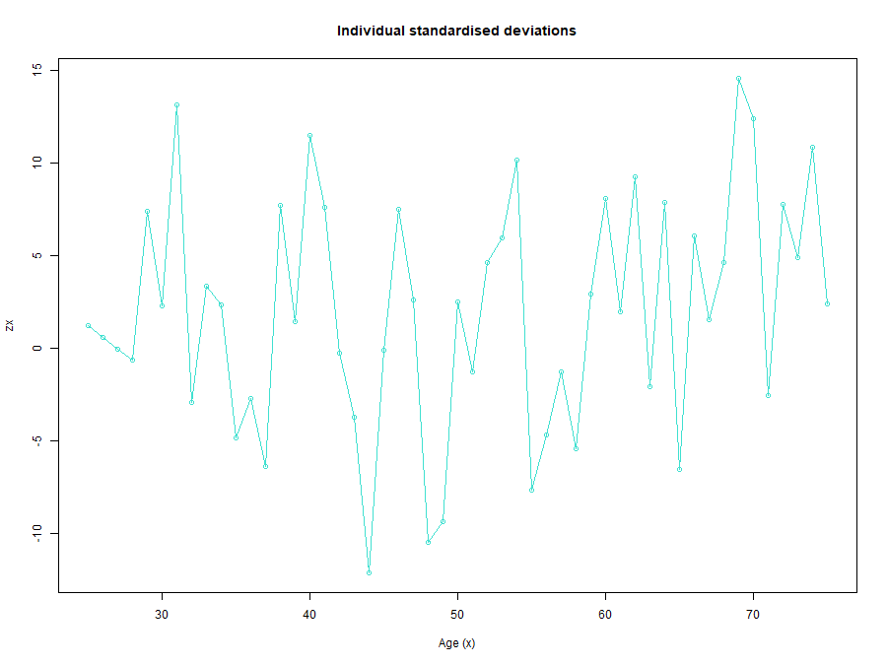
plot(df.graduation$AGE, df.graduation$ZX,type="o",xlab="Age (x)", ylab="zx",main="Individual standardised deviations", col="turquoise")

> table(cut(df.graduation$ZX, breaks = seq.int(from = -20,to = 20, by= 4)))

(-20,-16] (-16,-12] (-12,-8] (-8,-4] (-4,0] (0,4] (4,8] (8,12] (12,16] (16,20]
0 1 2 6 11 12 11 5 3 0
> # mad = 7.4471
> mean(df.graduation$ZX)
[1] 2.013451

# 2. absolute deviation
mad(df.graduation$ZX)
# mad = 7.4471
mean(df.graduation$ZX)
#mean = 2.013451
### Median absolute deviation is much higher than the expected mean value

min(df.graduation$ZX)
#min = -12.124
max(df.graduation$ZX)
# max = 14.614
iqr(df.graduation$ZX)
#iqr = 9.754

# 3. outliers
boxplot(df.graduation$ZX)$out
# from the boxplot we can see that there are no outliers
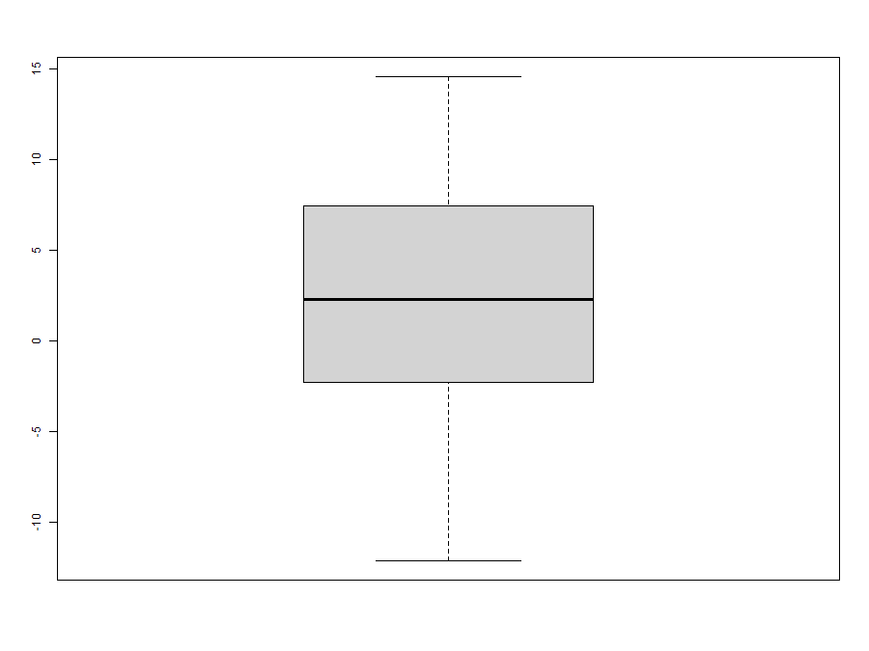
# 4. Symmetry
skewness(df.graduation$ZX)
# skew = -0.1272816, the graph is negatively skewed

# 5. conclusion
plot(df.graduation$GRADUATED, type = "l")
#we see that the graph is overgraduated, indicating greater smoothness with lesser accuracy. 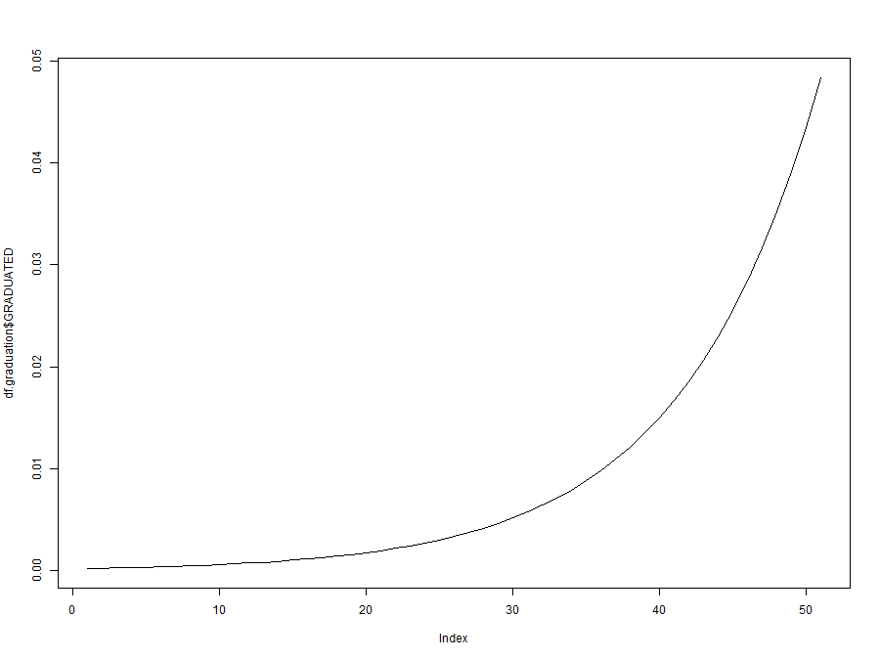
###5 b )
#signs test
sign.test = sign(df.graduation$ZX)
table(sign.test)

pbinom(31,51,0.5)

#cumulative deviations
observed = sum(df.graduation$DEATHS)
expected = sum(df.graduation$EXPECTED)
observed
expected
#observed = 66294
#expected = 61619.55
h =(observed - expected)/sqrt(expected)
h

##serial correlation
h1 = df.graduation$ZX[1:length(df.graduation$ZX)-1]
h2 = df.graduation$ZX[2:length(df.graduation$ZX)]
h1
h2

serial.test = cor(h1,h2)
serial.test
# serial.test = 0.1476081

test = sqrt(51)*serial.test
test
#test = 1.054133

