- C
- A
- C
- D
- D
- D
- C
- A
- C
- B
- D
- A
- B
- C
- C
- D
- A
- C
- C
- A
- C
- D
- C
- B
- A
- B
- B
- C
- C
- D
- B
- B
- A
- C
- D
- B
- D
- A
- To achieve an inflation target, central banks use monetary policy. If predicted inflation is higher than the target, they use contractionary policy to increase interest rates and lower aggregate demand, thus lowering the rate of inflation. If predicted inflation is lower than the target, they use expansionary policy to lower interest rates and increase aggregate demand. Advantages of inflation targeting
- A lower rate of inflation. Particularly in countries that have experienced persistent high rates of inflation, inflation targeting can be a method to reduce it. A more stable rate of inflation. This refers to reduced fluctuations in the rate of inflation, likely to be achieved when a target rate is pursued.
- Improved ability of economic decision-makers (firms, consumers) to anticipate the future rate of inflation. Public knowledge about the central bank’s objectives on inflation reduces uncertainty and facilitate economic decision making about the future (such as investment decisions).
- Greater co-ordination between monetary and fiscal policy. Knowledge about inflation targets allows the government to plan its fiscal policy to complement the central bank’s monetary policy.
- Greater central bank transparency and accountability. The central bank becomes more open about its activities and more accountable to the government and the public. If it fails to bring inflation close to the target, it must provide an explanation.
Disadvantages of inflation targeting
- Reduced ability of the central bank to pursue other macroeconomic objectives. If the central bank focuses only or mainly on inflation at a particular target rate, it is unable to use monetary policy to pursue other goals, such as for example, the full employment level of real GDP or exchange rate stability.
- Reduced ability of the central bank to respond to supply-side shocks. In the event of a supply-side shock, such as a sudden increase in oil prices, leading to cost-push inflation and stagflation, the central bank may need flexibility to pursue an expansionary policy to bring the economy out of recession, and this may mean a higher rate of inflation than the target.
- Reduced ability of the central bank to deal with unexpected events, such as financial crises. A financial crisis may also require an expansionary monetary policy, which might also lead to inflation higher than the target.
- Finding an appropriate inflation target. An inflation target that is too high or too low can lead to problems. If it is too low, it may lead to higher unemployment; if it is too high, it could lead to the problems resulting from high inflation.
- Difficulties of implementation. Inflation targeting is based heavily on forecasts of future inflation and economic activity, and forecasts are often highly unreliable.

1.There are many factors affecting the demand for money. Some major factors and their long-term stable relationships are as follows:-
The dependent variable -Real money
According to monetary theory, demand for money means demand for real money balance. In the money stock, almost all data are measured in nominal terms. It is necessary to divided by a price index to measure of real money. Also, it is generally accepted that a broadly base index.
The scale variables
The scale variables include the income or wealth variables. It always measure by the GDP and CPI. GDP stands for the gross domestic production. It is an important index to measure income generated by the United Kingdom economy situation. The data of GDP is constant price which means it is real GDP.
The opportunity cost variables
The dissertation has five opportunity cost variables which are short and long interest rate, money growth rate, inflation rate and stock exchange index. For the short run interest rate I choose the three month Treasury bill. For the long run interest rate I choose the yield from British Government securities for ten years.

- (i) An exchange rate index or the effective exchange rate is a weighted average of the exchange rate of a particular currency against all other currencies, where the weights are based on the proportion of transactions between each country.
ii) This is because a less developed country depends on developed countries for the import of plant and machinery (and related technology) for its development programs. This causes a situation of adverse or negative balance of payments for the less developed countries. Accordingly, their forex reserves are low while the need for such reserves (to cope with rising imports) continues to be high. High exchange rate (or paying more and more for a dollar in the international market) is the obvious consequence.
- The direct effect of a rise in interest rates is to raise the cost of current government borrowing and so raise the fiscal deficit. In addition, it will raise the cost of financing the national debt to the extent that the debt has been financed by floating rate debt. The indirect effects of a rise in interest payments are also likely to widen the fiscal deficit initially since the interest rate rise will slow down the economy so increasing government expenditure on social security and dampening government tax revenues.
- a. Money supply will be unaffected because the public’s cash is withdrawn from banks and government spends it, so it is redeposited in the banking system. Hence, no overall change in the amount of cash held in the banking system.
b. Increase because there will be more cash deposited in banks, rather than being held outside of the banking system, which they can use to create credit.
ii) a. A fall in the national income leads to a decrease in the transactions demand for money. The demand for money curve will shift to the left.
b. A decrease in the expected value of domestic currency will cause a decrease in the demand for the currency, i.e., the demand for money curve will shift to the left.
- i) Points on the IS curve show combinations of interest rates and national income at which injections equal withdrawals and consequently the total output (national income) equals total expenditure, giving equilibrium in the markets for goods and services.
Points on the LM curve show combinations of interest rates and national income at which the demand for money (liquidity) equals the supply of money, giving equilibrium in the money markets.
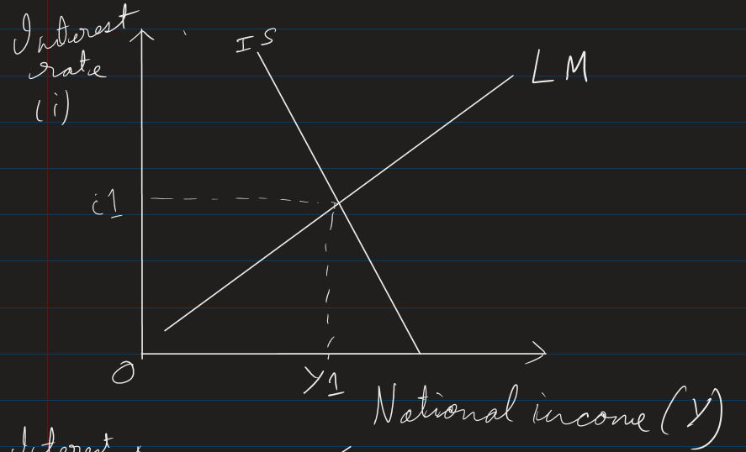
The IS-LM curves are drawn on a graph with interest rates on the vertical axis and national income on the horizontal axis. The IS curve slopes downward from left to right showing that lower rates of interest lead to higher levels of national income. The LM curve slopes upward from left to right showing that in order to obtain equilibrium in the money market, given the supply of money, higher levels of national income are associated with higher rates of interest.
At the rate of interest and level of national income where the IS-LM curves intersect in the graph both the money market and the market for goods and services are in equilibrium.
ii) An increase in the average price level will result in a reduction in the real value of the money supply. A reduction in the money supply will shift the LM curve to the left giving an increase in the equilibrium rate of interest and a fall in the equilibrium level of national income.
The reduction in the money supply gives an excess demand for money causing rates of interest to rise. The rise in interest rates discourages investment and consumer expenditure, reducing injections and causing the equilibrium level of national income to fall.
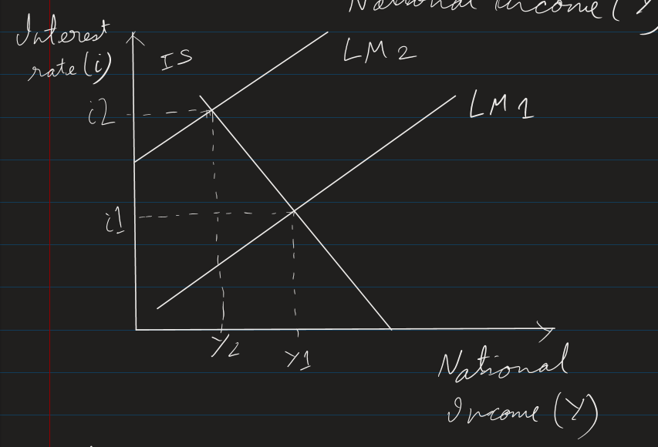
iii) With an expansionary fiscal policy financed by the sale of bonds, the government sells bonds and uses the proceeds raised to finance increased government expenditure. The effect on the money supply should be zero as the money raised from the bond sales is spent by the government.
However, the increase in the supply of bonds for sale pushes down bond prices and raises the interest rate. There is a multiplier effect associated with the increase in government expenditure which is only partially offset by the effect of rising interest rates on consumption and investment so there is a net increase in the level of national income.
This is depicted in the diagram below with the increase in government expenditure shifting the IS curve to the right from IS1 to IS2 and the interest rate rising from r1 to r2 and the level of national income rising from Y1 to Y2
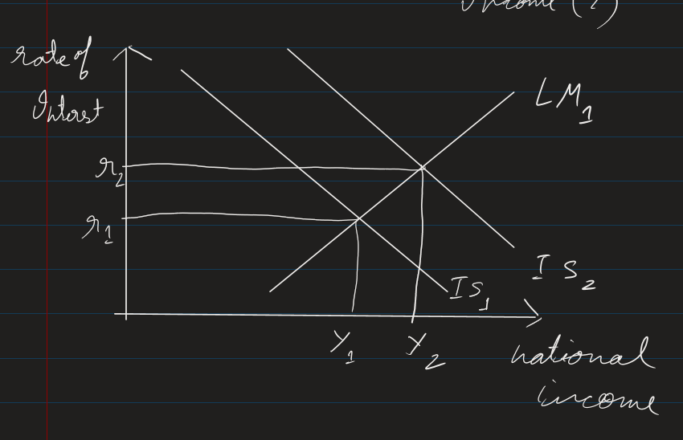
- Exports = 385
Balance of trade in services = -20
Income payments (Investment Income) = -175
Net Income flows = -35
Current Account Balance = -95
Capital and financial account balance = 95
- A
- 1. Frequent changes in currency value could adversely affect trade and investment by creating uncertainty and losing business confidence. Government, therefore, wish to prevent fluctuations in currency value.
2. The measures available to the central bank in this regard would depend on whether the aim is to curtail day to day or longer term changes in exchange rate.
3. If the government aims to maintain the value of currency close to a long term equilibrium value , it could buy or sell the domestic currency in the foreign exchange market. The central bank’s intervention will result in reverse shifts in demand and supply curves and the desired exchange rate would be restored.
4. To alleviate the downward pressure on the currency, the government could borrow foreign currency from other countries and international agency like IMF. It could use the loan to buy domestic currency in international market. This will result in returning the demand and supply curves to the original positions and the currency value to resume its original level.
5. The another measure is; the government could raise interest rate temporarily. This will encourage those aboard to deposit their money in the domestic country. Raising interest rate will result in an increase in demand for and decrease in supply for domestic currency.
6. Government can use fiscal and monetary policies to maintain the monetary value of the currency for longer periods such as months and years.
7. Contractionary fiscal and monetary policy can be used to reduce aggregate demand. A contractionary fiscal policy would involve raising taxes / reducing government spending. A contractionary monetary policy would involve raising interest rate to reduce borrowing and hence aggregate demand.
8. A reduction in aggregate demand would reduce expenditure on imported goods and hence reduce supply of currency in foreign exchange market. A reduction in aggregate demand would also reduce inflation. With lower prices in domestic market, exports will be cheaper and more attractive to consumers aboard and hence increase their demand for domestic currency. There will also less demand for expensive foreign goods leading to lower imports and lower supply of domestic currency. Both effects will support value of domestic currency.
9. The government may also improve supply side policies like improving the long term competitiveness of the domestic industry by improving quality of goods produced and lowering the production cost. This can be achieved for quality of training and research / development.
48. (i) 30m surplus
(ii) 10m deficit
iii) -40m
iv) No, the country does not have a fully flexible exchange rate. We can deduce this from the entry decrease in official reserves” which indicates that the central bank has been purchasing the domestic currency

