Q1]

A stochastic model is one that recognises the random nature of the input components. Stochastic models have the following advantages over deterministic models: 1. To reflect reality as accurately as possible, the model should imitate the random nature of the variables involved. 2. A stochastic model can provide information about the distribution of the results (e.g. probabilities, variances etc), not just a single best estimate figure. 3. Stochastic models allow you to use Monte Carlo simulation, which is an extremely powerful technique for solving complex problems.
For a time-inhomogeneous model the transition rates and are functions of t. It is certainly possible to improve the fit by using a time-inhomogeneous model in this instance. However, If the age profile is represented by a density function f(a); then the overall average rate at which a healthy employee falls sick is = , roughly constant for all t. The same of course applies to the overall average rate of recovery.
Proof: Given that Increment Xt+u –Xt for every u>0 are independent of past values of Xm and nonoverlapping.

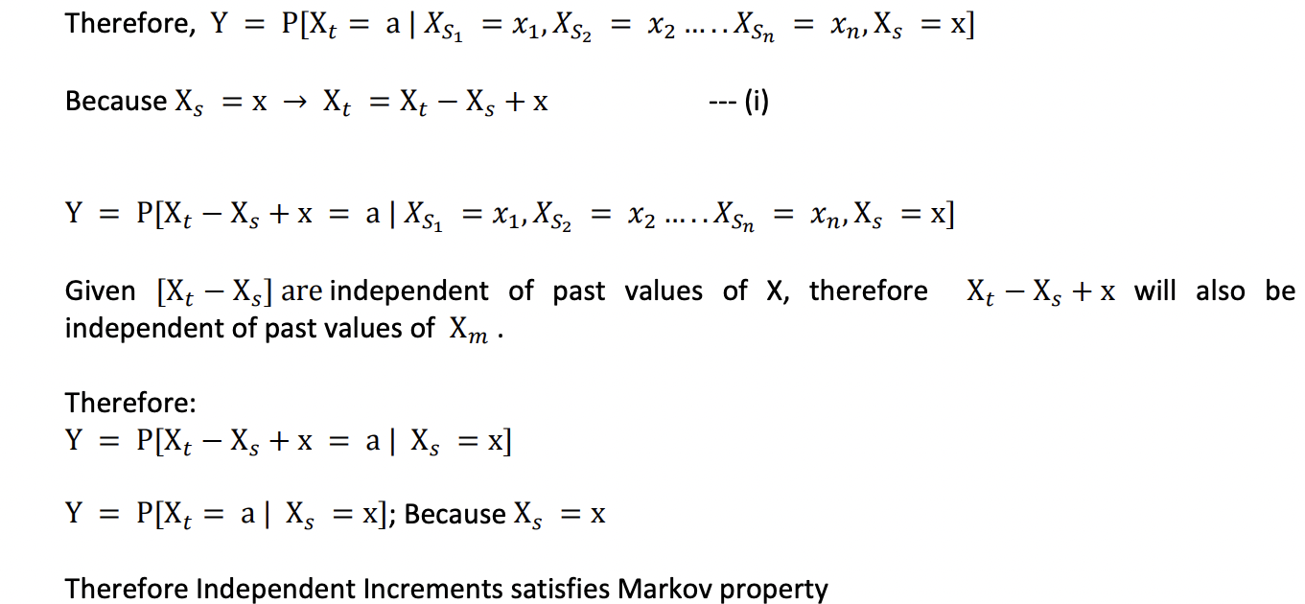

Q2] i) Consider a Markov chain taking values in the set S = {i : i = 0, 1, 2, 3, 4}, where i represents the number of umbrellas in the place where the Actuary currently is (at home or office). If i = 1 and it rains then he take the umbrella, move to the other place, where there are already 3 umbrellas, and, including the one he brings, therefore he will now have 4 umbrellas. Thus, p1,4 = p, because p is the probability of rain. If i = 1 but does not rain then he do not take the umbrella, goes to the other place and find 3 umbrellas. Thus, p1,3 = 1 − p ≡ q. However, if i=0, he must move to other place where 4 umbrellas are kept with probability P0,4 =1 Similarly for other states. The process is depicted by the following diagram.

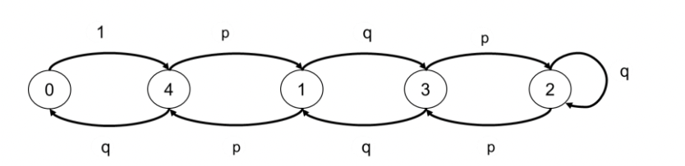
ii) 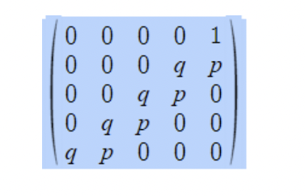

For stationary distribution πP = π Writing the equations:
π (0) = π (4).q ----1
π (1) = π (3).q + π (4).p ----2
π (2) = π (2).q + π (3).p ----3
π (3) = π (1).q + π (2).p ----4
π (4) = π (0) + π (1).p ----5
Substituting 1 in 5 π (4) =π (4).q + π (1).p => π (1) = π (4). (1-q)/ p => π (1) = π (4). p/ p => π (1) = π (4) --- 6

Substituting 6 in
2 π (1) = π (3).q + π (4).p => π (4) = π (3).q + π (4).p => π (3) = π (4).(1-p)/q => π (3) = π (4) ---7
Substituting 7 in 3 π (2) = π (2).q + π (3).p => π (2) = π (3).p/(1-q) => π (2) = π (3).p/(1-q) => π (2) = π (3). ----8
Substituting 6 & 7 in 4 π (3) = π (1).q + π (2).p => π (4) = π (1).q + π (4).p => π (1) = π (4).(1-p)/q => π (1) = π (4)

Therefore π (1)= π (2)= π (3)= π (4) = π (0)/q But π (0) + π (1) + π (2) + π (3) + π (4) = 1, substituting in terms of π (4) π (4).q + 4 π (4) =1
Therefore π (4) = 1/(4+q) = π (1)= π (2)= π (3) and π (0) = q/(4+q)

He will wet every time he happens to be in state 0 and it rains. The chance he is in state 0 is π (0). The chance it rains is p. Hence Probability that he gets wet.
P(WET) = Probability of being in state 0 and it’s raining
P(WET) =[q/(4+q)]. p

P(WET) = 0.6*0.4/(4+0.4) = 5.45%
If he want the chance to be less than 1% then, clearly, he need more umbrellas. So, suppose he need N umbrellas. Set up the Markov chain as above and generalising, it is clear that
π (1)= π (2)= π (3)= π (4) …… = π (N) = π (0)/q. But π (0) + π (1) + π (2) + π (3) + π (4) … π (N) = 1, substituting in terms of π N) => π (N).q + N π (N) =1 =>
π (N) = 1/(N+q)

Therefore probability of getting Wet P(WET)= p* π (0) = (p*q)/(N+q)

For P(WET) < 1/100 => (p*q)/(N+q)< 1/100
N > 100*p*q – q ; given p = 0.6, q =0.4

N > 24 -0.4 = 23.6
Thus it is not worth to keep 24 umbrellas instead of 4 to reduce the probability of getting wet from 6% to 1%. On the days he did not take the umbrella but it starts raining he may buy a cheap (use and throw) umbrella from nearby local shop or take a cab/ other mode of transport to office or borrow/ share an umbrella from some friend/ colleague using the same route or wait for the rain to subside etc. (any other suitable alternative is fine).

Q3] 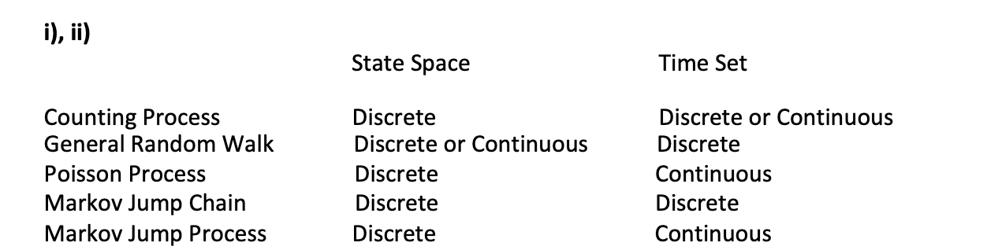

iii) a) Number of times the account has been overdrawn since it was opened – Poisson Process / Counting Process
b) Status (overdrawn, in credit) of the account on the last day of each month – Markov Jump Chain/ Counting Process
c) number of direct debits paid since the account was opened – Poisson
d) Status (overdrawn, in credit) of the account at any time since the account was opened. Markov Jump Process .

Q4] i) Past history is needed to decide where to go in the chain. If a sportsmen is at A and his/her performance reduces, you need to know what level of performance he was at the previous year to determine whether he or she drops one or two levels.

ii) The B level needs to be split into two. B+ is the level with no reduction in performance parameter last year B- is the level with reduction in performance parameter last year These levels are for modelling purposes and not the actual levels.

iii) The Process diagram is given below.

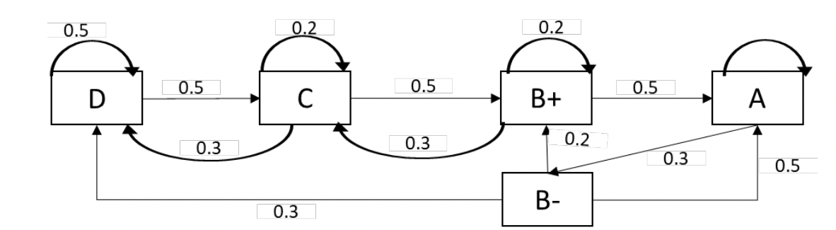

iv) The transition matrix is given by:

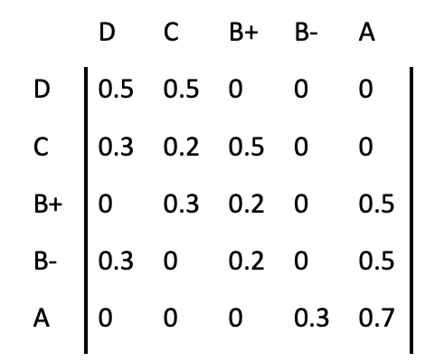

Stationary distribution:
The stationary distribution is the set of probabilities that satisfy the matrix equation

π = πP with and additional condition ∑ 𝜋𝜋𝑖𝑖 = 1

Written out fully, this set of matrix equation is

0.5𝜋𝜋𝐷𝐷 + 0.3𝜋𝜋𝐶𝐶 + 0.3𝜋𝜋𝐵𝐵− = 𝜋𝜋𝐷𝐷 ---a)
0.5𝜋𝜋𝐷𝐷 + 0.2𝜋𝜋𝐶𝐶 + 0.3𝜋𝜋𝐵𝐵+ = 𝜋𝜋𝐶𝐶 ---b)
0.5𝜋𝜋𝐶𝐶 + 0.2𝜋𝜋𝐵𝐵+ + 0.2𝜋𝜋𝐵𝐵− = 𝜋𝜋𝐵𝐵+ ---c)
0.3𝜋𝜋𝐴𝐴 = 𝜋𝜋𝐵𝐵− ---d)
0.5𝜋𝜋𝐵𝐵+ + 0.5𝜋𝜋𝐵𝐵− + 0.7𝜋𝜋𝐴𝐴 = 𝜋𝜋𝐴𝐴 ---e)
Substituting (d) in (e) 0.5𝜋𝜋𝐵𝐵+ + 0.5 ∗ 0.3𝜋𝜋𝐴𝐴 + 0.7𝜋𝜋𝐴𝐴 = 𝜋𝜋𝐴𝐴 => 𝜋𝜋𝐵𝐵+ =
0.3𝜋𝜋𝐴𝐴 …….(vi)
Substituting 𝜋𝜋𝐵𝐵+ 𝑎𝑎𝑎𝑎𝑎𝑎 𝜋𝜋𝐴𝐴 in (c) we get

0.5𝜋𝜋𝐶𝐶 + 0.2 ∗ 0.3𝜋𝜋𝐴𝐴 + 0.2 ∗ 0.3𝜋𝜋𝐴𝐴 = 0.3𝜋𝜋𝐴𝐴 => 𝜋𝜋𝐶𝐶 = 0.36𝜋𝜋𝐴𝐴
Substituting 𝜋𝜋𝐵𝐵+, 𝜋𝜋𝐶𝐶 𝑎𝑎𝑎𝑎𝑎𝑎 𝜋𝜋𝐴𝐴 in (b)
0.5𝜋𝜋𝐷𝐷 + 0.2 ∗ 0.36𝜋𝜋𝐴𝐴 + 0.3 ∗ 0.3𝜋𝜋𝐴𝐴 = 0.36𝜋𝜋𝐴𝐴 ---b)
=> 𝜋𝜋𝐷𝐷 = 0.396𝜋𝜋𝐴𝐴
Substituting all in ∑ 𝜋𝜋𝑖𝑖 = 1
𝜋𝜋𝐴𝐴 + 0.3𝜋𝜋𝐴𝐴 + 0.3𝜋𝜋𝐴𝐴+0.36𝜋𝜋𝐴𝐴+0.396𝜋𝜋𝐴𝐴=1
𝜋𝜋𝐴𝐴 = 0.42445
𝜋𝜋𝐵𝐵− = 0.12733
𝜋𝜋𝐵𝐵+ = 0.12733
𝜋𝜋𝐶𝐶 = 0.15280
𝜋𝜋𝐷𝐷 = 0.1680 8

vi) Long run average contract value is 100% πD + 120% πC + 150% ( πB+ + πB- ) + 175% πA = 1.4762 million USD

Let mi be the number of transitions ( and years) taken to reach level A from any current level i. Then
𝑚𝑚𝐷𝐷 = 1 + 0.5𝑚𝑚𝐷𝐷 + 0.5𝑚𝑚𝐶𝐶 …..(a)
𝑚𝑚𝑐𝑐 = 1 + 0.2𝑚𝑚𝐶𝐶 + 0.5𝑚𝑚𝐵𝐵+ + 0.3𝑚𝑚𝐷𝐷 .....(b)
𝑚𝑚𝐵𝐵+ = 1 + 0.2𝑚𝑚𝐵𝐵+ + 0.5𝑚𝑚𝐴𝐴 + 0.3𝑚𝑚𝐶𝐶 .....(c)
𝑚𝑚𝐵𝐵− = 1 + 0.3𝑚𝑚𝐷𝐷 + 0.5𝑚𝑚𝐴𝐴 + 0.2𝑚𝑚𝐵𝐵+ .....(c)
𝑚𝑚𝐴𝐴 = 0
from (a) we get,

𝑚𝑚𝐷𝐷 = 2 + 𝑚𝑚𝐶𝐶
substituting in (b) we get,

𝑚𝑚𝑐𝑐 = 1 + 0.2𝑚𝑚𝐶𝐶 + 0.5𝑚𝑚𝐵𝐵+ + 0.3(2 + 𝑚𝑚𝐶𝐶)
𝑚𝑚𝐵𝐵+ = 𝑚𝑚𝐶𝐶 − 3.2
substituting in (c) ,

𝑚𝑚𝐵𝐵+ = 1 + 0.2𝑚𝑚𝐵𝐵+ + 0.5𝑚𝑚𝐴𝐴 + 0.3𝑚𝑚𝐶𝐶
𝑚𝑚𝐶𝐶 − 3.2 = 1 + 0.2(𝑚𝑚𝐶𝐶 − 3.2) + 0.3𝑚𝑚𝐶𝐶

𝑚𝑚𝐶𝐶 = 7.12 years

Therefore, 𝑚𝑚𝐷𝐷 = 2+ 𝑚𝑚𝐶𝐶 = 9.12 years

Q5]
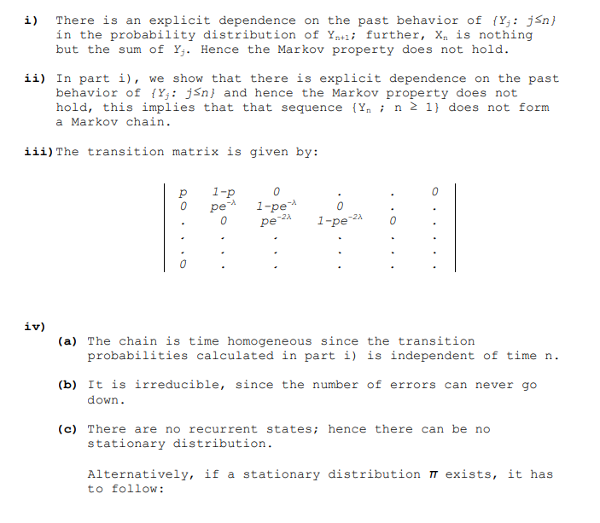
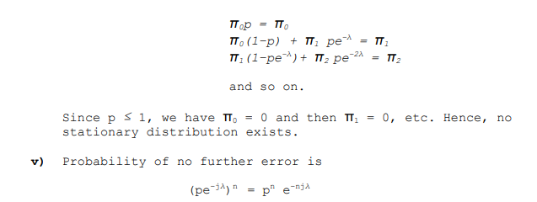

Q6]
a). A stochastic model allows for the randomness of the input parameters.

Stochastic model have following advantage over deterministic model:
-a stochastic model provides the distribution of the results ( probabilities and variances) and not just a single best estimate.
- Stochastic model correctly reflects the random nature of the variables involved as against deterministic one.
- Stochastic model allow to use Monte Carlo simulation which is a powerful technique to solve complex problem.

b). (i) Assume that the functions pij(s, t) are continuously differentiable, the transition rates are defined by differentiation with respect to t.
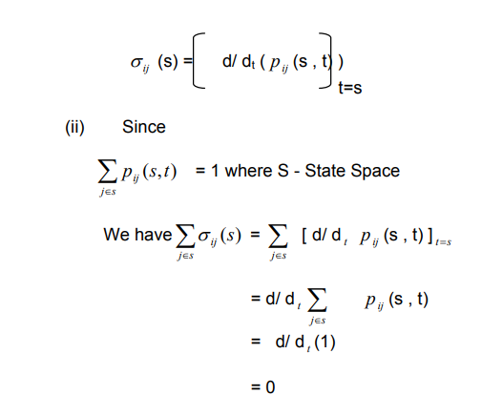

Q7]

(a) The process may be expressed as a Markov chain by considering following states. Each state indicates the current number of successive defeats.

State Number of successive defeats
1 0 – Not defeated last time
2 1 – Defeated in the last match
3 2 – Defeated in the last two matches
4 3 – Defeated in the last three matches
5 4 – Captain sacked

The transition matrix is as follows:

$$\left[\begin{matrix}0.7 & 0.3 & 0 & 0 & 0 \\ 0.7 & 0 & 0.8 & 0 & 0 \\ 0.7 & 0 & 0 & 0.8 & 0 \\ 0.7 & 0 & 0 & 0 & 0.8 \\ 0 & 0 & 0 & 0 & 0\end{matrix}\right]$$

(b) A Markov chain is said to be irreducible if any state j can be reached from any state i.
The above process is not irreducible as the captain, once sacked, can never become the captain again.

(c) (i) The probability of remaining the captain for exactly four matches is given by:
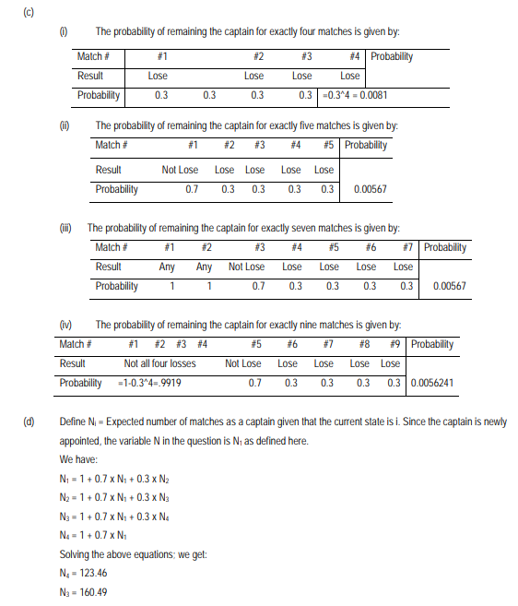
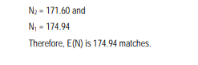

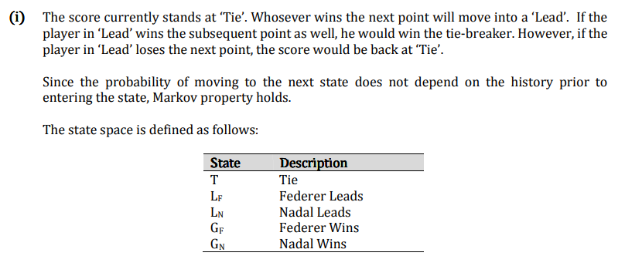
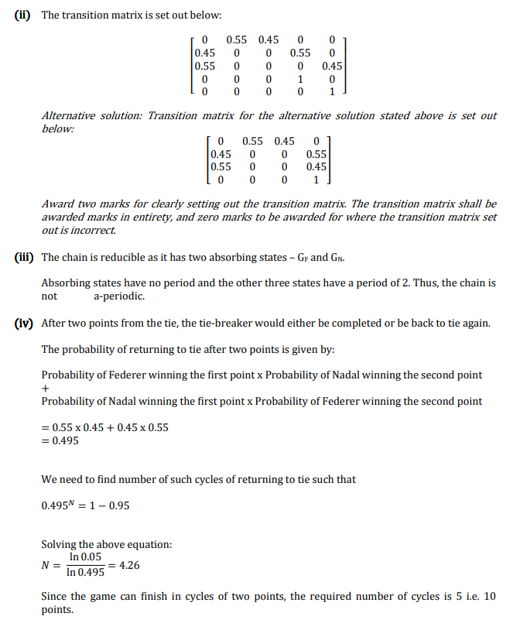
Q8]
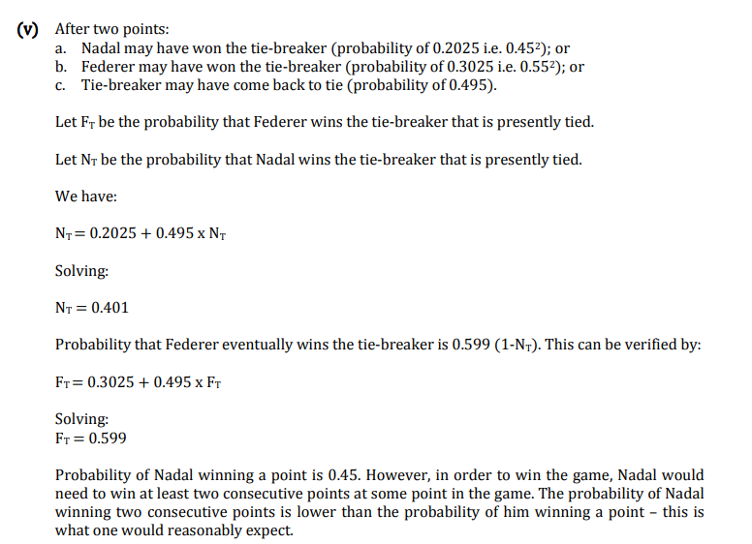

Q9]

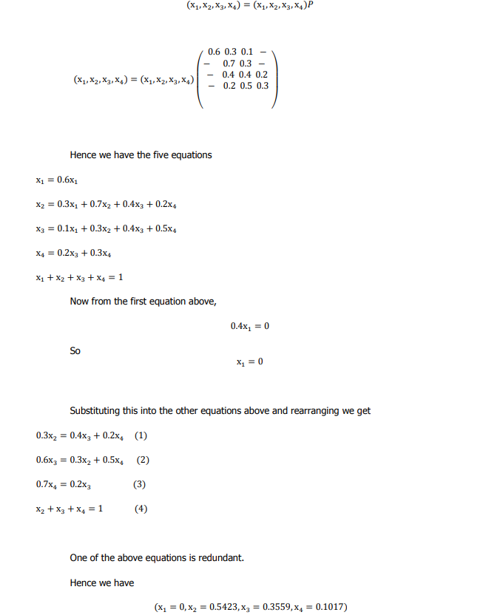
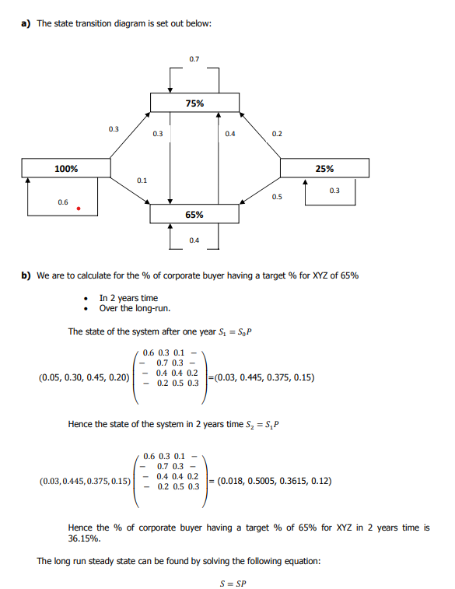
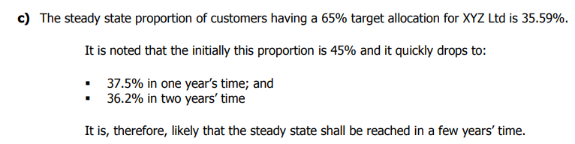
Q10]
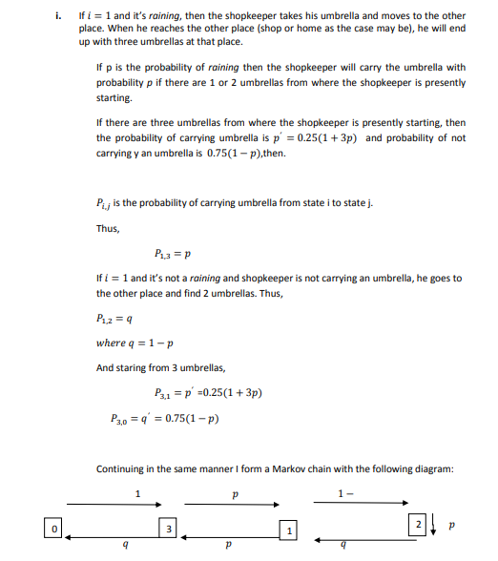
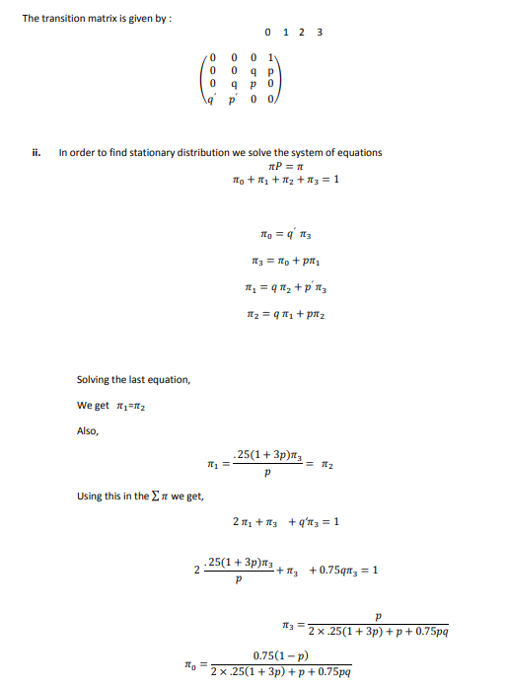
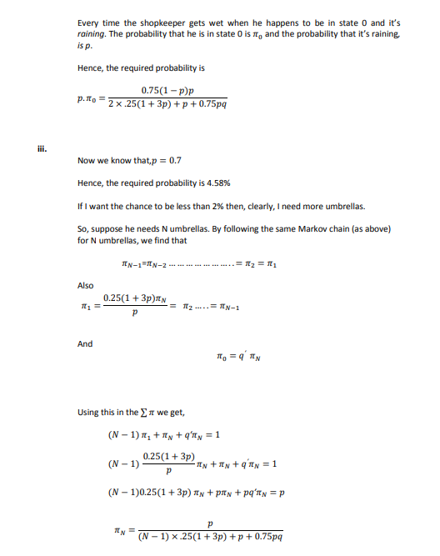
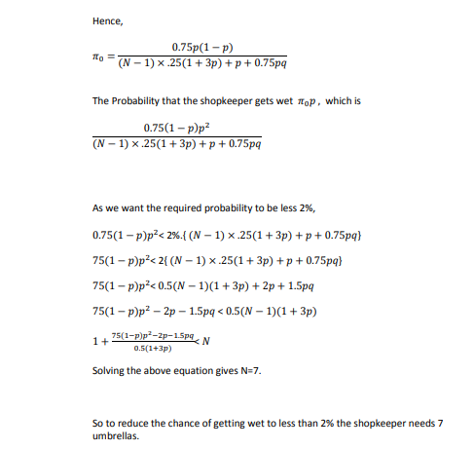

Q11]

i)If each room is represented by the state, then the transition matrix P for this Markov chain is as follows:
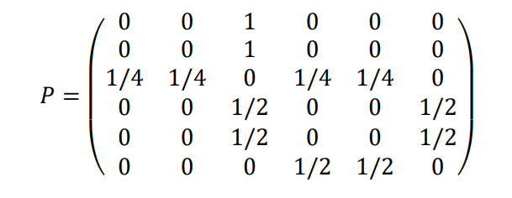

ii) The chain is irreducible, because it is possible to go from any state to any other state. However, it is not aperiodic, because for any even n ,𝑃6,1
𝑛 will be zero and for any odd n 𝑃6,5
𝑛 will also be zero . This
means that there is no power of P that would have all its entries strictly positive.

iii) For P to be stationary,
πP = P
Perform matrix multiplication and show that π P is equal to P
iv) We find from π that the mean recurrence time (i.e. the expected time to return) for the room 1 is
1/π(1)=12

v) Let, ψ(i) = E(number of steps to reach state 5 | X0 = i).
We have
ψ(5) = 0
ψ(6) = 1 + (1/2)ψ(5) + (1/2)ψ(4)
ψ(4) = 1 + (1/2)ψ(6) + (1/2)ψ(3)
ψ(3) = 1 + (1/4)ψ(1) + (1/4)ψ(2) + (1/4)ψ(4) + (1/4)ψ(5)
ψ(1) = 1 + ψ(3)
ψ(2) = 1 + ψ(3).

We solve and find ψ(1) = 7.

Q12]
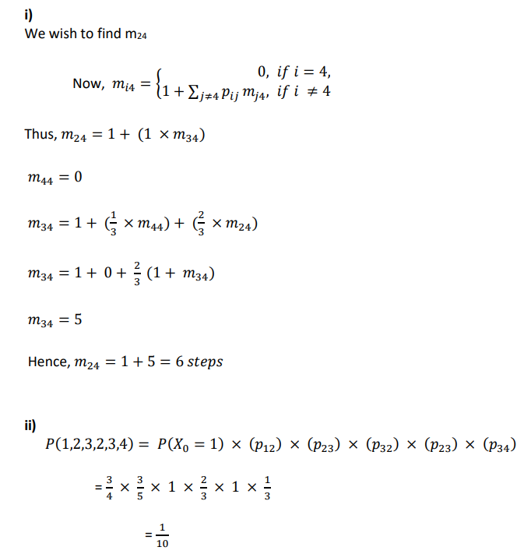

Q13]

