SRM Project – Word Documentation

Introduction
Graduation is a technique used to get a smooth and justifiable mortality rate. The crude mortality rates derived from a mortality investigation will not be the final rates that are published for use in actuarial calculations. The rates will have to pass through a further process called graduation. Graduation results in a ‘smoothing’ of the crude rates. The main objectives of performing graduation on mortality data is to get smooth and consistent output for calculations, minimize the sampling errors present in our crude data. To eliminate the unexplainable jumps or roughness present in the data which may hinder the further calculations.

Case Study Overview
We have been given the data of the total central exposed to risk and the total number of deaths for each age varying from age 25 to 75 years old. The given data is present in terms of age last birthday. We have 51 records in the data and have been asked to compute the crude mortality rates, graduated mortality rates, expected number of deaths and the standardized deviations between the actual and expected number of deaths. Following the computation of these values, we perform various tests on the graduated rates to test for their smoothness and adherence to the data i.e., the goodness of fit. All the calculations and tests are done using R software. The descriptions of columns of the dataset is given below:

Graduation Process
We need to go through certain steps in order to fully carry out the graduation and testing it.
- Finding crude mortality rates
Given the central exposed to risk at age x last birthday and the number of deaths at age x last birthday, the first and foremost step to perform is to compute the crude mortality rates for each age using the below formula:
number of deaths at age x last birthday
Central exposed to risk at age x last birthday
Crude mortality at age x last birthday =

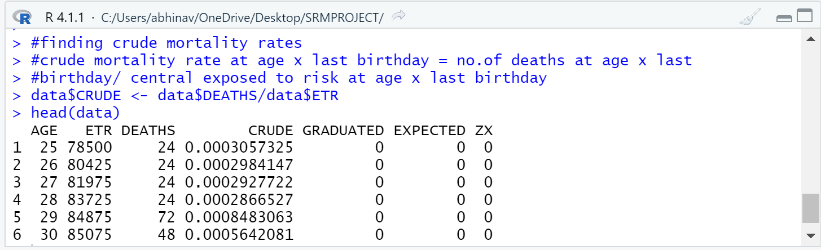
- Fitting a model to find graduated rates
We then move on to create a model for the mortality function to find the graduated mortality rates for the data. We will use a Gompertz model to model our mortality data as asked in the question.
Gompertz mortality functions: u(x) = alpha*exp(beta*x)
Where, u(x) is the mortality at age x
x is the age for which we are calculating mortality
alpha and beta are the parameters of the model.
There is no direct way in R software with which we could compute the parameters alpha and beta. What we do instead is we take the log of the whole Gompertz model so that we can make the whole function linear and then use linear regression to compute alpha and beta.
Log(u(x)) = log(alpha) + beta*x
So now, the overall equation can be seen as log(u(x)) being response variable, log(alpha) being intercept, and beta being the coefficient of age in the linear regression model. Then we use ‘lm’ function to set a linear model between log(u(x)) and age and use the coefficients to find the values of the parameters (alpha = exp(intercept) and beta = coefficient of age) and then compute the graduated rates using those parameters.
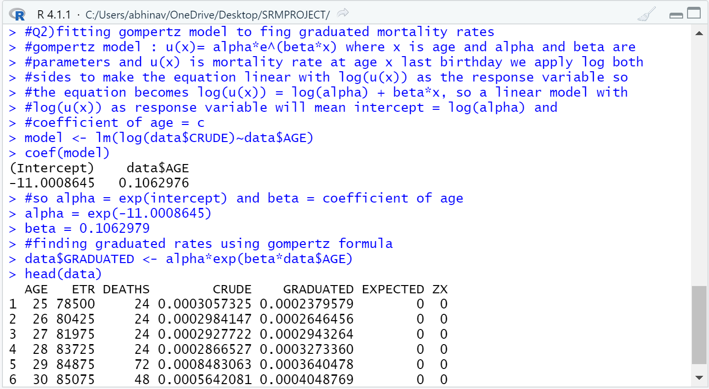

- Testing for smoothness
After fitting the graduated rates, we need to test them for smoothness as smoothing the mortality rates is one of the main purposes of graduation. We do this test by looking at the third differences of the graduated rates. If the third difference is small in magnitude compared to the graduated rates and progresses regularly, the graduated rates pass the test of smoothness.
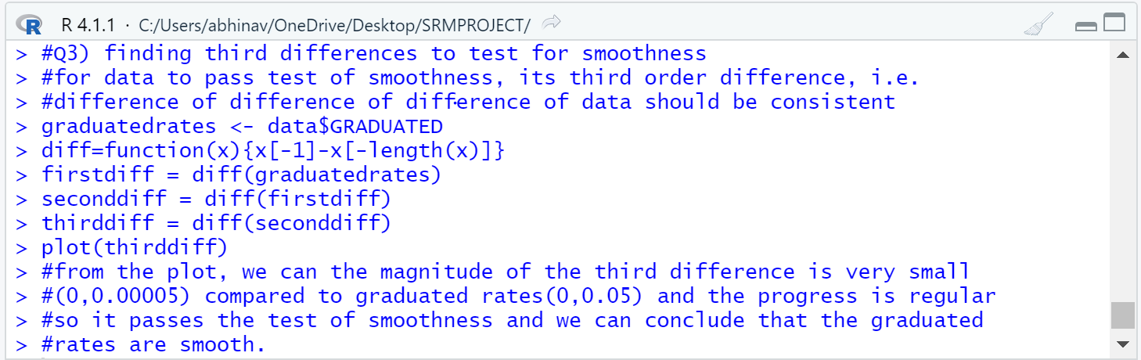
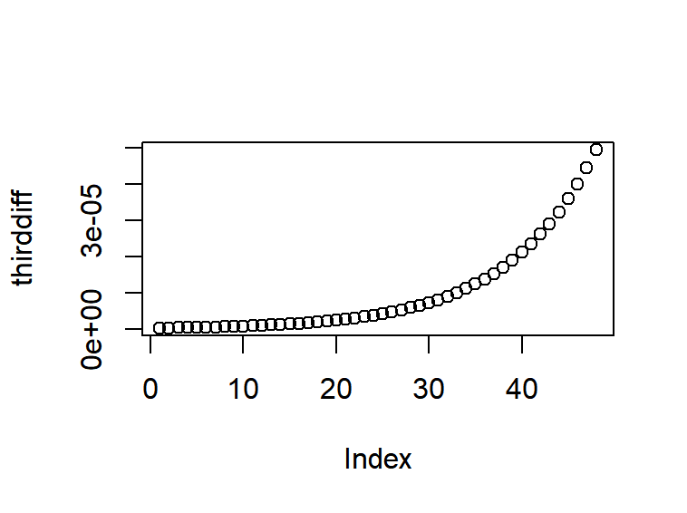
From the above graph, we can see that the third difference progress regularly and it is small in magnitude compared to graduated rates which range up to 0.05 and hence it passes the smoothness test.
- Calculating expected deaths and standardized deviations
After testing for smoothness, we can go ahead and calculated the expected number of deaths and the standardised deviations of the deaths using the below formulas.
Expected number of deaths at age x = graduated mortality rates at age x * central exposed to risk at age x
Standardized deviations (Zx) =
(Actual deaths at age x – expected deaths at age x)
sqrt (expected deaths at age x)

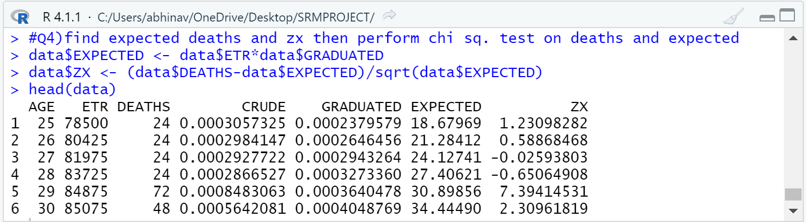

- Performing chi square goodness of fit test for actual and expected deaths
To find the whether the graduated rates are a good fit to the crude mortality rates, we need to perform a chi square test on expected and actual deaths with the null hypothesis being the graduated rates are a good fit to crude rates. The formula for degrees of freedom to test the data is no of records – no of parameters used. Here in, we have 51 data records and we used two parameters to find graduated rates so our degrees of freedom will be 51-2 = 49.
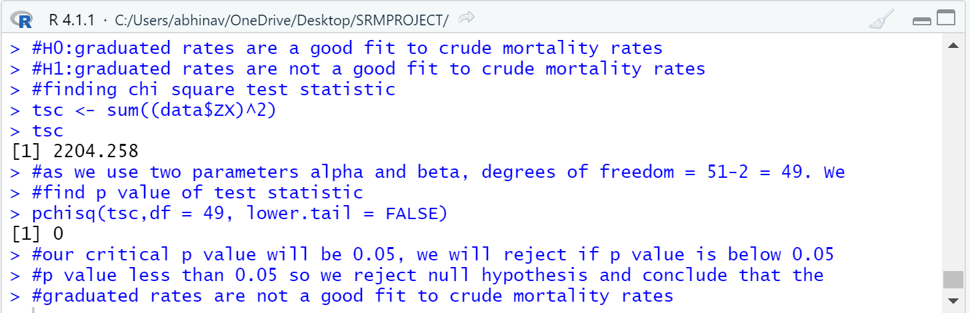
We can compute the test statistic by finding the sum of square of the standardized deviation and then finding its p value using degrees of freedom as 49. From the above result, we can see that our p value is less than 0.05, so we reject the null hypothesis and conclude that the graduated rates are not a good fit to crude rates.

- Performing Standardized deviations test
This test looks at the distribution of the standardized values. This is a good all-round test that detects most of the problems that might be present in a graduation including any outliers. For this test we compare the Zx values with a standard normal distribution. The null hypothesis of this test is the Zx is normally distributed.
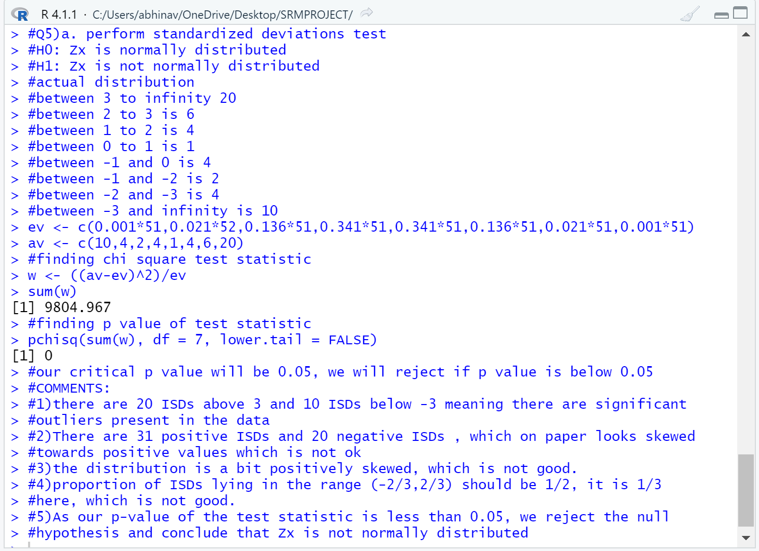
From the above test, we can see that the there are 30 Zx falling below -3 and above +3 suggesting the presence of outliers in the data. There are 31 positive and 20 negative Zx which is not ok. As far as symmetry is concerned, the Zx looks positively skewed. There should be 50% of ISDs but there’s only 33% which is not good. After performing chi square test for actual and expected numbers of distribution, we reject the null hypothesis and conclude that the ISDs are not normally distributed.

- Performing Signs test
The signs test is a simple test for overall bias. In other words, this test checks whether the graduated rates are too high or too low.
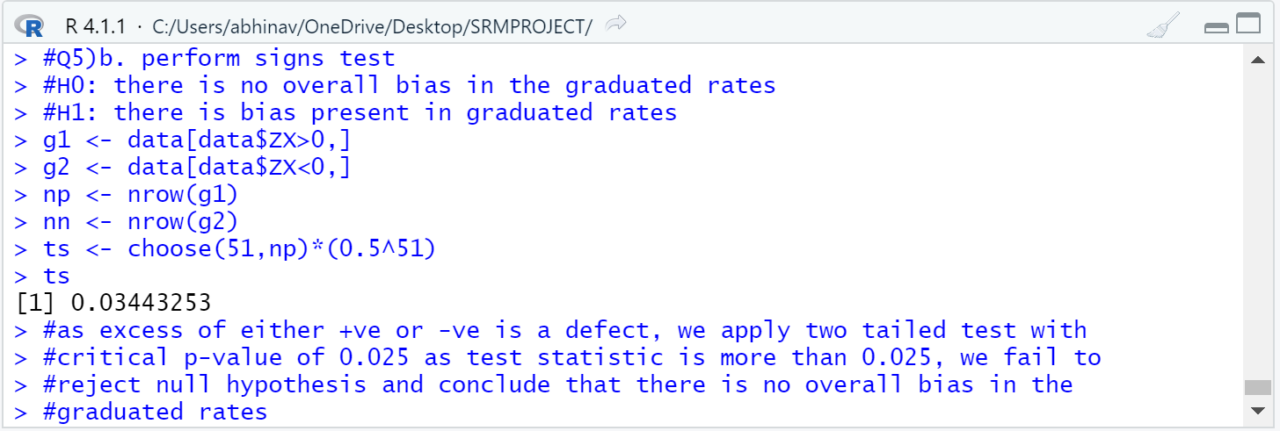
For a test at the 5% significance level, we compare the p value with the lower and upper 2.5%. Since 0.034 is greater than 0.025, we fail to reject the null hypothesis and
conclude that there is no evidence of overall bias in the graduated rates.

- Performing Cumulative deviations test
The cumulative deviations test detects overall bias or long runs of deviations of the same sign. We compute the test statistic using the formula:

Test statistic = (total actual deaths – total expected deaths)/ sqrt (total expected deaths)

The test statistic follows a normal distribution so we use normal distribution to conclude the hypothesis. The null hypothesis is there is no overall bias in the data.
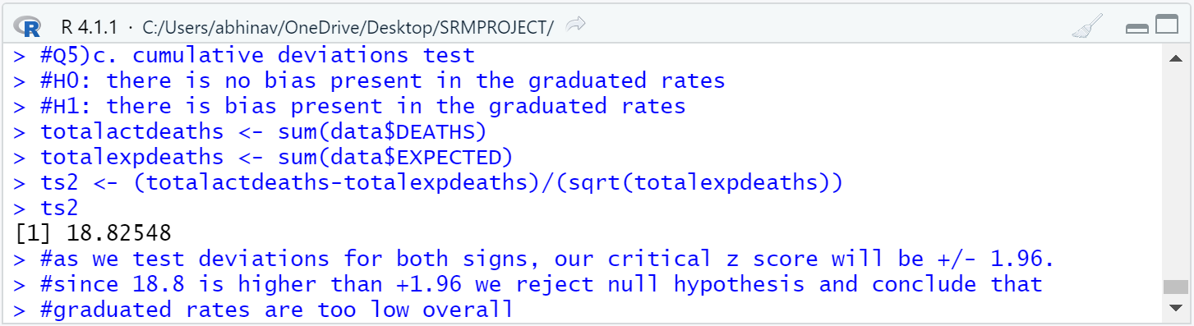
From the above test, we obtain a test statistic of 18.8. For a test at the 5% significance level, we compare the value of the test statistic with the lower and upper 2.5% points of N(0,1) , i.e. with ±1.96 . Since 18.8 is greater than 1.96, we reject the null hypothesis and conclude that the graduated rates are too low overall.

- Performing Serial correlation test
We have this test to test for clumping of deviations of the same sign. If clumping is present, then the graduation has the wrong shape. We will assume lag to be 1. Null hypothesis is there is no clumping of same sign present in data. We will find the correlation using the formula:
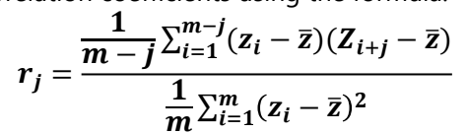
And the formula of test statistic, which follows normal distribution is : r1*(sqrt(m)) where m is the number of records (51 in this case).
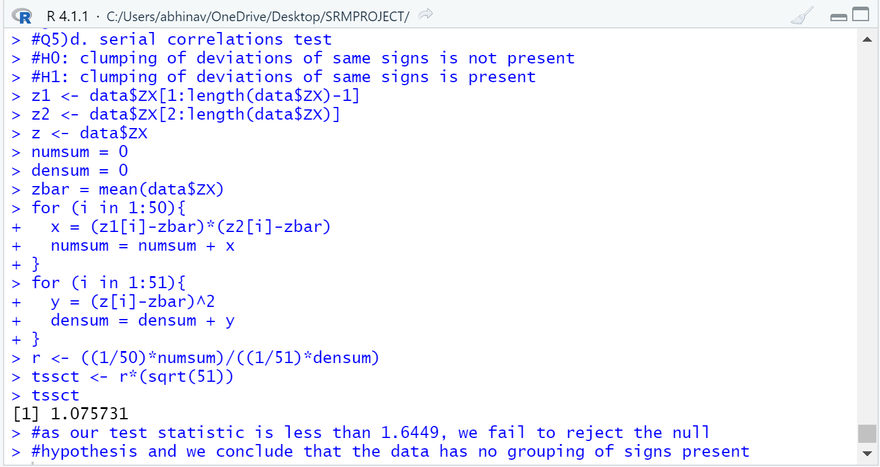
From the above test, the test statistic obtained is 1.075. As we are only testing for positive correlation, we compare the value of the test statistic with 1.6449, the upper 5% point of N (0,1). We find that there is insufficient evidence to reject the null hypothesis or, in other words, there is no evidence of grouping of signs.

Conclusion

From the above steps and tests, we can conclude that the graduation manages to achieve smoothness but fails to replicate the adherence required to make a good graduation fit. The graduation was not able to adjust to sudden jump in mortality rates at age 31 and typically deeply overestimated o underestimated the deaths in 30 out of 51 cases. A Makeham model would probably resolve this problem.

