Name : katakam Shriya
Roll number 403

Q1) the crude death rate is the no of deaths in a certain age group/ the no of lives at the start of the age group. That is Graduation_data$CRUDE <-Graduation_data$DEATHS/Graduation_data$ETR

Q2) Gompetz law is $μ_{x}=b. c^{x}$
Taking log on both sides gives $\log\left(μ_{x}\right)=\log\left(b\right)+xlog(c)$
Fitting a lm on the same gives model1<- lm(log(CRUDE)~AGE, data= Graduation_data)
The intercept of the model gives log(b) and the coefficient of x gives log(c)
B= 1.668727e-05
C= 1.112153

Q3) Smoothness of the data is when there aren’t any sudden changes in the data
The third difference is apply difference ti the differences twice. The data hence obtained is very small and it has reduced significantly compared to the first difference. This shows the data is smooth. This has also been proved the the graph plotted of the third difference.
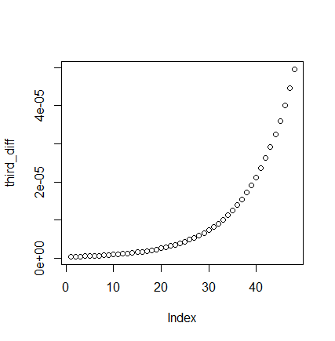
Q5) 5a)Standardized deviations test
table(cut(Graduation_data$ZX, breaks = seq.int(from = -20,to = 20, by= 4)))
i. The graph is very wide compared to a standard normal graph, with several values higher than abs(10)
ii. the Values of the absolute deviations are very high relative to the expected value
iii. The lower bound is approx. -2 and the upper bound is approx. 6. IQR is 8. There are some outliers on the lower side but none on the upper side
iv. The Graph is positively skewed. It looks like it is centered about 2
v. The graduated rates do not represent the underlying mortality rates with accuracy

Q5b) #since it's a two tailed test, at 5% significance level, we accept the NULL hypothesis that the data is a true representation of the underlying mortality rates.
Q5c) #at 5% significance level, we accept the NULL hypothesis that the data is a true representation of the underlying mortality rates.
Q5d) at 5% significance level, we accept the NULL hypothesis that the data is a true representation of the underlying mortality rates.

