Q1
i) Explain arbitrage opportunity.
i) Arbitrage opportunity is a situation where we can make a certain profit with no risk. This is sometimes described as a free lunch
An arbitrage opportunity means that
(a) we can start at time 0 with a portfolio that has a net value of zero (implying that we are long in some assets and short in others). This is usually called a zero-cost portfolio.
(b) at some future time T:
the probability of a loss is 0
the probability that we make a strictly positive profit is greater than 0
If such an opportunity existed then we could multiply up this portfolio as much as we wanted to make as large a profit as we desired.
ii) Define law of one price.
ii) Law of one price
The Law of one price states that any two portfolios that behave in exactly the same way must have the same price. If this were not true, we could buy the 'cheap' one and sell the 'expensive one to make an arbitrage (risk- free) profit.

iii) Let pt be the price of 3-month European put option on a share with current share
price Rs 125 and strike price of Rs 120. The call options on the same share are priced
at Rs 30 and the current risk- free force of interest is r= 5% p.a.
a) If dividends are payable continuously at a rate of q= 15% p.a., calculate pt.
b) Explain the strategy for arbitrage profit if, instead, the price of the put option is Rs
23.
a) Using Put-Call parity, the value of put option should be:
p1=c1+ Kexp(-(T-1))-Stexp(-q(T-1))
-30+120exp(-05 25)-125exp(-15.25) - 28.11

b) Arbitrage profit
If the put options are only Rs. 23 then they are cheap. If things are cheap then we buy them.
So, looking at the put-call parity relationship, we "buy the cheap side and sell the
expensive side", ie we buy put options and shares and sell call options and cash. For example:

sell 1 call option Rs. 30
buy 1 put option (Rs. 23)
buy 1 share (Rs.125)
sell (borrow) cash Rs.118

This is a zero-cost portfolio and, because put-call parity does not hold, we know it will make an arbitrage profit. We can check as follows:
In 3 months' time, repaying the cash will cost you 118exp(0.05-3/12) = Rs. 119.48
We also receive dividends d on the share.

If the share price is above 120 in 3 months' time then the other party will exercise their call option and we will have to give them the share. They will pay 120 for it and our profit is:
120-119.48+d=0.52+d
(The put option is useless to us)
If the share price is below 120 in 3 months' time then we will exercise our put option and sell it for 120. Our profit is: 120-119.48+d=0.52+d
(The call option is useless to the other party and will expire worthless)

Q2 The process X has the stochastic differential equation
dXt = α μ (T-t) dt + σ √(T − t) dZt,
where α > 0 & μ are fixed parameters and Z is a standard Brownian motion under Q.
The function f is given by
where m is a differentiable function
Find ∂m
∂t if f(x, t) is a martingale.
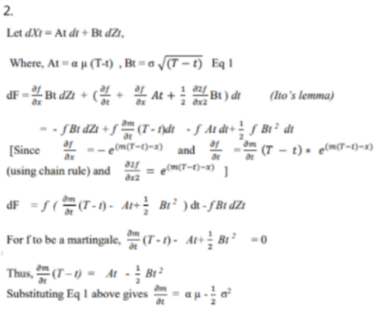

Q3 The stochastic process X follows the SDE given by
where W is a standard Brownian motion.
Consider the new process Y defined by Yt = f(t, Xt) where
i) Write an expression for dYt (4)
ii) Under what condition will the process be a martingale?
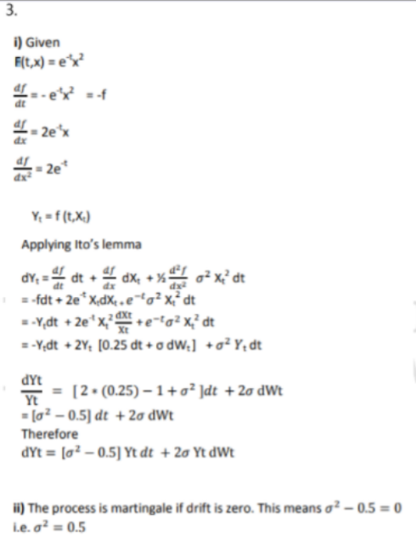

Q4
Consider an American call option on a stock with 10 months to maturity and risk free
rate of interest is 9.5% per annum, exercise price is Rs. 350. A dividend of Rs.10 is
expected after three months from now and again after six months from now.
Show that it can never be optimal to exercise the option on either of the two
dividend dates. (3)
Let ex-dividend dates are anticipated for a stock and t1<t2<t3<….<tn the times before which the stock goes ex-dividend Dividends are denoted by d1….dn .
If the option is exercised before the ex-dividend date then the investor receives S(tn)-K
If the option is not exercised, the price drops to S(tn)-dn. The value of the American option is greater than S(tn)-&- Kexp(-tn(T-tn)
It is never optional to exercise the option if S(tn)-dn-Kesp(T-tn) >= S(tn)-K
Using this equation we have K*(1-exp(-r(T-tn))=350(1-exp(-0.95*(08333-0 251)) = 18.87 and 65*(1-exp(-0.95*(0.8333-0.25)) = 10.91 Hence it is never optimal to exercise the American option on the two ex-dividend rates.

Q5.
A stock price follows Geometric Brownian Motion with an expected return of 16% and a volatility of 35%. The current price is Rs. 254. What is the probability that a European call option on the stock with an exercise price of Rs. 258 and a maturity date in six months will be exercised?
What is the probability that a European put option on the stock with the same exercise price and maturity will be exercised?
The required probability is the probability of the stock price being greater than Rs. 258 in 6 months' time.
The stock price follows Geometric Brownian motion Le. St-50 expla-o^2/2)t + oWt
Therefore Ln (St) follows normal distribution with mean Ln (50)+ (-o^2/2)t and variance (o^2)t
Implies Ln (St) follows ip(Ln 254+ (0.16-0.35^2/2)*0.5, 0.35 0.5^(1/2)) -p (5.59, 0.247)
This means [Ln (St)-St))/ ot^(1/2) follows standard normal distribution,
Hence the probability that stock price will be higher than the strike price of Rs. 258 in 6 months time = 1-N(5.55-5.59)/0.247=1-N(-0.1364) -0.5542
The put option is exercised if the stock price is less than Rs. 258 in 6 months time.
The probability of this 1-0.5542 = 0.4457

6. The market price of a certain share is modelled as Geometric Brownian motion.
The price St at time t ≥ 0 satisfies:
log(St/S0) = μ t + σ Bt
where Bt is a standard Brownian motion and μ and σ are constants
i. Show that dSt can be written as: dSt/St = x dBt + y dt
where x and y are constants to be specified. (4)
ii. Derive E[St] and Var[St] (4)
iii. Derive cov[St1, St2] where 0 < t1 < t2 (6)
i) The given relationship can be written as:
Since St is a function of standard Brownian motion, Bt, applying Ito's Lemma, the SDE for the underlying stochastic process becomes:
dBt=0X dt+ 1 X dBt
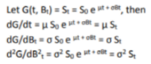
Hence, using Ito's Lemma from Page 46 in the Tables we have:
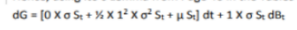
Thus,
ii) The expected value of St is:
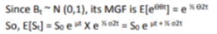
The variance of St is:
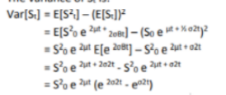
iii)
From above,
The expected value of the product is:
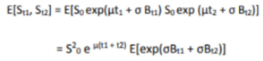
To evaluate this we need to split Bu into two independent components:
Hence,
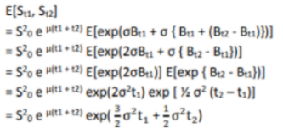
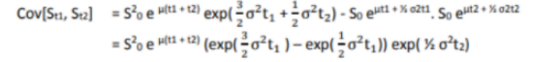

Q7. A commodity of price C is assumed to follow the process:
dC= μCdt+σCdWt
where μ and σ are positive constants and Wt is a standard Brownian motion. The
continuously compounded risk free interest rate r is a constant.
You wish to value a special type of option.
You construct a recombining binomial tree algorithm using a proportionate “up
step” u and “down step” d for each small time interval Δt, and the stock price at time
0 is S0.
i) Specify fully the first step of the binomial process, giving formulae for the up and
down probabilities and step sizes u and d. (3)
The initial commodity price is 80, σ is 15% per annum and r=0. You may assume that
u can be approximated by exp(σ√Δt) for small Δt
ii) For the tree specified in (i)
a) Draw three steps of the tree with quarter- year time steps and calculate the
commodity price at each node. (3)
b) Using this tree, calculate the price of a 9- month European call option with an
at-the-money strike. (2)
c) By considering each possible path in the tree, evaluate the price of a 9- month
European lookback call option, where the lookback period includes time 0. Note that
lookback call pays the difference between the minimum value and the final value of
any asset price. (5)

i) Setting up the commodity tree using u for up move and d for down move, p is up-step probability:
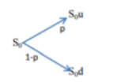
Where p is the up probability and (1-p) the down probability

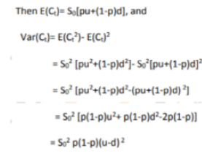
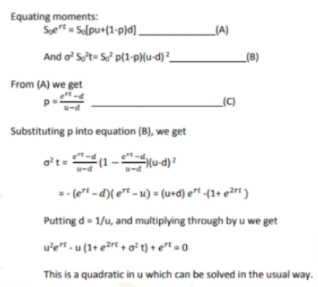
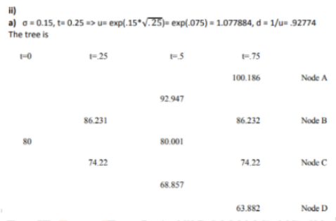
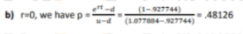
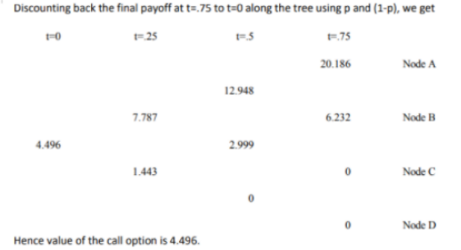
c) The lookback call pays the difference between the minimum value and the final value.
Notate paths by U for up and D for down, in order
We get the payoffs
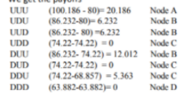
The lookback payoffs are, for each successful path (i.e. with a non-zero result)
Probabilities of arriving at each node are:
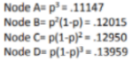
Hence the tree value of lookback option is:
(11147* 20.186)+ (0.12015 *(6.232+6.232+ 12.012)+(12950*5.363) = 5.8854
Q8
i) Derive the price of an option in one step binominal model using risk neural valuations. (5)
ii) What does the price of an option derived above say about the probabilities of the underlying stock going up or down? (2)
iii) Show that the underlying stock price grows on average at risk free rate (3)
iv) Interpret (i) and (iii) in terms of risk neutral world. (2)
i) Consider a stock whose current price is S0 and an option whose current price is f. We suppose that the option lasts for time T and that during the life of the option the stock price can either move up from 50 to a new level S0u or move down to S0d where u> 1 and d < 1.
Let the payoff be fu if the stock price becomes S0u and fd if stock price becomes Sod Let us construct a portfolio which consists of a short position in the option and a long position in A shares. We calculate the value of & that makes the portfolio risk-free. Now if there is an upward movement in the stock the value of the portfolio becomes ASOU - fu and if there is a downward movement of stock, the value of the portfolio becomes ASOD The two portfolios are equal if AS-, ASud-t
Or 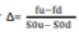so that the portfolio is risk-free and hence must earn the risk free rate of interest.
This means the present value of such a portfolio is
Where is the risk free rate of interest.
The cost of the portfolio is
Since the portfolio grows at a risk free rate, it follows that
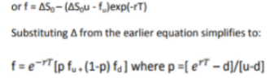
ii. The option pricing formula does not involve probabilities of stock going up or down although it is natural to assume that the probability of an upward movement in stock increases the value of call option and the value of put option decreases when the probability of stock price goes down.
This is because we are calculating the value of option not in absolute terms but in terms of the value of the underlying stock where the probabilities of future movements (up and down) in the stock already incorporates in the price of the stock. However, it is natural to interpret p as the probability of an up movement in the stock price.
The variable 1-p is then the probability of a down movement such that the above equation can be interpreted as that the value of option today is the expected future value discounted at the risk free rate
The expected stock price E(St) at time
or
Substituting p from above equation in
We get
i.e. stock price grows at a risk free rate or return on a stock is risk free rate

iv. In a risk neutral word individuals do not require compensation for risk or they are indifferent to risk. Hence expected return on all securities and options is the risk free interest rate. Hence value of an option is its expected payoff in a risk neutral discounted at risk free rate.

Q9 Consider the following table of prices of European call and put options on a non-
dividend-paying stock Iota Ltd.

i) Calculate the price of a 3-month forward on Iota Ltd. (4)
ii) Also, calculate the forward rate for delivery between 3 months from now and 6
months from now. (2)
iii) Fill in the missing values a, b, c in the above table.

The forward price is given by F=S*exp(rt) where S is the stock price, t is the delivery time and r is the continuously compounded risk-free rate of interest applicable up to time t.
Put-call parity states that c + K*exp(-rt) = p + S where c and p are the prices of a European call and put option respectively with strike K and time to expiry t and 5 is the current stock price.
To compute F, we need to find 5 and r.t is given to be 0.25 years.
Substituting the values from the first two rows of the table in the put-call parity, we get two equations in two unknowns (S and r):
13.334+70*exp(-0.25r) = 0.120 + S
8.869 + 75*exp(-0.25r) 0.568 + S
Solving the simultaneous equations for S and r, we get
5 = 82 and r = 7%
Therefore, we get the forward price

ii) Let the (continuously compounded, annualized) rate of interest over the next k months be n. Then the required forward rate re can be found from:
We know that r = 7%
To find r6, we substitute values from the last row in the put-call parity relationship and S = 82:
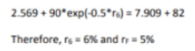
iii) Using the put-call parity for each row in the given table, we get:
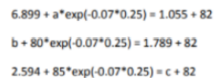

11. i) Explain what is meant by a recombining binomial tree. State the advantage and
disadvantage of using a recombining tree [vis-à-vis a non-recombining tree] to
model share price movements. (4)
ii) A trader in derivatives is using a two-step binomial tree to determine the value of
a 6- month European put option on a non-dividend-paying share. The put option
has a strike price of Rs. 950. The trader assumes that during the first 3 months, the
current share price of Rs. 1000 will either increase by 10% or decrease by 5%. The
continuously compounded risk free rate during the first 3 months is 1.75%. During
the following 3 months, the trader assumes that the share price will either increase
by 20% or decrease by 10%. The risk free rate during this period is expected to be
2.5%
a) Calculate the value of the put option. (6)
b) The trader believes that a more accurate value of the put option can be
determined by dividing the term of the option into “months”. State the
disadvantages of applying this modification to the model; and suggest an alternative
model based on months that might be efficient numerically.
i) A recombining binominal tree or binominal lattice is one in which the sizes of the up-steps and down-steps are assumed to be the same under all states and across all time intervals, ie, ut@-u and dt @)-d for all times t and states j, with d < exp(r) <u
-> It therefore follows that the risk neutral probability 'q' is also constant at all times
-> The main advantage of a 'n' period recombining binominal tree is that it has only [n+1] possible states of time as opposed to 2n possible states in a similar non-recombining binominal tree. This greatly reduces the amount of computation time required when using a binomial tree model.
-> The main disadvantage is that the recombining binomial tree implicitly assumes that the volatility and drift parameters of the underlying asset price are constant overtime, which assumption is contradicted by empirical evidence.

a) The risk-neutral probabilities at the first and second steps are as follows:
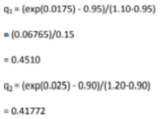
Put payoffs at the expiration date at each of the four possible states of expiry are 0,0,0 and 95.
Working backward, the value of the option V1 (1) following an up step over the first 3 months is

V1 (1) exp(0.025) - (0.41772* 0)+[0.58228*0] i.e. V1 (1) = 0

The value of the option V1 (2) following a down step over the first 3 months is: V1 (2)exp(0.025) [0.41772*0] + [0.58228*95) Le, V1 (2) 53.9508
The current value of the put option is:
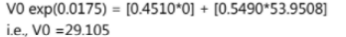
b) While the proposed modification would produce a more accurate valuation, there would be a lot more parameter values to specify. Appropriate values of u and d values of 'r for each month would be required for each branch of the tree and values of r for each month would be required.
The new tree would have 2 = 64 nodes in the expiry column. This would render the calculations prohibitive to do normally, and would require more programming and calculation time on the computer. An alternative model that might be more efficient numerically would be a 6-step recombining tree which would have only 7 nodes in the final column.
Q12. Let {Z(t)} be a standard Brownian motion. You are given

Derive the SDEs and explain which of the processes defined above has / have zero
drift?
Given Z(t) is standard Brownian
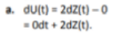
Thus, the stochastic process (U(t)) has zero drift.
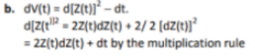
Thus, dv(t)- 2Z(t)dz(t). The stochastic process (Vit)) has zero drift.
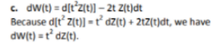
Thus The process (Wit)) has zero drift

Q13. Consider an at-the-money American put option on the geometric average of price
of a non-dividend paying stock currently priced at Rs. 200. Risk free interest is 10%
per annum, volatility is 35% per annum and time to maturity is 2 months.
i) Determine values of u and d assuming stock price follows Geometric Brownian
motion with drift μ and volatility σ stating any other assumption used. (5)
ii) Evaluate the value of an American put option using a 2-time step. The geometric
average is measured from today till the option matures

Let S/S, follows lognormal distribution with parameters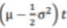, and (o^2)t such the
expected return on a stock is u and volatility is sigma
This means Expected value of stock price at the end of first time step = On the tree the expected price at that time =
To match the expected return on the stock with the tree's parameters we have
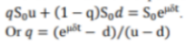

Volatility a of a stock price is defined so that is the standard deviation of the return on the stock price in a short time
The variance of stock price return is
Substituting the value of q in the expression above we have
When higher powers of ot other than öt are ignored. This implies 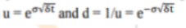
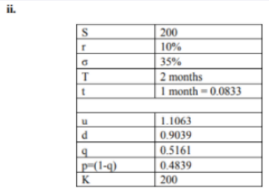
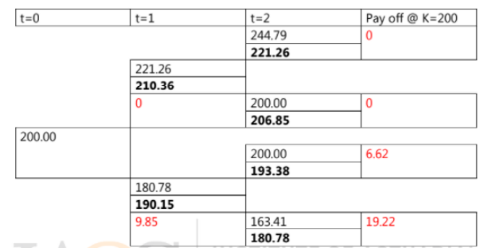
Note: Bold italies are GM of stock price,reds and the payoffs.
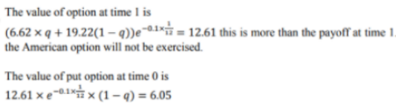
Q15} Suppose the stock price S follows geometric Brownian motion with expected return
μ and volatility σ:
Where dz is a wiener process
The risk free rate of interest (with continuous compounding) is r.
i) Determine the process followed by the variable SK
(where k is a positive integer).
Find the expected return and variance of SK. (5)
ii) For the same measure corresponding to dz, show that the stock price discounted
at risk-free rate is a martingale only for a specific value of μ. (3)
iii) Can you make any similar claim about the process followed by SKin part (i)? What conditions are needed? (1)
