2022
Sannidhya Upadhyay - 404
Sahil Minocha - 405
2/1/2022
Environmental Economics: New age macroeconomic guide

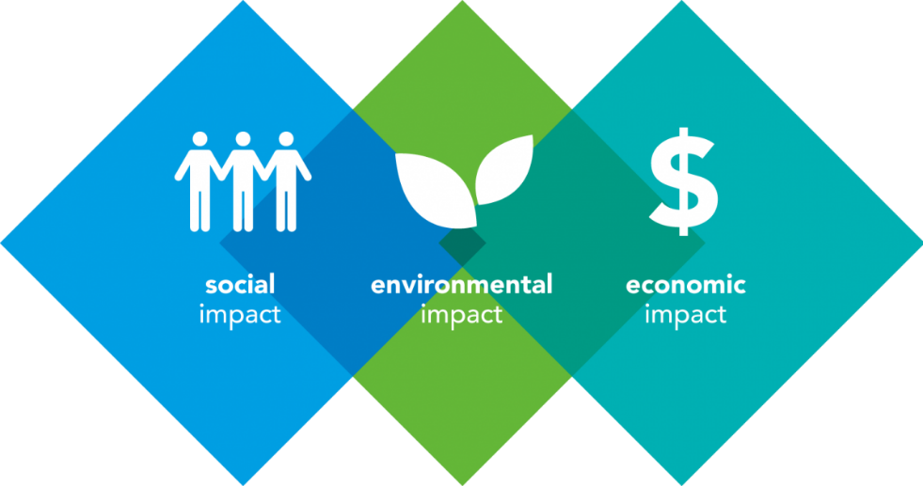

INDEX
Sr.No. | TOPICS | Page No.
1 | Abstract | 2
2 | Introduction  - Origin  - Relationship between Environmental Economics and Economics | 3
3 | Literature review  - Prev. research studies  - Questions  - Challenges and Further scope | 7
4 | Methodology | 10
5 | Body  - Sustainable Development  - Market failure and Externalities  - Cost Benefit Analysis  - Valuation | 11
6 | Conclusion
7 | Bibliography

ABSTRACT

Macroeconomics is a branch of economics that studies how an economy operates on a large scale considering their performance, structure, behaviour, and decision making. And it is impossible for economy to operate without it as it’s the main supplier for the material and energy and still its exploitation and depletion is not considered a major issue till now as its affect is hard to define in economical or financial terms. This contradicts the long-term aspect of the economy. There are several initiatives by the Governing bodies for the same like penalties for violators and financial advantages to those who abide with (according to the extent).
Indian Government collected 382cr (in rupee) last for air pollution norm violation from firms which seems very less in an economy of 3.25 trillion dollars and it does seem justified at all because with the size of the economy you can imagine the goods and services produced using natural resources and we are one of the countries where waste management systems are not very efficient, we have a poor air quality index as well so that fines collected doesn’t seem that accurate.
PROBLEM STATEMENT: Determining how the values are allotted to these resources considering there tangible and intangible impacts and.
In this project we discussed about how the use values and non-use values are allocated. Methods used for same are:
• Revealed preference method
• State preference method
• Multi criteria analysis
And discussing their drawbacks and possible solutions in brief.
However, this is an aspect of economics will be growing amongst all because of increase of awareness.

##This Project is highly dependent on the past researches and the procedures followed by governing institutions##

INTRODUCTION

ORIGINS

ECONOMICS

It is a science of the managing any commodity/material resources of a private/individual, community, or country.

ENVIRONMENT

A surrounding environment containing all the organisms and also includes all the factors which are affecting their expansion.

In the 1970s at the time of the Neoclassical paradigm, the concept of Environmental Economic was developed.
Environment Economic is concerned with: -

- Issues regarding Market failure
- Unequal Resource allocation
- Improper Management of public goods.

Ecological Economics

Ecological economics is a multidisciplinary field of academic research addressing the coevolution of human economies and natural ecosystems.

Environmental Economics is the mainstream economic analysis of the environment, by highlighting the preservation of natural capital we can say that the field of ecological economics is different from environmental economics.

Relationship of Environmental Economics to Economics

Supplier of resource inputs

There are 2 types of natural resources which are –
- Renewable
- Non-renewable.

This bisection is important as it will influence how natural resources are going to be managed for production.

Land, water, and stocks of raw materials are important resources to production. In the Production sector these resources are used to manufacture goods and services. They are also used as inputs for several other parts of the production sector. These resources vary between countries, so some countries will have large stocks of minerals, while others will have good cultivable land.

Supplier of Environmental goods

Environmental goods are non-market goods like –
- Clean air and water
- Landscape (Mountains, Forests, Beaches, etc.)
- Green transport infrastructure (like greenways and etc.)

These Economic benefits may be directly derived from the consumption
of these services that are forthcoming from a stock of Environmental goods.
People enjoy biodiversity that exists in this world, like for example trees absorbs carbon dioxide and contribute to climatic change.

Waste sink capacity

As we know the Environment is used as a waste sink. The capacity of the environment to accumulate the waste products during the process of production and consumption and converting them into non-toxic or ecologically products.

Other than our waste products, the Environment is also affected by release of some harmful chemicals like –
- Pesticides
- Paints
- Wood preservatives, and
- Lubricants.

There is a physical assimilative capacity of the Environment. Absorption of waste by the land, water and the atmosphere is determined by few physical factors such as –
- Climate,
- Rainfall,
- Wind patterns, and
- Geographical location.

Environmental management requires us to take actions to prevent further pollution to avoid surpassing an important threshold. This type of Environmental management known as Precautionary principle.

The Precautionary principle states that action on restricting or preventing environmental damage should not be delayed just because there are uncertainties about the level of the damage.

A Different Approach

There are many global environmental risks that we are suffering, such as: -
- Climate change,
- Ozone hole depletion,
- Melting of snow and others.

Our Economic systems especially the Capitalist systems that are always looking for material profit regardless of any future outcomes that can affect humanity, they are the reason for all these issues.

By utilizing Green Economy and the Blue Economy which is compatible with the environment and the we can hope for ​​sustainable development.

A Green economy –
It focuses its growth on employment and income by investing in various industries, renewable solar energy, and wind energy, socially inclusive economic activities, infrastructure and assets that allow decrease in carbon emissions and pollution, increased efficiency in energy, and preventing loss of our Ecosystem.

The Blue Economy –
It deals with sustainable use of water resources like rivers, seas, and various marine resources such as gas and oil, including the generation of electrical energy from water and others, for economic growth and improved livelihoods while preserving the health of ocean ecosystem.

LITERATURE REVIEW

Previous Research Studies

- An Introduction to Environmental Economics and Economic Concepts

This research paper contains of 5 units. In these units they have provides us with an overall view about the scopes of Environmental Economics. At the end of each unit there are several self-assessment questions for practice.
The relationship between the Economy and the Environment is the main concept they are trying to explain by linking both of them with the help of various real life examples, graphs and formulas. They have also used the first 2 Laws of Thermodynamics to connect Economy and Environment. They defined some important Economic principles and terminology in relation to Environmental Economics which are used across the research paper.

Some terminologies and concepts are –
- Economic agents
- Markets
- Efficiency
- Opportunity costs
- Productivity
- Marginal analysis
- Elasticity
- Substitutes
- Public goods
- Entropy
- Political economy
- Pareto optimality
- Market failure and Government failure

They have constructed theories with the help of scientific reasoning’s to explain us.

Different Methods of Economic analysis –

- Comparative static and dynamic analysis
- General equilibrium analysis
- Partial equilibrium analysis

They have also examined why government policy can affect the environment in a negative way.

By providing enough examples, graphs and other valuation methods, they have given us significant amount of information about hoe Economics is related to Environment

- Valuating the environment in economics terms: an Empirical Investigation by Olivier Vardakoulias, Susan Steed, James Meadway :: MSEP (The Marine Socio-Economics Project) and nefconsulting

Evaluated how environment is valued in present times and defined role of natural environment in the economy. How our economy is dependent on the environmental resources and the circular flow of income is connected to the flow of natural resources and waste (pollution). This research focused on how the use vale and non-use value is calculated and their contribution in TEV (total economic value). Argued on if its even necessary to value the nature. And what are the possible alternatives if valuation doesn’t seem as effective in longer term.

Unanswered Questions

Some important unanswered questions in Environmental Economics:

- What Environmental challenges are faced during Economic and Institutional affairs?

- If someone produces pollution, how would economists evaluate his or her price and output?

- How can we improve Environmental quality and deter Environmental damage by introducing Economic incentives and Environmental policies?

- Why do we have to value nature in project appraisal and evaluation?

- How can we evaluate the economic value of our nature?

- Is valuing the environment an acceptable methodology?

Challenges faced while evaluating Environment:

- Analysis –
Valuing the worth of complex and non-linear nature of our Ecosystems of non-marketed goods can be an invalid exercise.

- Monetisation of natural assets –
We cannot judge consumption and production of goods, based on weighing up the extinction of species (expressing it in dollar values) with consumption gains.

- Incorporating Environmental Valuation into Cost-Benefit Analysis warns that doing so may encourage the adoption of a Weak sustainability rather than a
Strong sustainability approach. This method makes it possible for market benefits to override environmental losses.

Weak Sustainability approach assumes manufactured capital can replace natural capital.
Strong Sustainability is an approach where natural capital is irreplaceable.

FURTHER SCOPE

We require an economy that will operate within our Ecological boundaries without breaching any important thresholds.

METHODOLOGY

- Defining problem statement and going to general approaches followed by economic institutions and researches.

- Going through to research papers for the same.

- Understanding the initiatives by firm for environment protection and the extent to which they do it; also finding out the penalties and disciplinary actions for not doing so.

- Figuring how the value is allotted to natural and environmental resources for both of their tangible and intangible effects.

- Drawbacks of the approaches.

- Possible solutions and conclusion.

BODY

Valuating Environment
No economy can operate without the flow of material and energy from the environment. Since the economy is dependent of the nature for it process so it is supposed to have an economic value. However, like other commodities it cannot be attained through a similar price system.

Natural Resources Goods and Services Pollution

Consumer Expenditure

Households Firms

Wages, rent, dividends

Pollution Factors and Production Natural Resources

But considering the dependence of economy on the eco-system it is very important to price them the best way possible, which is time consuming and expensive process because it is complex process to allocate price to natural resources and their intangible benefits but can contribute a lot in long term. Environmental economics helps to evaluate diversity of options in managing challenges with usage of environmental and natural resources.
There are several aspects of environmental economics like sustainable development, market failure, externalities which are to be considered while policy formation for the benefit of the society(mainly) and also to get themselves protected against any fines or disciplinary actions and even customer acquisition (which are still very much underrated but can turn significant rarely).
Subsequently we have also described the traditional cost benefit analysis and its scope in present time before moving to actual value allocation and the methods of calculation from different approaches.

Sustainable Development
Meaning
It is an Economic development that meets the needs of the present without depletion of our natural resources.
It helps us to analyse the role of economic development in supporting sustainable development.
Sustainable Development
Environmental Protection
Social Equity
Economic Growth

Institutional Capacity

Sustainability could be a paradigm for considering the longer term during which Environmental, Societal and Economic considerations are balanced within the pursuit of an improved quality of life. For instance, a prosperous society relies on a healthy environment to supply food, resources and water, safe potable and clean air for its citizens.

Market Failure and Externalities

It is allocative inefficiency of natural resources, it occurs when the conditions of perfect competition are not met and market fails to protect environment. If the market fails, then Government intervention is necessary to correct the market failure and secure the benefits for the society i.e. producing what is desirable by the society. So, in environmental context it is the difference between the price of the resource and the expected price that would have existed if there was a proper market for that resource.
Reasons for Market Failures:

- Externalities
- Information asymmetry
- Monopoly powers
- Common access resources
- Public goods – pure and impure
- Merit and demerit goods

Externality means the production/consumption of an individual or firm impact another individual or firm (and the doer is not concerned about it because of absence of any transaction.) i.e. these are unintentional benefits or injuries caused by economic activity carried by third party and the parties are not directly in exchange.

There are many services that the general public desires, except for which it's difficult to charge an appropriate price. Goods and services supplied to 1 consumer may automatically get provided to several others just like the pesticides sprayed for malaria, during this case it's unfeasible to charge one and all for it but the benefit are going to be received by all.

The Negative Externalities are the most important concern in most cases because they constitute in many of our environmental problems. However, this spillover effect constitutes hazard to the people within the neighborhood which is omitted entirely from the factory’s calculation of its receipts and costs. the very fact that the business running the factory causes adverse externality without paying any cost, helps to elucidate the failure of the market mechanism which does an imperfect job of protecting the environment.

Cost-Benefit Analysis

Cost-benefit analysis provides an organizational framework for identifying, quantifying, and comparing the costs and benefits of a proposed policy action. The ultimate decision is informed by a comparison of the total costs and benefits.

Traditional cost–benefit analysis mainly focuses on economic returns. Cost-benefit analysis considers it efficient only if the financial benefit of an action outweighs its respective costs, irrespective of any externalities or environmental impacts.

Costs of Environmental Regulations can include: -

- Opportunity costs,
- Internal & External costs, and
- Externalities.

Benefits of Environmental Regulations can include: -

- Reduced human and wildlife mortality
- Extra Income
- Improved quality of life
- Improved water quality
- Species preservation

In the Policy Arena, Environmental Economists tend to favor cost-benefit analysis because of the discipline and transparency it provides in evaluating policy options.

Economical value of nature

- Use Value: the value of the aspects of nature directly useful by the human producer and consumers.

    - Direct use values: Market values may exist for those whose material benefits are provided by ecosystem and are directly linked to our economic system.
    - Indirect use values: material benefits which are indirectly linked to the economic system and for which market values are more difficult (yet possible) to derive – like air purification, green-house effect, etc.
    - Option value: the value placed on preserving a resource for future direct or indirect use (cost of maintaining river catching for irrigation)

- Non-use Value: the value of aspects that have much lesser tangible attributes or has an intrinsic value.
    - Existence or intrinsic values: value from knowing an environmental good exists and is preserved, despite the fact that it may never be used or seen.
Bequest value: it is the value which is derived, while knowing that the resource is maintained for the future generations

TEV (Total Economic Value) of environment is referred as sum of its Use value and Non-use value.
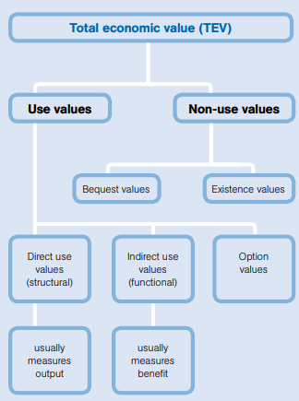

Methods of valuation

- Revealed Preference methods:

This method involves determining the value that consumer holds for an environmental product by observing their purchase pattern of the goods that directly or indirectly relate to environmental quality. It is used to determine the use value of nature. Revealed-preferences method also known as household production approach. Revealed preferences can be used to see the worth of unpolluted air and clean water by differentiating home prices of pristine and polluted areas. Revealed-preferences method is also termed as hedonic approach. Factors taken into consideration while determining the use value:
  - Market Price
  - Averting Price (actions or expenditure that individuals undertake to avoid something)
  - Hedonic Price (impact of green spaces on real estate price changes)
  - Travel cost (distance people are ready to travel for any certain service or aspect of nature.
The household production and hedonic approaches have the advantage of looking forward to actual consumer choices to infer the worth society holds for a selected environmental good, instead of depending on hypothetical scenarios. Other than Cost-Benefit Analyses and Maximum Environmental Damages, valuation techniques are also useful in market failures but there are some Environmental goods for which the spot values is impossible to find through market interactions.
Revealed-preferences methods are commonly used by researchers since the late 20th century for observing the worth of clean air and clean water. This method can be important for determining the cost of fine for those firms who are responsible for pollution.
Criticisms: too many assumptions to be made and no proper evidences to back them as the preferences of the consumers keeps changing.

- State Preference methods:

Is a seemingly simple method that involves asking people directly about their values for a selected environmental good. This method is especially useful in determining the value of environmental goods that. These includes surveys which covers the Willingness to pay and Willingness of accept i.e. determining how much they are eager to pay, sacrifice or exchange to get something good or to avoid something bad. However, in this form of approach biasness is likely to rise are:

- Information Bias: no information with respondent with respect to the objective
- Hypothetical Bias: where the respondent will not be affected by that issue and is even not interested to answer reasonably.
- Starting-point Bias: respondent influenced by past numbers.
- Response and Strategic Bias: respondents intentionally try to manipulate the outcome of survey.
Dealing with the Bias:
- Providing the respondent with enough information to have an accurate response
- Solving this requires significant pretesting of a survey’s design.
- Randomness of the survey will reduce the impact of strategic survey.
This method is mainly used to determine the worth of old-forest preservation and growth of forest in this face of industrialization.
- Multi Criteria analysis

Multi-criteria analysis is a very important tool to support our decision making process where choices have to be made between different competing options. It is mainly useful for Sustainability assessment, where there is a complex and inter-connected range of issues like –
- Environmental,
- Social, and
- Economic

These factors are essential and must be taken into consideration where objectives are often competing, making trade-offs unavoidable. It provides us with a robust and transparent decision-making structure, making explicit the key considerations and the values assigned to them. This method can be applied at all levels of decision-making, from the alternative projects to policy decisions guiding towards Sustainability and the Green economy.

CONCLUSION

From the research we have concluded that the procedures used for Environmental valuations are very subjective and assumptions dependent. Also, it faces a lot of biasness when come to valuation of intangible benefits as the satisfaction derived from it differ from person to person.
The revealed preference method, contingent valuation and multi criteria are able to produce a lot of relevant information for environmental economics but also comes with a lot of drawbacks and even at the end of the day give the value in money terms.
Their inefficiency is because of their personalised approach of behaviour patterns and surveys. These procedures have been made easier with the introduction of AI and social media but still a lot of transactions in developing Economies like INDIA occurs out of e commerce.
Since the monetary value of this sector in particular is not that big but at a growing stage so, in future it will surely require some less time consuming and more accurate methods to valuate environment.

This finally leads us to have a specific governing body for these environmental affairs independent of the market and that will not value the natural resources in terms of money.

BIBLIOGRAPHY

www.nefconsulting.com | Economic value of nature
www.mypaperwriter.com | Environmental Economics
www.soas.ac.uk | Market failure and Government failure, Relationship between environment and economics
www.britannica.com | Revealed preference and state preference method
www.cambridge.org | Sustainable development
www.knowledgiate.com | Externalities
www.env-econ.net | Cost Benefit Analysis

