Name: Darshan Lodha
Roll No.: 433
Assignment 2
Semester 4
Business Economics - Macro

MCQs
Question 1]
Answer: C: A competitive economy free of Government intervention would result in full employment.
Question 2]
Answer: B: Real wages are back at long-run equilibrium level.
Question 3]
Answer: C: There is excess demand and the exchange rate should rise.
Question 4]
Answer: D: Interest rate must fall to restore equilibrium in the goods market.
Question 5]
Answer: D: Quantitative easing.
Question 6]
Answer: C: Real wages are highly flexible.
Question 7]
Answer: C: Negative relationship between inflation and unemployment.
Question 8]
Answer: B: Weaken.
Question 9]
Answer: C: Information on job availability.
Question 10]
Answer: B: The velocity of circulation must have fallen.
Question 11]
Answer: D: Imposition of indirect tax.
Question 12]
Answer: A: Negative
Question 13]
Answer: B: There is a “trade-off” between inflation and unemployment in the short run.
Question 14]
Answer: C: An inflow of foreign investment into country X.
Question 15]
Answer: C: A contractionary fiscal policy.
Question 16]
Answer: B: Capital Account.
Question 17]
Answer: B: Frictional unemployment.
Question 18]
Answer: C: Money plays a neutral role in the modern economy.
Question 19]
Answer: C: Transaction and Precautionary.
Question 20]
Answer: C: Commercial Bonds.
Question 21]
Answer: C: Cash reserves + credit money + other deposits
Question 22]
Answer: D: Fiscal stimulus to the economy.
Question 23]
Answer: A: Open market operations.
Question 24]
Answer: D: Reviewed corridor.
Question 25]
Answer: A: The extent to which investors prefer to keep their assets in cash holdings.
Question 26]
Answer: D: Accumulating money for saving does not create demand for money.
Question 27]
Answer: H(This is an error in the question, should be D): Slightly falls.
Question 28]
Answer: K(This is an error in the question, should be C): 2016
Question 29]
Answer: O(This is an error in the question, should be C): Dovish
Question 30]
Answer: D: Better education and training.
Question 31]
Answer: D: Fall while import value may rise or fall.
Question 32]
Answer: Property income from abroad.
Question 33]
Answer: D: Accelerate if the government increase its capital expenditure.
Question 34]
Answer: D: Increase and the domestic money supply fall.
Question 35]
Answer: B: Imports become more expensive when measured in the domestic currency.
Question 36]
Answer: B: High rates of interest are discouraging borrowing.
Question 37]
Answer: C: Removal of barriers to trade and capital movements.
Question 38]
Answer: A: International supply-side policy
Question 39]
Answer:
- The advantages of inflation targeting are as follows:
- The rate of inflation is lower owing to the targeted influence of the government.
- Since, the government tries to maintain and control the rate of inflation, the rate of inflation remains more stable.
- The ability of economic decision makers like firms and consumers improves in order to anticipate the future rate of inflation.
- There is a greater co-ordination between monetary and fiscal policy.
- There is greater central bank transparency and accountability.
- The disadvantages of inflation targeting are as follows:
- The ability of the central bank to pursue other macroeconomic objectives reduces.
- The ability of the central bank to respond to supply-side shocks reduces.
- The ability of the central bank to deal with unexpected events such as covid 19 pandemic reduces.
- There is ambiguity in finding an appropriate inflation target.
- There is difficulty in its implementation.
Question 40]
Answer:
The major factors that affect the demand for money are as follows:
- Money national income.
- Innovations in the financial system.
- The interest rates in the economy.
- Speculation regarding the expected returns on financial assets.
- The frequency with which people are paid.
Question 41]
Answer:

The term exchange rate index i.e., the effective exchange rate is a weighted average of the exchange rate of a particular currency against all other currencies, where the weights involved are based on the proportion of transactions between each country.

Equilibrium exchange rate in the foreign exchange market is often unfavourable to less developed countries because less developed country depends on developed countries for the import of plant and machinery for its development and infrastructure programs. This causes a situation of adverse BOP for the less developed countries. Accordingly, their foreign exchange reserves are low while the requirement of such reserves continues to be high. The outcome of this is a high exchange rate.
Question 42]
Answer:
- The direct consequence of an increase in interest rates is the rise of cost of current government borrowing and so a rise in the fiscal deficit may be observed. Also, it will cause the cost of financing the national debt to rise and the extent that the debt has been financed by floating rate debt to rise as well. The indirect effects of a rise in interest payments are also likely to widen the fiscal deficit initially since the interest rate rise will slow down the economy so increasing government expenditure on social security and dampening government tax revenues.
Question 43]
Answer:

The effect on money supply for an increase in the public sector deficit financed by borrowing from the non-bank private sector.
Money supply will be unaffected because the cash is withdrawn from banks and spent by the government, so it indirectly finds its way to the banking system. Hence, no overall change in the amount of cash held in the banking system.
The effect on money supply for a decrease in the non-bank private sector’s holding of cash.
The money supply will increase because there will be more cash deposited in the banks, rather than being held outside of the banking system, which they can use to create credit in the banking system.

The effect on demand for money for a fall in the notional national income.
A fall in the national income leads to a decrease in the demand for money. The demand for money curve will shift to the left owing to a factor that affects the demand curve.
The effect on demand for money for a fall in the expected value of the domestic currency.
A decrease in the expected value of domestic currency will lead to a decrease in the demand for the currency, i.e., the demand for money curve will shift to the left.
Question 44]
Answer:
(All the graphs for this question have been separately drawn by Darshan on a graph paper for the ease of drawing. Image has been pasted here of the same.)
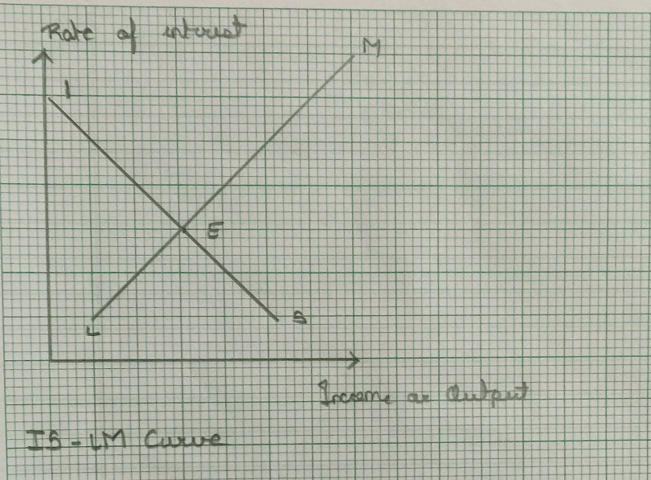
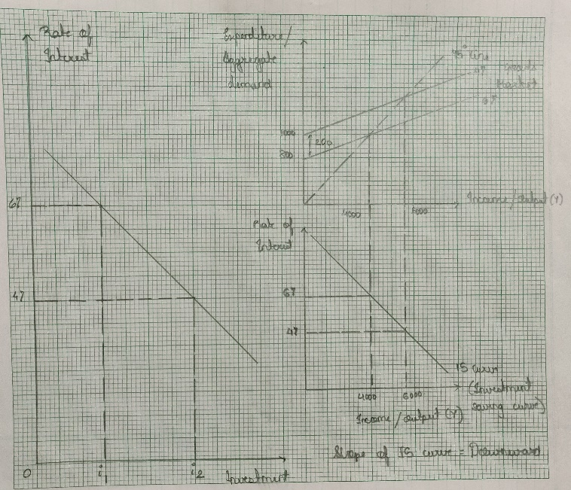
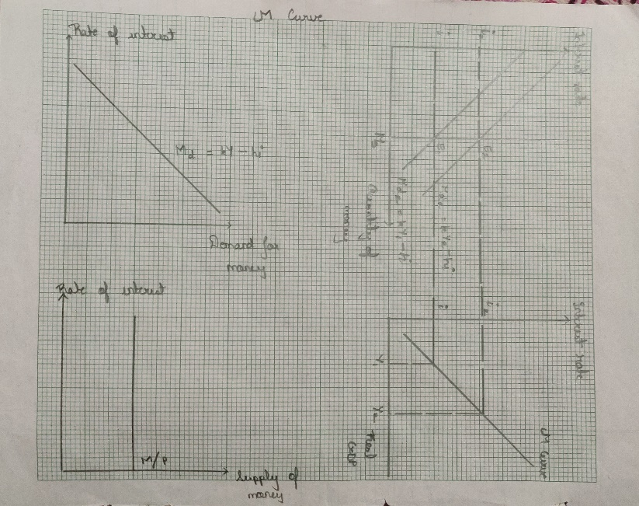

- The IS curve shows the combinations of interest rates and national income at which injections equate to the withdrawals and consequently the total output equates to the total expenditure, resulting in the equilibrium point for goods and services.
- The IS curve is represented in the above graph.

An increase in the average price level will result in a reduction in the real value of the money supply. A reduction in the money supply will shift the LM curve to the left giving an increase in the equilibrium rate of interest and a fall in the equilibrium level of national income.

With an expansionary fiscal policy financed by the sale of bonds, the government sells bonds and uses the proceeds raised to finance increased government expenditure. The effect on the money supply should be zero as the money raised from the bond sales is spent by the government.

Question 45]
Answer:

(Calculations are performed in rough. Details can be provided)
- Exports = 385m
6. Balance of trade in services = -20m
8. Income payments = -175m
12. Current account balance = -95m
18. Capital and financial account balance = 95m
(ii)
- Japanese purchase of Indian T bonds = Credit
Japanese payment using Mumbai bank = Debit
- Indian citizen having a meal in Paris = Debit
Paying the meal with American Express = Credit
- Export of programming service = Credit
British payment out of its account in India = Debit
Question 46]
Answer:

The aggregate demand for labour curve displays the total demand for labour at different average real wage rates in the economy.

The aggregate supply for labour displays the number of people willing and able to accept jobs at each wage rate that is prevalent in the economy.

Equilibrium level of unemployment refers to the level of unemployment of a labour market at the perfect equilibrium point.

Disequilibrium unemployment refers to the unemployment where usually due to the imposition of minimum wage laws by the government of the country which in turn refers that there will be higher demand for jobs then supply.

The reasons for equilibrium unemployment are as follows:
- Structural unemployment
- Frictional unemployment
- Seasonal unemployment
- Geographical unemployment
- Technological unemployment

The reasons for disequilibrium unemployment are as follows:
- Growth in supply of labour
- Real-wage unemployment
- Demand deficit unemployment
Question 47]
Answer:
- Consistent changes in the value of the domestic currency could negatively affect trade and investment by introducing uncertainty and losing business confidence. Thus, the government desires to avoid fluctuations in the value of its domestic currency.
- The solutions to curb the volatility in the value of its domestic currency would depend on whether the aim is to curtail short term or longer-term changes in exchange rates.
- If the government aims to maintain the value of currency close to a long-term equilibrium value , it could buy or sell the domestic currency in the foreign exchange market. The central bank’s intervention will result in reverse shifts in demand and supply curves and the desired exchange rate would be restored.
- Another measure is; the government could raise interest rate temporarily. This will encourage those aboard to deposit their money in the domestic country.
- Government can use fiscal and monetary policies to maintain the monetary value of the currency for longer periods such as months and years.
- The government may also improve supply side policies like improving the long-term competitiveness of the domestic industry by improving quality of goods produced and lowering the production cost. This can be achieved for quality of training and research / development.
Question 48]
Answer:

Current account balance = 30m

Capital account balance = -10m

Value of the statistical error = -40m.
The value of the statistical error is negative.

The country does not have a fully flexible exchange rate. This can be inferred from the decrease in official reserves which indicates that the central bank has been purchasing the domestic currency.

