P R O J E C T W O R K

ARYAN SINGH RAJAWAT ROLL NO: 410
BSC. ACTUARIAL SCIENCE AND QUANTITATIVE FINANCE

STATISTICAL RISK MODELLING-1

November 24 | 2021

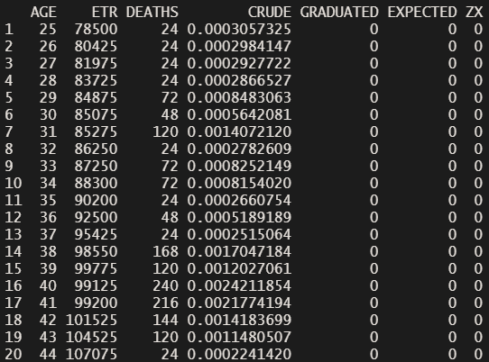
Q1Read in the data file as a data table & fill in the entries for the CRUDE column in your table. Ans. we Know that crude rate = Deaths/ exposed to risk. we substitute in the data frame.

Q2Use Gompertz law to fill entries in the GRADUATED column in the data.
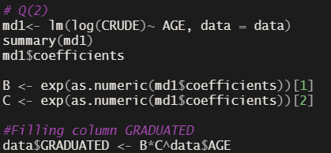
Ans. Gpmpertz law μ(x) = α · eβx. we use the linear regression function in r to find the coefficient and use it in the equation to find the graduated rates.

Q3. Check for smoothness by applying the third differences to the crude and graduated rates and comment on your results.
Ans. in order to do the smoothness test I created an differentiation function in r .
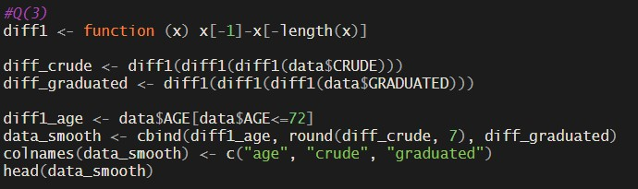
The third difference of the graduated rates is very small and they progress in regular manner. Hence, graduated rates are very smooth.

Q4 Calculate the values in EXPECTED and ZX values in the table. Hence, perform a chi squared test to check goodness of fit between DEATHS and EXPECTED. You should specify the degrees of freedom used.
Ans. we find the expected rates by multiplying the exposed to risk by graduated rates. and we find the ZX using the formula

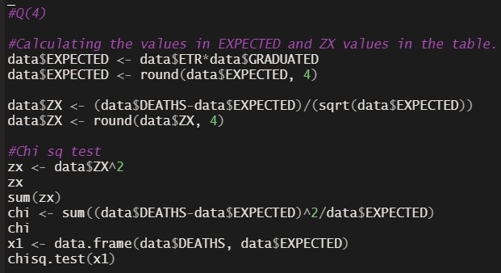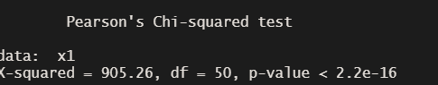There are 50 degrees of fredom and we reject the null hypothesis that the data does not fit

Q5 a. Perform the standardised deviations test on the individual deviations and comment on the-
- Overall shape
- Absolute deviations
- Outliers
- Symmetry
- Final conclusion about Null hypothesis
- Perform the Signs test and give your conclusion
- Perform the Cumulative deviations test for the entire age range and give your conclusion.
- Perform the Serial correlations test and give your conclusion. Ans.
- The graph shows lot values towards positive side. Only 20 observations are to the left side while 31 are on right side.
- The Values of the absolute deviations are high compared to the expected value
- There are some outliers on the lower side but none on the upper side.
- The Graph is not symmetric. It is positively skewed.
- The graduated rates do not represent the given mortality rates

b.At 5% level of significance, we accept the NULL hypothesis that the data is a true representation of the given mortality rates.

c.At 5% level of significance, we accept the NULL hypothesis that the data is a true representation of the given mortality rates.

d.At 5% level of significance, we accept the NULL hypothesis that the data is a true representation of the given mortality rates.

