ASSIGNMENT 2 :
Q1. Script:
#Q1.
n= 1000
meanlog = 5
sdlog = 2.5
set.seed(10221)
data = rlnorm(100, 5, 2.5)
round(quantile(data),5)

x = c(0, 0.25, 0.5, 0.75, 1)
qlnorm(x, 5, 2.5)

"We note that there are differences in the empirical and true values of the
quantiles. This exists because the data set used is limited. As this data set
tends the infinity, the differences will be negligible."
Console:
n= 1000
> meanlog = 5
> sdlog = 2.5
> set.seed(10221)
> data = rlnorm(100, 5, 2.5)
> round(quantile(data),5)
0% 25% 50% 75% 100%
0.44315 39.50624 123.40703 716.95278 87212.86544
>
> x = c(0, 0.25, 0.5, 0.75, 1)
> qlnorm(x, 5, 2.5)
[1] 0.00000 27.48872 148.41316 801.29116 Inf

Q2. Script:
#Q2.
modelx = mtcars

#a
modela = lm(mpg ~ 1, modelx)
modela
#b
modelb = lm(mpg ~ wt, modelx)
modelb
#c
modelc = lm(mpg ~ log(wt) + log(disp), modelx)
modelc

#d
#r-squared
summary(modela)$r.squared
summary(modelb)$r.squared
summary(modelc)$r.squared
#adjusted r-squared
summary(modela)$adj.r.squared
summary(modelb)$adj.r.squared
summary(modelc)$adj.r.squared
#AIC
AIC(modela, modelb, modelc)
"From the above data we can conclude that modelc is the best fit since it
has the highest r-quared and adjusted r squared value, and lowest aic "

#e
plot(modelb$fitted.values, col = "Orange" )
abline(lm(mpg ~ wt, data = mtcars), col = "Red")
Console:
> #Q2.
> modelx = mtcars
> #a
> modela = lm(mpg ~ 1, modelx)
> modela

Call:
lm(formula = mpg ~ 1, data = modelx)
Coefficients:
(Intercept)
20.09

> #b
> modelb = lm(mpg ~ wt, modelx)
> modelb

Call:
lm(formula = mpg ~ wt, data = modelx)
Coefficients:
(Intercept) wt
37.285 -5.344

> #c
> modelc = lm(mpg ~ log(wt) + log(disp), modelx)
> modelc
Call:
lm(formula = mpg ~ log(wt) + log(disp), data = modelx)
Coefficients:
(Intercept) log(wt) log(disp)
57.128 -8.369 -5.232

> #d
> #r-squared
> summary(modela)$r.squared
[1] 0
> summary(modelb)$r.squared
[1] 0.7528328
> summary(modelc)$r.squared
[1] 0.8600604
> #adjusted r-squared
> summary(modela)$adj.r.squared
[1] 0
> summary(modelb)$adj.r.squared
[1] 0.7445939
> summary(modelc)$adj.r.squared
[1] 0.8504093
> #AIC
> AIC(modela, modelb, modelc)
df AIC
modela 2 208.7555
modelb 3 166.0294
modelc 4 149.8261

> #e
> plot(modelb$fitted.values, col = "Orange" )
> abline(lm(mpg ~ wt, data = mtcars), col = "Red")

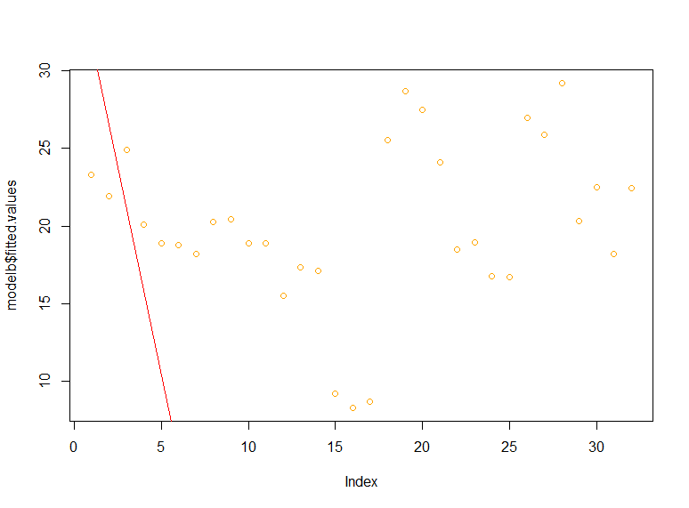
Q3. Script:
#Q3.
set.seed(2919)
s = rnorm(100, 5, 2.5)
quantile(s)
qnorm(c(0, 0.25,0.5, 0.75, 1), 5, 2.5)
“The mode of a normal distribution is equal to its median. The differences in true and empirical values can be reduced by increasing sample size”
Console:
> set.seed(2919)
> s = rnorm(100, 5, 2.5)
> quantile(s)
0% 25% 50% 75% 100%
-1.504619 3.270002 5.234976 6.274119 9.842555
> qnorm(c(0, 0.25,0.5, 0.75, 1), 5, 2.5)
[1] -Inf 3.313776 5.000000 6.686224 Inf
Q4. Script:
xi = c(0,1,2,3,4,5,6)
fi = c(739280,185309,23349,1937,114,1,3)
lambda_cap= sum((xi*fi))/sum(fi)
Ei = dpois(xi,lambda_cap)*sum(fi)
prob = dpois(xi,lambda_cap)
data.frame(xi,fi,Ei = round(Ei,4))
ChiSq_cal = sum((((fi-Ei)^2)/Ei))
chisq.test(fi,prob)
#since p-value is greater than alpha which is 5%, we do not reject our
#null hypothesis stating that Poisson is a good fit for our data.
Console:
> xi = c(0,1,2,3,4,5,6)
> fi = c(739280,185309,23349,1937,114,1,3)
> lambda_cap= sum((xi*fi))/sum(fi)
> Ei = dpois(xi,lambda_cap)*sum(fi)
> prob = dpois(xi,lambda_cap)
> data.frame(xi,fi,Ei = round(Ei,4))
xi fi Ei
1 0 739280 739233.4866
2 1 185309 185429.9160
3 2 23349 23256.6938
4 3 1937 1944.5759
5 4 114 121.9447
6 5 1 6.1177
7 6 3 0.2558
> ChiSq_cal = sum((((fi-Ei)^2)/Ei))
> chisq.test(fi,prob)

Pearson's Chi-squared test

data: fi and prob
X-squared = 42, df = 36, p-value = 0.227

Q5. Script:
#Q5
library(MASS)
Data = Animals

#a
cor1 = cor(Data$body,Data$brain)
#The two variables are uncorrelated

#b
cor2 = cor(log(Data$body),log(Data$brain))
#The two variable are strongly correlated

#c
"H0 - Pearson's correlation coefficient (rho) = 0.6"
"H1 - Pearson's correlation coefficient (rho) > 0.6"
n = length(Animals$body)
rho = 0.6
W = 0.5*log((1+cor1)/(1-cor1))
mu = 0.5*log((1+rho)/(1-rho))
sigma = 1/sqrt(n - 3)
Zcal = (W - mu)/sigma
Zcal
Ztab = qnorm(0.95,0,1)
Ztab

#d
#H0: mu1 = mu2
#H1: mu1 > mu2
t.test(Data$body,Data$brain, alternative = "greater")
#p-value greater than alpha therefore we do not reject H0

#e
qqnorm(Data$body, main = "Body")
qqline(Data$body, col = "red")
qqnorm(Data$brain, main = "Brain")
qqline(Data$brain, col = "Red")
"It is evident from the Q-Q Plots that the variable Body Weight
is more likely Normal Distribution"
"Since Zcal < Ztab, we do not have enough evidence to reject H0. Hence, we can
say that pearson's correlation coefficient = 0.6"

#f
Data$Log_Body = log(Data$body)
hist(Data$Log_Body,freq = F, xlim = c(0,10),
ylim = c(0,0.3))
lines(seq(0,10),dnorm(seq(0,10),3.77,1.5),
col = "Blue")
"We can see the histogram is approaching normal distribution"

Console:
library(MASS)
> Data = Animals

> #a
> cor1 = cor(Data$body,Data$brain)
> #The two variables are uncorrelated

> #b
> cor2 = cor(log(Data$body),log(Data$brain))
> #The two variable are strongly correlated

> #c
> "H0 - Pearson's correlation coefficient (rho) = 0.6"
[1] "H0 - Pearson's correlation coefficient (rho) = 0.6"
> "H1 - Pearson's correlation coefficient (rho) > 0.6"
[1] "H1 - Pearson's correlation coefficient (rho) > 0.6"
> n = length(Animals$body)
> rho = 0.6
> W = 0.5*log((1+cor1)/(1-cor1))
> mu = 0.5*log((1+rho)/(1-rho))
> sigma = 1/sqrt(n - 3)
> Zcal = (W - mu)/sigma
> Zcal
[1] -3.492442
> Ztab = qnorm(0.95,0,1)
> Ztab
[1] 1.644854

> #d
> #H0: mu1 = mu2
> #H1: mu1 > mu2
> t.test(Data$body,Data$brain, alternative = "greater")

Welch Two Sample t-test

data: Data$body and Data$brain
t = 1.1854, df = 27.354, p-value = 0.123
alternative hypothesis: true difference in means is greater than 0
95 percent confidence interval:
-1615.936 Inf
sample estimates:
mean of x mean of y
4278.4388 574.5214
> #p-value greater than alpha therefore we do not reject H0

> #e
> qqnorm(Data$body, main = "Body")
> qqline(Data$body, col = "red")
> qqnorm(Data$brain, main = "Brain")
> qqline(Data$brain, col = "Red")
> "It is evident from the Q-Q Plots that the variable Body Weight
+ is more likely Normal Distribution"
[1] "It is evident from the Q-Q Plots that the variable Body Weight \nis more likely Normal Distribution"
> "Since Zcal < Ztab, we do not have enough evidence to reject H0. Hence, we can
+ say that pearson's correlation coefficient = 0.6"
[1] "Since Zcal < Ztab, we do not have enough evidence to reject H0. Hence, we can\nsay that pearson's correlation coefficient = 0.6"

> #f
> Data$Log_Body = log(Data$body)
> hist(Data$Log_Body,freq = F, xlim = c(0,10),
+ ylim = c(0,0.3))
> lines(seq(0,10),dnorm(seq(0,10),3.77,1.5),
+ col = "Blue")
> "We can see the histogram is approaching normal distribution"
[1] "We can see the histogram is approaching normal distribution"

Q6. Script:
Oi = matrix(c(40,20,10,30,35,15,30,45,25),nrow = 3, ncol = 3,byrow = T)
Oi
chisq.test(Oi,correct = F)

Console:
Oi = matrix(c(40,20,10,30,35,15,30,45,25),nrow = 3, ncol = 3,byrow = T)
> Oi
[,1] [,2] [,3]
[1,] 40 20 10
[2,] 30 35 15
[3,] 30 45 25
> chisq.test(Oi,correct = F)
Pearson's Chi-squared test
data: Oi
X-squared = 13.415, df = 4, p-value = 0.009416

