Predictive Analytics and Machine Learning Assignment
Name: Atharva Padwal
Roll No. 703

Introduction to Machine Learning
Machine learning is an application of AI that enables systems to learn and improve from experience without being explicitly programmed. Machine learning focuses on developing computer programs that can access data and use it to learn for themselves.
The machine learning process begins with observations or data, such as examples, direct experience or instruction. It looks for patterns in data so it can later make inferences based on the examples provided. The primary aim of ML is to allow computers to learn autonomously without human intervention or assistance and adjust actions accordingly.

There are limitless applications of machine learning and there are a lot of machine learning algorithms are available to learn. They are available in every form, from simple to highly complex.
In order for machine learning to be useful in tackling a problem we need the following to apply:
- A pattern should exist. If there is no pattern, there is no information to be had, and
- machine learning will not help (indeed, it might be counterproductive by ‘discovering’ patterns that do not exist).
- The pattern cannot be practically pinned down mathematically by classical methods.
- If it could be pinned down, we could proceed to describe it mathematically.
- We have data relevant to the pattern.
Examples of problems which are commonly solved in this way include:
- Targeting of advertising at consumers using web sites
- location of stock within supermarkets to maximise turnover
- forecasting of election results
- prediction of which borrowers are most likely to default on a loan.
In context of the Actuarial/ Finance domain, ML can be applied to solve the following problems:
- Classifying the risk for motor insurance policyholders using in-car monitoring devices
- Identifying marker genes that are associated with particular medical conditions
- Identifying insurance claims that might be fraudulent
- Identifying fraudulent benefit claims.
- Using health-monitoring devices such as wearables to track real team data of customers willing to purchase health insurance products.
- Identifying fraudulent tax declarations.

Advantages and Disadvntages of Machine Learning
Advantages:
- Easily identifies trends and patterns
- No human intervention needed (automation)
- Continuous Improvement
- Handling multi-dimensional and multi-variety data
- Wide Applications
Disadvantages:
- Data acquisition
- Time and Resources involved
- Interpretation of results
- High Error Susceptibility

Supervised vs Unsupervised Learning

Supervised learning is an approach to creating artificial intelligence (AI), where a computer algorithm is trained on input data that has been labeled for a particular output. The model is trained until it can detect the underlying patterns and relationships between the input data and the output labels, enabling it to yield accurate labeling results when presented with never-before-seen data.
Supervised learning is good at classification and regression problems, such as determining what category a news article belongs to or predicting the volume of sales for a given future date. In supervised learning, the aim is to make sense of data within the context of a specific question.
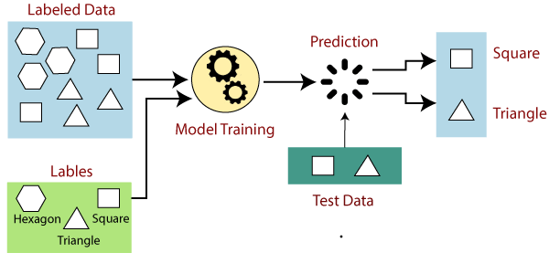
Unsupervised learning is a machine learning technique in which models are not supervised using training dataset. Instead, models itself find the hidden patterns and insights from the given data. It can be compared to learning which takes place in the human brain while learning new things.
Unsupervised learning cannot be directly applied to a regression or classification problem because unlike supervised learning, we have the input data but no corresponding output data. The goal of unsupervised learning is to find the underlying structure of dataset, group that data according to similarities, and represent that dataset in a compressed format.

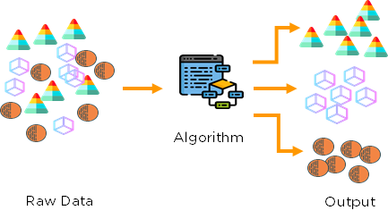

Supervised Learning model: Logistic Regression

Logistic regression is a process of modeling the probability of a discrete outcome given an input variable. The most common logistic regression models a binary outcome; something that can take two values such as true/false, yes/no, and so on. Multinomial logistic regression can model scenarios where there are more than two possible discrete outcomes. Logistic regression is a useful analysis method for classification problems, where you are trying to determine if a new sample fits best into a category. As aspects of cyber security are classification problems, such as attack detection, logistic regression is a useful analytic technique.
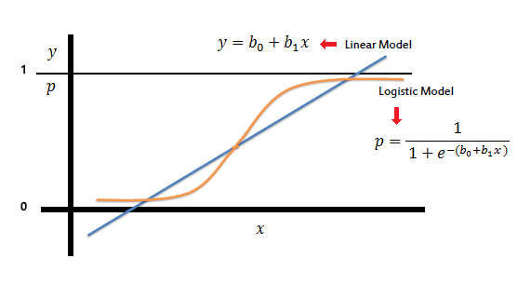
Logistic regression essentially uses a logistic function defined below to model a binary output variable (Tolles & Meurer, 2016). The primary difference between linear regression and logistic regression is that logistic regression's range is bounded between 0 and 1. In addition, as opposed to linear regression, logistic regression does not require a linear relationship between inputs and output variables. This is due to applying a nonlinear log transformation to the odds ratio (will be defined shortly).
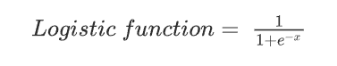
As opposed to linear regression where MSE or RMSE is used as the loss function, logistic regression uses a loss function referred to as “maximum likelihood estimation (MLE)” which is a conditional probability. If the probability is greater than 0.5, the predictions will be classified as class 0. Otherwise, class 1 will be assigned. Before going through logistic regression derivation, let's first define the logit function. Logit function is defined as the natural log of the odds. A probability of 0.5 corresponds to a logit of 0, probabilities smaller than 0.5 correspond to negative logit values, and probabilities greater than 0.5 correspond to positive logit values. Logistic function ranges between 0 and 1 (P∈[0,1]) while logit function can be any real number from minus infinity to positive infinity (P∈[−∞, ∞]).
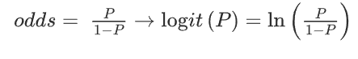
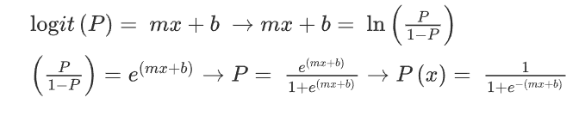

The mathematics of logistic regression rely on the concept of the “odds” of the event, which is a probability of an event occurring divided by the probability of an event not occurring. Just as in linear regression, logistic regression has weights associated with dimensions of input data. In contrary to linear regression, the relationship between the weights and the output of the model (the “odds”) is exponential, not linear.

Unsupervised Learning model: K-means clustering
K-means clustering is one of the simplest and popular unsupervised machine learning algorithms. Typically, unsupervised algorithms make inferences from datasets using only input vectors without referring to known, or labelled, outcomes.
The objective of K-means is simple: group similar data points together and discover underlying patterns. To achieve this objective, K-means looks for a fixed number (k) of clusters in a dataset. A cluster refers to a collection of data points aggregated together because of certain similarities.
You’ll define a target number k, which refers to the number of centroids you need in the dataset. A centroid is the imaginary or real location representing the center of the cluster. Every data point is allocated to each of the clusters through reducing the in-cluster sum of squares. In other words, the K-means algorithm identifies k number of centroids, and then allocates every data point to the nearest cluster, while keeping the centroids as small as possible. The ‘means’ in the K-means refers to averaging of the data; that is, finding the centroid.
To process the learning data, the K-means algorithm in data mining starts with a first group of randomly selected centroids, which are used as the beginning points for every cluster, and then performs iterative (repetitive) calculations to optimize the positions of the centroids
It halts creating and optimizing clusters when either:
- The centroids have stabilized — there is no change in their values because the clustering has been successful.
- The defined number of iterations has been achieved.
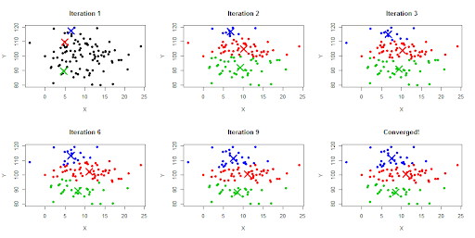
Difference in Usage of Supervised and Unsupervised Learning
The main distinction between the two approaches is the use of labelled datasets. To put it simply, supervised learning uses labelled input and output data, while an unsupervised learning algorithm does not. However, there is also a difference between the two, when it comes to purpose of model building and their applications
Goals: In supervised learning, the goal is to predict outcomes for new data. You know up front the type of results to expect. With an unsupervised learning algorithm, the goal is to get insights from large volumes of new data. The machine itself determines what is different or interesting from the dataset.
Applications: Supervised learning models are ideal for spam detection, sentiment analysis, weather forecasting and pricing predictions, among other things. In contrast, unsupervised learning is a great fit for anomaly detection, recommendation engines, customer personas and medical imaging.

Image classification

Image Classification is an important task in various fields such as remote sensing, biometry, biomedical images, and robot navigation.
A typical classification system consists of a camera fixed high on the interested zone, where images are captured and consequently processed.
In Supervised classification, some pixels are known grouped and gives the label to classes. This process is known as training. After that classifier uses trained pixels for classify other images.
In Unsupervised classification, pixels are grouped with the help of their properties. This process known as clustering and groups are known a cluster. In this user decides how many clusters he wants. The unsupervised classification used when no trained pixels are available.
In Image classification different methods are used: Decision Tree, Artificial Neural Network (ANN) and Support Vector Machine (SVM).
Image Classification includes following steps:
a. Image Acquisition: acquire the images from for image processing.
b. Image Pre-Processing: In preprocessing image transformation, noise removal, atmospherically
correction techniques are used.
c. Feature Extraction: Extracting the important characteristics of the image. Classification: The images are classified based on the extracted features into predefined categories by using suitable methods that compare the image pattern with images which inside the database.

Support vector machines (SVM) are powerful yet flexible supervised machine learning algorithms which are used both for classification and regression. Support vector machines have their unique way of implementation as compared to other machine learning algorithms. They are extremely popular because of their ability to handle multiple continuous and categorical variables. Support Vector Machine model is basically a representation of different classes in a hyperplane in multidimensional space. The hyperplane will be generated in an iterative manner by support vector machine so that the error can be minimized. The goal is to divide the datasets into classes to find a maximum marginal hyperplane. It builds a hyper-plane or a set of hyper-planes in a high dimensional space and good separation between the two classes is achieved by the hyperplane that has the largest distance to the nearest training data point of any class. The real power of this algorithm depends on the kernel function being used. The most commonly used kernels are linear kernel, gaussian kernel, and polynomial kernel.
