- C If the Government raises output above the free market level, consumers will get
no benefit from the extra units of output.
- C The gap between S+tax and S will be Rs 5 at each quantity.

- C Is rival and excludable.
- C Improved terms of trade for all countries.

- B Provide consistency with regards to taxation and subsidies
- C To impose trade sanctions on countries with which it disagrees politically
- A Oil is a scarce resource.
- D Nominal GDP uses current prices; real GDP uses constant prices.
- C the periodic fluctuations of output around the long run trend.
- C Net income from abroad
- C This could lead to ‘black’ market where the cylinders are sold at more than ceiling
price
- C Rs. 120 Cr
- D Rs. 800 Cr

- D Zero net social benefit

- C Y = C + I + G + X – M
- B Government expenditure

- B Country Y has a comparative advantage in the production of mobiles

- Using Income Method,
Net Domestic Income (NDP at FC) = Compensation of employees + Operating Surplus + Mixed income of self-employed = Rs. [24,000 + 10,000 + 28,000] crores = Rs.62,000 crores.
- Gross Domestic Income (GDP at MP) = NDP at FC + Depreciation + Net Indirect Tax (Indirect Tax - Subsidies) = Rs [62,000 + (-300) + (9,000 - 1,800)] crores = Rs.68,900 crores.
- Net National Income (NNP at FC) = NDP at FC + Net Factor Income from Abroad = Rs. [62,000 + (-300)] crores = Rs.61,700 crores.

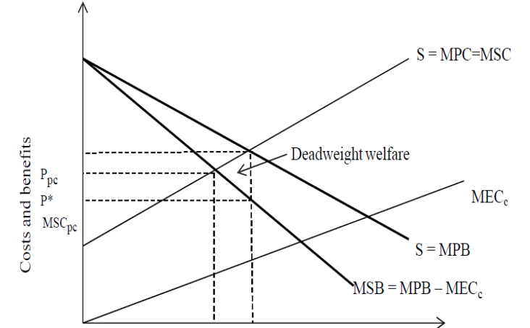
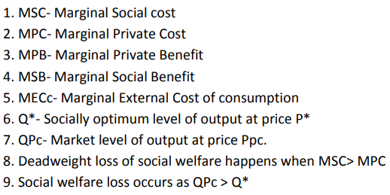
- As plastic is causing environmental pollution, it has social cost. Individuals are using plastic as it is convenient for them. Therefore, Marginal Social Cost (MSC) differs from Marginal Personal Cost (MPC).
- Plastic usage cause environmental pollution and animals may die due to consumption of plastic bags. Therefore, there is Marginal external Cost which may be incurred to keep water bodies clean and to protect animals from consumption of plastic.
- Therefore, MSB is lower than MPB. MSB= MPB - MECc. This is represented by MSB curve below MPB curve in the diagram. Market will have equilibrium position at QPc with Price Ppc. At socially optimal equilibrium at output Q* of price P*, MSB = MSC.
- The external cost of consumption result in level of output above socially optimum level, QPc > Q* From society’s point of view, too many plastic bags are being produced and consumed. This results in a dead weight welfare loss caused by overconsumption and represented by a triangle in diagram A.
- The short-run aggregate supply curve shows the aggregate output of the economy that firms are willing to supply in the short run – i.e., between long-run equilibria – for each price level.
The short-run aggregate supply curve slopes upwards because wages are not fully flexible in the short run.
This is due to either money illusion, which means that workers base their decisions the level of their money wages as opposed to their real wages, ...
... and/or fixed wage contracts, which mean that workers are unable to immediately renegotiate their wages in response to changes in the price level.
Now, an increase in the price level resulting from increased aggregate demand means that
firms will enjoy higher marginal revenue for their output.
Given that inflexible wages will not immediately rise to the same extent the marginal cost
that firms face will not have risen by as much as marginal revenue.
Therefore, it will be profitable for firms to expand output by employing more workers.
Thus, in the short run higher prices are associated with higher output (and vice versa), and
so, the short-run aggregate supply curve is upward sloping.

- Negative externalities occur when production and/or consumption impose external costs on third parties outside of the market for which no appropriate compensation is paid. This causes social costs to exceed private costs.
An example of a negative externality:
- People may smoke in public places and ignore harmful impact of toxic passive smoking on non-smokers.
- The passive smoking may harm health of non-smoker and may cause various respiratory diseases.
- In young lady’s passive smoking may cause pre-mature child birth and asthma.
- Passive smoking increases the risk of respiratory illnesses in children,
- including asthma, bronchitis and pneumonia.
- Healthcare expenditure involved in treatment of smoking related illnesses
- Price Related Intervention:
- The Government imposes a tax on the producer that reflects the marginal cost of the externality.
- Fines are imposed if smoking is done in public places
Non- Price Related Intervention:
- Smoking is banned in public places like gardens, restaurants, libraries, work places, etc.
- A law prohibiting any manufacturer, retailer, or distributor of tobacco from selling or distributing products to persons under age eighteen.
- Use of media / advertisements, public education to emphasize ill effects of smoking and motivate smokers to leave smoking
- Specially designed medical care and or programs for smokers to quit smoking.
- Diagram- marginal social benefit curve and marginal private benefit curve when a negative externality in consumption exists
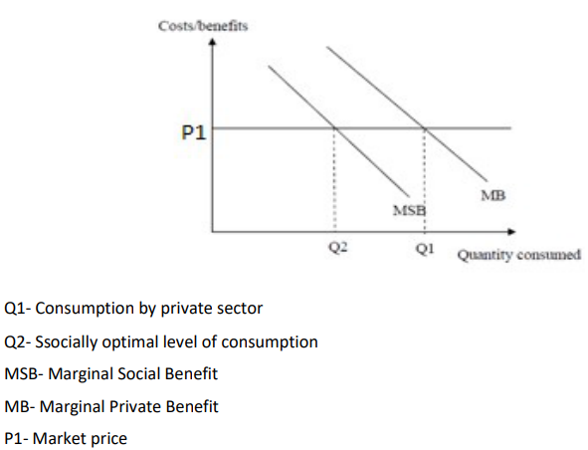
- Difference between actual and potential growth
The term actual economic growth refers to increases in the real Gross Domestic Product or real Gross National Product. The economic growth rate measures the percentage increase in the real Gross Domestic Product from one year to the next. The term actual economic growth refers to the increase in the trend rate of real Gross Domestic Product rather than the actual increase in output.
Potential economic growth refers to the speed at which the economy could grow and so it measures the percentage increase in an economy’s capacity to produce.

