
Universal Swap- Liquidity pools

REPORT



Ascertain the before and after-tax incremental cash flows.
Calculate the Net Present value of investing in a new studio or not.
Deduce the IRR pertaining to the various aspects of the project.
Consider several key assumptions, assessing how sensitive the project is subject to changes in the former. Derive the Weighted-Average Cost of Capital (WACC) which is a quintessential component to consider while investing in projects.

TABLE OF CONTENTS


Cash Flow Analysis


NPV of the project


IRR & Cost of Capital

INCOME( WITHOUT ALTERNIUM)

Given below is a Table that includes all calculated future cashflows Universal Swap - Liquidity pools will make in 10 years.

This income is subject to 10% tax rate.

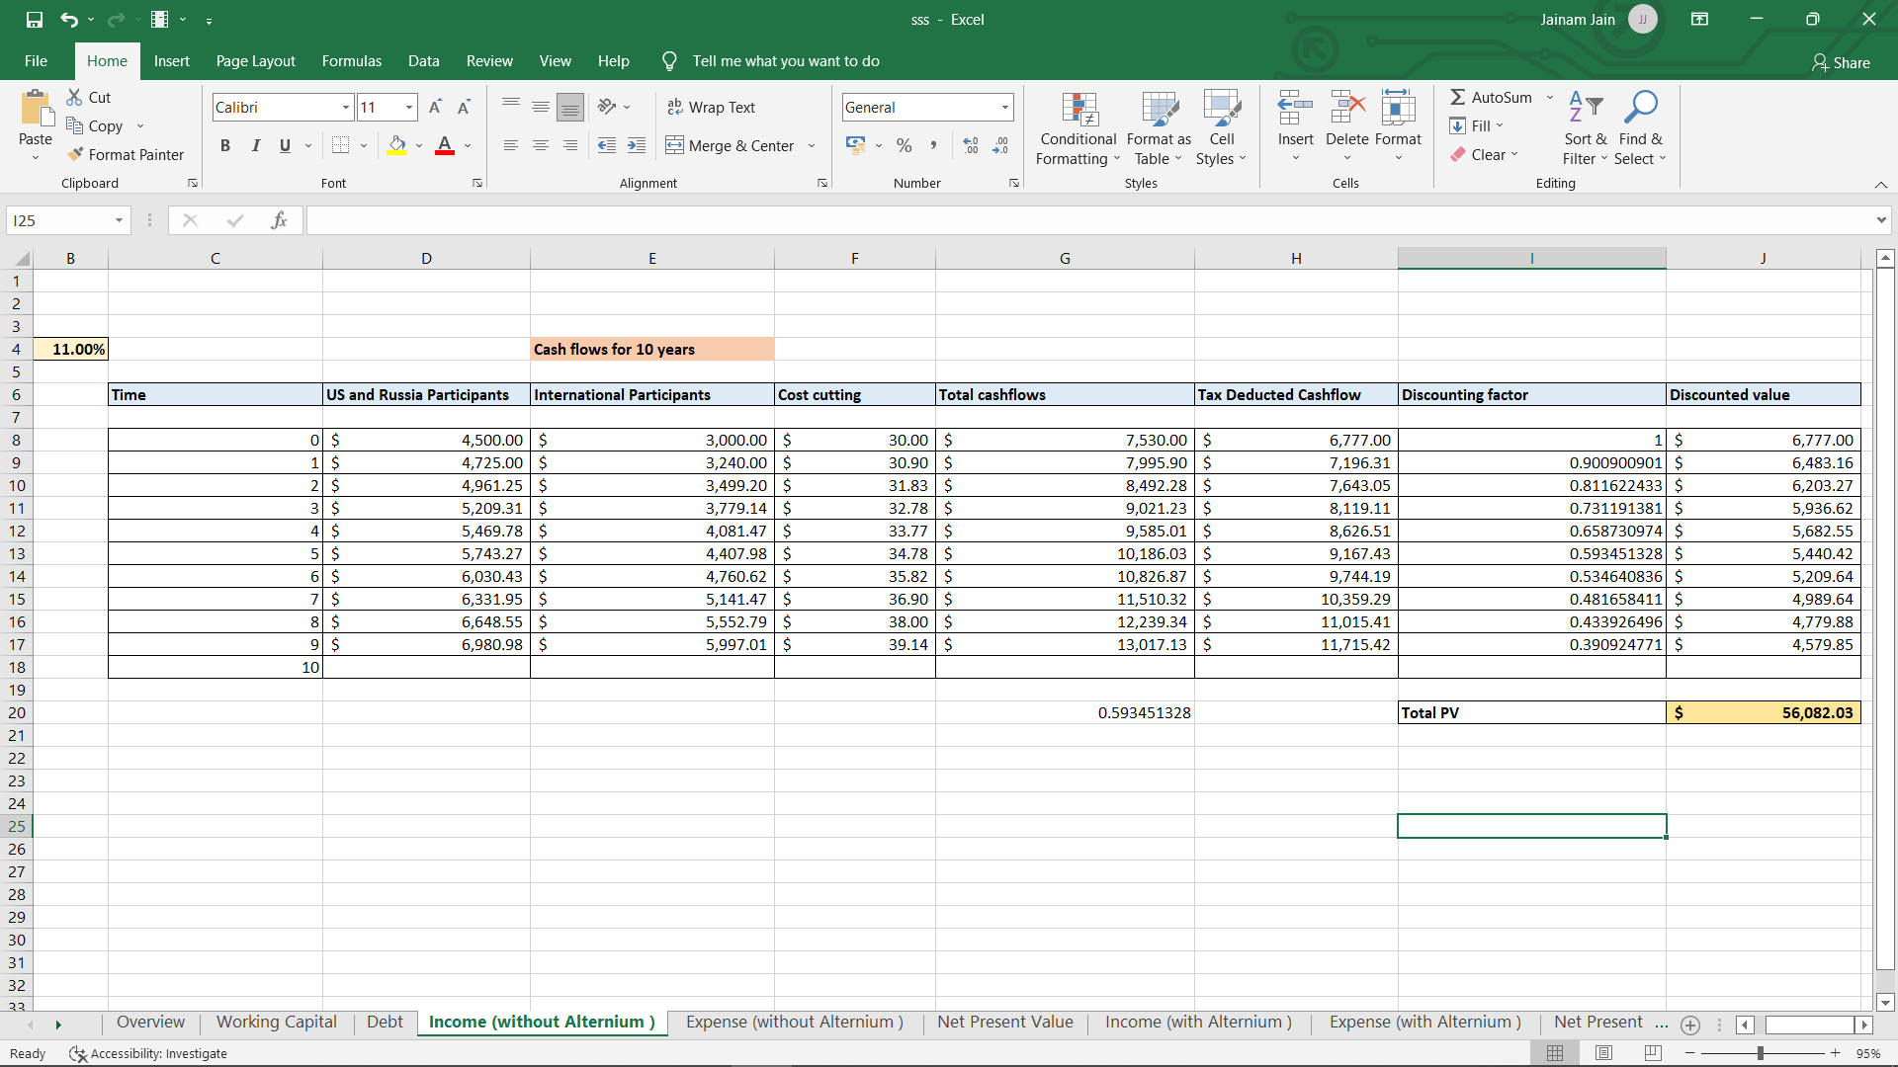

Further the amount has been discounted to present day, in order to find the NPV for this project

This table represents the Inflows for the company, without the new alternium.

Total present value for the inflows of 10 years is estimated to be $56082.03 millions.

EXPENSE (WITHOUT ALTERNIUM)

The Table below represents all calculated future cash outflows for the Universal Swap - Liquidity pools.

The cost of capital used for calculating the discounting factor is 11%.

Further, the amount has been discounted, to find out the NPV for the project.

This table basically represents the expenses for the company, without the new alternium.

The Present Value of the outflows is $24826.97.




Net Present
Value

The table above represents the Net Present Value (NPV) for Universal Swap - Liquidity pools, Without the new alternium.

This NPV is calculated by taking in account the present day values of all the cash inflows and outflows

INCOME( WITH ALTERNIUM)

Given below is a table that includes all calculated future inflows Universal Swap - Liquidity pools will make in 10 years.
This income is subjected to 10% corporate taxes.
Further , the amount has been discounted to present day in order to calculate NPV for the project.

Given below is a table that includes all calculated future inflows Universal Swap - Liquidity pools will make in 20 years.
This income is subjected to 10% corporate taxes.
Further , the amount has been discounted to present day in order to calculate NPV for the project.

EXPENSE( WITH ALTERNIUM)

Given below is a table that includes all calculated future expenses Universal Swap - Liquidity pools will be required to bear in 10 years.
This income is not subjected to taxes.
The amount has been discounted to present day in order to calculate NPV for the project.

Given below is a table that includes all calculated future expenses Universal Swap - Liquidity pools will be required to bear in 20 years.
This income is not subjected to taxes.
The amount has been discounted to present day in order to calculate NPV for the project.


IRR
9
for
10
years

IRR(10 YEARS) -19.99%

The internal rate of return is a metric used in financial analysis to estimate the profitability of potential investments. The internal rate of return is a discount rate that makes the net present value (NPV) of all cash flows equal to zero in a discounted cash flow analysis.

THANK YOU

MADE BY- JAINAM JAIN

