1) Read in the data file as a data table & fill in the entries for the CRUDE column in your table.
Code:
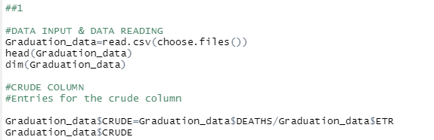
Output:
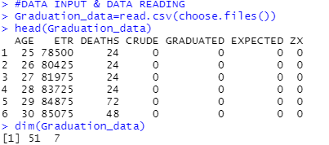
Entries for the Crude Column:
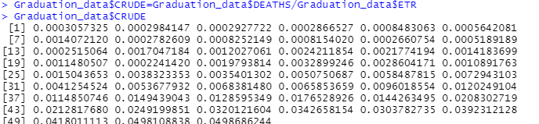

2) Use Gompertz law to fill entries in the GRADUATED column in the data.
Code:
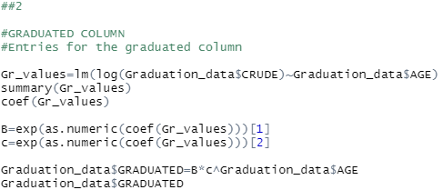

Output:
1.
We perform linear Regression to Obtain the Coefficients which are required to fill the Graduated column.
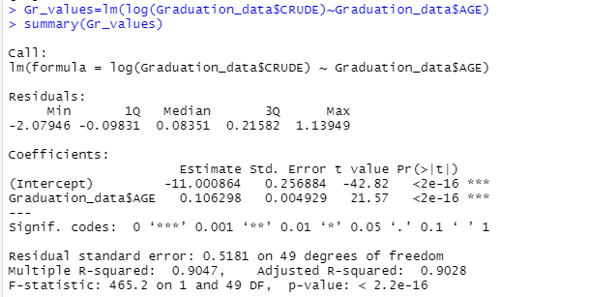

2. With the help of this Coefficient we use this values in the eq Ux(mu)=Bc^x

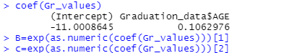

3.Hence we obtain the values.

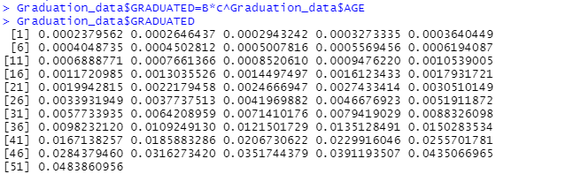

3) Check for smoothness by applying the third differences to the crude and graduated rates and
comment on your results.

Code:
Third difference refers to using the function “diff1” three times
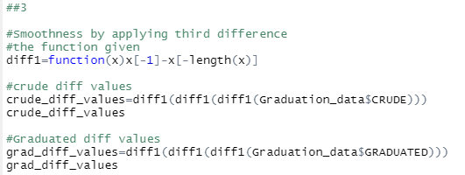

Output:
Third difference drastically makes all the values small which regular or continuous progress. Hence, it smoothened the values.
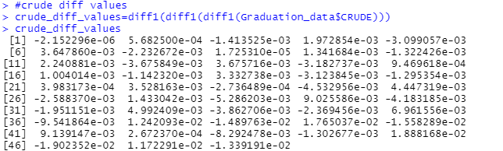

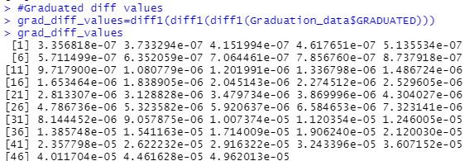

4) Calculate the values in EXPECTED and ZX values in the table. Hence, perform a chi-squared test to check goodness of fit between DEATHS and EXPECTED. You should specify the degrees of freedom used.

Code:
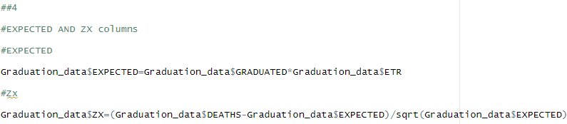

Output:
1. Expected values
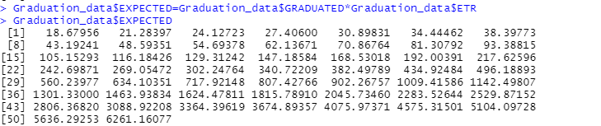
2. Zx Values
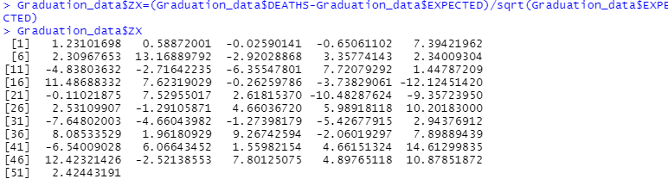
3. After the completion of all the Columns.

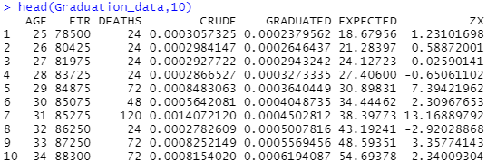

5)

a. Perform the standardised deviations test on the individual deviations, and comment on the-
i. Overall shape
ii. Absolute deviations
iii. Outliers
iv. Symmetry
v. Final conclusion about Null hypothesis

Code:
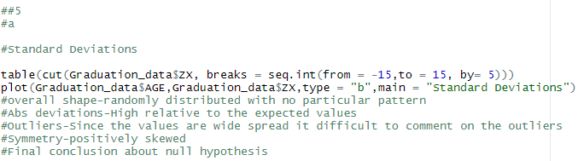

Output:
Overall shape is randomly distributed ,It is relatively high compared to expected values, because of wide spread it is difficult to comment about the Outliers, positively skewed, and overall it is not much overgraduated rates.
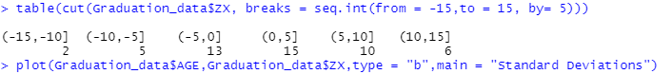

Plot:
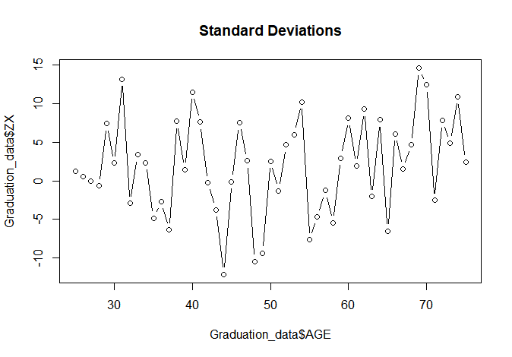

b. Perform the Signs test and give your conclusion

Code:
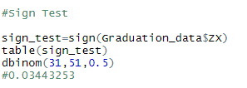

Output:
It has high positive values and sign test value is 0.03443253.
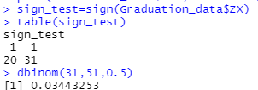

d. Perform the Serial correlations test and give your conclusion.
Code:
It has a correlation of 0.1477466
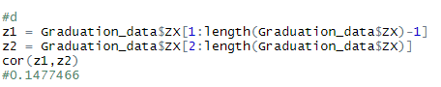
Output:
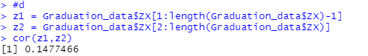

Variables Stored/Used:

