#importing data
mscmarks <- read.csv(file.choose())
dim(mscmarks)
OUTPUT: [1] 104 7
str(mscmarks)
OUTPUT: 'data.frame': 104 obs. of 7 variables:
$ Exam1 : num 60 90 130 130 90 100 105 120 120 130 ...
$ Exam2 : num 10 0 20 10 5 30 20 40 20 45 ...
$ Exam3 : num 16 0 24 24 22 20 22 18 30 22 ...
$ Exam4 : num 7 0 1 8.5 9.5 3 8 16 18 10.5 ...
$ Final_score: num 40.8 69.2 76.8 75.7 55.5 ...
$ Grade : Factor w/ 4 levels "A ","B ","C ",..: 3 2 2 2 3 2 2 1 1 1 ...
$ Pass.fail : Factor w/ 2 levels "0","1": 2 2 2 2 2 2 2 2 2 2 ...
#cleaning data
colnames(mscmarks)[1] <- "Exam1"
mscmarks$Exam1 <- as.numeric(mscmarks$Exam1)
mscmarks$Exam2 <- as.numeric(mscmarks$Exam2)
mscmarks$Exam3 <- as.numeric(mscmarks$Exam3)
mscmarks$Grade <- as.factor(mscmarks$Grade)
mscmarks$Pass.fail <- as.factor(mscmarks$Pass.fail)
mscmarks$Pass.fail <- ifelse(mscmarks$Pass.fail == "P",1,0)
#sampling dataset
nos <- sample(nrow(mscmarks),0.7*nrow(mscmarks))
modeldata <- mscmarks[nos,]
predictdata <- mscmarks[-nos,]
#model
mmodel <- lm(Final_score~.-Pass.fail,data = modeldata)
summary(mmodel)
OUTPUT: Call:
lm(formula = Final_score ~ . - Pass.fail, data = modeldata)

Residuals:
Min 1Q Median 3Q Max
-10.0855 -3.3744 -0.0433 3.5796 11.5179

Coefficients:
Estimate Std. Error t value Pr(>|t|)
(Intercept) 70.86562 3.26089 21.732 < 2e-16 ***
Exam1 0.06344 0.01752 3.622 0.00058 ***
Exam2 0.14885 0.05369 2.773 0.00727 **
Exam3 0.08767 0.09141 0.959 0.34113
Exam4 0.08933 0.13577 0.658 0.51294
GradeB -13.53196 1.76862 -7.651 1.33e-10 ***
GradeC -27.71683 2.36887 -11.700 < 2e-16 ***
GradeD -60.32426 3.57880 -16.856 < 2e-16 ***
---
Signif. codes: 0 ‘***’ 0.001 ‘**’ 0.01 ‘*’ 0.05 ‘.’ 0.1 ‘ ’ 1

Residual standard error: 4.995 on 64 degrees of freedom
Multiple R-squared: 0.9455, Adjusted R-squared: 0.9396
F-statistic: 158.7 on 7 and 64 DF, p-value: < 2.2e-16
#predicting
predmarks <- predict(mmodel,predictdata)
predmarks
OUTPUT: 2 10 21 24 26 30 32
63.04283 88.67729 16.33065 50.20975 88.30919 52.00255 88.62931
36 41 42 43 44 48 51
45.62013 16.41159 49.16731 73.14503 69.47452 12.12273 72.25022
55 62 63 67 69 72 74
70.05425 10.72002 16.80886 10.98800 49.73174 69.21336 50.68639
75 77 79 81 86 88 92
18.39651 47.48567 52.16705 18.53291 69.53451 47.70392 11.12200
93 95 97 101
69.16797 48.27285 73.14503 70.88996
#checking model
correlation <- cor(predmarks,predictdata$Final_score)
accuracy <- correlation^2
accuracy
OUTPUT: [1] 0.853569
#decision tree question
library("rpart")
library("rattle")
#decision tree
grdtree <- rpart(Grade~.,data=modeldata,method="class")
fancyRpartPlot(grdtree)
OUTPUT: 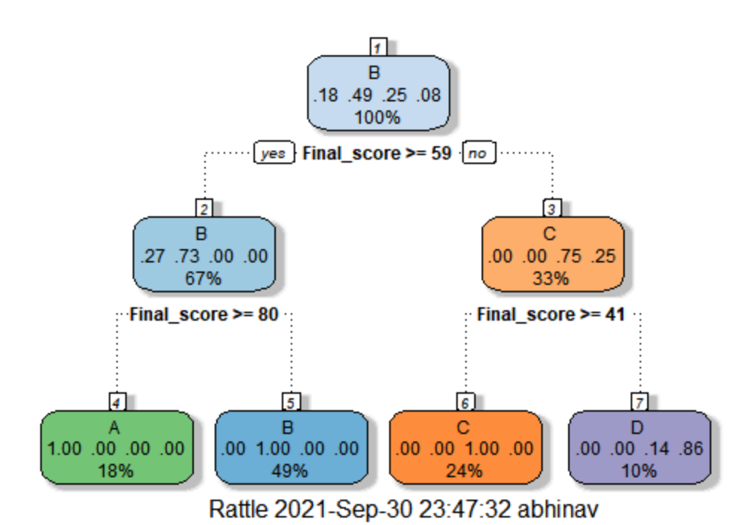
printcp(grdtree)
OUTPUT: Classification tree:
rpart(formula = Grade ~ ., data = modeldata, method = "class")

Variables actually used in tree construction:
[1] Final_score

Root node error: 37/72 = 0.51389

n= 72

CP nsplit rel error xerror xstd
1 0.48649 0 1.000000 1.00000 0.114622
2 0.35135 1 0.513514 0.51351 0.101076
3 0.13514 2 0.162162 0.18919 0.067942
4 0.01000 3 0.027027 0.10811 0.052531
plotcp(grdtree)
OUTPUT: 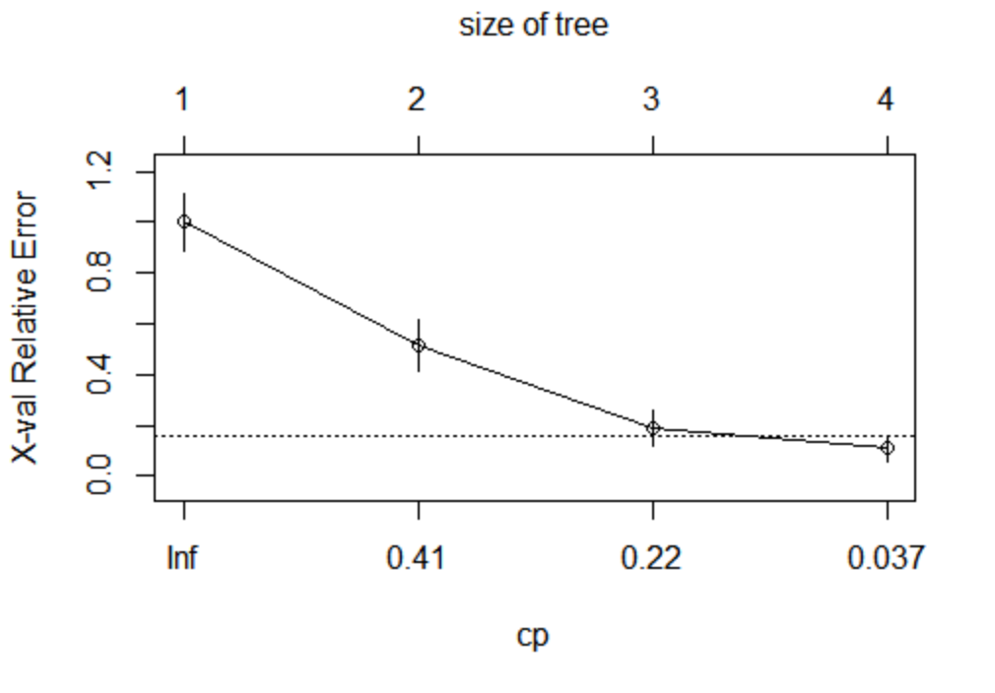
#pruning tree
prunedtree <- rpart(Grade~.,data=modeldata, control=rpart.control(maxdepth=1))
fancyRpartPlot(prunedtree)
OUTPUT: 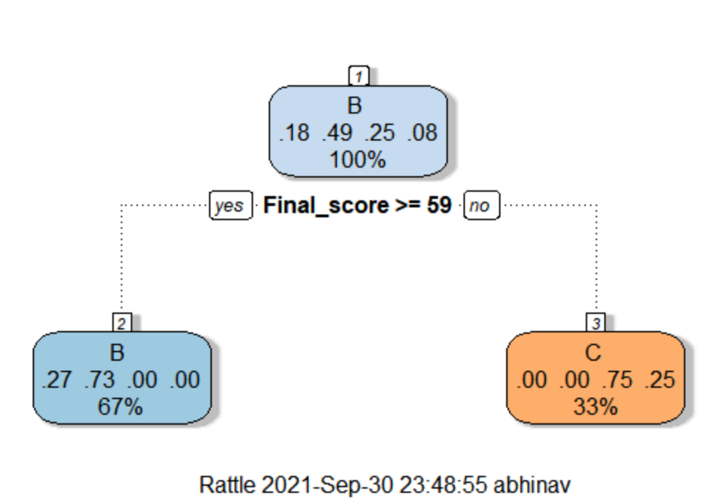
printcp(grdtree)
OUTPUT: Classification tree:
rpart(formula = Grade ~ ., data = modeldata, control = rpart.control(maxdepth = 1))

Variables actually used in tree construction:
[1] Final_score

Root node error: 37/72 = 0.51389

n= 72

CP nsplit rel error xerror xstd
1 0.48649 0 1.00000 1.00000 0.11462
2 0.01000 1 0.51351 0.51351 0.10108
plotcp(grdtree)
OUTPUT: 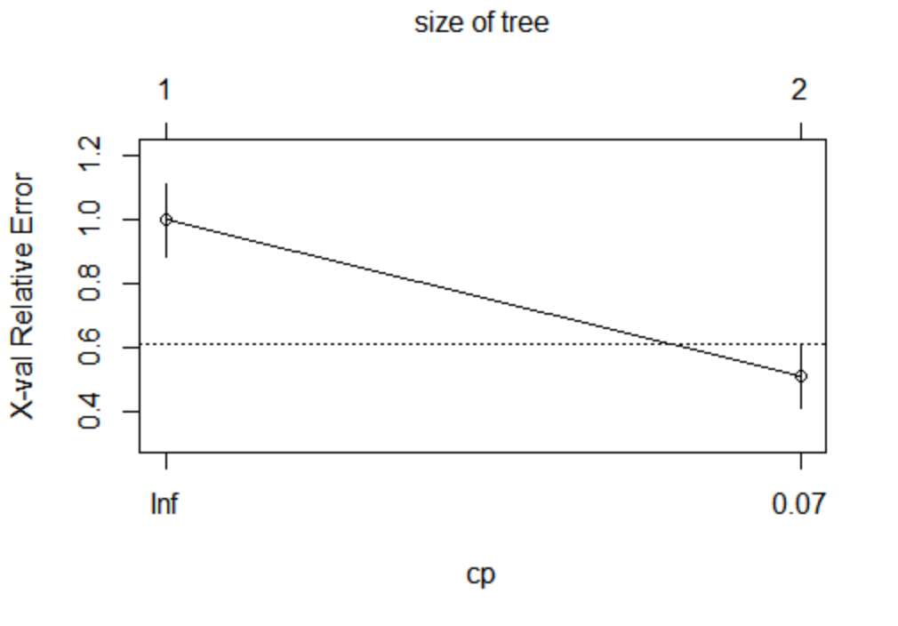
#the tree before has lower cp.
#predictions and accuracy
#tree1
btrpred <- predict(grdtree,predictdata,type="class")
btrpred
OUTPUT: 2 10 21 24 26 30 32 36 41 42 43 44 48 51 55 62 63
B A D C A C A C D C A B D A B D D
67 69 72 74 75 77 79 81 86 88 92 93 95 97 101
D C B D D C B D B C D B C A B
Levels: A B C D
c <- table(predictdata$Grade,btrpred)
accuracy = sum(diag(c))/sum(c)
accuracy
OUTPUT: [1] 0.9375
#tree2
btrpredp <- predict(prunedtree,predictdata,type="class")
btrpredp
OUTPUT: 2 10 21 24 26 30 32 36 41 42 43 44 48 51 55 62 63
B B C C B C B C C C B B C B B C C
67 69 72 74 75 77 79 81 86 88 92 93 95 97 101
C C B C C C B C B C C B C B B
Levels: A B C D
d <- table(predictdata$Grade,btrpredp)
accuracyp = sum(diag(d))/sum(d)
accuracy
OUTPUT: [1] 0.5
#therefore grdtree is better model.

