PRODUCT DESIGN
-Insurance for Political Activists
Activism- In general it refers to efforts put in to promote or intervene in social, political economic or environmental reform, the final goal being realising a changed society leading up to a better place to live in. Most often than not these well-intentioned concerns are met with scrutiny and misconstrued as being intended to target a particular group or community.
Political Activism- In particular, it is the practice of taking vigorous actions or getting involved to achieve political or other goals by means of demonstrations or protests of various kinds.
Effects- The government and the state overall feel threatened when such uprisings take place and do anything and everything to try and supress these activities. They try and pass legislations to curb this and may also resort to arresting activists or beating them up to the point of hospitalization or even death sometimes.
-The following instance could possibly shed light on the adversity of the situation and the plight of such activists.
Stan Swamy an Indian Roman Catholic priest and a member of the Jesuit order was a tribal rights activist for several decades. He had questioned the non-implementation of the Fifth Schedule of the Constitution, which stipulates setting up of a Tribes Advisory Council with members solely of the Adivasi community for their protection, well-being and development in the state and was falsely accused of being a Maoist sympathizer and was arrested for the same. Swamy suggested his arrest was linked to his work, as it involved dissent against government policies
Swamy while in jail said,
“What is happening to me is not something unique happening to me alone. It is a broader process that is taking place all over the country. We are all aware how prominent intellectuals, lawyers’ writers, poets, activists, students, leaders, they are all put into jail because they have expressed their dissent or raised questions about the ruling powers of India. We are part of the process. In a way I am happy to be part of this process. I am not a silent spectator, but part of the game, and ready to pay the price whatever be it.”
Many such cases have been reported in the past years and the lives of such people needs to be protected for the sake of their families as well as the society at large.
Role of Insurance-
- Such causes don’t seem to be reducing in the near future as more and more such people have started to raise their voices against this. Thus, protection for such groups is key.
- Insurance can come to the rescue by offering policies that cover the following:
- the bail money,
- lawyer fees
- Hospitalization bills
- The policy could also state the sum-assured that could be paid to the nominees (family member/dependents) of the insured in case of untimely death of the latter owing to the risks they are taking.
Premium
- The rates could be set based on the above factors mentioned.
- The payment of the premiums could be in the form of a single lump sum at the beginning itself to prevent future hassles in case regular and timely payments were to be made.

JAMIE’S CASE STUDY
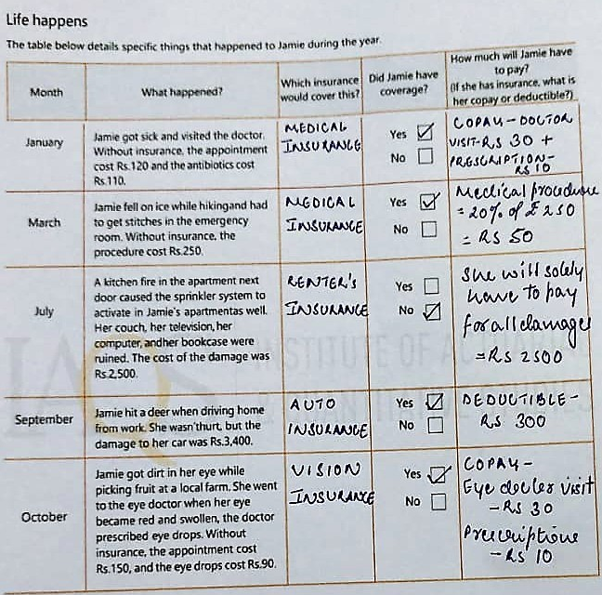

Summarizing the costs
As per the case study, Jamie shortlisted a couple of insurance products that she thought would be best for her. This was due to the presence of budget constraints which allowed her to only spend up to Rs. 2150 on premiums annually.
From those shortlisted ones, Jamie had the following policies in place:
- Medical insurance
- For this Jamie paid a monthly premium of Rs. 103.
- In January when Jamie got sick her doctor’s appointment and antibiotics that would have cost her Rs. 120 and Rs. 110 in the absence of the insurance, cost her only Rs 30 and Rs 10 in the form of co-pay respectively.
- In March she had to get stitches because of a fall she suffered while hiking.
The visit to the emergency room cost her only Rs. 50. Additionally she had to pay Rs. 50 for her stitches. (20% of her Rs.250- cost of the medical procedure)

- Auto insurance-
- She pays an annual premium of Rs.889
- In September her car was damaged when she hit a deer. In the presence of the auto insurance, according to its terms and conditions she only had to pay Rs.300 as part of the deductible. The rest of the damages were covered by the company.
- In the absence of the insurance, she would have had to pay the complete amount.

- Vision Insurance-
- She only had to pay a monthly premium of Rs.2. Rest of the charges were covered for her through her employer.
- Her October’s visit to the eye doctor due to an infection cost her only Rs 30 for the visit and Rs 10 for the prescriptions. In the absence of this she would have had to pay the full amount.

- Renter’s insurance-
- Since Jamie declined this insurance in the beginning, the damaged caused to her furniture because of the sprinklers had to be borne by her solely.

Insurance in my life
A couple of months back, a family member had undergone a cataract treatment. Being a retired employee of RBI, she was able to avail the RBI Group Mediclaim Policy.
MEDICLAIM INSURANCE POLICY
- A Mediclaim health insurance offers specific financial aids against health-related issues. A claim is processed in the form of reimbursement as well as cashless treatment.
- The premium is decided on the basis of the sum assured, age of the insured, gender, location as well as term of the policy.
- It doesn’t offer any add on coverage as opposed to that of a regular health insurance policy. No coverage is offered for critical illnesses.
- Claims can be filed up until the sum assured limit is realised.

RBI MEDICLAIM POLICY
- The RBI Mediclaim Policy covers its employees as well as their spouse.
- It covers hospitalization expenses, doctor fees, dental treatment, and certain other diseases. as well.
- The cataract operation in this case had a cap of Rs 40000/eye.

Jamie gives advice
Date-25/12/2021
To: jimmyandrew23@gmail.com
From: jamie134@gmail.com
Subject: Role of insurance in one’s life
Hi Jimmy. Hope you’re doing well. First off wanted to congratulate you for graduating. This new job that has been offered to you has opened new avenues in your life and it is just the beginning of the very next phase of your life.
Keeping this in mind your concerns regarding whether insurance is worth the cost or not is quite normal and something to think about. Insurance simply put is a way to manage one’s risks and enables a person to be financially secured to a large extent. Apart from this having the right insurance is key. It is important to understand and analyse various policies before one buys an insurance. Research needs to be done for one to avail the right policy with appreciable premium rates and sufficient coverage benefits.
If I still haven’t been able to convince you, maybe my personal experiences could change your perception regarding this. A couple of months back a fire broke out in the neighbour’s apartment that caused the water sprinklers in my apartment to go off leading to a lot of furniture getting damaged. Having declined the renter’s insurance, I had to bear all the expenses myself.
Another instance was when my auto insurance covered almost 90% of the damages that were caused to my car when I accidently hit a deer while driving home back in September.
These experiences are not meant to alarm you. It’s important to be aware about the various risks one faces in life and the insurance covers offered to reduce the financial burden that follows.

