Name: Darshan Lodha
Roll No.: 433
Assignment 1
Semester 4
Business Economics - Macro

MCQs
Question 1]
Answer: C: If the Government raises output above the free market level, consumers will get no benefit from the extra units of output.
Question 2]
Answer: C: The gap between S + tax and S will be Rs 5 at each quantity.
Question 3]
Answer: D: Average Revenue = Marginal Cost
Question 4]
Answer: C: Is rival and excludable.
Question 5]
Answer: C: Improved terms of trade for all countries.
Question 6]
Answer: C: Rise and real GDP will rise.
Question 7]
Answer: B: Provide consistency with regards to taxation and subsidies.
Question 8]
Answer: C: to impose trade sanctions on countries with which it disagrees politically.
Question 9]
Answer: A: Oil is a scarce resource.
Question 10]
Answer: D: Nominal GDP uses current price; real GDP uses constant prices.
Question 11]
Answer: C: The periodic fluctuations of output around the long run trend.
Question 12]
Answer: C: Net income from abroad.
Question 13]
Answer: C: This could lead to ‘black’ market where the cylinders are sold at more than ceiling price.
Question 14]
Answer: C: Rs 120 Cr
Question 15]
Answer: D: Rs 800 Cr
Question 16]
Answer: C: Efficient management in production to increase profits.
Question 17]
Answer: D: Zero net social benefit.
Question 18]
Answer: B: Only negative externality exists.
Question 19]
Answer: B: Y = C + I + G
Question 20]
Answer: B: Government expenditure.
Question 21]
Answer: B: 606 billion.
Question 22]
Answer: A: 538 billion.
Question 23]
Answer: D: 621 billion.
Question 24]
Answer: C: 556 billion.
Question 25]
Answer: D: Large population.
Question 26]
Answer: B: GDP at constant prices for 2021 is estimated with the base year as 2010-2011.
Question 27]
Answer: B: Country Y has a comparative advantage in the production of mobiles.
Question 28]
Answer: C: 270 million.
Question 29]
Answer:

To find: Net Domestic Income
Solution:
$$Net Domestic Income=Mixed Income of the self-employed+Operating surplus+Compensation of employees$$
$$Net Domestic Income=28000+10000+24000=Rs 62000 cr$$

To find: Gross Domestic Income
Solution:
$$Gross Domestic Income=Net Domestic Income+Depreciation$$
$$Gross Domestic Income=62000+1700=Rs 63700 cr$$

To find: Net National Income
Solution:
$$Net National Income=Net Domestic Income+Net Income from Abroad$$
$$Net National Income=62000-300=Rs 61700 cr$$
Question 30]
Answer:
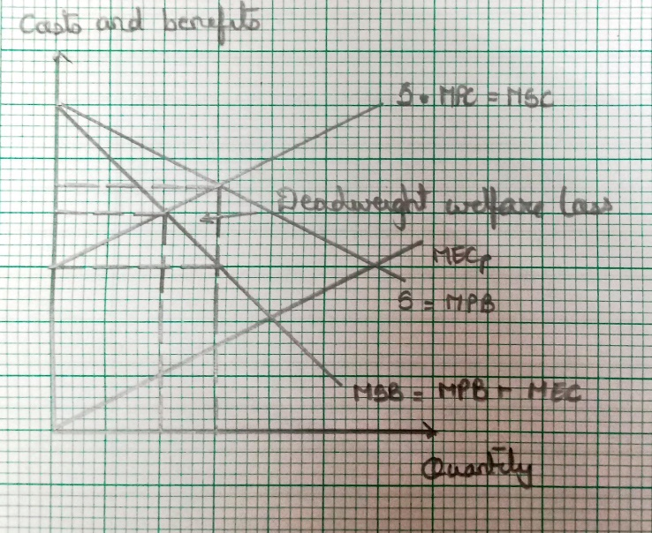
(This graph was separately drawn on a graph paper by Darshan for the ease of drawing.)
- As plastic is causing adverse effects on the environment, it has certain externalities. Plastic is used owing to its convenience to use. Thus. Marginal social cost differs from marginal private cost.
- Use of plastic causes pollution and negative effects on the global biodiversity. Hence, marginal external cost may be incurred to keep water bodies clean and to protect animals form consuming plastic.
- Therefor, MSB is lower than MPB. This is represented in the graph above.
- From society’s point of view, too many plastic bags are being produced and consumed. This results in a dead weight welfare loss caused by overconsumption and represented by a triangle labelled in the above graph.
Question 31]
Answer:
- The short-run aggregate supply curve shows the aggregate output of the economy that firms are willing to supply in the short-run i.e., between long-run equilibria for each price level.
- The short-run aggregate supply curve slopes upwards because wages are not fully flexible in the short-run.
- This is due to either money illusion, which means that workers base their decisions the level of their money wages as opposed to real wages and/or fixed wage contracts, which mean that workers unable to immediately renegotiate their wages in response to changes in the price level.
- Now, an increase in the price level resulting from increased aggregate demand means that firms will enjoy higher marginal revenue for their output.
- Given that inflexible wages will not immediately rise to the same extent the marginal cost that firms face will not have risen by as much as marginal revenue.
- Therefore, it will be profitable for firms to expand output by employing more workers.
- Thus, in the short run higher prices are associated with higher output (and vice versa), and so the short-run aggregate supply curve is upward sloping.
Question 32]
Answer:
- A negative externality occurs when either production or consumption or both causes external costs on any third party apart from the parties concerned in the process of production or consumption for which no appropriate compensation is paid.
e.g., Waste dumped by a factory in a river where people practice fishing for their livelihood.
- A price related intervention can be that the government imposes a tax equal to the marginal external cost of production.
A non-price related intervention can be that an appropriate restriction or law s imposed which prevents the factory from dumping waste in the river.
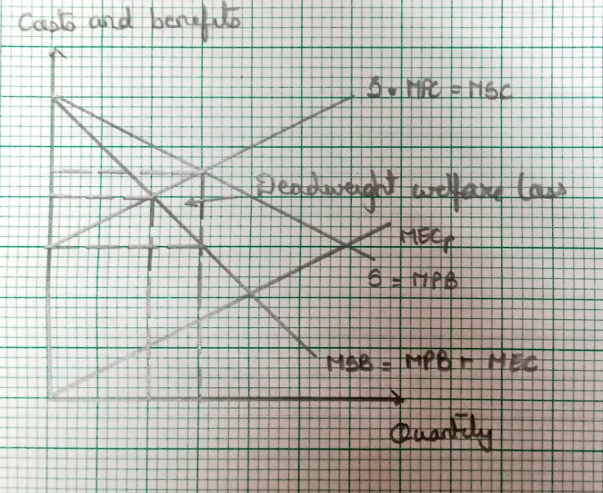

(This graph was separately drawn on a graph paper by Darshan for the ease of drawing. The same graph as that of Question 30 applies)
Question 33]
Answer:
- The term actual economic growth refers to increases in the real GDP or real GNP.
- The economic growth rate measures the percentage increase in the real GDP for a specified time interval.
- The term actual economic growth refers to the increase in the trend rate of real GDP rather than the actual increase in output.
- The term potential economic growth refers to the speed at which the economy could grow and so it measures the percentage increase in an economy’s capacity to produce.
Question 34]

Answer:
The three methods of measuring national income are as follows:
- Income measure
- Output measure
- Expenditure measure
- Income measure: This measures the total of factor earnings. These are factor payments to land, labour and capital. Transfer payments are not included (to avoid double counting).
- Output measure: This measures the value of goods and services produced. To avoid double counting we only include the “value added” component of firms’ output.
- Expenditure method: This includes all expenditure (including exports minus imports) in the economy and also what would have to be spent to purchase increases in inventories (or stocks). To avoid double counting, we include only expenditure on final goods.
- The three methods are similar. However, in practice difficulties of measurement and data limitations mean that the three measures will not be equal.

