SRM ASSIGNMENT
New Roll.No-4

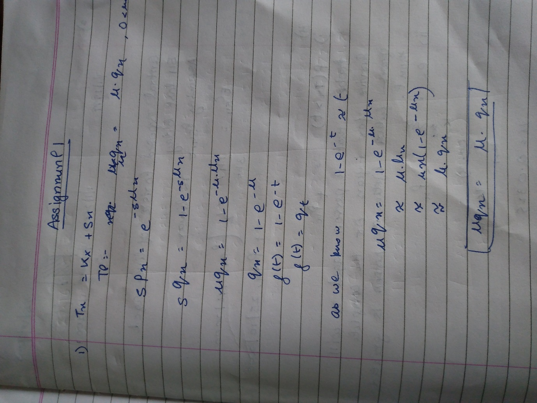

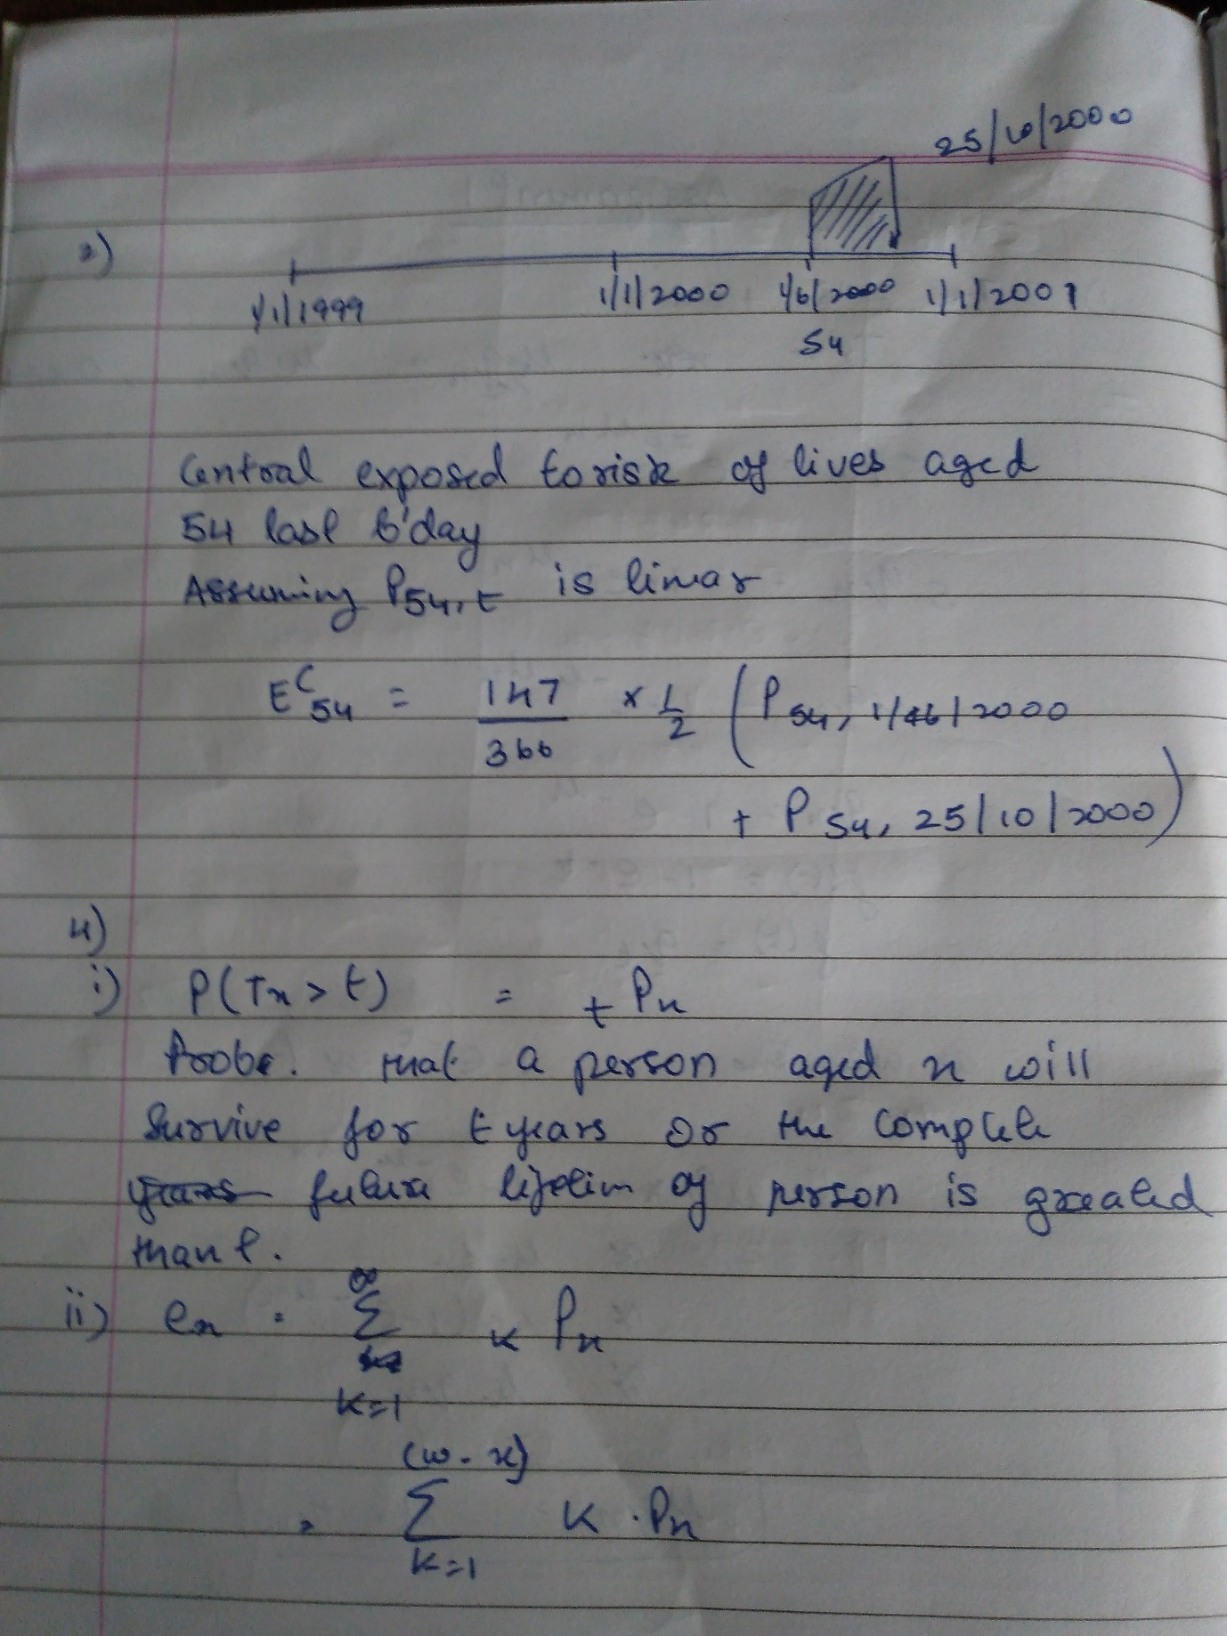

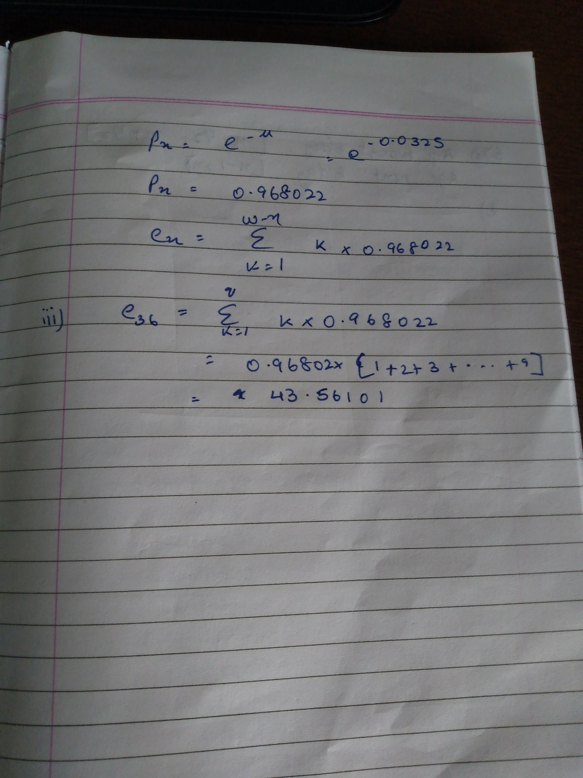

5
- Between ages 35 to 90 years.
- $tp_{x}=\exp\left(-\int_{0}^{t}{μ_{\left(x+s\right)}ds}\right)$
$$=\exp\left(-\int_{0}^{t}{Bc^{x+s}ds}\right)$$

$$We can write c^{x+s} as c^{x}e^{s*logc}, so that the integral becomes:$$
$$\int_{0}^{t}{B*c^{x}*e^{s*\log{c}}ds}=\frac{Bc^{x}}{\log{c}}{\left[e^{s*\log{c}}\right]}_{0}^{t}$$
$$=\frac{Bc^{x}}{\log{c}}{\left[c^{s}\right]}_{0}^{t}=\frac{Bc^{x}}{\log{c}}\left[c^{t}-1\right]$$

$$If we introduce the auxiliary parameter g defined by log=-\frac{B}{\log{c}}, the value of the integral is-logg*c^{x}\left(c^{t}-1\right) and we find that:$$

$$tp_{x}=exp⁡[\log{g}*c^{x}\left(c^{t}-1\right)=$$
$$\left(e^{\log{g}}\right)*c^{x}*\left(c^{t}-1\right)=gc^{x}(c^{t}-1)$$
6
- Female smoker aged 30 at entry.

- $\frac{h_{j}\left(t\right)}{h_{i}\left(t\right)}=\frac{\exp{-0.05}}{\exp{0.1}}=0.86070$
Where j is male smoker aged 30 at entry and i is female smoker aged 40 at entry.
$$But s\left(t\right)=\exp\left(-\int_{0}^{t}{h\left(s\right)ds}\right)hence$$
$$s_{j}\left(t\right)={\left(s_{i}\left(t\right)\right)}^{0.86070}$$
Which implies that
$$s_{j}\left(t\right)>s_{i}\left(t\right) for all t>0$$

- $\frac{h_{j}\left(t\right)}{h_{i}\left(t\right)}=\frac{\exp{0.2}}{\exp{0.05}}=1.161$
Where j is male smoker aged 30 at entry and i is male smoker aged 40 at entry
$$But s\left(t\right)=\exp\left(-\int_{0}^{t}{h\left(s\right)ds}\right)hence$$
$$s_{j}\left(t\right)={\left(s_{i}\left(t\right)\right)}^{1.161}$$
Which implies that
$$s_{j}\left(t\right)<s_{i}\left(t\right) for all t>0$$

7

- The average age at the start of the rate interval is x – ½ assuming that birthdays are uniformly distributed over the policy year.

- $P_{x,t}$ to represent the in force at time t from the 1 January 1997 classified x next birthday on policy anniversary nearest to time t

$θ_{x.t}$ to represent the deaths in the calendar year 1997 aged x next birthday on policy anniversary (= age next birthday at entry plus curtate duration at date of death) before death

$P_{x}\left(t\right)$ to represent the in force at time t from the 1 January 1997 classified x next birthday on the policy anniversary preceding time t.
$P_{x}\left(t\right)=\frac{1}{2}\left(P_{x,t}+P_{x+1,t}\right)$
$E_{x}^{c}=\int_{0}^{10}{P_{x}\left(t\right)dt}=\frac{1}{2}\sum_{t=0}^{9}{\left(P_{x}\left(t\right)+P_{x}\left(t+1\right)\right)}$
$E_{x}=E_{x}^{c}+\frac{1}{2}\sum_{t=0}^{9}{θ_{x,t}}$
assuming that in aggregate the deaths occur on average halfway through the policy year.

8

- Types of censoring presents:
- Type I censoring present because the study ends at a predetermined duration of 45 days.
- Type II censoring is not present because the study did not end after a predetermined number of patients had died.
- Random censoring is present because the duration at which a patient left hospital before the study ended can be considered as a random variable.
- Right Censoring is present for those lives that exit before the end of investigation period.
- The censoring is likely to be informative.
The patients who died were probably recovering less well that patient who discharged from the hospital.
If they had not died, they would likely to remain in the hospital for longer than those who were not censored.

T | n | d | c | d/n | (1-d/n) | S(t)
0 | 13
5 | 13 | 1 | 0 | 0.0769 | 0.9231 | 0.92
7 | 12 | 1 | 0 | 0.0833 | 0.9167 | 0.85
14 | 11 | 1 | 2 | 0.0909 | 0.9091 | 0.77
28 | 8 | 1 | 2 | 0.1250 | 0.8750 | 0.67
35 | 5 | 1 |  | 0.2000 | 0.8000 | 0.54
So, the value survival function at end of investigation period is 0.54
Assumptions:
- The censoring happens just after the death.
- Ignoring the discharge on any other ground except recovery from illness.
- Ignore any admission period before the start of investigation.
- Comments:
- The survival of a patient from the infection who given treatment is around 50% in light of the answer in c) above.
- However, the hospital excluded the number of deaths who died within two weeks of observation period.
- It also ignores the admission pre investigation period
- It is assuming that the censored patient at the end of investigation will survive for sure.
- Also ignoring the patients being discharged on any other ground like shifting to another hospital etc.
- It claims that 8 out of 10 patients who responded the treatment beyond two weeks would survive.
9

- Under the uniform distribution of deaths assumption:
$$\int_{0}^{1}{tPxdt}=\int_{0}^{1}{\left(1-tqx\right)dt}$$
$$={\left[t-0.5t^{2}q_{x}\right]}_{0}^{1}$$
$$Since q_{x}=0.3, we have$$

$$m_{x}=\frac{0.3}{1-0.15}=0.352941$$

- Under the constant force of mortality:
$$q_{x}=1-e^{-μ}$$
$$\int_{0}^{1}{tPxdt}=\int_{0}^{1}{e^{-μ}dt}=\frac{1}{μ}*\left(1-e^{-μ}\right)=\frac{q_{x}}{μ}$$
$$So, m_{x}=μ=-\ln\left(1-q_{x}\right)=-\ln{0.7}=0.356675$$
10
- Under the Cox model each individual’s hazard is proportional to the baseline hazard, with the constant of proportionality depending on certain measurable quantities called co-variates. Hence the model is also called a proportional hazards model.

- (t) 0(t)exp (F* F M * M D * D), where (t) is the estimated hazard and 0 (t) is the baseline hazard.
- The baseline hazard refers to annual policy taken through the Online channel and where premiums are paid by direct debit.
- The results imply that
exp [(βD *1)]/ exp [(βD *1) + βF*1 + βM*1] = 0.75
exp (βF + βM) = 4/3
exp (βD*1) / exp [(βF *1)] = 1
exp (βM*1) / exp [(βD *2)] = 0.75
Substituting from (2) into (1) gives
exp (βD + βM) = 4/3
exp(βD) * exp(βM) = 4/3
From Eqn 3
(Exp(βD)) ^2*0.75 = exp(βM)
So
Substituting in Eqn 4
exp(βD) * (exp(βD))2*0.75 = 4/3
(Exp(βD)) ^3= 1.7778
exp(βD) = 1.2114
βD = 0.19179
βF = 0.19179
βM = 0.0959
11

T | S(t) | Λ(t) | nt | dt | ct
0 | 1 | 0 | 12 | 0
1 | 0.9167 | 0.0833 | 12 | 1 | 2
3 | 0.7130 | 0.22 | 9 | 2 | 2
6 | 0.4278 | 0.4 | 5 | 2 | 3
- Summing up the number of deaths we have total deaths = d1+d3+d6= 1+2+2= 5. Since we started with 12 insects, the remaining 7 insects’ histories were right censored.
12
- Gompertz Law is an exponential function, and it is often a reasonable assumption for middle and older ages. It can be expressed as follows:
$$λ_{x} = Bc^{x};$$
$$where, λ_{x} is a force of mortality at age x$$
- Substituting, 𝐵𝐵 = exp (𝛽0+𝛽1𝑋1 + 𝛽2𝑋2) ;
into the Gompertz model,
𝜆𝑥 = exp (𝛽0+𝛽1𝑋1 + 𝛽2𝑋2). 𝑐^𝑥;
defining x as duration since 50th birthday.
The hazard can therefore be factorized into two parts:
exp (𝛽0+𝛽1𝑋1 + 𝛽2𝑋2), which depends only on the values of the covariates, and
𝑐𝑐𝑥𝑥, which depends only on duration.
So, the ration of between the hazards for any two persons with different characteristics does
not depend on duration, and so the model is a proportional hazards model.

- The baseline hazard in this model relates to a non-smoker female

- For a female cigarette smoker, we have
𝑋1 = 0 and 𝑋2 = 1 and x = 4
Therefore, the hazard at age 54 is given by
𝜆𝑥 = exp (𝛽𝛽0 + 𝛽𝛽1. 0 + 𝛽𝛽2. 1). 𝑐^4
= exp (-4+0.65) x 1.05^4
= 0.0351x1.2155
= 0.04266

- The hazard for a non-smoker at duration, ‘s’ is given by the formula
𝜆𝑠 = exp(𝛽0+𝛽1𝑋1). 𝑐^𝑠
The hazard for a smoker at duration, ‘t’ is given by the formula
𝜆𝑡 = exp (𝛽0+𝛽1𝑋1 + 0.65). 𝑐^𝑡
If the smoker’s and non-smoker’s hazards are the same, then
𝜆𝑠 = 𝜆𝑡
i.e., exp(𝛽0+𝛽1𝑋1). 𝑐^𝑠 = exp (𝛽0+𝛽1𝑋1 + 0.65). 𝑐^𝑡
i.e., 𝑐^𝑠 = exp (0.65). 𝑐^𝑡
i.e., 𝑐^(𝑠−𝑡) = exp (0.65) = 1.9155
Since, c = 1.05
Hence, 1.05^(𝑠−𝑡) = 1.9155
So, s-t = ln (1.9155)/ln (1.05) = 0.65/0.04879
s-t = 13.32
Hence, when the two hazards are equal, the non-smoker is approximately 13 years older than the smoker.

13
- (Let P’x(t) be the number of policies in force aged x nearest birthday at time t.
Also, let Px(t) be the number of policies in force aged x last birthday at time t.
Let Ex^C refers to the central exposed to risk at age label x respectively.
$$E_{x}^{C}=\int_{t=0}^{2}{P^{'}x\left(t\right)dt}$$
Assuming that P’56(t) is linear over the year (2015,2016) and (2016,2017), we can
approximate the exposure as follows
E56^c = ½*(P’56(2015) + P’56(2016)) + ½*(P’56(2016) + P’56(2017))
= ½*P’56(2015) + P’56(2016) +½*P’56(2017)
Since, the number of policyholders aged label 56 nearest birthday will be between 55.5 and 56.5 i.e., between age label 55 last birthday and 56 last birthdays. Assuming that the birthdays are uniformly distributed over the calendar year:
P’56(2015) = ½*(P55(2015) + P56(2015))
= 20050
Similarly,
P’56(2016) = ½*(P55(2016) + P56(2016))
= 20800
And,
P’56(2017) = ½*(P55(2017) + P56(2017))
= 19250
E56^c = ½*20050+20800+1/2*19250
= 40450
µ56 = d56/ E56^c
= 1380/40450
= 0.0341
Deriving the force of mortality for age 57 as above:
P’57(2015) = ½*(P56(2015) + P57(2015))
= 19850
Similarly,
P’57(2016) = ½*(P56(2016) + P57(2016))
= 20900
And,
P’57(2017) = ½*(P56(2017) + P57(2017))
= 17500
E57c = ½*19850+20900+1/2*17500
= 39575
µ57 = d57/ E57^c
= 1420/39575
= 0.03588
dx is deaths aged x nearest birthday on the date of death. So, the age label at death changes
with reference to life year. Therefore, the age at the middle of life year is x and estimates µx.
- We can estimate the initial rates of mortality using the estimated values of µ from part (i) and the following formula
q55.5 = 1- exp(-µ56)
= 0.0335
And
q56.5 = 1- exp(-µ57)
= 0.0352

15
- Two advantages of central exposed to risk over initial exposed to risk are:
- The central exposed to risk is simpler to calculate from the data typically available compared to the initial exposed to risk. Moreover, central exposed to risk has an intuitive appeal as the total observed waiting time and is easier to understand than the initial exposed to risk.
- It is difficult to interpret initial exposed to risk in terms of the underlying process being modelled if the number of decrements under study increase or the situations become more elaborate. On the contrary, the central exposed to risk is more versatile and it is easy to extend the concept of central exposed to risk to cover more elaborate situations.

