Assignment – 2 (Unit 3 & 4) – Business Economics – Macro

The answers to the assignment questions are as follows:

- B
- B
- A
- D
- D
- C
- C
- A
- C
- C
- D
- A
- B
- D
- C
- D
- B.
- C
- B
- A
- C
- A
- D
- A

The advantages of inflation targeting are as follows:

  - Sustainable growth and prevention of bubbles - Keeping inflation under control would help a country in maintaining sustainable growth and development. If inflation is allowed to grow disproportionately, it will eventually lead to a phase of recession. Thus, it is important to maintain inflation targets to prevent bubbles and maintain sustainable growth.
  - Aversion of economic disaster - If inflation targeting is not adopted, the cost levels in the economy may go haywire. The prices of general goods and services will skyrocket, and eventually even essential goods and services will become unaffordable. Lower and middle-income families would be unable to keep up with the rising costs and eventually the economy will collapse. Thus, it is important to maintain a target percentage of inflation.
  - Maintaining balance between expectation and predictability - Inflation targeting helps in maintaining predictability and expectation. Without inflation targeting there would be an air of confusion in the minds of various stakeholders of the economy – businesses, workers, etc. The technique of inflation targeting helps the stakeholders in knowing what price levels to expect. Thus, it instils a sense of normalcy and calmness and certain degree of baseline expectation in the minds of people.

The disadvantages of inflation targeting are as follows:
- Deterrent to development-We are aware that development leads to increase in costs and price levels, thereby increasing the level of inflation. However, simply to maintain inflation targets it might not be wise to restrict development.
- Unrealistic targets - At times, the inflation target set might be unrealistic in nature. As we are aware, the economy is affected by thousands of factors which cannot be controlled. If the government or central banking agency tries to counter a factor, it might lead to complications of severe nature. Thus, in controlling inflation, other dire problems might crop up.
- Other side effects - Maintaining inflation targets might lead to other side effects. Industries might become uncompetitive, governments might take on too much financial burden due to which the financial deficit might widen, welfare and packages might be poor, etc.

The key factors affecting the demand of money are as follows:
  - Rate of interest
  - Value of transaction that one expects to carry out
  - Transaction frequency
  - Rate of inflation
  - Level of financial innovation in the country
  - Holding period of other financial assets
  - Expectation of making unexpected pay-outs
  - Change in GDP

- It is a tool to measure the performance of a country’s currency against a basket of other currencies of the world. Basically, it shows the % change in the value of the currency against its main competitors.
- The countries that are less developed are mostly depended of the developed nations for their imports especially of advanced technology, goods and services that are unavailable or less developed in their home country. This sometimes leads to negative BOP of the less developed/ developing countries and the negative BOP causes deficit in the country’s foreign reserves. This causes a rise in exchange rates this implies that the domestic currency has a low value in terms of the foreign currency.

- It is observed that the government expenditure increases as the fiscal deficit rises. The AD rises and money supply in the market increases. The money supply in the market then increases, which leads to rise in AD and consequently rise in inflation and this leads to rise in the interest rates.

Effect of rise in interest rate:
The rise in interest rate leads to increase in cost of borrowing and the people will become hesitant in applying for loans. This will reduce the spending and so the government with along with RBI takes step to stimulate demand through various operations in order to avoid recessionary phase. One policy that government announces is expansionary fiscal policy where the government expenditure is more than its revenues which causes deficit. In order to make up for this deficit the government will borrow funds from the market at the prevailing interest rate, thereby increasing the level of national debt. All these funds are pumped into the market to stimulate demand. This would go on until the interest rates become so high that it deters people from borrowing.

- .
- .
- As borrowing increases, the supply of money in the economy will be reduced and will restrict the spending of the private sector. If a substantial borrowing takes place, it will drive up the interest rate and thereby deter businesses from making capital investments as the opportunity cost of borrowing money has risen.
- Non-bank private sector companies play a significant role in stimulating demand in the economy by lending funds to the public for their spending on essentials and commodities. Low holding of cash would prevent such companies from lending aggressively, thereby reducing the flow and supply of cash in the economy and reducing the aggregate demand.
- .
- Money and income have a direct corelation. Rise in income levels would make people demand more money and vice-versa. Thus, a fall in the nominal national income would lead to a decrease in the demand for money.
- A fall in the expected value of the domestic currency will make the nationals of that country demand more of it. This is because they will now require more money to buy a product which could you have bought earlier by paying less.

- .
- We can see that the points on IS curve represents the various combinations of interest rates and national income at which injections are equal to withdrawals and total output is equal to total expenditure which gives us equilibrium in the goods and service market.

Along with IS curve there is upward sloping LM curve which represents various combinations of interest rates and national income where the demand for liquidity is equal to the supply of money.
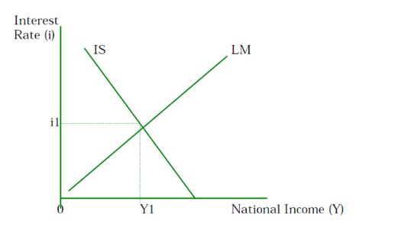
- There will be reduction in the real value of money supply with increase in the average price level. There will be leftward shift in the LM curve when the money supply is reduced. This will increase the equilibrium rate of interest and a fall in the equilibrium level of national income.
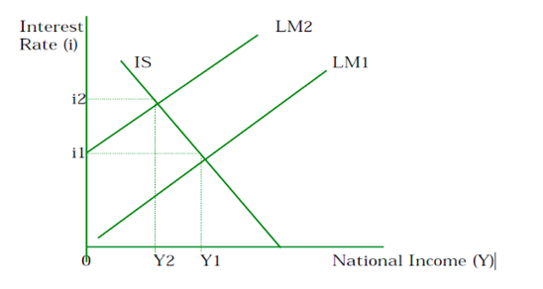

Sr No | $Million 2018
1 | 385
6 | -20
8 | -175
11 | -35
12 | -95
18 | 95

- .
- Credit- A Japanese insurance company purchases Indian Treasury bonds
Debit- The payment is made using its bank account in Mumbai
- Debit - Indian citizen consume a meal at a restaurant in Paris
Credit- Payment by the citizen is made using the American Express Card
- Credit- Hiring a Indian computer programmer by a British company
Debit – An Indian Bank account is used to make the payment

- The labour model explains the aggregate demand and aggregate supply of labour.
The total demand for labour with respect to different real wage rates in the market is explained by the aggregate demand for labour curve. As the wage rate increases the employers prefer to recruit a smaller number of labourers whereas there will be more labourers who will want to take up jobs under this situation. The number of people willing and being able to accept the job on the terms of wage rate decided by the employer is explained by the aggregate supply labour curve. Here also we can see a similar trend of increasing number of people taking up jobs with increasing wage rate

- The equilibrium level of employment is where AD of labour = AS of labour.
Reasons for equilibrium employment: Technological, structural, regional, seasonal and frictional unemployment
Disequilibrium unemployment is when there is excess supply of labour force.
Reasons for disequilibrium employment: Demand deficiency, real wage and growth in labour supply

.

- Frequent changes in currency value could adversely affect business, trade, and investment by brewing uncertainty in the minds of people and businesses. If the government tries to maintain the value of currency close to the long-term equilibrium value, it should buy or sell the domestic currency in the foreign exchange market. This will result in reverse shifts in demand and supply curves and the desired exchange rate would be restored.
- To alleviate the downward pressure on the currency, the government could borrow foreign currency from other countries and international agencies.
- Another measure is that the government could raise interest rate temporarily. This will encourage those aboard to deposit their money in the domestic country. Raising interest rate will result in an increase in demand for and decrease in supply for domestic currency.
- Government can use fiscal and monetary policies to maintain the monetary value of the currency for longer periods.
- Contractionary fiscal and monetary policy can be used to reduce aggregate demand. A reduction in aggregate demand would reduce expenditure on imported goods and hence reduce supply of currency in foreign exchange market. A reduction in aggregate demand would also reduce inflation. With lower prices in domestic market, exports will be cheaper and more attractive to consumers aboard and hence increase their demand for domestic currency. There will also less demand for expensive foreign goods leading to lower imports and lower supply of domestic currency. Both effects will support value of domestic currency.
- The government may also improve supply-side policies like improving the long-term competitiveness of the domestic industry by improving quality of goods produced and lowering the production cost. This can be done by training and R&D.

Based on the given information, following are the answers:
- 30 million surplus
- 10 million deficit
- -40 million
- On the basis of the above given information, I feel that the country does not have a complete free-floating policy because there is a dip in the official reserves which indicates that the central bank has been buying domestic currency.

