MONEY CONTROL NEWSLETTER
- 28/04/2022
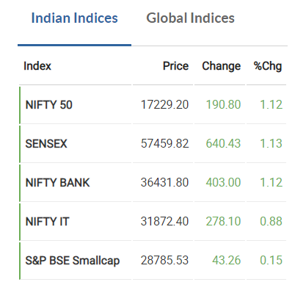

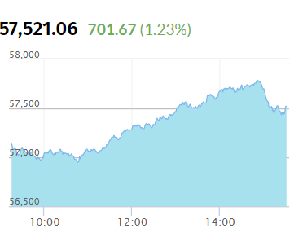
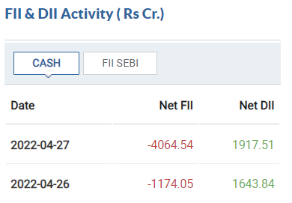

Top 5 Nifty 50 Gainers
India VIX
Advance to Decline ratio in Nifty 50
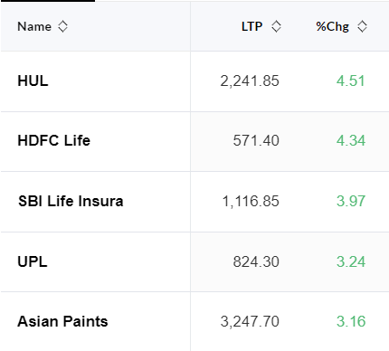
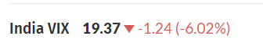
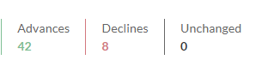



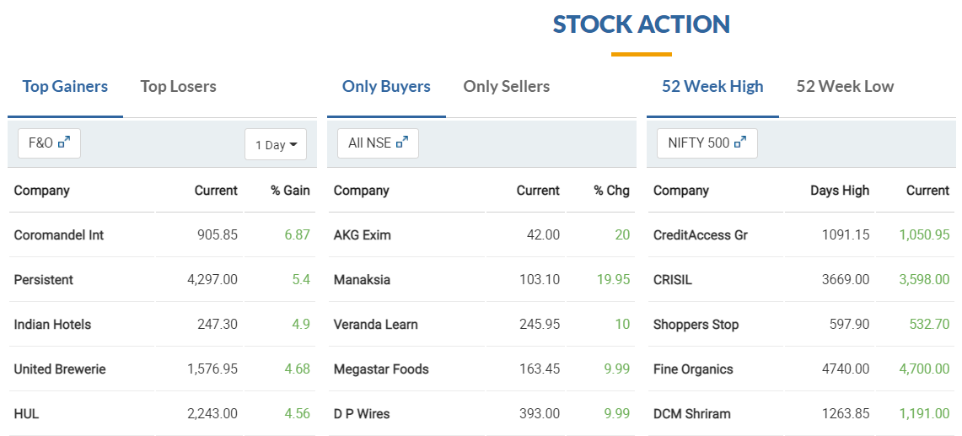
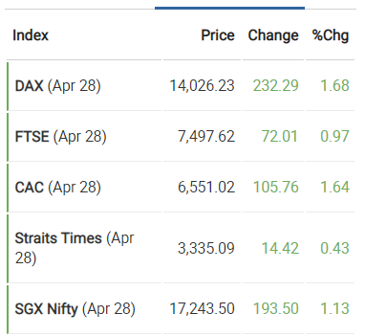

Q.2)
a) The market is driven by domestic institutional investors
b) The change in the fear index (VIX) is negative 6.02% which implies that the market fear is decreasing, the stability in the market is increasing which ultimately implies that the investors are investing in the markets with less fear.
c) HUL and HDFC were the top two stocks that influenced the upward performance of the market
d) Nifty Banks is the best top performing sector and HDFC contributed to the majority of it

Q.3)
5 Stocks that hit 52 Week High and match all the qualification criteria are:
- Sun Pharma
- Tata Elxsi
- Solar Industries
- Page Industries
- KPR Mill
The Qualification criteria to screen 52-week high stocks are:
- There should be no circuits or breaks on the chart
- The chart should have an upward trend and it should have a smooth shape
- There should be no extreme dips in the middle of the chart
- The size of the candles should be small
- The chart should be for the past 1 year and candles should be monitored daily
- Lastly, the chart should begin from bottom left of the screen and end at the top right of the screen

