GRADUATION TESTS
Statistical and Risk Modelling – 1
JUILEE JAYADE
415
- Data Extraction
As data was extracted , it was discovered that , there were some missing coloumns that were to be filled.This document takes into account the steps to filling the missing data and doing tests on that data filled.The coulumns to be filled are – Crude , Graduated , Expected and Zx
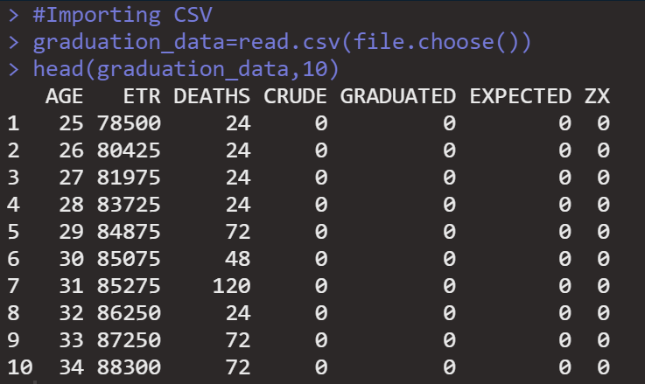

Please Note-
A snapshot like the one above will be attached once all the coloumns have been filled and not after filling each coloumn

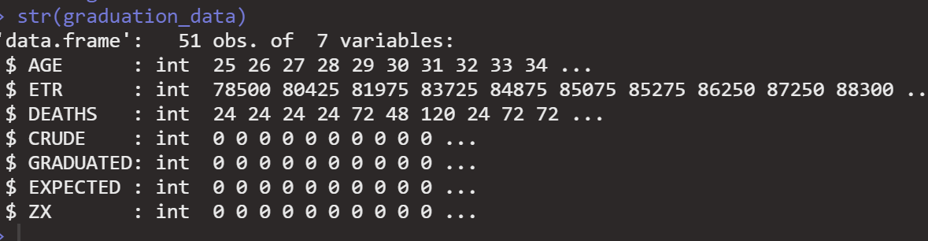

- CRUDE
The CRUDE coloumn can be found by $\frac{Deaths recorded at age x last birthday}{Central exposed to risk as age x last birthday}$

- GRADUATED-Gompertz Law

STEPS-
- Using ‘lm’ to fit the model
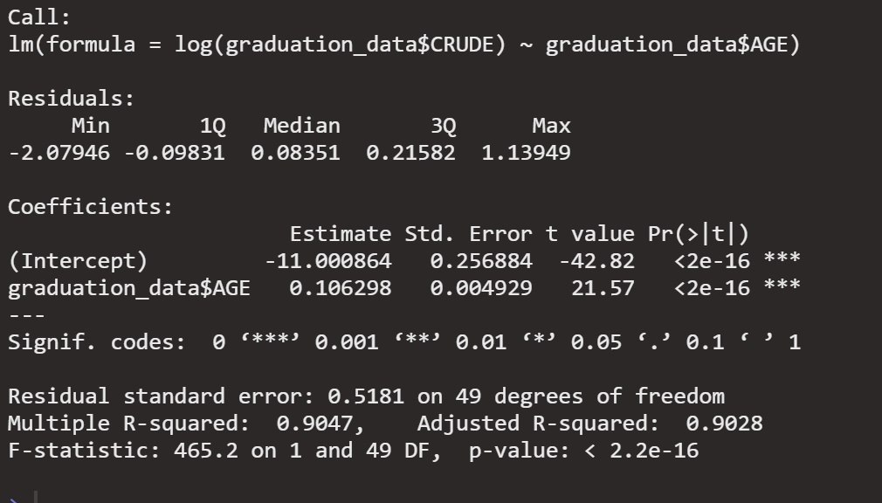
- Gompertz Law-BC^{x}

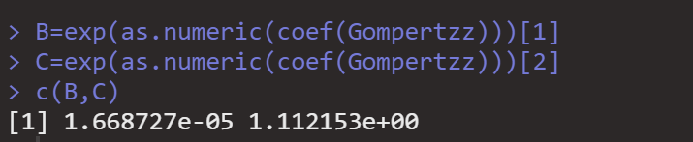
- COEFFICIENTS-

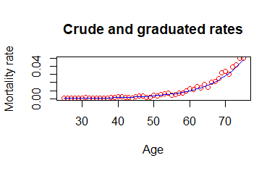
- CRUDE VS GRADUATED

- GRADUATED & CRUDE - THIRD DIFFERENCES
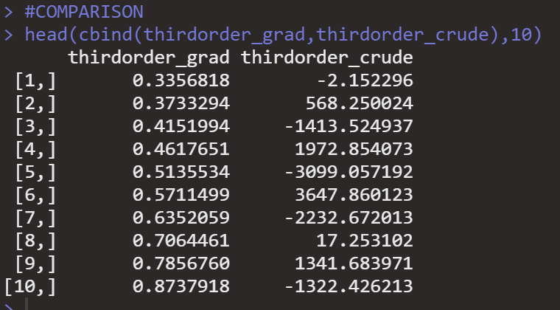
Graduated rates appear to be smoothly increasing , while crude rates have massive fluctuations accompanied by rises and falls,thus very unstable and not smooth
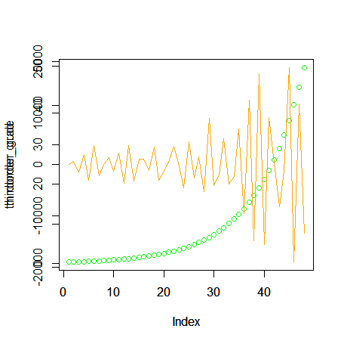

- EXPECTED & Zx
Expected=Exposed to risk for age x last birthday * Graduated
=ETR*Graduated

Zx =$\frac{Actual-expected}{\sqrt{expected}}$

All the coloumns have been filled-
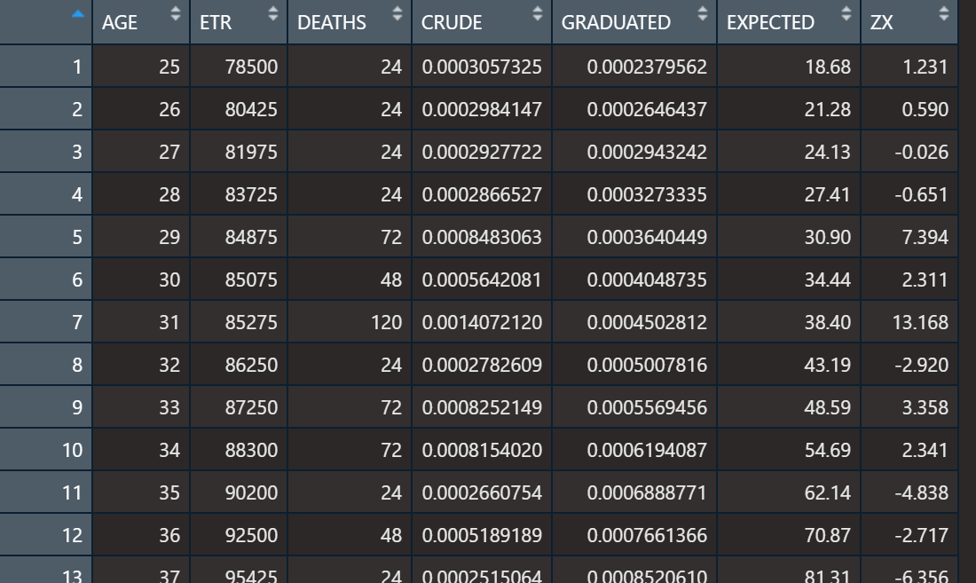

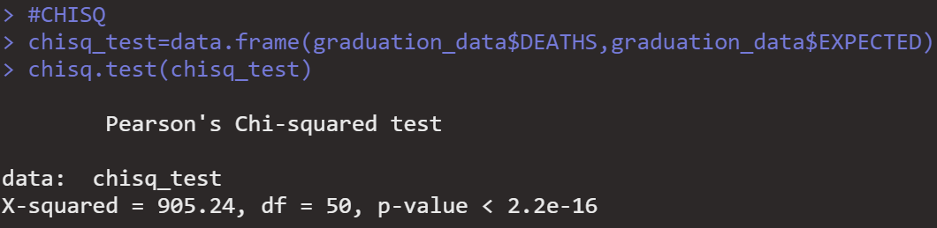
- CHI SQUARED TEST

DF=50
H0:Mortality experience confirms to the distribution used
HA: Mortality experience doesn’t confirm to the distribution used
We reject the null hypothesis at 5% level and confirm that mortality experience doesn’t confirm to the distribution used .

- A
INDIVIDUAL STANDARISED DEVIATIONS PLOT & NORMAL DISTRIBUTION
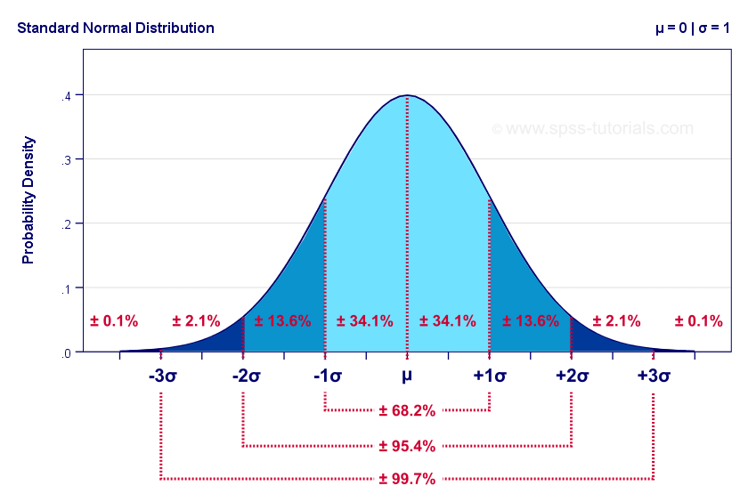
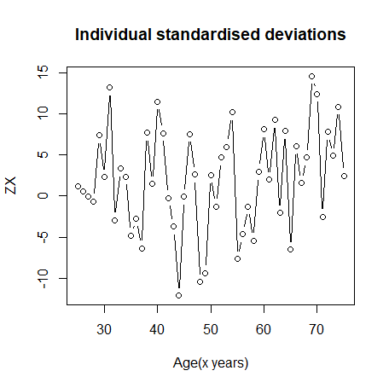
- Standardised Deviations Test

 | (-inf,-3) | (-3,-2) | (-2,-1) | (-1,0) | (0,1) | (1,2) | (2,3) | (3,inf)
Observed | 10 | 4 | 2 | 4 | 1 | 4 | 6 | 20
Expected | 0.051 | 1.07 | 6.94 | 17.3 | 17.3 | 6.94 | 1.07 | 0.051

- Overall shape – Looking at the values , the distribution seems positively skewed and doesn’t confirm to normal distribution
- Absolute deviations- the values are very high in the tails,indicating overgraduation
- Outliers-There seem a lot of outliers with values touching 20
- Symmetry -Since there are more positive deviations ,the distribution isnt symmetrical
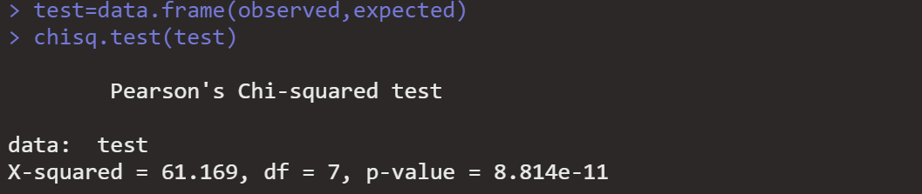
- Conclusion and Hypothesis-Thus observed mortality experience doesn’t confirm to the assumed rates , thus the observed data isnt normally distributed and we reject null hypothesis at 5% as the chi squared test also gives a p value of <0.05

- B Signs Test
Signs test has been performed using binomial test in R
H0: There is no bias in the data
HA: There is bias in the data
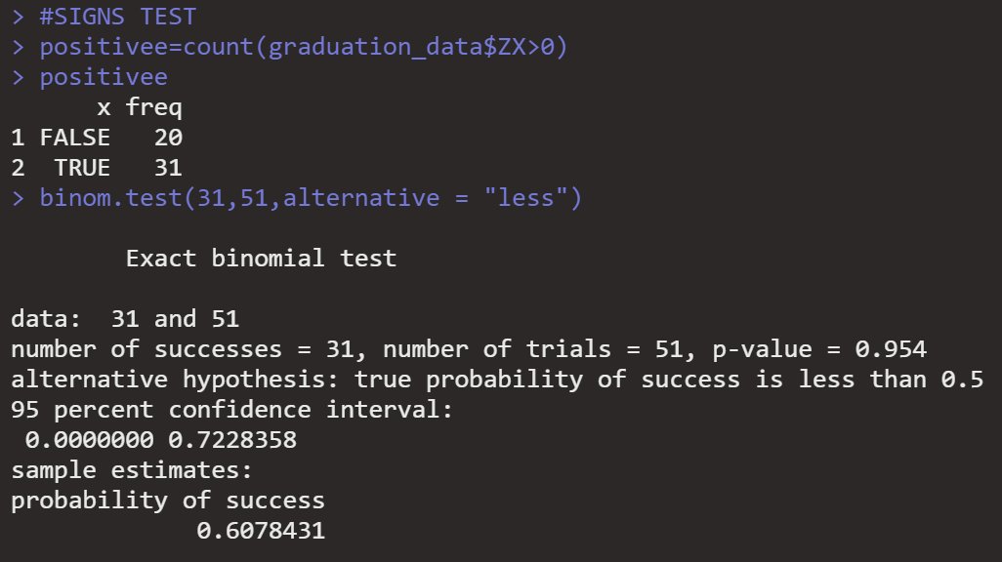
Since p value>0.05 , we fail to reject the null hypothesis and conclude there is no bias

- C Cumulative Deviations Test
H0:The statstic comes from the normal distrubution
HA: The statstic doesnt come from the normal distrubution
Since the statistic is not between the range of +- 1.96 we reject the null hypothesis at 2.5% level

- D Serial Correlation Test
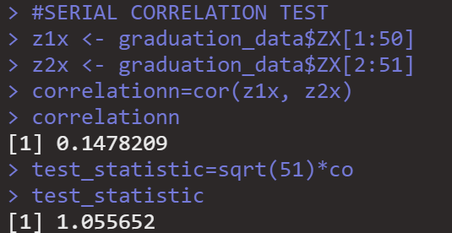
H0: Grouping of signs is absent
HA:Grouping of signs is present
The test statstic is <1.6449 , we fail to reject H0 at 5% level
We conclude that there is no grouping of signs

