Business Finance Assignment 2
Unit 3&4
MCQs
- D
- A
- A
- D
- i) Given: Sales=2500, Costs=1500, Date 1, tax%=40%, Disc rate=20%
Therefore, (2500-1500) *0.6 * (1-20%)
=480.
ii)
iii)

- Several ratios available to help measure business efficiency are:
A] Inventory turnover ratio- This is one of the most important efficiency ratios since it shows the number of days in which a business cycles out it’s inventory. The more the number the efficient the business.
B] Trade Receivables and Trade Payables turnover ratio- Both of these on an average depict the time frame for which the business actually needs to have liquid cash available. The former shows the receivables period count whereas the latter the payables count.

These ratios therefore help an analyst conclude how efficient a particular business is with its important current assets and liabilities.

- The areas which show up as the limitations of ratio analysis are: -
  - Ratios entirely depend upon the accuracy of the financial statements provided. The more accurate and updated they’re, the better the ratios depict the company.
  - Non inclusion of business practises and methods followed by the company. Since all the firms are free to follow different accounting methods, ratios could be affected by the same.
  - Unavailability of actual values. This is a limitation since in case of absence of actual values, proxies need to be taken. Thus, it would be unfair to compare a firm with proximate values to one with actual.
  - Unaccountability of external factors and human element which form critical parts of firm-to-firm comparisons.
  - These ratios are also only effect when comparison is made between likewise firms in terms of size and type.

- i) Betas as we know are used to represent the exposure to risks that a particular firm has. These hence take into account the systematic as well as specific risk that a particular firm faces. This is why different firms trade at varying Betas in the stock market. possible reasons why stocks trade at different betas in the stock market.
ii) B_{g}=1.1, d/e=1:2, tax%=30%, [Assuming the B_{u} to be same in both the cases]
New d/e=2:2, New B_{g}=?
1.1=B_{u}(1+[1/2][1-0.3])
B_{u}=0.8148
New B_{g}=0.8148(1+[2/2][1-0.3])
New B_{g}=1.3852

- Given: -
Initial invst-100 lakhs
Old COC-10%
NPV-10 lakhs
IRR-21%
New COC-11%

New NPV= (100/11)
= 9.0909
New IRR =

- i)Systematic risk is a risk which is borne by the entire economy as a whole therefore, affecting all the industries and firms that do lie therein. Its examples could include: - Interest rate fluctuations, change in govt. taxation rules, etc.
Specific risk in contrary, as the name suggests, is one which majorly has its impact on certain specific industries. The best part however is that this risk could be averse by undertaking certain measures. Examples are: - Changes in demand, worker strikes, supply issues, etc.
ii)
Systematic risk | Specific risk
Affects the entire economy. | Affects specific industries.
Beta accounts for this risk. | Doesn’t get accounted for since could be averse.
Its sources are Trade cycles, inflation rates, etc. | Its sources are Business management, labour shortages, etc.

Its quite important and relevant to consider the systematic risk i.e. Beta of undertaking any new projects and investments. This is because it helps the investors assess the returns they would get and how these would be affected by the market Beta. Broadly speaking, a beta of more than 1 is said to amplify the market effect of either positive or negative growth. However a Beta of -1 or lesser creates a contra-amplified effect.

- i)Beta in simple terms is the figure which represents the systematic risk component of a particular stock in relation to the market stock.
It is computed as 1) σim/σm²
2) ρim. (σi/σm)
ii)Beta is determined as first dividing the security's standard deviation of returns by the benchmark's standard deviation of returns. The resulting value is multiplied by the correlation of the security's returns and the benchmark's returns.
iii) I would as an investor prefer to invest in a stock with Beta as 1 since, it would give me amplified returns for the investment. The risk factor thus would be more since if the market starts to fall, one must be quick enough to stop the forthcoming loss. Beta of (-1) wouldn’t be preferred since not much historical data would be available. Also the actual market returns would be difficult to project in such a scenario.
iv) Government Bonds

- 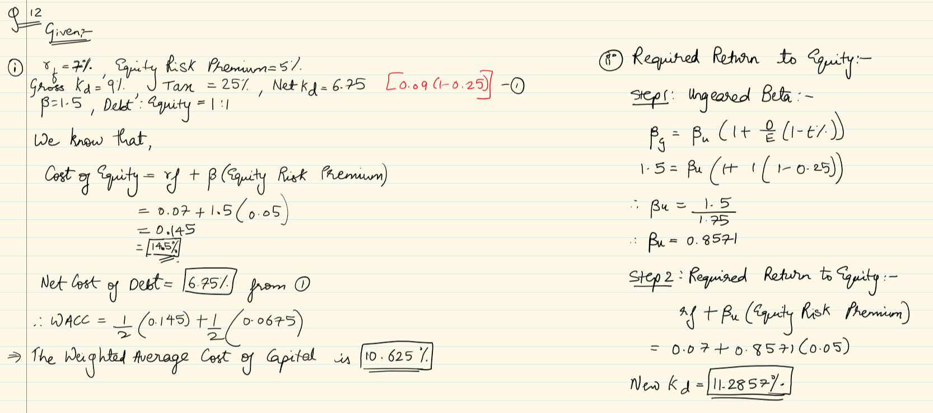
- -.-.-.-.-.
- i)a) Current ratio is one of the important liquidity ratios which as the name states, helps measure the liquidity position of a particular firm. Its formulated as:($Current assets)/(current liabilities)$. Its used to ascertain how fast a business could convert it’s assets into cash.
b) Debtors’ turnover ratio also known as receivables turnover is one which helps a business know how much time it takes for a cycle of receiving money from debtors to complete. Its formulated as (trade receivable/credit sales)*365. This ratio indicates the degree of management of debtors or sales. The high debtors turnover ratio refers to effective management of sales or debtors and liquid of debtors and vice versa.
ii) He should track (trade receivable/credit sales)*365 on regular basis. Its recommended to maintain this at 2:1 which literally means, twice the assets for owe liabilities.

