

Business Economics micro Project
  - STudy of demand on COVISHILED vaccine
  - Name: Animish ABhay Sathe
  - Roll no. 29

Index
Sr. No | Topic | Pg. no.
1 | Introduction | 2
2 | Body | 3
3 | Product analysis | 5
4 | Demand of product | 8
5 | Conclusion | 14

Excel Sheet

Introduction
Aim: To Do a detailed in-depth and well-researched analysis of COVISHILED vaccine.
COVID-19 is a highly infectious disease that is caused by the coronavirus (SARS-CoV2). In tough times, there was high demand for covid-19 vaccine. Later on, Serum institute made COVISHILED vaccine as a preventive measure for covid-19. This vaccine is given in two batches with 4 to 6 weeks of gap between each batch. In this case study, we are going to study the demand on COVISHILED vaccine. Also, we are going to look at different components which can affect demand.
To study the demand on COVISHILED vaccine, I did a survey and collected 30 responses from the people who took COVISHILED vaccine. I asked general yes, no questions to find out how consumers would react if for say there are changes in prices of COVISHILED vaccine. This 30 responses from 30 people is my sample data for this study. Then, I applied microeconomic concepts to the data I received and made an analysis about my product.

Body
The product I received to find demand was COVISHIELD vaccine. From survey I received 33 responses.
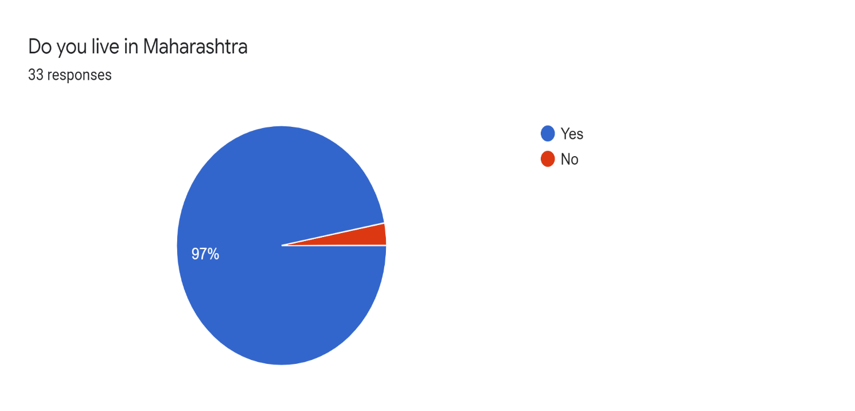

Out of these 33, over 30 people live in Maharashtra. Rest three are out of Maharashtra. For the sake of demand analysis, I excluded those three from analysis.

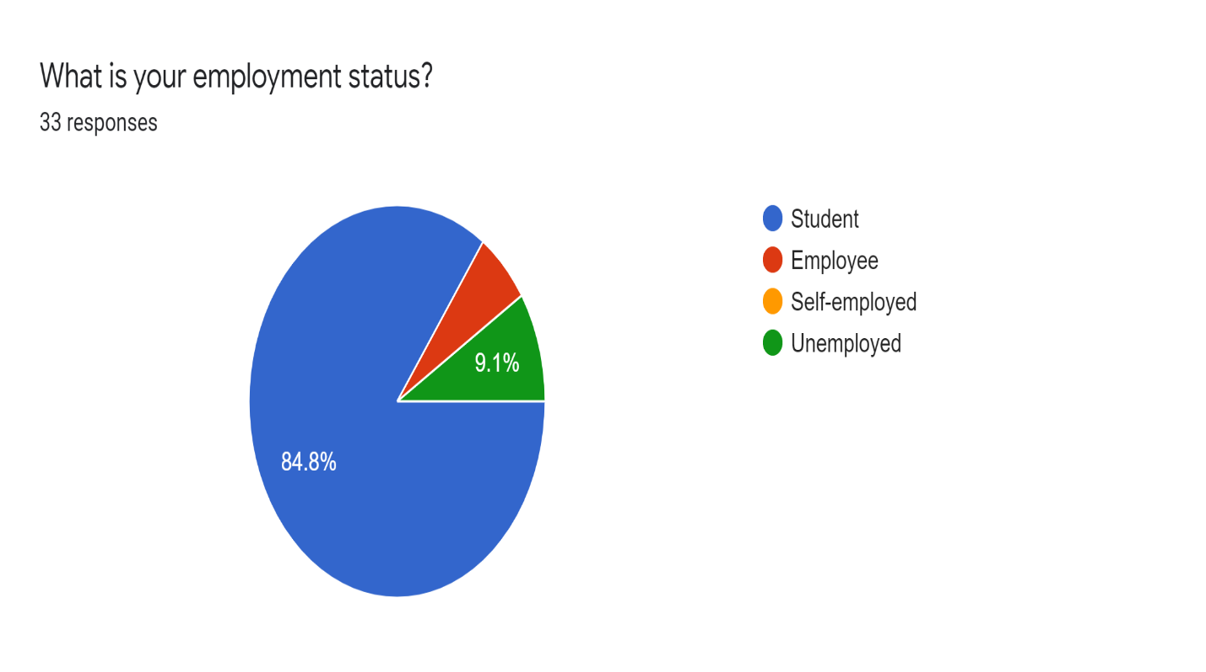
- From the graph we can see that, majority of people are students. And around 9.1% people are unemployed and some are employed.
- So we can say that data is diversified. I am not targeting only people with specific type of employment status. I will take everyone in the analysis.

Product Analysis
- Product : COVISHIELD Vaccine
- Type of good: My product comes under the category of Normal goods which means increase in income causes an increase in demand. It has a positive income elasticity of demand. Normal good can be income elastic or income inelastic.
- Features : COVISHIELD vaccine is used to fight against COVID-19 virus. Its taken in batch of two with gap of 4 to 6 weeks between each dose. There are three types of vaccines available in India right now.
- COVISHIELD Vaccine
- COVAXIN
- Pfizer–BioNTech COVID-19 vaccine
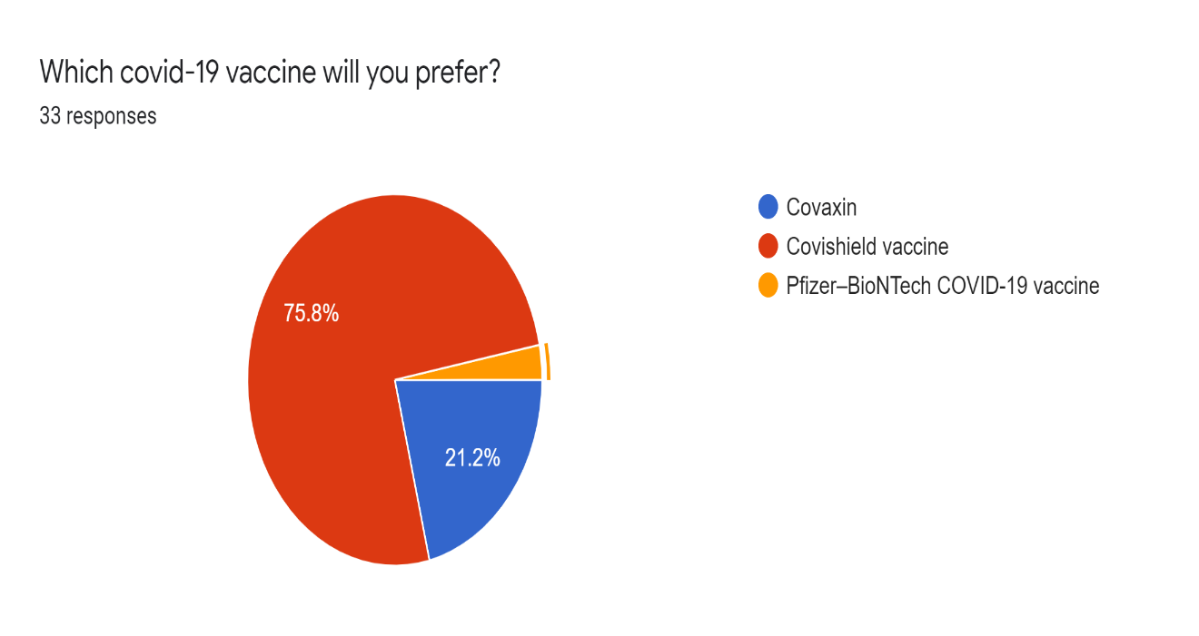

From data, 75.8% people prefers COVISHIELD Vaccine. 21.2% prefer COVAXIN and rest of the people prefer Pfizer vaccine.
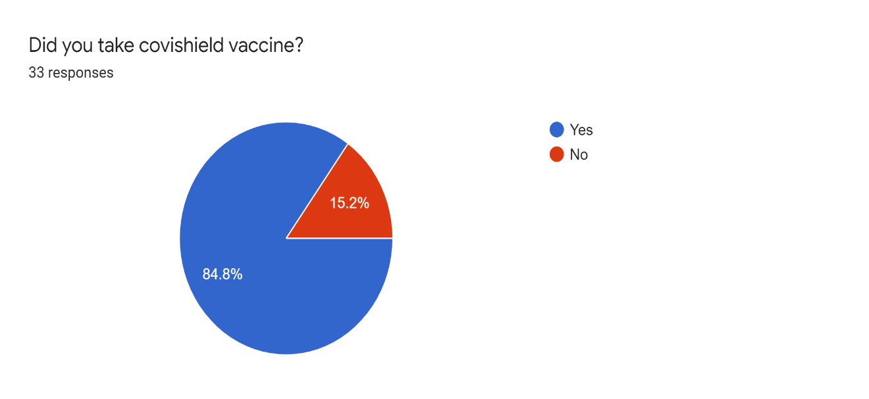
From the survey data, around 84.8% people took COVISHIEILD vaccine Pricing: Currently price of COVISHIELD vaccine is 400 Rs. As it was high in demand and supply was less, its prices were high for a brief time in the beginning.
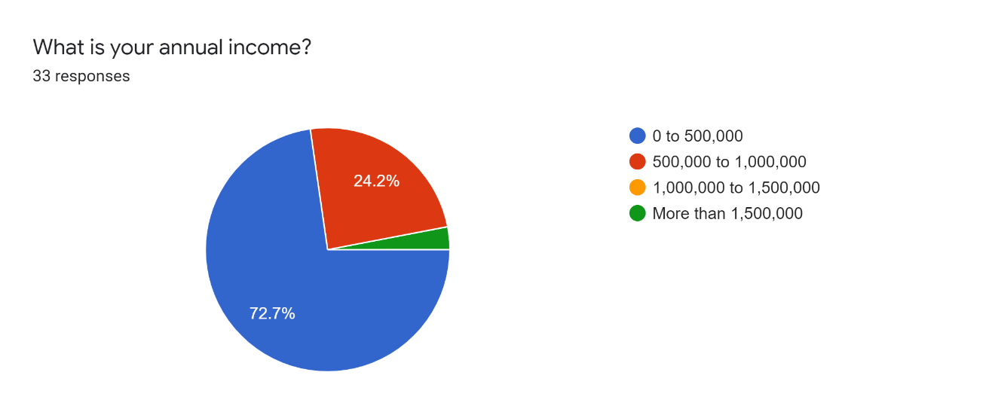
From the data, 72.7% people come under 0 to 500,000 annual income slab.

- Availability : In the dire situation the vaccine was not easily available. Also only the people like doctors and other people who’s life was important were allowed to take vaccine. Vaccine was not available for common people in the start. But later it became available for common people. But supply was less. At this time, vaccine is easily available according to the survey.
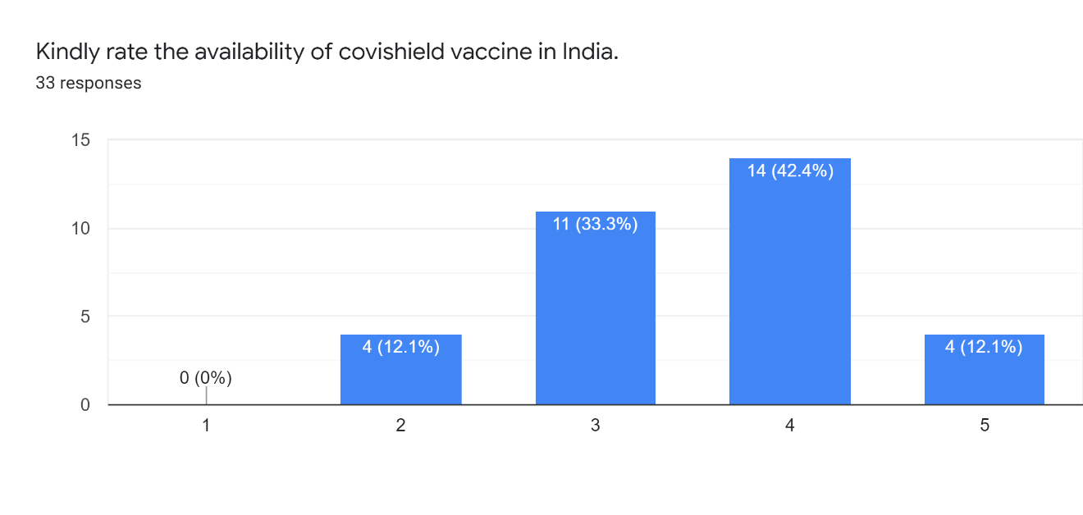
Here, 5 stands for easily available and 1 stands for not available at all.
- Swot Analysis:
- Strength : The existing immunization program, indigenous vaccine production, setting up of the National Expert Group on Vaccine Administration for COVID-19, updated guidelines, and training followed by dry runs are identified as strengths
- Weakness : The weaknesses identified are knowledge gap about vaccines, apprehensions, lack of temperature loggers and vaccine vial monitors, demand supply gap, and digital divide.
- Opportunities to strengthen: The experience of conducting the general elections, intersectoral coordination forged during the pandemic response, Information Technology platform, and vaccine eagerness present opportunities to strengthen the program.
- Threats : The emergence of virus variants, commercial interests, laxity in COVID-19 appropriate behavior, and receding wave of the pandemic can pose significant threats to the implementation of the vaccination campaign.

Demand Of COVISHIELD Vaccine
(Based on data collected)
From the preference graph, we concluded that about 75.8% people from sample prefer COVISHIELD vaccine. So out of all three available vaccines, COVISHILED has highest demand.
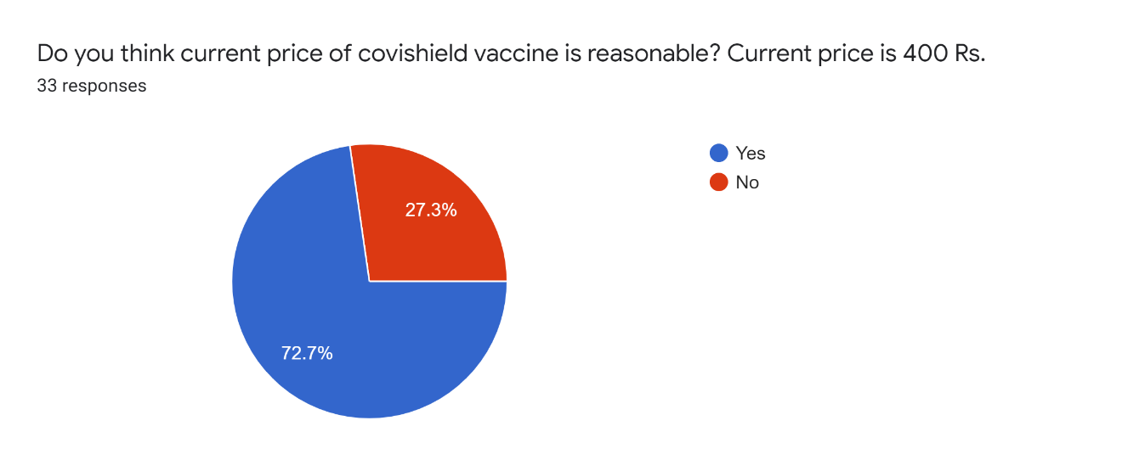
Out of 33 people 72.7% people think 400 price is reasonable. Not let us see how this demand will get affected if we increase the price of the vaccine from 400 to 500.
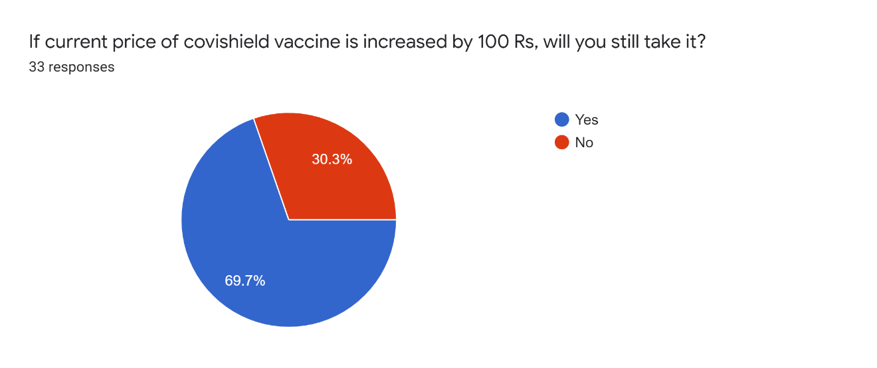
If price were to increase by 100 then demand will fall from 72.7% to 69.7%
Now lets see what will happen if price is increased by 200.
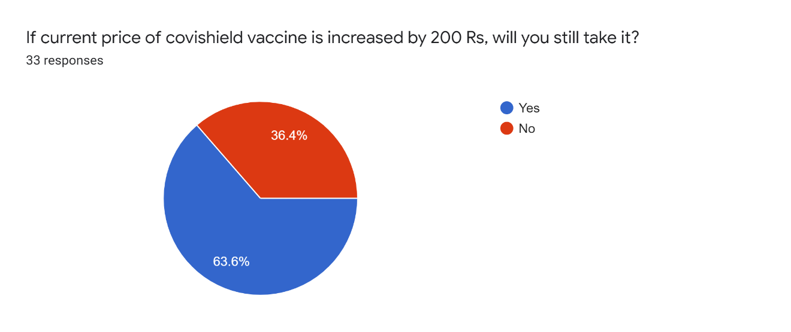
If price were to increase by 200, demand will fall from 72.7% to 63.6 %.
Just like this, I have results for demand for price increased by 300, 400 and 500.
The aggregate demand curve is as follows.

This graph represents the Demand curve for my product.
On the Y-axis we have the Price and
On the X-axis we have the quantity of the product.

Industry Analysis
- COVISHIELD vaccine is the second vaccine against COVID-19 which was given emergency use authorization in India. COVISHIELD’s COVID-19 vaccine is considered to be safe on the human body with mostly mild-to-moderate side effects such as body ache, rise in body temperature, etc. According to the reports, the efficacy of the vaccine is 82.4% and is to be administered in two separate doses.
- Compared to peers COVAXIN and Pfizer vaccine, COVISHIELD vaccine is approved by WHO.
- The Embassy of India Rome (Italy) on September 24 confirmed Italy has recognized Serum Institute's COVISHIELD vaccine.
- WHO granted emergency use listing (EUL) to COVISHIELD for individuals over 18 years of age, including for those over 65 years of age. This EUL allows two full doses to be administered between four to 12-week interval. This enables the company to export nearly 20 million doses to countries under the COVAX initiative of the WHO.
From all these comments, we can say that COVISHIELD is better compared to its peers.
Let us take a look at the best qualities of COVISHIELD vaccine from people.
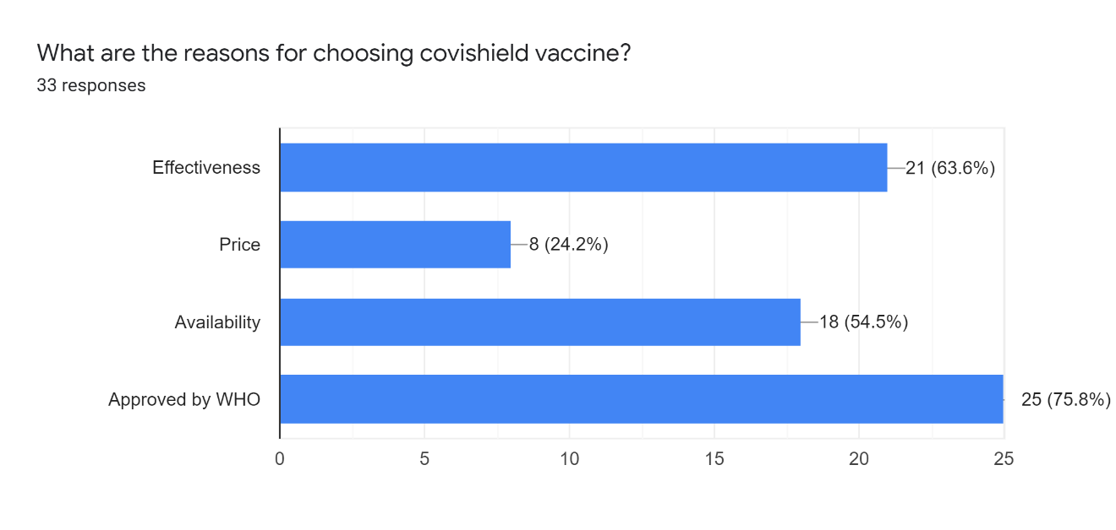
Supply Of The Product

- No. Of Sellers : Only Serum Institute provides COVISHIELD vaccine to every hospitals. Then, it can be bought in hospitals only. Nowadays, there are camps for getting COVISHIELD vaccine. You can register and pay online and then get a vaccine in that camp.
- Available substitutes : Substitute goods or substitutes are at least identical, similar, or comparable two products that could be used for the same purpose by the same consumers. There are two more available substitutes to COVISHIELD vaccine. They are COVAXIN and Pfizer Vaccine.
- Complementary Products : Complementary goods refer to two or more items that are usually consumed simultaneously. There are no complementary goods for COVISHIELD vaccine.

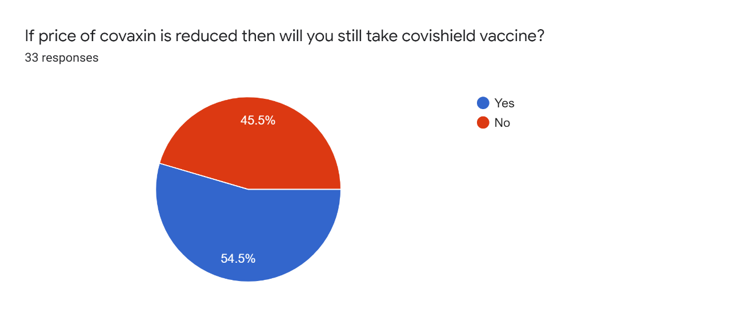
This graph shows comparison of COVISHIELD vaccine with its substitute COVAXIN and how people will react if only price of COVAXIN is reduced. From the graph we can say that demand for COVISHIELD will fall drastically.

Price Elasticity of the Product
(Calculation is shown in excel)

- To find price elasticity of demand, first I took aggregate demand by multiplying percent demand by no. of people.
- Then I took prices
- After taking prices and quantity, I took average of both quantity and price.
- Then I used the formula of elasticity to find elasticity of demand.
- Graph below describes how price elasticity of demand is different for each price.

Conclusion
After completing my analysis, I witnessed real world/practical scenario where I collected primary data through google forms and used that data and found demand curve and price elasticity of data. As given data was a sample data, it represent small part of population. If I get more data then results may vary.
This was a very small basic analysis for product COVISHIELD vaccine from which we cannot understand the whole industry. There are various other parameters on which demand and price elasticity depends. Including those parameters will also give different results.

