TOPIC: - DOMINO’S
ROLL NUMBER: - 34
NAME: - MADEEHA SHAIKH

INTRODUCTION
Domino's Pizza, Inc., branded as Domino's, is an American multinational pizza restaurant chain founded in 1960 and led by CEO Richard Allison. The corporation is Delaware domiciled and headquartered at the Domino's Farms Office Park in Ann Arbor, Michigan. As of 2018, Domino's had approximately 15,000 stores, with 5,649 in the U.S., 1,232 in India, and 1,094 in the U.K. Domino's has stores in over 83 countries and 5,701 cities worldwide.
Industry trade publication Pizza Today magazine named Domino's Pizza "Chain of the Year" in 2003, 2010, and 2011. In a simultaneous celebration in January 2006, Domino's opened its 5,000th U.S. store in Huntley, Illinois, and its 3,000th international store in Panama City, Panama, making 8,000 total stores for the system. In August 2006, the Domino's location in Tallaght, Dublin, Ireland, became the first store in Domino's history to hit a turnover of $3 million (€2.35 million) per year. As of September 2006, Domino's has 8,200+ stores worldwide, which totalled $1.4 billion in gross income.
In August 2012, Domino's Pizza changed their name to simply Domino's. At the same time, Domino's introduced a new logo that removed the blue rectangle and text under the domino in the logo, and changed the formerly all-red domino to be blue on the side with two dots and red on the side with one dot. This was done because the company wanted to "expand" menu choices rather than simply rely on their traditional pizza.
In February 2016, Domino's opened its 1,000th store in India.^{[24]} Outside the United States, India has the largest number of Domino's outlets in the world.
PRODUCT ANALYSIS
Domino’s is a consumption good whose expertise and passion for delivering hot and fresh pizzas has earned these people numerous awards and the particular loyalty of an incredible number of pizza lovers around the globe. Dominos is a market directed business because it gets used to using products in each country, to what is wanted by the consumers.
To cater to the different customer segments and their different willingness to pay, Dominos utilizes the concept of ‘Everyday value pricing’. Apart from this, Dominos offer the following discrimination under Price Offer Configuration and Price Fences: -
Price Offer Configuration
• Customization: Dominos provides the option of customization (ala carte) to the consumer on purchase on both mobile app and website for the size of pizza, type of crust, toppings and the option of extra cheese or sides/beverages/desserts.
• Combo offer: To cater to different customer segments that usually don’t have time to go for customization will opt for combo offer. Following types of combos are currently offered: - i) Work from home: Introduced during lockdown mainly to cater to the employees working from home (Both Veg and Non Veg) ii) Pasta treat: Mainly to cater to Pasta lover customers- Moroccan spice, Creamy tomato, Cheesy Jalapeno (Both Veg and Non Veg) iii) Cheese burst: To cater to cheese lovers- Ultimate Cheese burst Deluxe, Premium (Both Veg and Non Veg) iv) Family treat: Introduced during lockdown to cater to families so as to create emotional connect among family members (Both Veg and Non Veg) v) Movie marathons: To cater to people glued to watching movies/ tv shows on OTT platforms in 2020.
Price Fencing
• Group pricing: Corporate discounts offered to select companies
• Channel pricing: Dominos provides the option of location based pricing- online order, dine-in option, order on train and Drive-N- pick. Due to change in customer preferences and safety precautions, the company is focusing mainly on safe order online and Drive-N-pick option for office going people/long trips with family/ friends or any other customer who is currently avoiding dine-in option.
• Volume discounts: This is offered by Dominos on any size of pizza usually on higher priced pizzas. E.g.- 40% off on any two pizzas.
• Regional pricing: Dine-in prices at airports will be higher due to positive differentiation offered of comfort, ambience, safety and hygiene measures.
• Self-selection: ‘Your 3AM friend’ service provided in Bengaluru mainly caters to IT people working late night.
• Product Versioning: Extra cheese burst combo over regular combo to create the impression of a superior product
• Time based differentiation: It creates fencing by offering discounts and offers on particular days apart from Everyday value offer like Monday Magic, What’s a Wednesday and Friday Freak out 7.
DOMINO’S SWOT ANALYSIS:

Strengths in the SWOT analysis of Dominos
- Brand Recall: High brand recall due to its regular advertising with taglines such as ’30 minutes nahi to free’. Such aggressive marketing has created awareness & a promise for the brand in the market.
- Fantastic channel network: With its 9000 franchise & company owned outlets Dominos has extensive network spread over more than 60 countries.
- Quick service & deep menu: Quicker than expected service delights the consumers and helps the company to differentiate itself from others. In India Domino’s is trying to attract the middle class and lower middle class people who are interested to spend their money on pizza but in low price. Those people are eager to go for an outing in any festival and want cheap and best family restaurant. Domino’s would be most preferable.
- Low cost alternative: They do not need high class Ambiance or amusement in the shop so the establishment cost is low for the dealers and the price of pizza is very reasonable for the customers.
- Healthier alternatives: To combat health awareness among consumers, Dominos is trying to change their dough by having healthier fats, which is done by incorporating more whole wheat into their crusts. The pizza toppings are also becoming healthier, and some pizzerias are introducing salads into their menus.
- Efficient supply chain: Due to its efficient supply chain Dominos has made it possible for quicker service so that customers don’t have to wait for long. The preference of Dominos is because the customer can have home delivery within 30 minutes. Making a small breakfast at home itself takes 15 minutes.

Weaknesses in the SWOT analysis of Dominos
- Operations: Large number of franchised outlets results in difficulty in handling operations. Quality control too becomes challenging. Due to this, some of the Dominos outlets got closed affecting the image of the brand.
- Decreasing sales in mature markets: Due to rise in health conscious population there is decrease in revenue affecting the business as a whole.
- Low staff retention: High attrition due to the absence of proper training & development is a major challenge for Dominos. Plus the manpower employed is also unskilled so they quickly change jobs when they cannot adjust to the hectic environment.
- Lesser number of eateries: Dominos has more delivery outlets then eating joints which is a problem especially in places like malls and other locations where clearly customers want a sitting place.

Opportunities in the SWOT analysis of Dominos
- Market Expansion: Expanding to the developing markets will be beneficial as far as Pizza industry is concerned, as developed markets are maturing. Targeting the developing economies should be the future strategy of the company.
- Penetration: Strengthening its outlet network by further penetrating the current market will help Dominos to increase its revenues.
- Health conscious eatables: Introducing health conscious menu with new flavour additives which is low in fat will result in increasing it revenues in future.
- Restaurants: By introducing exclusive Dominos restaurants in cream areas will help the brand with more brand recognition and will also help in getting the customers who like to eat outside in plush restaurants.

Threats in the SWOT analysis of Dominos
- Direct and Indirect Competition: Intensive competition from the local & national players like “Pizza hut”, US pizza and more. In fact, Indirect competition is more from the likes of McDonalds and KFC wherein customers prefer burgers over pizza.
- Changing Consumer Eating habits: With government & NGO’s concentrating more on health awareness, people are becoming more aware of what to consume & what to avoid which is affecting the business of Dominos.
- Cost: As the cost of vegetables and raw materials rises, the cost of maintaining the pizza chain also goes up. Plus, competition affects the bottom line of the company. Thus, managing the cash flow becomes difficult.
MARKET ANALYSIS
With 1,325 stores across 282 cities in the country and a continually growing footprint, it’s safe to say that Domino’s is one of the market leaders in the fast food industry. It forayed into the Indian market in 1996 by opening its first store in New Delhi and has tasted immense success ever since. Dominos was initially perceived as luxurious indulgence when it was first launched in India. Today, Domino’s has strategically expanded into a number of smaller cities across India by lowering the prices of food items to ensure that they become accessible to people of different social strata. They also introduced several food items at lower price brackets thus expanding their menu while also giving the people the option to have more than just pizza. The attractive discounts and exclusive deals also gave Domino’s an edge over its competitors by making it more affordable. Dominos was one of the first food chains in India to recognise the importance and growth of smartphone culture in India. Most internet users in India predominantly rely on their smartphones. Therefore, it launched its mobile app enabling people to order from a Domino’s restaurant near me with just a few taps on the mobile food delivery app.
Dominos was one of the first to introduce zero contact delivery in India to ensure the safety of customers and their employees alike. Even during unprecedented times like these, Domino’s continues to thrive due to their strong core values and the ability to adapt quickly.
JFL is India’s largest foodservice company. Its Domino’s Pizza franchise extends across a network of 1,380 restaurants in 298 cities. The Company has the exclusive rights to develop and operate Domino’s Pizza brand in India, Sri Lanka, Bangladesh and Nepal. It also enjoys exclusive rights to develop and operate Dunkin’ Donut’s restaurants in India. JFL has ventured into the Chinese cuisine segment with its first owned restaurant brand ‘Hong’s Kitchen’.
For Q1FY21, JFL reported a consolidated net profit of Rs 69.06 crore in the first quarter ended June 30, aided by higher revenues despite the second wave of Covid-19 disrupting operations. It had posted a consolidated net loss of Rs 74.47 crore in the same quarter last fiscal. Ebitda (earnings before interest, taxes, depreciation, and amortization) margins remained unchanged at 24.1 per cent in Q1FY22 against 24.3 per cent in Q4FY21.
Its revenue from operations in the first quarter stood at Rs 893.19 crore as compared to Rs 388.41 crore in the corresponding period last year when operations were also disrupted by the outbreak of the pandemic. With vaccinations well underway, the management believes that the worst is behind us and we are confident of delivering strong, sustained growth in the periods ahead.
Analysts at Prabhudas Lilladher remain constructive on JFL given increased store opening guidance of 150-170 Domino's stores with a medium-term potential of 3000 stores, lower competition given Covid led shakeout, increased investment in digital infrastructure to emerge as a food tech company and ability to capitalize on increasing convenience sales given strong digital/delivery network.
The brokerage firm believes JFL’s aggression towards store opening and increase investment towards digital infrastructure will allow JFL to emerge stronger from the pandemic.
“Store addition for Domino’s was low (20 new stores) in Q1 due to lockdowns. But JFL’s expansion plan is aggressive, with a target of 150-175 new stores in FY22. Management is upbeat about digital and tech initiatives aimed at becoming a food tech powerhouse. JFL offers a strong growth outlook with solid expansion plans and increased investments in digital and tech initiatives, which can further strengthen leadership and offer efficiency gains ahead,” analysts at Emkay Global Financial Services said in a recent note.
Domino’s, with global retail sales of $8 billion, is to expand its reach in the Indian market aggressively despite the slowdown in the quick service sector with people checking their discretionary spending. In second quarter, Jubilant FoodWorks’ same-store sales growth slowed to 5.3 per cent compared with 6.6 per cent a year earlier. The company, which also operates the Dunkin’ Donut’s chain in the country, reported a 12.7 per cent year-on-year drop in its standalone net profit for the second quarter at Rs 29 crore as it spent big on opening new stores.
It plans to continue expanding its reach at a fast clip. Kaul said Domino’s is looking to set up 150 new stores every year and hopes to touch 1,500 to 2,000 stores by 2020.
Domino’s, has clear policies to ensure ethical business operations. As can be found in our publicly available corporate governance information, Domino’s has very specific policies around ethics, including:
- Anti-bribery and anti-corruption policies which includes a gifts and entertainment policy;
- Securities Trading Policy dealing with insider trading that is posted on the ASX and on our website;
- Governance Code of Conduct and Business Partner Code of Conduct.
Domino’s position is to engage on matters of policy, not politics. They spend less than $100,000 per year on consultants to discuss matters of policy relevant to our business and franchisees with government. Governments may also ask Domino’s to make submissions to parliamentary committees to help shape public policy – recent examples of this include franchisees, wage theft and digital development.
Domino’s believes it stands to benefit when economic realities force DSP delivery subsidies to end. The chain’s fortressing strategy also helps drive incremental carryout sales by adding convenience to better address the largest segment of the pizza industry. Notably, Domino’s impressive 70% – 75% digital sale mix drives higher group checks with its check also benefiting from add-on sales enabled by its broad menu (salads, chicken, stuffed cheesy bread & desserts). Having said all this, delivery is a challenging business given increased competition from DSPs which extend the reach of new competitors (including smaller pizza chains) that previously did not offer delivery. In turn, the DSPs are driving-up delivery labour costs and creating a short-fall of delivery drivers. This creates an impetus for Domino’s to emphasize carryout, a line of business that it is less well known for (remembering Domino’s delivers core equity). In conclusion, while it is our opinion that Domino’s is doing a great job in strategy and execution, its competitive bar is certainly the highest ever with much resting on what the DSPs do about their delivery charge pricing over the long-term.

DEMAND FOR DOMINO’S
Domino’s Pizza reported that its U.S. same-store sales climbed 3.5% in its latest quarter, despite tough comparisons to its skyrocketing sales during lockdowns last year.
Shares of the company rose more than 11% in morning trading.
Here’s what the company reported compared with what Wall Street was expecting, based on a survey of analysts by Refinitiv:
- Earnings per share: $3.12 adjusted vs. $2.87 expected
- Revenue: $1.03 billion vs. $972.3 million expected
The pizza chain reported fiscal second-quarter net income of $116.6 million, or $3.06 per share, down from $118.7 million, or $2.99 per share, a year earlier.
Excluding recapitalization expenses, Domino’s earned $3.12 per share, beating the $2.87 per share expected by analysts surveyed by Refinitiv.
Net sales rose 12.2% to $1.03 billion, beating expectations of $972.3 million.
In the U.S., Domino’s reported positive same-store sales growth. On a two-year basis, U.S. same-store sales rose 19.6% in the quarter. Executives said that customers were spending more money on their orders, fuelled by purchases with more food items, a “modest” menu price hike and a higher delivery fee. The segment’s strong performance this quarter is a sign that the company may be able to avoid a sales slump stemming from pizza fatigue.
As per the data collected, this is how the demand changes with changes in its price:
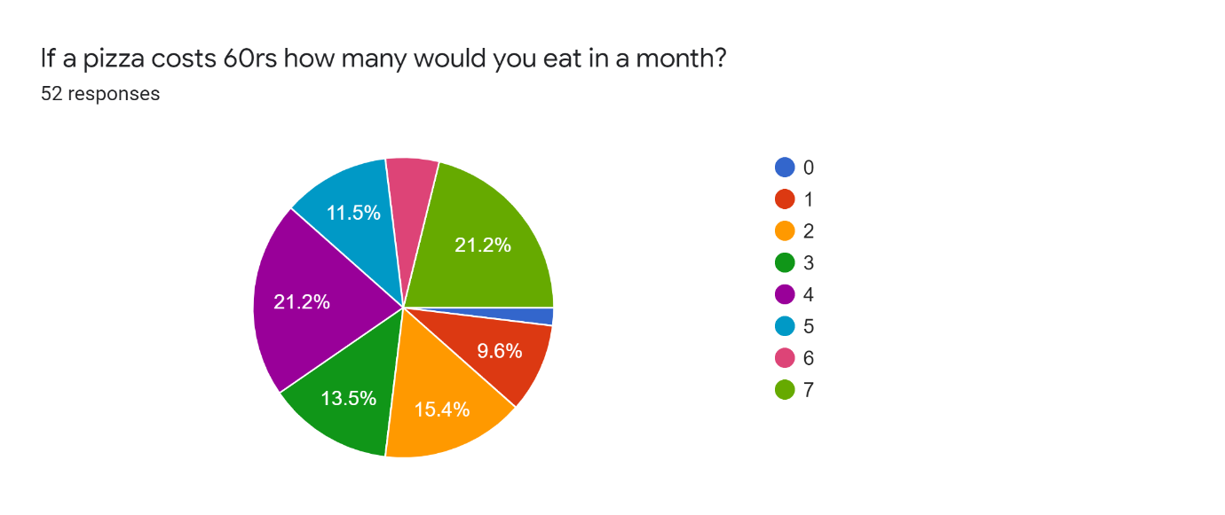
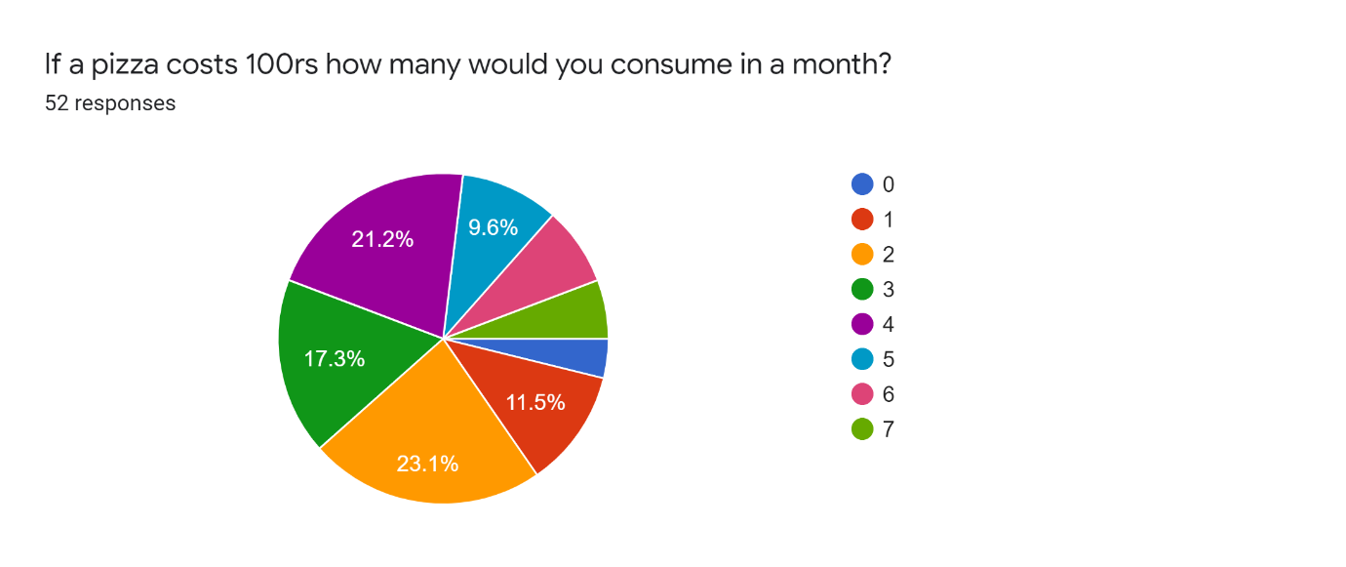
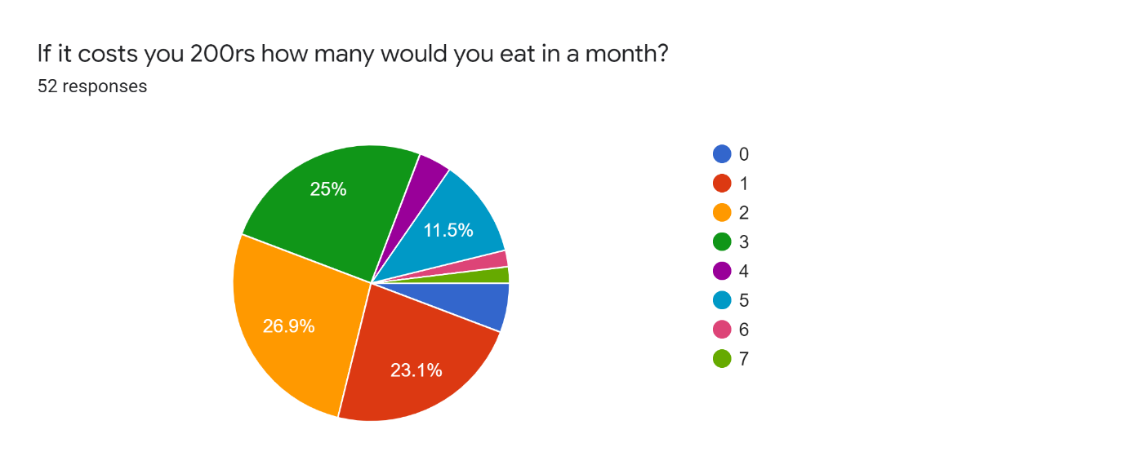
Demand curve:

Free market economy suggests that when the price of a pizza rises, consumer demand will go down. This equation gives a downward sloping demand curve.
DOMINO’S SUPPLY
Jubilant food works has closed 100 stores of Domino's Pizza in the second quarter of this fiscal, bringing it down to 1,264 stores. However, it also opened 10 new stores of Domino's Pizza and ventured into a new city as well but its operations have been reduced to 281 cities as of September 30, 2020. However, the group has taken various measures to protect profit margins. The group has made detailed assessments of its liquidity position for the next one year and of the recoverability and carrying values of all its assets and liabilities as on September 30, 2020 and on the basis of evaluation based on the current estimates has concluded that no material adjustments is required in the consolidated financial results.
Domino's Pizza's substitutes
- Papa John’s.
- Pizza Hut.
- Little Caesars.
- Yum! Brands.
- McDonald's.
- Starbucks.
- Subway.

In 2014, Domino’s generated $1.9 billion dollars of revenue of which 62% percent was from selling the ingredient to its franchisees supply chain management. Although most of us think of Domino’s as a pizza company, the company is dependent on its efficient logistics. Domino’s Supply chain is divided into three main tiers. Tier2 is comprised of Domino’s key suppliers that ship ingredients to Domino’s distribution centres. Tier 2 includes nine Leprino’s foods cheese suppliers, three Paradise tomato sauce suppliers, thirty eight Ardent Mills flour supplier and two Domino’s thin crust bread and veggie supplier centre. Tire 2 supplies pizza ingredients cheese, tomato sauce, flour, thin crust bread to tier1 (Domino’s Distribution centres). Tier1 is comprised of 16 Domino’s distribution centres that supply all ingredients to each of the stores in the US. Tier1 supplies the pizza ingredients to Tier 0 (5098 Domino’s stores). Tier 0 takes these ingredients and produce pizza to each of Domino’s customers.
DATA FINDING’S (GRAPHICAL)
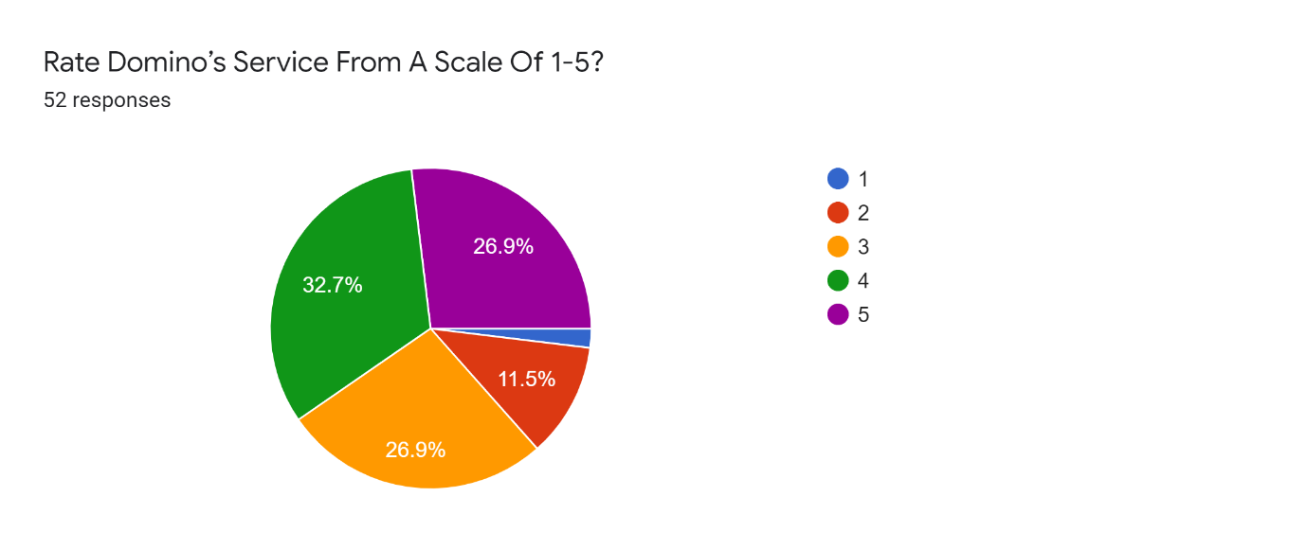
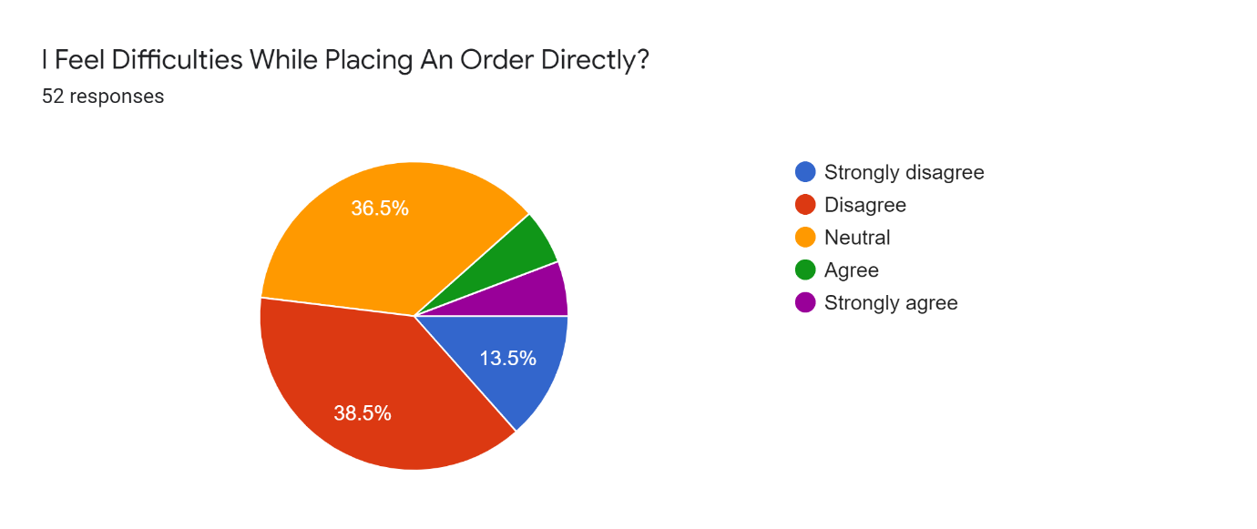
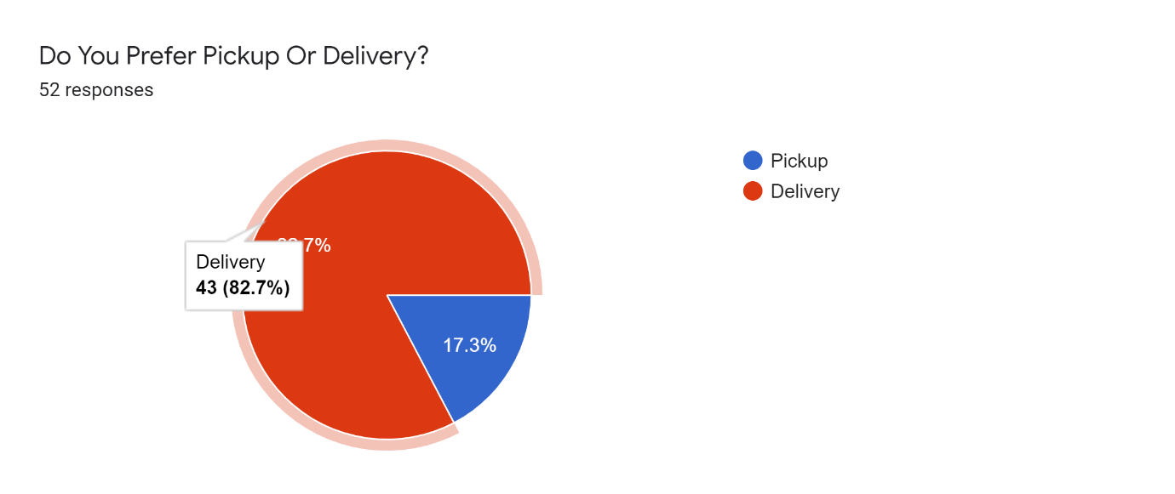
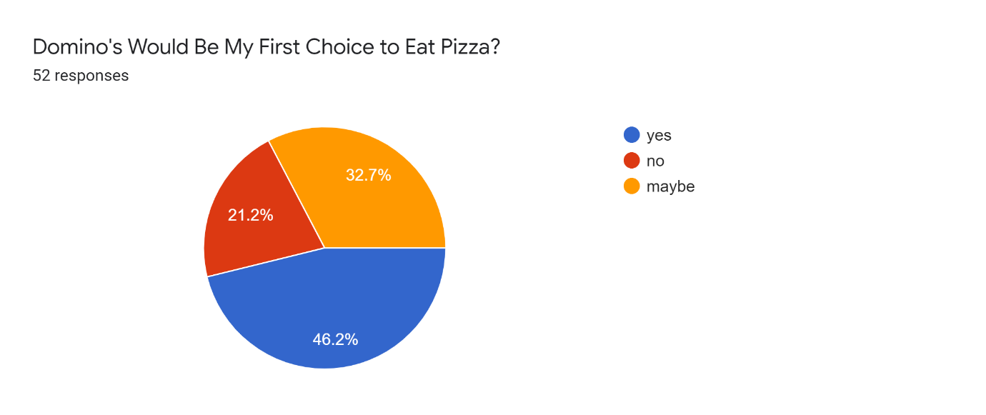
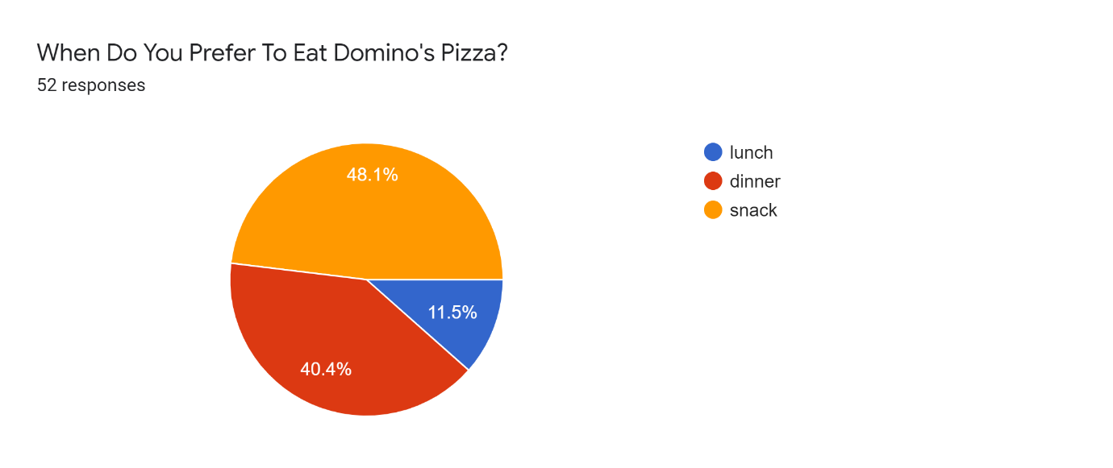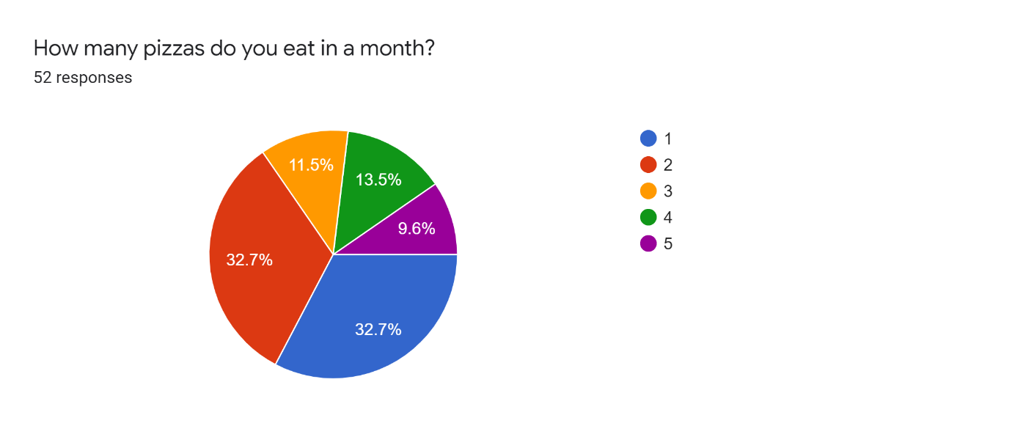
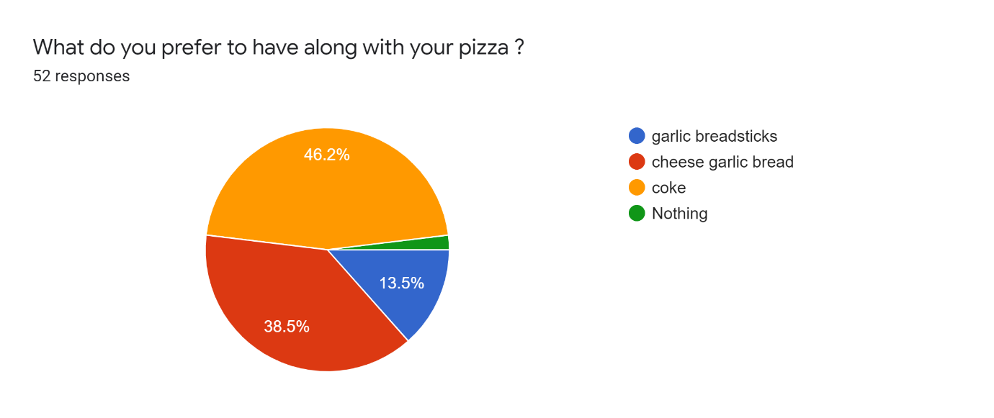
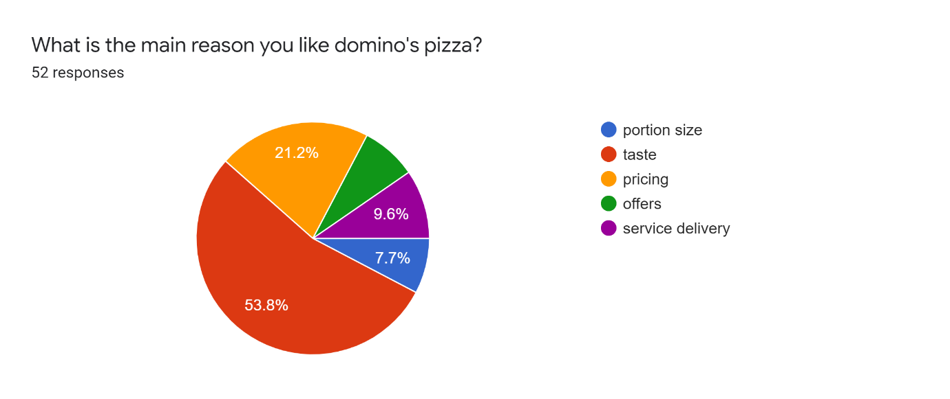
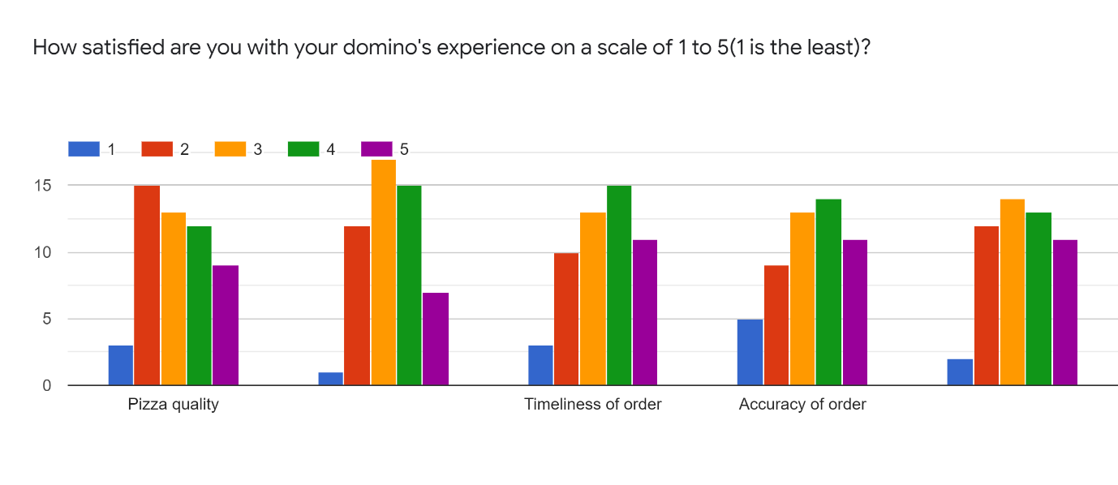
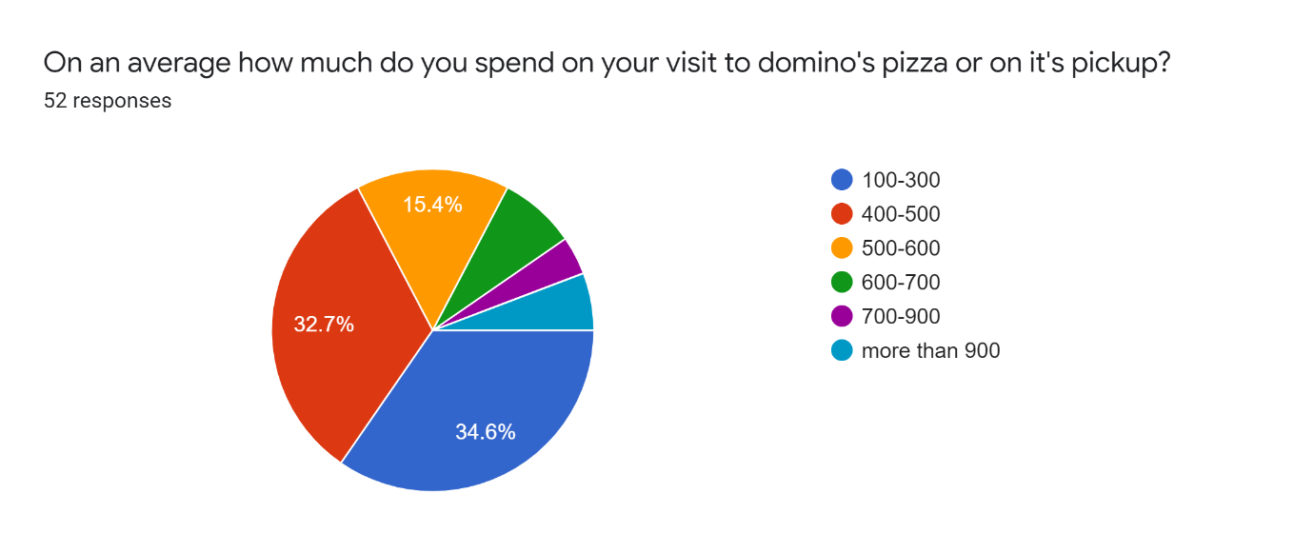
CONCLUSION
Domino’s Pizza constantly strives to develop products that suit the tastes of its consumers and hence delighting them. Dominos believes strongly in the strategy of ‘Think global and act local’. Thus, time and again Domino’s Pizza has been innovating with delicious new products such as crusts, toppings and flavours suitable to the taste buds of Consumers. Further, providing value for money at affordable products to the consumers has been Domino’s motto.
Domino’s Pizza is a leading global fast-food restaurant chain whose headquarters and foundations are based in the USA, but it has an enlarged network covering over 70 countries. The chain is currently considered as the second-best performing in the market after another American brand Pizza Hut. Domino’s greatest strength is in its innovation skills and capabilities that have seen it emerge as a market pioneer in many instances.
However, it’s advertising and marketing strategies have hampered its market performance following its promise to the market that it would manage to deliver hot and fresh pizza to its clientele during the cold season. Improving the global financial situation, especially after a long-term crisis, is proving to be of benefit to the company as it offers added opportunities for growth. Equally, the international expansion of the company is influencing its overall market performance by expanding the market and increasing sales volume.
The greatest market challenges for the firm are the failure of its US-based franchises to access credit and expand their business operations. This is affecting the overall business performance because the American market is by far the largest globally in as far as pizza sales are concerned.
Thus, any firm must take the American market seriously if it intends to compete effectively. As a remedy, the firm should invest directly in opening up branches in the country and invite franchisees to manage the branches on its behalf, instead of wasting time in waiting for the normalization of the domestic credit market.
BIBLIOGRAPHY
Allen, M., McLees, J., Richardson, C. and Waterford, D., 2015.
Project Planning and Best Practices.
Journal of Information Technology and Economic Development,6(1), p.1.Barrett, L., 2014.
Pizza, A Slice of American History.
Voyageur Press (MN). Brown, D.A.M., 2015.
The Great Data Breach. Davies, M. and Walsh, T.R., 2018.
A colistin crisis in India. Kirkpatrick, J., Cavalier, K. and Flanagan, J., 2018.
Chartered Financial Analyst Challenge: Analysis & Research of Domino's Pizza.
Magazine, P., 2017. Pizza Power 2017-A State of the Industry Report.

