R – Programming Test Roll No.70
Name – Divya Sharma

"Q2"
result = c("Fail","Pass")
result_1 = sample(result,1)
result_2 = sample(result,1)
result_3 = sample(result,1)
(result_1 == "Pass")|(result_2 == "Pass")|(result_3 == "Pass")
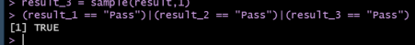
"Q4"
set.seed(9281)
X = rpois(1000,sample(seq(30,35,0.5),1))
which.max(table(X))
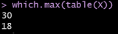
"Q3"
A = 0
while(A != 6){
A= sample(seq(1,6,1),1)
print(A)
}
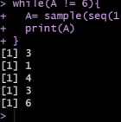
"Q1"
set.seed(2811)
X = rbinom(50,sample(seq(10,20),1),0.36) Data = data.frame(table(X))
Data$Prob = Data$Freq/sum(Data$Freq) Y = Data[3:6,3]
sum(Y)

