Aliya Fernandes, Roll no 426.
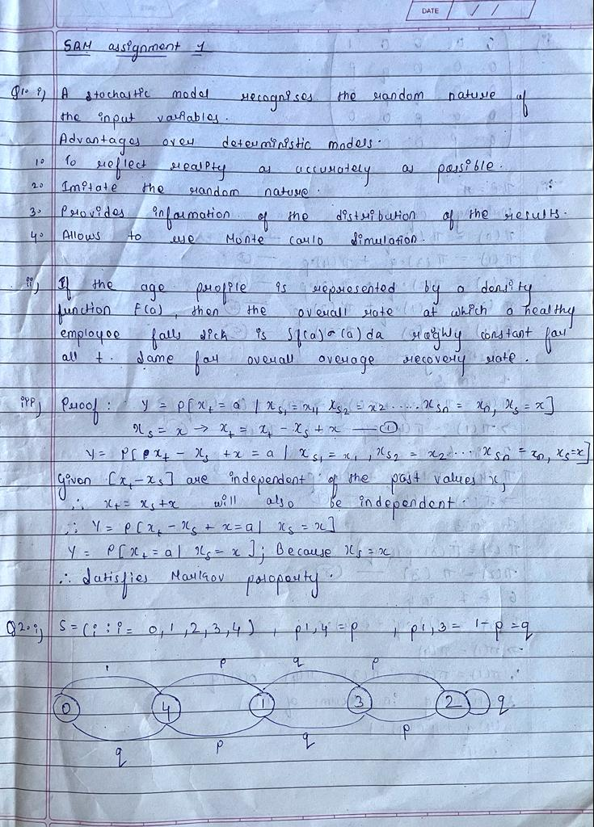

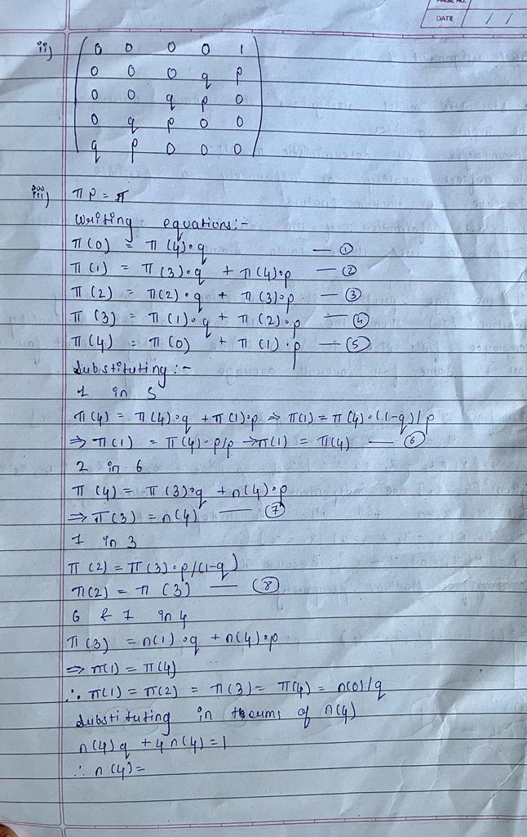
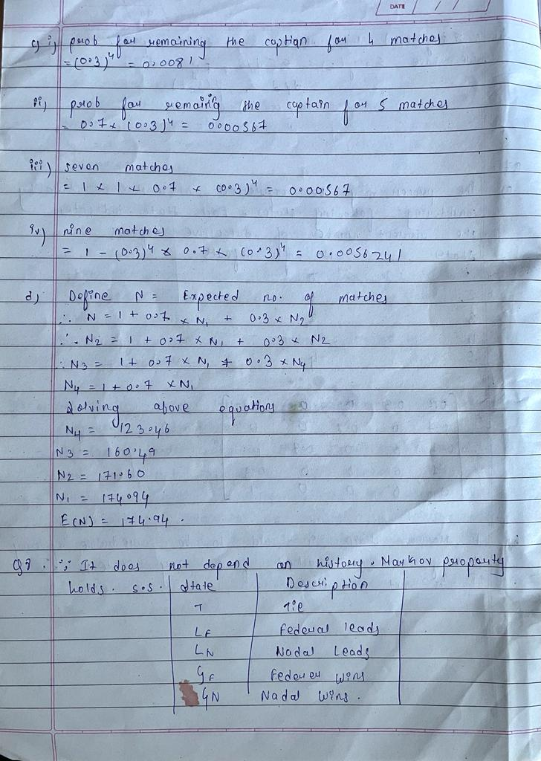

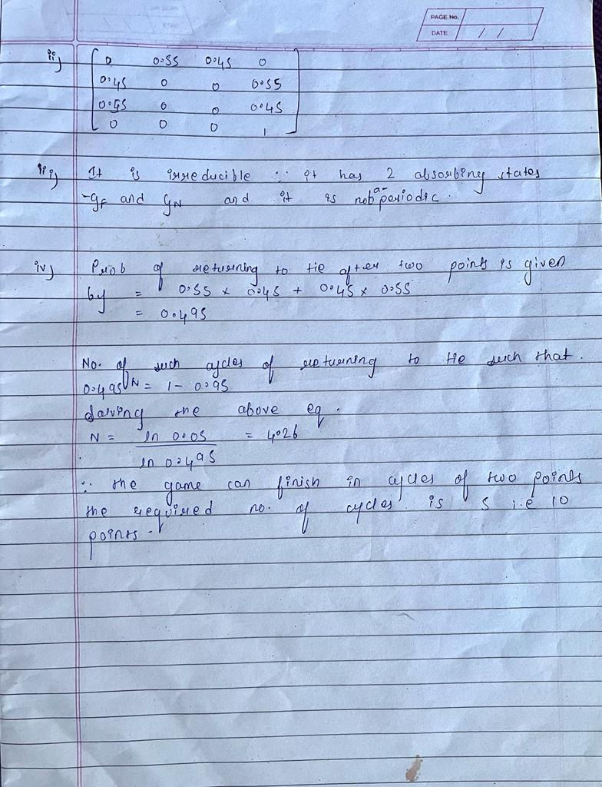

Q9
- The state transition diagram is set out below:
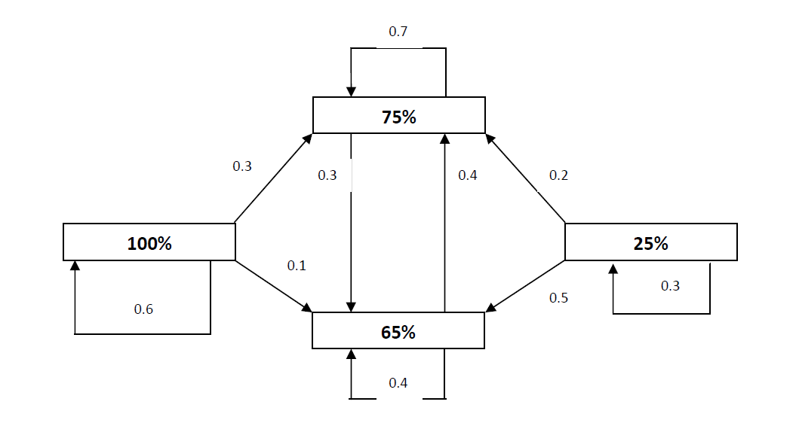
- We are to calculate for the % of corporate buyer having a target % for XYZ of 65%
• In 2 years time
• Over the long-run.
The state of the system after one year S1 = S0P
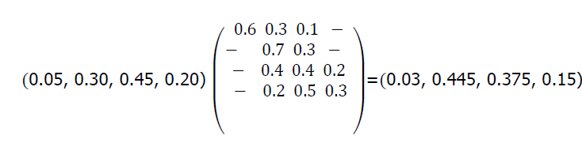
Hence the state of the system in 2 years time S2 = S1P
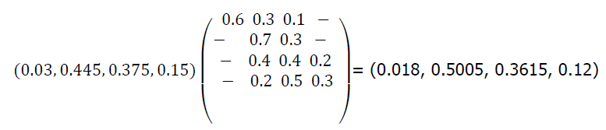
Hence the % of corporate buyer having a target % of 65% for XYZ in 2 years time is
36.15%.

The long run steady state can be found by solving the following equation:
S = SP
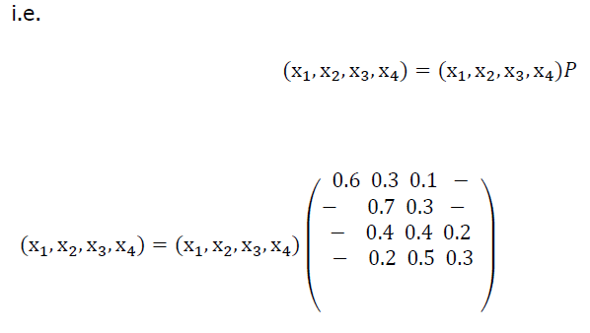
Hence we have the five equations
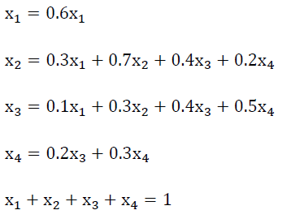
Now from the first equation above,
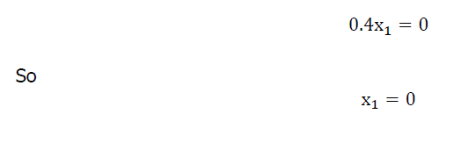
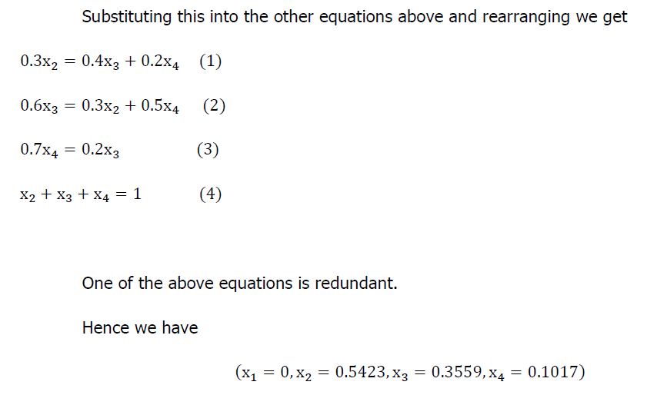

c) The steady state proportion of customers having a 65% target allocation for XYZ Ltd is 35.59%.
It is noted that the initially this proportion is 45% and it quickly drops to:
- 37.5% in one year’s time; and
- 36.2% in two years’ time
It is, therefore, likely that the steady state shall be reached in a few years’ time.
Q11
- If each room is represented by the state, then the transition matrix P for this Markov chain is as follows:
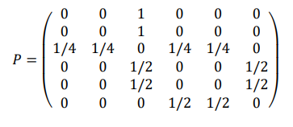
- The chain is irreducible, because it is possible to go from any state to any other state. However, it is not aperiodic, because for any even n ,𝑃6,1 𝑛 will be zero and for any odd n 𝑃6,5 𝑛 will also be zero . This means that there is no power of P that would have all its entries strictly positive.
- For P to be stationary, πP = P
Perform matrix multiplication and show that π P is equal to P
- We find from π that the mean recurrence time (i.e. the expected time to return) for the room 1 is 1/π(1)=12
- Let, ψ(i) = E(number of steps to reach state 5 | X0 = i). We have ψ(5) = 0 ψ(6) = 1 + (1/2)ψ(5) + (1/2)ψ(4) ψ(4) = 1 + (1/2)ψ(6) + (1/2)ψ(3) ψ(3) = 1 + (1/4)ψ(1) + (1/4)ψ(2) + (1/4)ψ(4) + (1/4)ψ(5) ψ(1) = 1 + ψ(3) ψ(2) = 1 + ψ(3). [1.5] We solve and find ψ(1) = 7.

